SUPPLEMENTARY DATA

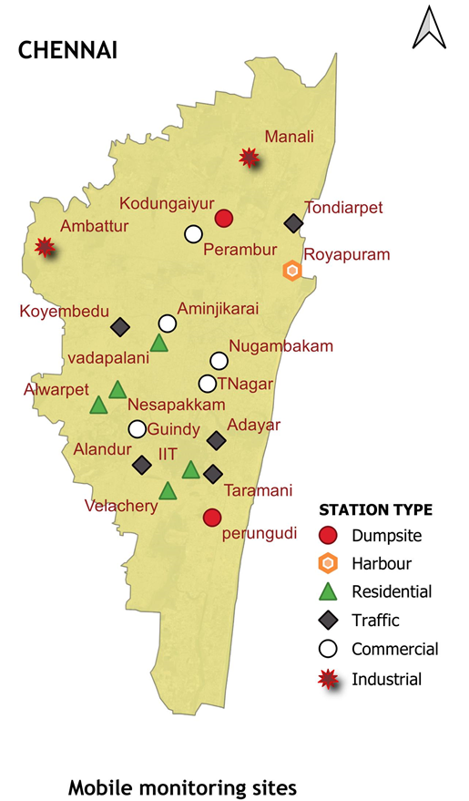
Fig. S1. The locations of air quality monitoring stations utilized for hotspot identification in Chennai city
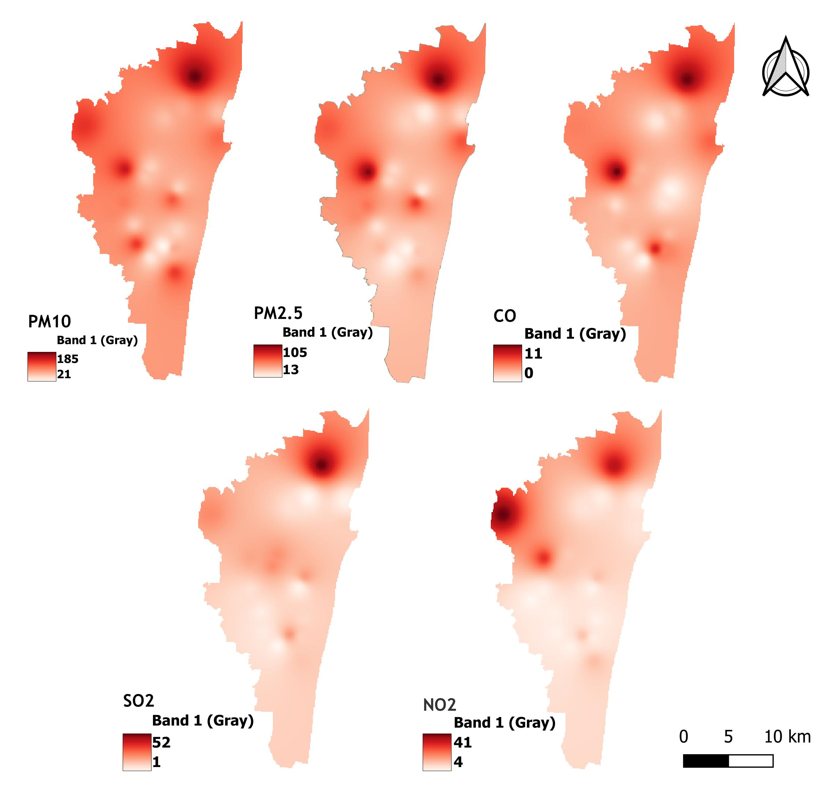
Fig. S2. Interpolation of Pollutants in Chennai Map Using QGIS Software.

Table S1. Summary of Pollutant Data in Selected Hotspots
Location | Type |  | PM₁₀  (µg/m³) |  | PM_{2.5}  (µg/m3) |  | NO₂  (µg/m³) |  | SO₂  (µg/m³) |  | CO  (mg/m³)
Manali |  | Industrial |  | 185.51 |  | 104.56 |  | 40.54 |  | 52.15 |  | 8.81
Alandur |  | Traffic |  | 130.41 |  | 77.47 |  | 18.01 |  | 14.78 |  | 5.46
Perungudi |  | Dumpsite |  | 129.61 |  | 45.11 |  | 16.83 |  | 12.74 |  | 2.74
Royapuram |  | Harbour |  | 106.70 |  | 66.99 |  | 24.15 |  | 11.17 |  | 1.30
Velachery |  | Residential |  | 36.73 |  | 13.20 |  | 4.57 |  | 1.52 |  | 0.51

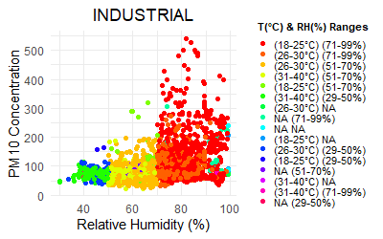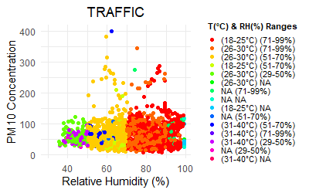
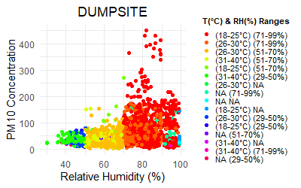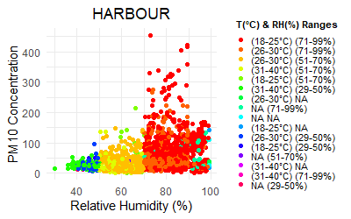
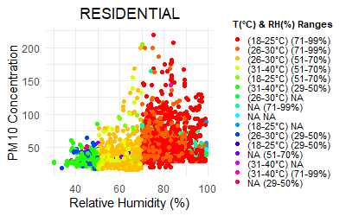
Fig. S3. The scatter plot depicting PM₁₀ concentrations alongside relative humidity and temperature

Table S2. Correlation Analysis of PM₁₀ with Temperature and Relative Humidity (RH)
 | INDPM₁₀ | TRAPM₁₀ | HARPM₁₀ | DUMPM₁₀ | RESPM₁₀
winter
TEMP | -0.48 | -0.36 | -0.39 | -0.44 | -0.40
RH | 0.41 | 0.35 | 0.36 | 0.40 | 0.40
Summer
TEMP | -0.32 | -0.33 | -0.29 | -0.40 | -0.38
RH | 0.38 | 0.32 | 0.35 | 0.32 | 0.40
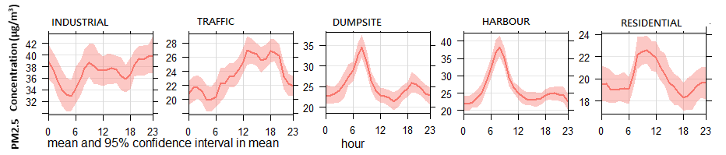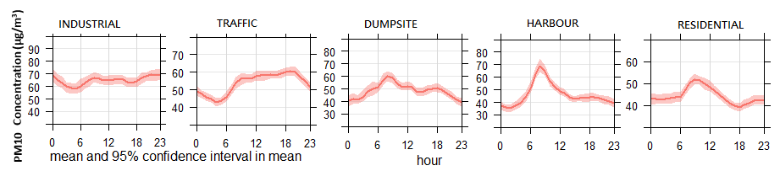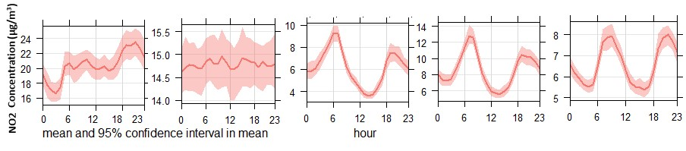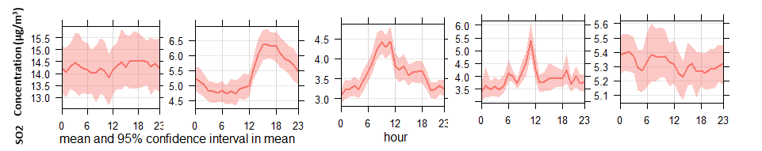
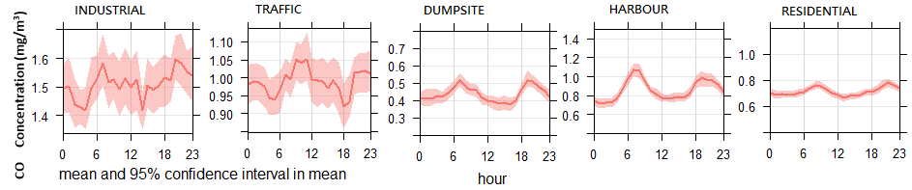
Fig. S4. Hourly variation of PM_{2.5}, PM₁₀, NO₂, SO₂, and CO at all the study sites.
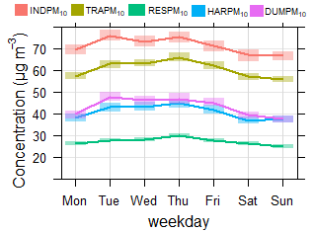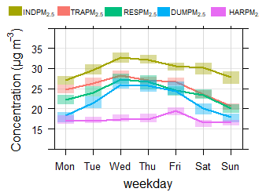

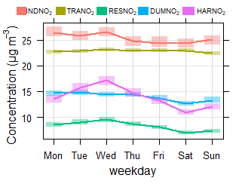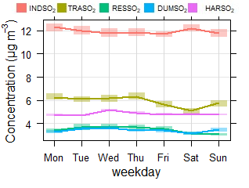

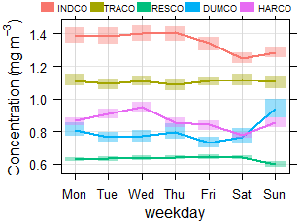
Fig. S5 Variations in Pollutant Concentrations Between Weekdays and Weekends Across Five Study Sites

Table S3. Skewness and kurtosis values of PM_{2.5}, PM₁₀, NO₂, SO₂ and CO at 5 study sites
 | PM_{2.5} |  | _{PM10} |  | SO₂ |  | NO₂ |  | CO
Station | Skewness | Kurtosis | Skewness | Kurtosis | Skewness | Kurtosis | Skewness | Kurtosis | Skewness | Kurtosis
S-I | 1.71 | 7.26 | 1.7 | 9.52 | 1.74 | 7.58 | 1.19 | 4.72 | 2.17 | 11.08
S-T | 2.03 | 8.94 | 0.97 | 4.02 | 1.6 | 5.51 | 2.28 | 10.94 | 1.12 | 4.34
S-C | 1.79 | 6.63 | 1.7 | 7.1 | 2.45 | 11.5 | 1.79 | 8.88 | 3.37 | 21.9
S-H | 2.16 | 10.64 | 2.05 | 9.29 | 1.52 | 6.47 | 6.36 | 64.04 | 2.29 | 12.84
S-R | 2.44 | 10.39 | 1.91 | 8.02 | 0.8 | 2.99 | 1.39 | 15.73 | 0.57 | 4.97

Table S4. Percentage of Air Quality Standard Exceedance (EF>1) for PM_{2.5}, PM₁₀, NO₂, SO₂, and CO at Each Study Site
 | Industrial | Traffic | Dumpsite | Harbour | Residential
PM₁₀ | 25.75 | 14.52 | 7.95 | 12.33 | 6.30
PM_{2.5} | 26.58 | 16.44 | 11.23 | 20.00 | 5.75
SO₂ | 6.03 | 4.66 | 4.93 | 4.66 | 3.84
NO₂ | 21.92 | 17.53 | 4.11 | 2.74 | 1.92
CO | 23.73 | 20.45 | 10.18 | 7.58 | 6.01

