Supplementary Information
A game-changing core-sheath yarn with large-scalable production to transform wool static nuisance into usable energy for wearable electronics
Chengdong Xiong¹, Bin Luo¹, Sailing Lei², Linqi Dai¹, Jinlin Yu¹, Liming Wang¹, Rongwu Wang^{1,*}, Xiaohong Qin^{1,*}
1. Key Laboratory of Textile Science & Technology of Ministry of Education, College of Textiles, Donghua University, Shanghai 201620, China;
2. College of Textile Science & Engineering, Zhejiang Sci-Tech University, Hangzhou 310018, China;
These authors contributed equally: Chengdong Xiong, Bin Luo
*Corresponding authors.
Email: wrw@dhu.edu.cn (R. Wang), xhqin@dhu.edu.cn (X. Qin)

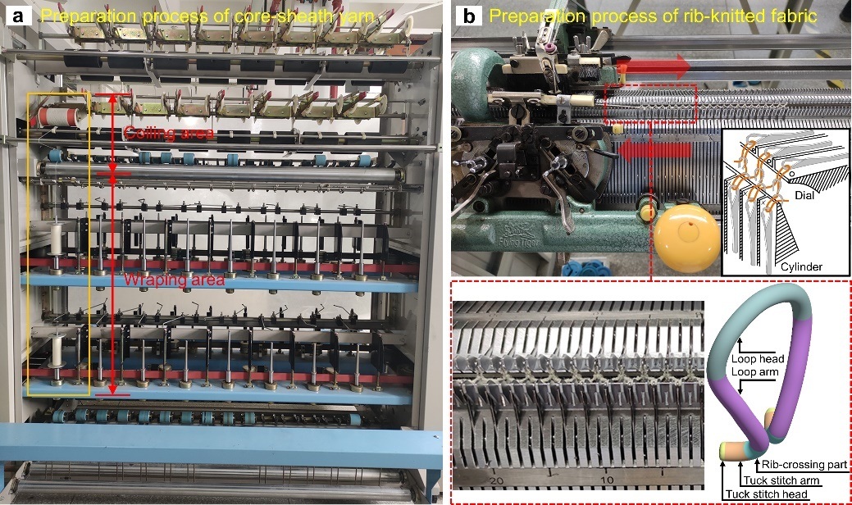
Figure S1. Preparation process of CSY and CSYF. (a) A photographic image of wrapping yarn machine for preparing CSY. (b) Looping process of CSYF with “1 × 1” ribbed structure using a flat knitting machine.

Figure S2. Diameters of CSYs with various twist counts.

Figure S3. Dyeing process flow chart for rib-knitted T-800 CSYF.
The dye used is reactive dye ANOFIX® Red C-2B (Shanghai ANOKY Textile Chemicals Co., Ltd., China), the dyeing assistants are ammonium sulfate ((NH₄)₂SO₄, 99%, Shanghai Aladdin Reagent Co., Ltd., China) and sodium sulfate (Na₂SO₄, 99%, Shanghai Aladdin Reagent Co., Ltd., China), and the pH regulator is formic acid (HCOOH, 88%, Sinopharm Chemical Reagent Co., Ltd., China) and sodium hydroxide (NaOH, 96%, Sinopharm Chemical Reagent Co., Ltd., China). The dyeing process is mainly divided into the following five steps:
Step 1: Pretreatment
The temperature of dye bath is controlled at 40ºC. The dye bath ratio (the ratio of dye solution to the weight of the dyed fiber/fabric) is 1:100. The consumption of ANOFIX® Red C-2B is 2.5% (owf, on weight of fiber/fabric). Next, (NH₄)₂SO₄ and Na₂SO₄ are added as dyeing assistants. Then, titrate the dye bath with HCOOH to a pH of 5. Finally, the rib-knitted T-800 CSYF is immersed in the dye bath for 10 min.
Step 2: Dying
The dye bath is heated to 80ºC at a rate of 1 ºC/min. The CSYF is held at this temperature for 60 min to achieve the desired dye results.
Step 3: Fixation
The dye bath is adjusted to a pH of 8 by adding a solution of 2 g/L NaOH to fix the dye on the CSYF. The color fixation process lasts for 15 min.
Step 4: Washing
The dyed CSYF is removed from dye bath and placed in distilled water at 70ºC, undergoing continuous washing for 20 min until the surface is free of floating color.
Step 5: Drying
After washing, extract the CSYF and transfer it to an oven set at 50ºC for 8 h. Finally, let it cool naturally to room temperature.

Note S1. Calculation of yarn electrical conductivity
The electrical conductivity ($ρ$) of steel wires in CY can be calculated from the electrical resistance ($R$):
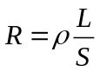,
where $L$ and $S$ are the length and cross-sectional area of steel wires, respectively.

Figure S4. Various parts of CSY pressing mode used for model parameterization and boundary condition settings.
The analysis of electric potential distribution of CSY was conducted by finite element simulations using COMSOL Multiphysics software version 6.1 (COMSOL, Inc., Sweden). These simulations visually captured and analyzed the deformation state and power generation process of CSY in pressing mode. The electrostatic physical field is set as the occurrence domain for the model composed of CSY and Kapton film. The materials in the physical field include air, Kapton, wool, polyethylene terephthalate (PET), and steel wire, with their corresponding relative permittivity values set as 1, 2.8, 5.4, 3.4, and 14.2, respectively. And their geometric dimensions are shown in Table S1. In order to facilitate the subsequent calculation of the area of the geometry, the width of the lines at the interface of the geometry is assumed to be a constant $D_{1}=1$ m. In the electrostatic module, the boundary of the square air region is set to be grounded. The surface charge density of Kapton film contact interface ($ρ_{K1}$), wool yarn surface ($ρ_{W1}$), and PET yarn surface ($ρ_{P1}$) are set to -4.7×10⁻⁶ C/m², 1.2×10⁻⁶ C/m², and -1.1×10⁻⁶ C/m², respectively. The conductive steel wire surface is set as the floating potential boundary condition. According to the law of charge conservation and the dimensions of geometries of Table S1, the floating potential charge ($Q_{1}$) can be calculated by the following formula:
,
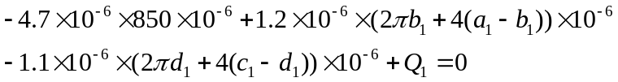,
C.
Values for surface charge densities ($ρ_{K1}$, $ρ_{W1}$, $ρ_{P1}$) and floating potential charge ($Q_{1}$) are assigned. Subsequently, the meshing style adopts a free tetrahedral mesh. Finally, the dynamic piezoelectric outputs of CSY in the pressing mode are computed.

Table S1 Dimensions of geometries in the pressing mode.
Parameter | Value (µm) | Description
k | 850 | Length of Kapton film
t | 50 | Thickness of Kapton film
a₁ | range (450, -5, 425) | Major axis length of the assumed elliptical cross-section of two wool yarns
b₁ | range (400, 5, 425) | Minor axis length of the assumed elliptical cross-section of two wool yarns
c₁ | range (150, -2, 140) | Major axis length of elliptical PET cross-section
d₁ | range (130, 2, 140) | Minor axis length of elliptical PET cross-section
r₁ | 30 | Radius of circular steel wire cross-section
y | range (425, 5, 450) | Distance between Kapton film and CSY center
C_{K1} | $$850=k$$ | Length of Kapton film contact surface
C_{W1} | $$2πb_{1}+4(a_{1}-b_{1})$$ | Perimeter of the assumed elliptical cross-section of two wool yarns
C_{P1} | $$2πd_{1}+4(c_{1}-d_{1})$$ | Perimeter of elliptical PET cross-section
C_{S1} | $$2πr_{1}$$ | Perimeter of circular steel wire cross-section

Figure S5. T-800 CSYs with modified core and sheath yarns and their fabric (4 × 5 cm) output voltages in pressing mode. (a) CSY with PET/C CY and wool SY. (b) Comparison of output voltages: original CSYF, CSYF integrated with PET/C CY and wool SY, and dyed CSYF combined with PET/S CY and Hwool SY.

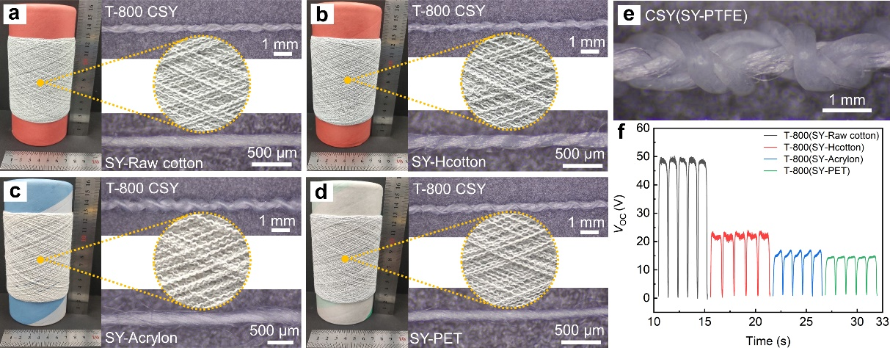
Figure S6. T-800 CSYs with different SY materials and their fabric output voltages in pressing mode. CSYs with different SYs including (a) raw cotton, (b) Hcotton, (c) acrylon, (d) PET, and (e) PTFE. (f) Comparison of output voltages of CSYFs with different SYs. These SYs are all commercially available (Henan Xinye Textile Co., Ltd., China) and used without further modification.

Table S2 Summary of performances and applications of yarn-based E-textiles for wearable electronics.
Material | Preparation method | Production capacity  (m/min) | Electric output of fabric | Peak power density (mW m⁻²) | Fabric stretchability (reversible strain) | Main application | Reference
Silicone rubber/stainless steel/PAN | Melt-spinning, braiding and weaving | ~28 (Silicone rubber/stainless steel core-sheath yarn) | ~35 V, 2 Hz | 6.62 | ~100% | EG and MM | Gong et al.¹
Geniomer/metal alloy | Preform fabrication and thermal drawing | 0.05-0.6 | 490 V, 2 Hz | — | — | EG and MM | Dong et al.²
Ag and silicone coated PA/cotton | Knitting | — | ~50 V, ~0.15 µA, ~2 Hz | ~3.4 | 50% | EG and MM | Chen et al.³
Terylene-twisted stainless steel/nylon | Knitting | — | ~30 V | — | ~30% | MM | Fan et al.⁴
Metal-coated nylon/spandex/P(VDF-TrFE) | Braiding and conjugate electrospinning | ~0.03 | ~300 V, ~8 µA, 2 Hz | 1250 | — | EG and MM | Zhang et al.⁵
Silver-plated nylon /cotton/ nylon/PDMS@BaTiO3/PVA | Yarn spinning, coating and braiding | 2 (nylon coated core-spun yarn) | 174 V, 7.5 µA, 5 Hz | 275 | — | EG and MM | Gao et al.⁶
Silver-coated PA/PU | Braiding | ~6 | ~2.0 V, ~6 nA, 1 Hz | — | — | MM | Wu et al.⁷
Elastomers/latex/MWCNT/PDMS | Coaxial screw extrusion and dip-coating | 0.6 | 43.2 V, 6.12 µA (Stretching mode) | 118.9 | 100% | EG | Kim et al.⁸
Silver-plated nylon/PET | Braiding | ~1.73 | 12 V, 0.15 µA, 2 Hz | 3.0 | — | EG and MM | Cui et al.⁹
Graphene-coated PET/nylon/PET | Melt-spinning, dip-coating and multiaxial winding | — | ~40 V, ~0.4 µA, 2 Hz | 1.03 | ~40% | EG and MM | Xiong et al.¹⁰
PI/conductive nylon | Braiding | 2 | 155.3 V, 34.3 µA | 42.3 | — | EG and MM | Peng et al.¹¹
PA/PTFE/silver-plated yarn | Knitting | — | 133.8 V, 21.9 µA, 2 Hz | 530 | ~92% | EG and MM | Yan et al.¹²
Liquid metal/sodium alginate/MWCNT/water PU/PET | Printing | — | 130 V, 4µA, 2 Hz | 162 | 100% | EG and MM | Chunget al.¹³
Wool/PET/steel | Wrap spinning and knitting | 6.25 | 430 V, 2.7 µA, 2 Hz | 740 | 200% | EG and MM | This work
The following are the abbreviations used in the table. PAN: polyacrylonitrile. Geniomer: a two-phase block copolymer made up of a soft polydimethylsiloxane phase and a hard aliphatic isocyanate phase. PA: polyamide. P(VDF-TrFE): Poly(vinylidene fluoride-co-trifluoroethylene). PDMS: polydimethylsiloxane. PVA: polyvinyl alcohol. PU: polyurethane. Elastomers: poly(styrene-isoprene-styrene). MWCNT: multiwalled carbon nanotube. PI: polyimide. PTFE: polytetrafluoroethylene. EG: energy generator, MM: motion monitoring.

Note S2. Analysis of structural deformation of SY in stretching mode
As shown in the purple dotted box of Fig. 5b, for the ease of theoretical analysis, both the CY and SY are assumed to have circular cross-sections. The SY is depicted in a finer yellow cylinder to highlight the changes in length before and after stretching. $R_{0}$ and $R_{1}$ represent the pre- and post-stretching distances between the centers of the CY and SY cross-sections, respectively. $L_{0}$ and $L_{1}$ are the pre- and post-stretching lengths of SY, and $h$ is the helix pitch (length per unit twist, m,) which is the inverse relationship of the twist count ($T$, twists/m). Unwinding the helix of SY can allow $2πR_{0}$, $L_{0}$ and $h$ for a right triangle. When the elongation of CSY is $ε$ after stretching, the helix pitch is $h\left(1+ε\right)$. We assume that SY only stretches its helical structure without inherent elongation under the stretching mode, meaning $L_{0}=L_{1}$. So the relationship between $R_{0}$ and $R_{1}$ can be expressed as follow:
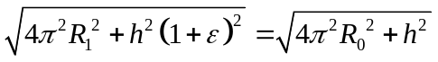,
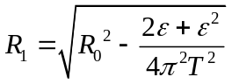.

Figure S7. Influence of (a) single-wrapped and (b) double-wrapped SY on the CSY structure.

Note S3. Analysis of forces on SY under the stretching mode
As shown in the green dotted box of Fig. 5b, a short segment $l$ of SY is taken for analysis. Denoting $γ$ as the wrapping angle of SY around the CY, tension $F_{l}$ exists on both ends of $l$ under the axial stretching when ignoring the friction force generated in the segment $l$. Defining$F_{R}$ as the sum of the projections of the tension $F_{l}$ at both ends in the central normal direction of the segment $l$, which is also the centripetal pressure exerted by the SY on the CY, expressed as
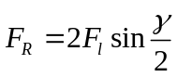.

Note S4. Analysis of forces on fibers within CY under the stretching mode
As shown in the red box of Fig. 5b, if $r$ represents the helical radius of a fiber with length $c$ in the CY, and $ρ$ is the curvature radius of this helix, then
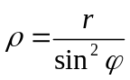,
where $φ$ is the angle between the helix and the CY axis. Given that $d_{c}=ρd_{θ}$, the centripetal force ($N$) of the outermost fiber can be deduced as
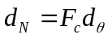,
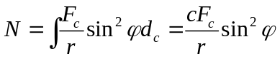,
where $F_{c}$ is the tension on both ends of helix. And it can be expressed as
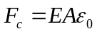,
where $E$, $A$ and $ε_{0}$ are the initial modulus, cross-sectional area, and strain of the fiber, respectively. Combining Eqs. , , and , $N$ can be calculated as
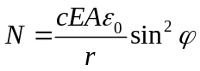.

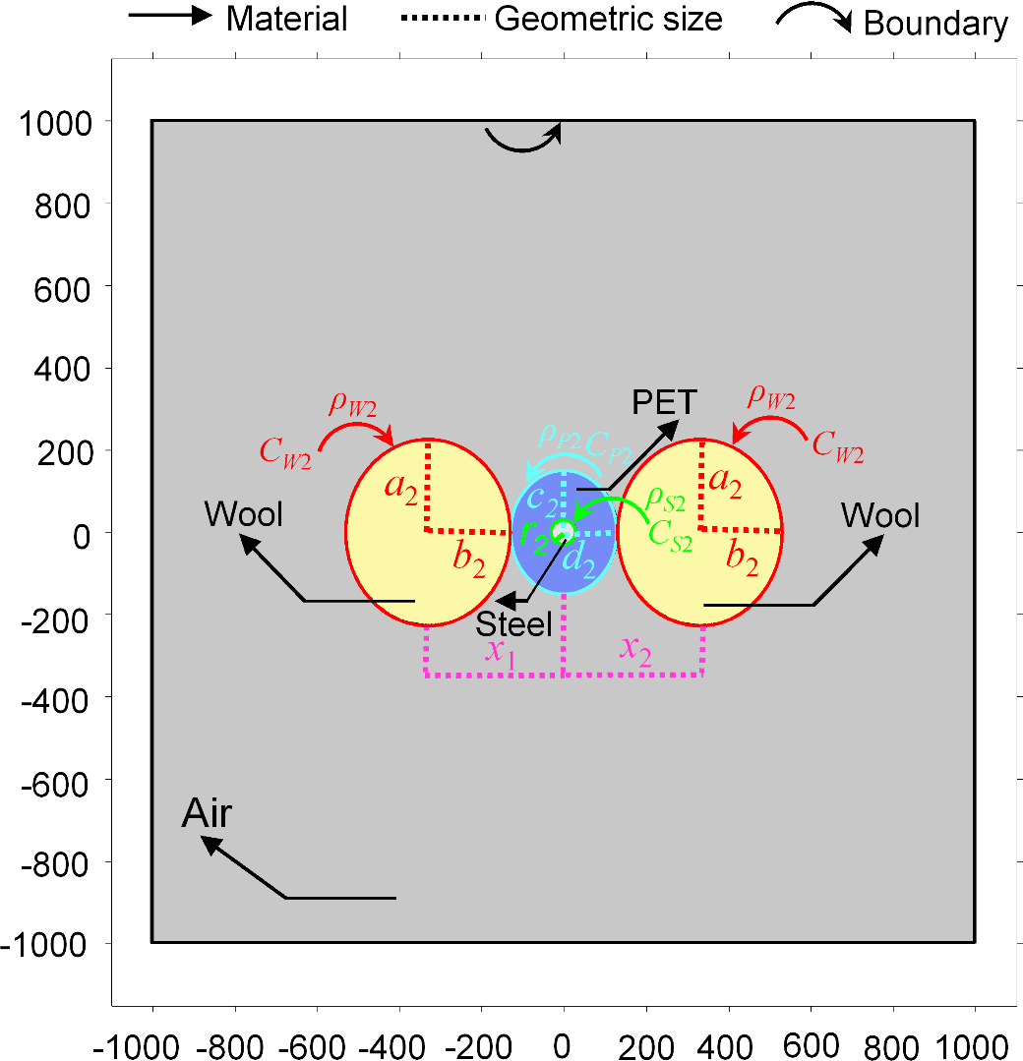
Figure S8. Various parts of CSY stretching mode used for model parameterization and boundary condition settings.
Similar to the simulation of the electric potential distribution of CSY in the pressing mode, the same COMSOL software and electrostatic module were used to analyze the dynamic electric potential distribution of CSY under the stretching mode. The CSY model is composed of two sheath wool yarns and a core conductive PET yarn with embedded steel wires. The materials in the physical field include air, wool, PET, and steel wire, with their corresponding relative permittivity values set as 1, 5.4, 3.4, and 14.2, respectively. And their geometric dimensions are shown in Table S3. In order to facilitate the subsequent calculation of the area of the geometry, the width of the lines at the interface of the geometry is assumed to be a constant $D_{2}=1$ m. In the electrostatic module, the boundary of the square air region is set to be grounded. The surface charge densities of wool yarn surface ($ρ_{W2}$) and PET yarn surface ($ρ_{P2}$) are set to 1.2×10⁻⁶ C/m² and -1.1×10⁻⁶ C/m², respectively. The conductive steel wire surface is set as the floating potential boundary condition. According to the law of charge conservation and the dimensions of geometries of Table S3, the floating potential charge ($Q_{2}$) can be calculated by the following formula:
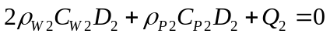,
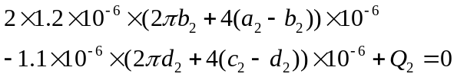,
C.
Values for surface charge densities ($ρ_{W2}$, $ρ_{P2}$) and floating potential charge ($Q_{2}$) are assigned. Subsequently, the meshing style adopts a free tetrahedral mesh. Finally, the dynamic piezoelectric outputs of CSY in the stretching mode are computed.

Table S3 Dimensions of geometries in the stretching mode.
Parameter | Value (µm) | Description
a₂ | range (225, -2.5, 212.5) | Major axis length of the elliptical cross-section of single wool yarn
b₂ | range (200, 2.5, 212.5) | Minor axis length of the elliptical cross-section of single wool yarn
c₂ | range (150, -2, 140) | Major axis length of elliptical PET cross-section
d₂ | range (130, 2, 140) | Minor axis length of elliptical PET cross-section
r₂ | 30 | Radius of circular steel wire cross-section
x₁ | range (-330, -4.5, -490) | Distance between PET center and single wool yarn center
x₂ | range (330, 4.5, 490) | Distance between PET center and another single wool yarn center
C_{W2} | $$2πb_{2}+4(a_{2}-b_{2})$$ | Perimeter of the elliptical cross-section of single wool yarn
C_{P2} | $$2πd_{2}+4(c_{2}-d_{2})$$ | Perimeter of elliptical PET cross-section
C_{S2} | $$2πr_{2}$$ | Perimeter of circular steel wire cross-section

Figure S9. Response signals of T-800 CSYF in different motions and its versatility. (a) Output current of CSYF sutured on the knee of sweatpants. (b) Output current of CSYF with “DHU” pattern sutured on the chest of a sleeveless tee in running. Output (d) voltage and (e) current of (c) CSYF directly in contact with the skin and sutured with a chest strap in running.

1. Gong W, et al. Continuous and scalable manufacture of amphibious energy yarns and textiles. Nat Commun 10, 868 (2019).
2. Dong C, et al. High-efficiency super-elastic liquid metal based triboelectric fibers and textiles. Nat Commun 11, 3537 (2020).
3. Chen C, et al. 3D double-faced interlock fabric triboelectric nanogenerator for bio-motion energy harvesting and as self-powered stretching and 3D tactile sensors. Materials Today 32, 84-93 (2020).
4. Fan W, et al. Machine-knitted washable sensor array textile for precise epidermal physiological signal monitoring. Sci Adv 6, eaay2840 (2020).
5. Zhang DW, et al. Abrasion Resistant/Waterproof Stretchable Triboelectric Yarns Based on Fermat Spirals. Advanced Materials 33, (2021).
6. Gao Y, et al. Scalable core–spun coating yarn-based triboelectric nanogenerators with hierarchical structure for wearable energy harvesting and sensing via continuous manufacturing. Nano Energy 91, (2022).
7. Wu R, Liu S, Lin Z, Zhu S, Ma L, Wang ZL. Industrial Fabrication of 3D Braided Stretchable Hierarchical Interlocked Fancy‐Yarn Triboelectric Nanogenerator for Self‐Powered Smart Fitness System. Advanced Energy Materials 12, (2022).
8. Kim WJ, Cho S, Hong J, Hong JP. Geometrically versatile triboelectric yarn-based harvesters via carbon nanotubes-elastomer composites. Composites Science and Technology 219, (2022).
9. Cui XJ, Li A, Zheng ZN, Wu HG, Wang R. A Machine-Braided Flame-Retardant Triboelectric Yarn/Textile for Fireproof Application. Advanced Materials Technologies 8, (2023).
10. Xiong Y, et al. Scalable spinning, winding, and knitting graphene textile TENG for energy harvesting and human motion recognition. Nano Energy 107, (2023).
11. Peng Z, et al. Enhancing electrical output and thermal adaptivity in an interlocked core-sheath triboelectric yarn/fabric for intelligent fire-rescue systems. Chemical Engineering Journal 486, (2024).
12. Yan J, Liu J, Li Y, Wang K, Kang W, Yang G. High-performance textile-based triboelectric nanogenerators with damage insensitivity and shape tailorability. Nano Energy 126, (2024).
13. Chung KY, Xu B, Tan D, Yang Q, Li Z, Fu H. Naturally Crosslinked Biocompatible Carbonaceous Liquid Metal Aqueous Ink Printing Wearable Electronics for Multi-Sensing and Energy Harvesting. Nanomicro Lett 16, 149 (2024).

