Figure S1: ROC curves of the ability of the LAR and SOFA score to predict 28-day mortality.
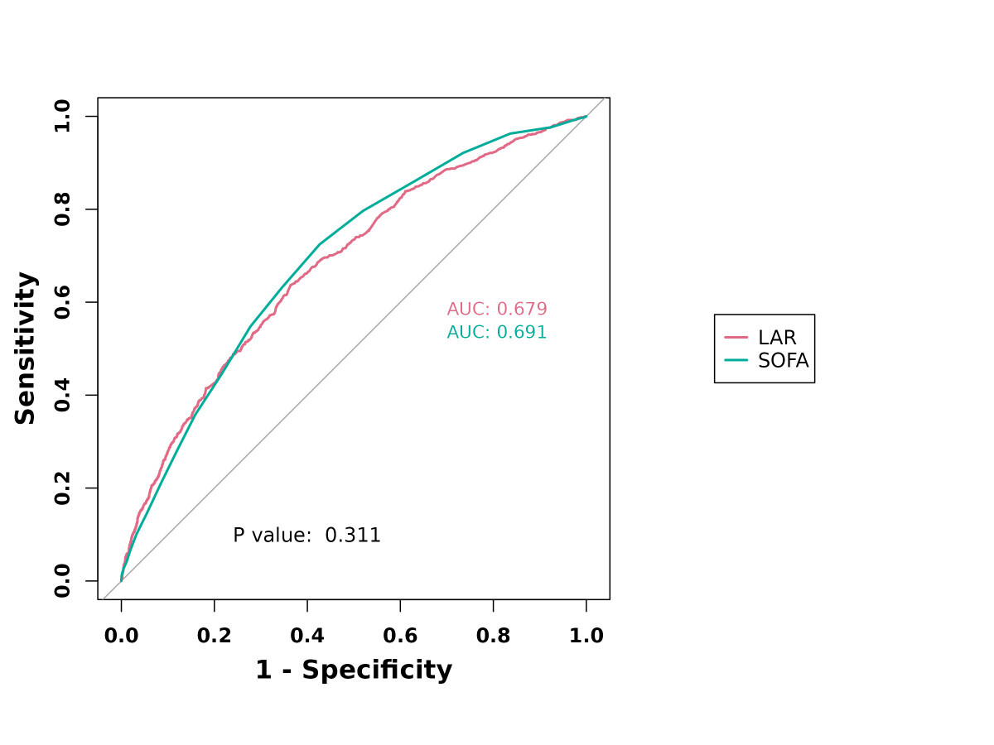
Figure S2: Kaplan‒Meier survival analysis curve for 90-day mortality.
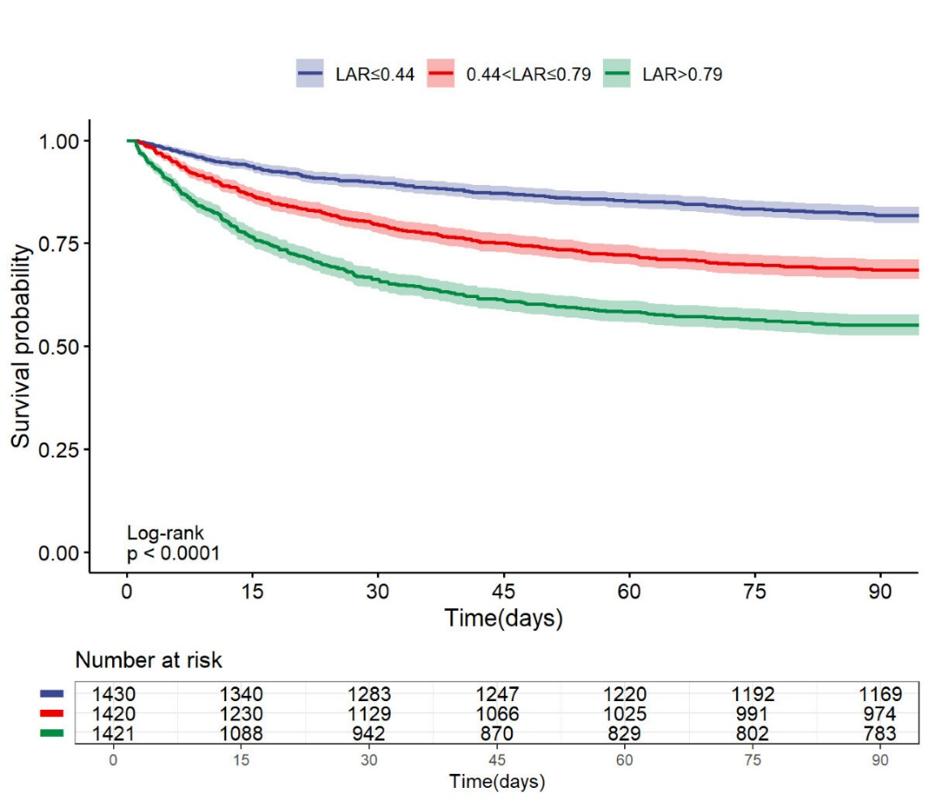

Figure S3: Kaplan‒Meier survival analysis curve for one-year mortality.
