Supplementary material for “Histopathology and proteomics are synergistic for

High-Grade Serous Ovarian Cancer platinum response prediction”

Oz Kilim^{1,4}, Alex Olar^{1,3}, András Biricz^{1,4}, Lilla Madaras⁶, Péter Pollner^{2,4}, Zoltán Szállási^{5,7,8}, Zsofia Sztupinszki^{5,7,8*}, and István Csabai^{1*}
1Eötvös Loránd University, Department of Physics of Complex Systems, Budapest, Hungary
2Eötvös Loránd University, Department of Biological Physics, Budapest, Hungary
3Eötvös Loránd University, Department of Informatics, Budapest, Hungary
4Semmelweis University, Data-Driven Health Division of National Laboratory, Budapest, Hungary
5Danish Cancer Institute, Copenhagen, Denmark.
6Semmelweis University, 2nd Department of Pathology, Budapest, Hungary
7Computational Health Informatics Program, Boston Children’s Hospital, Boston, MA, USA
8Harvard Medical School, Boston, MA, USA
*Corresponding authors

Supplementary Tables

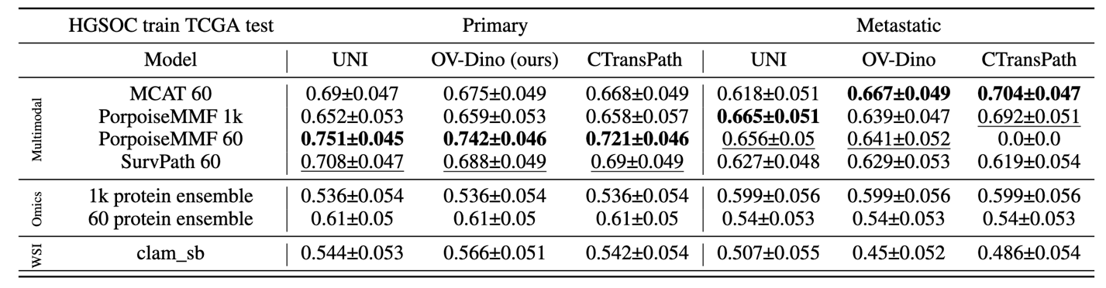
Table. S1. Testing on TCGA samples AUC scores. Bold values are the highest scores for a given feature extractor
and architecture. Underlined are the second-highest scores.

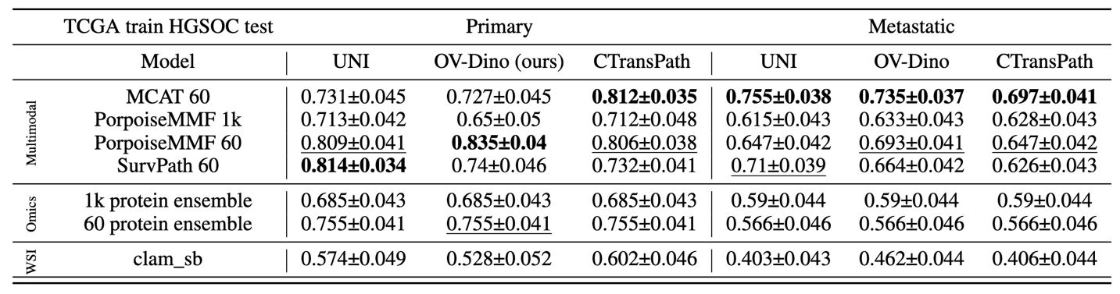
Table. S2. Testing on all HGSOC samples AUC scores. Bold values are the highest scores for a given feature
extractor and architecture. Underlined are the second-highest scores.
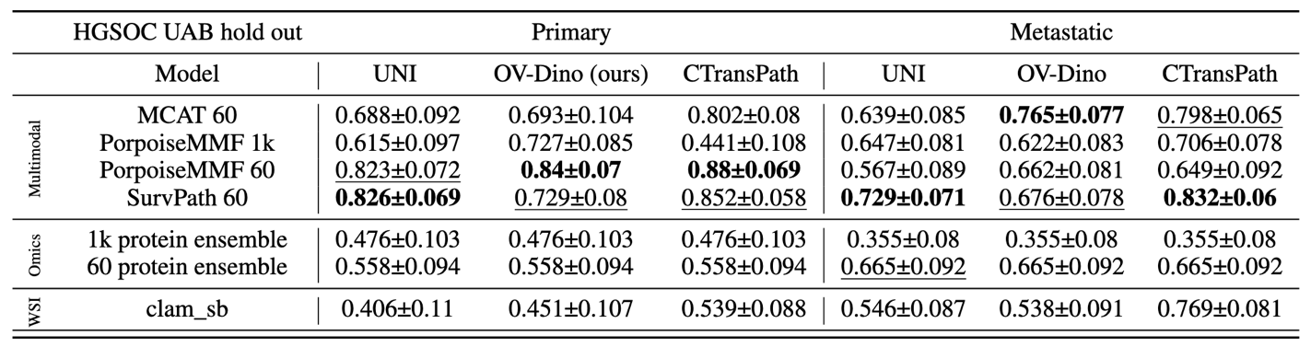
Table. S3. Testing on HGSOC-UAB samples AUC scores. Bold values are the highest scores for a given feature
extractor and architecture. Underlined are the second-highest scores.

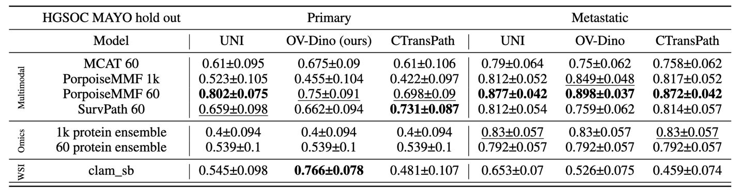
Table. S4. Testing on HGSOC-Mayo samples AUC scores. Bold values are the highest scores for a given
feature extractor and architecture. Underlined are the second-highest score

Dataset | Number of WSIs | Micron per pixel | slide type
TCGA-OV ⁴² | 1481 | 0.5040 | FFPE + Fresh frozen
Bevacizumab response⁴⁵ | 284 | 0.5 | FFPE
CPTAC 2 ¹² | 221 | 0.2501 | FFPE
UBC Ocean ⁴² | 538 | 0.5 | FFPE
PTRC-HGSOC ⁹ | 349 | 0.4965 | FFPE
Table S5. Opensource datasets used for OV-Dino ViT pre-training.

Supplementary Figures

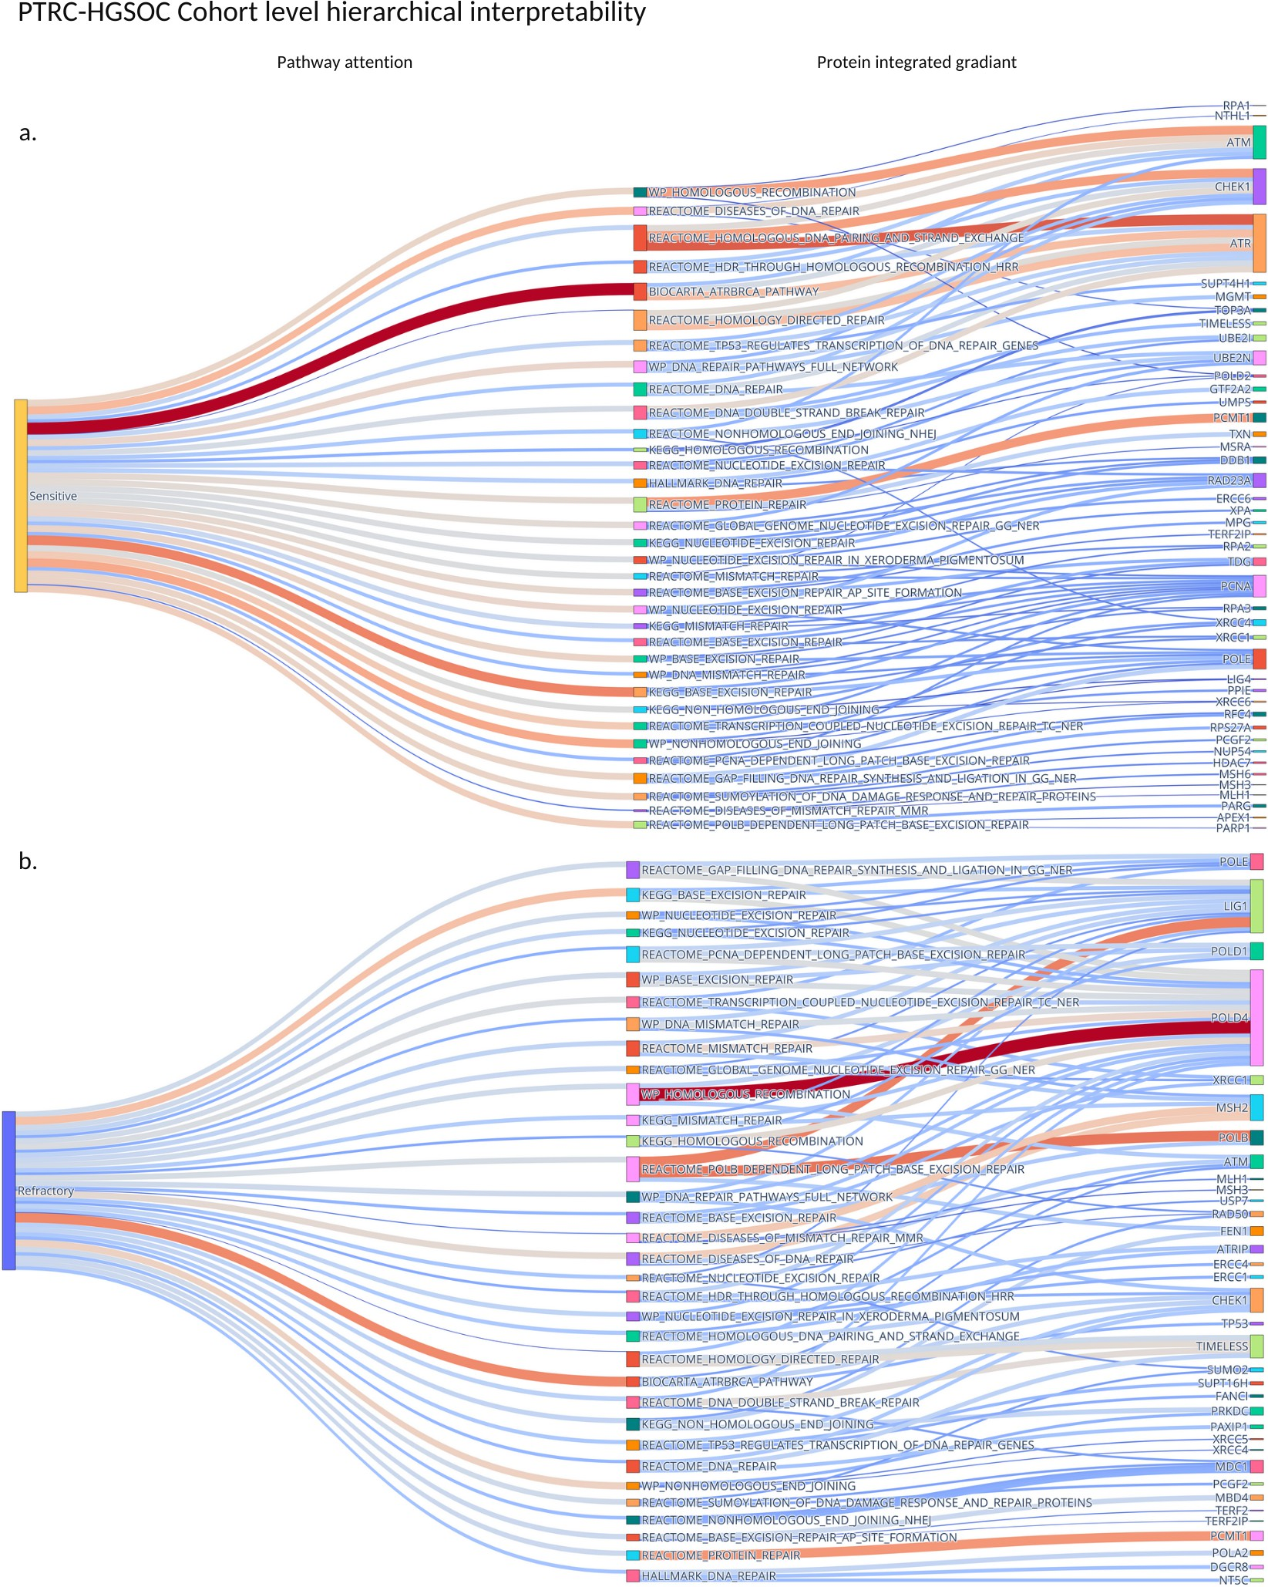

Figure. S1. Global interpretability for entire cohorts for the MCAT model. Sankey diagrams where weights connecting cohorts to pathways are the mean model weights. Connections between pathways and proteins represent the four proteins in each given pathway with the largest integrated gradients. Wider connecting lines are higher integrated gradients important. This offers a hierarchic interpretability. a. Sensitive pathways and proteins with high attention, b. Refractory pathways and proteins with high attention.

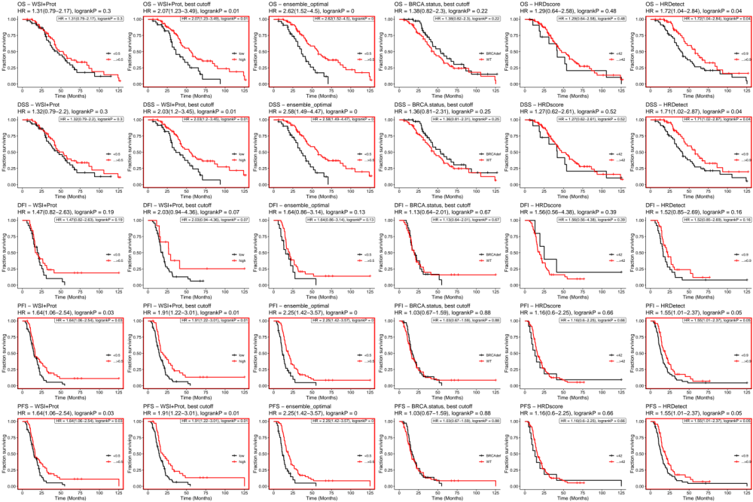
Figure. S2. Survival analysis for OS, DSS, DFI, PFI, PFS for TCGA-OV as a test cohort with genetic data available.

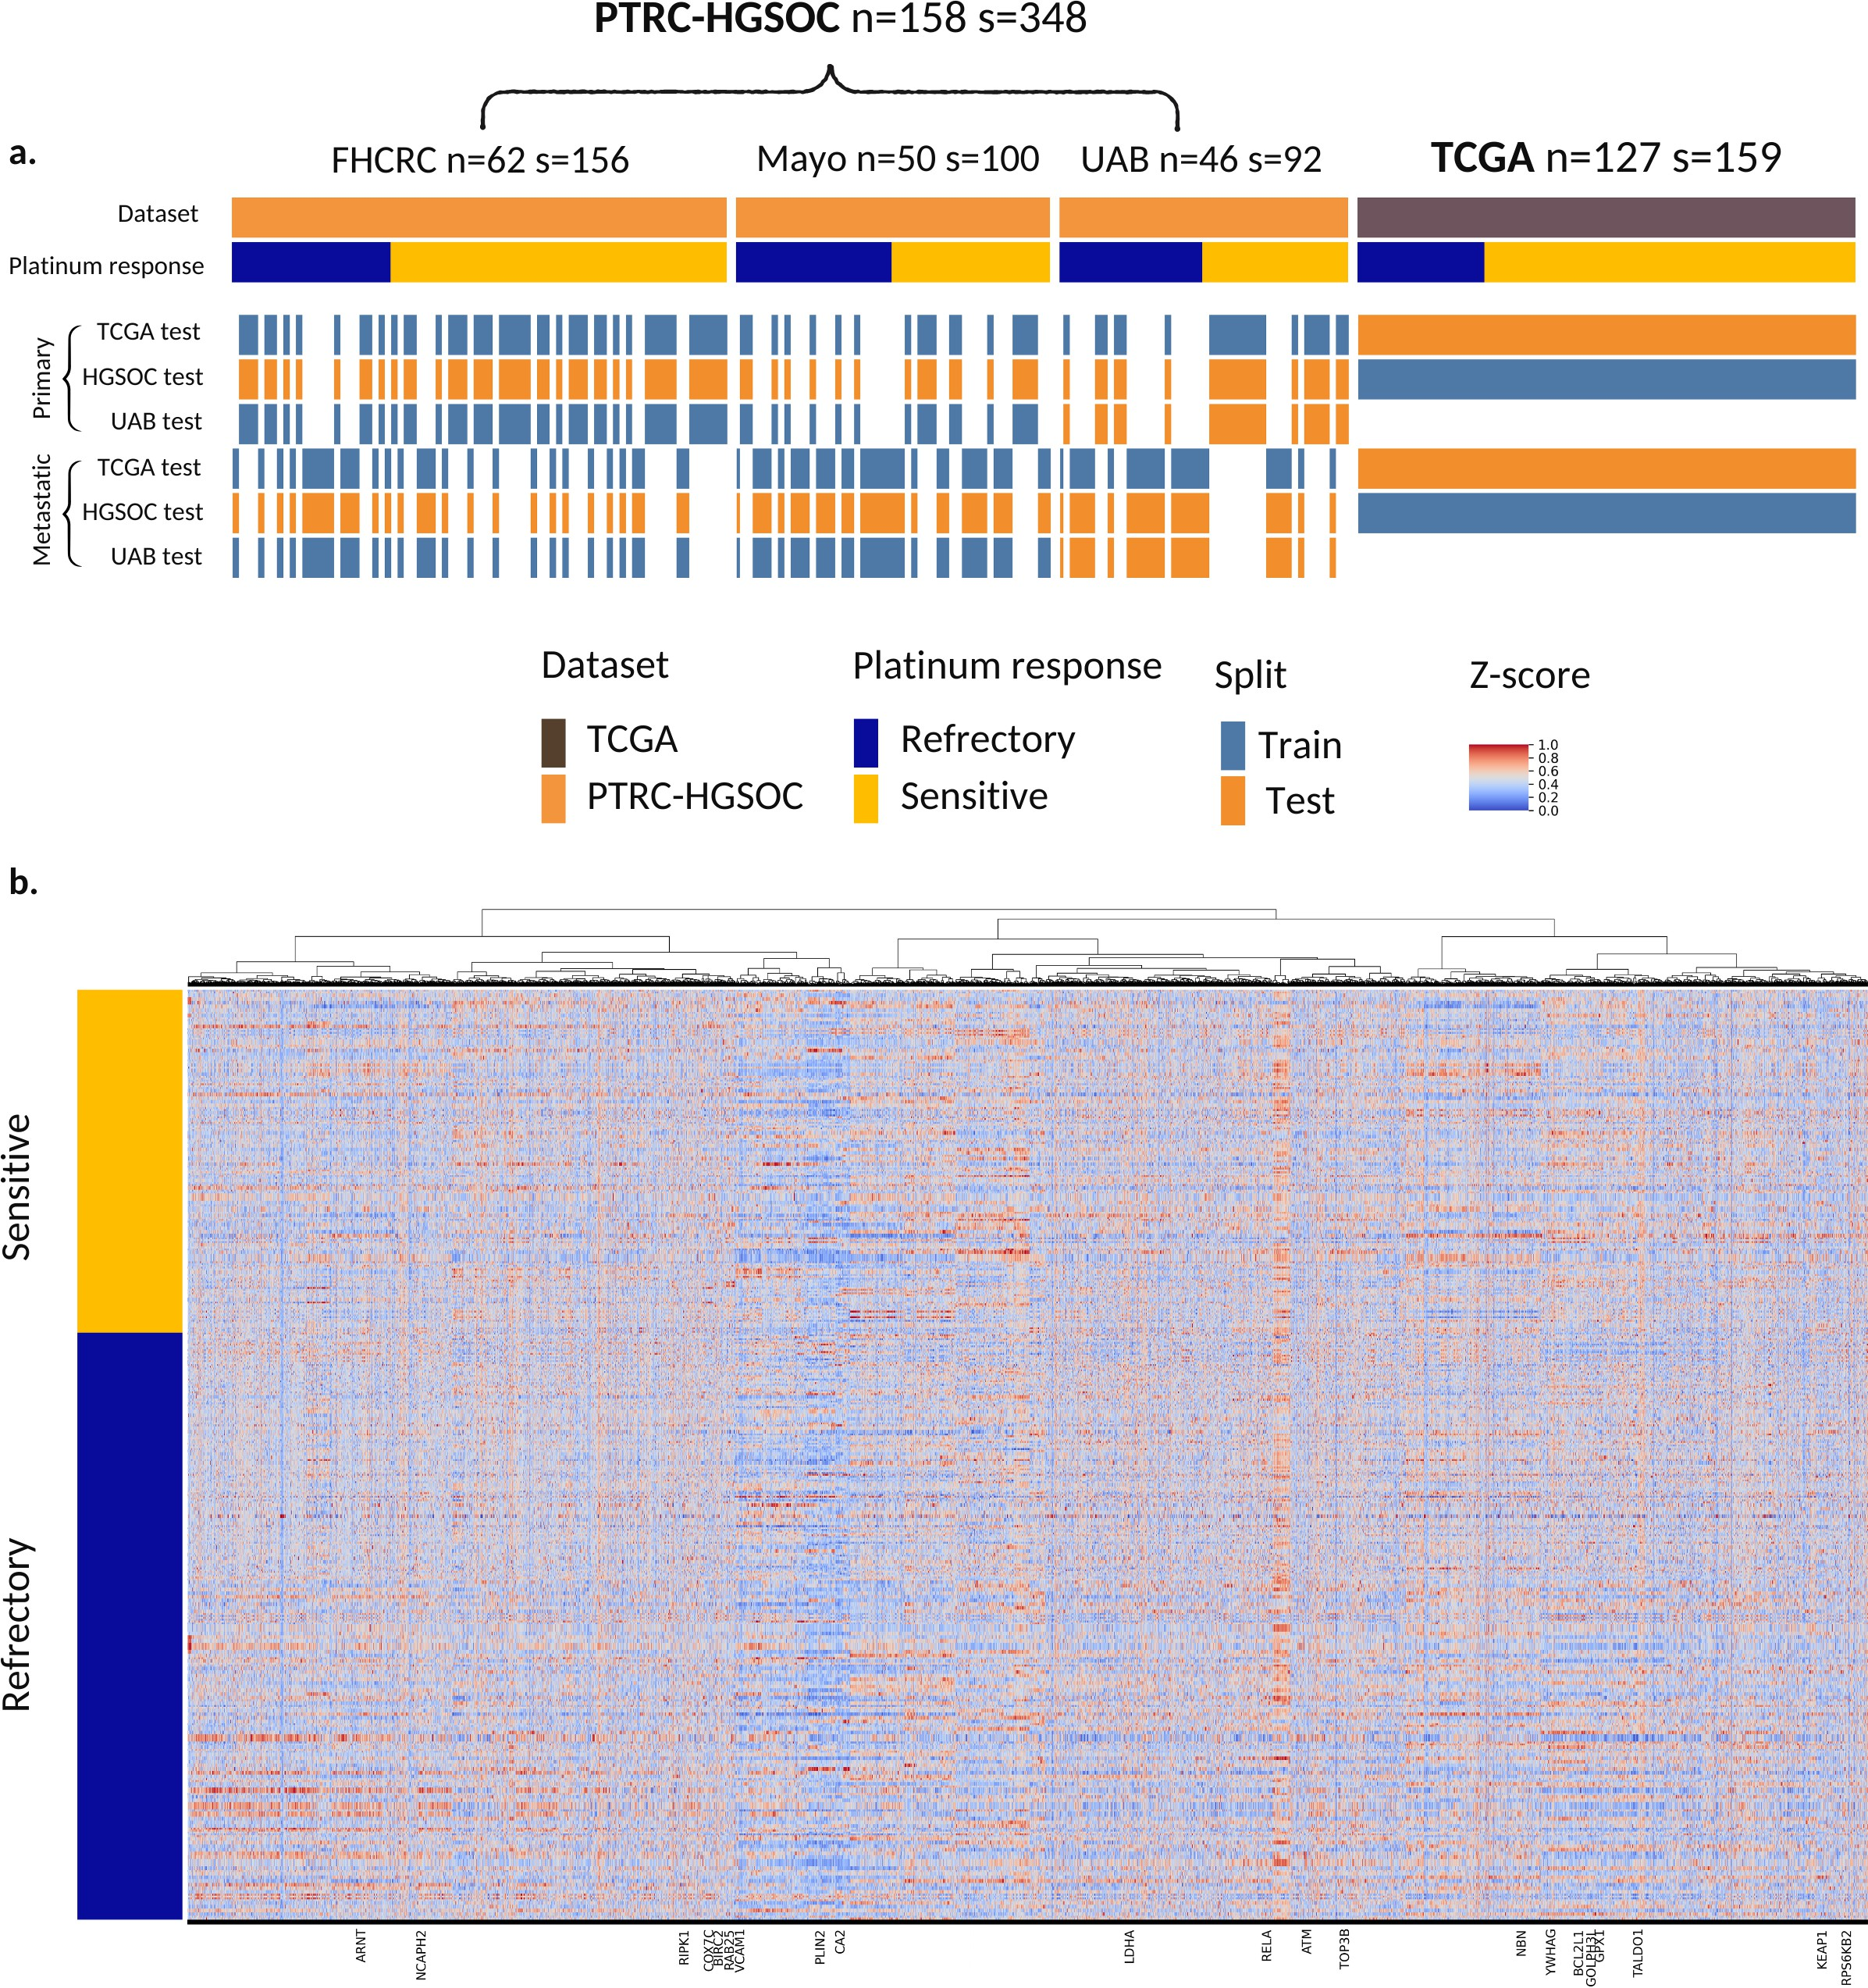
Figure. S3. Data overview for the study. a. cohorts and splits used for experimental validation. b. Hierarchical clustering of 7567 proteomics measurements available for each patient

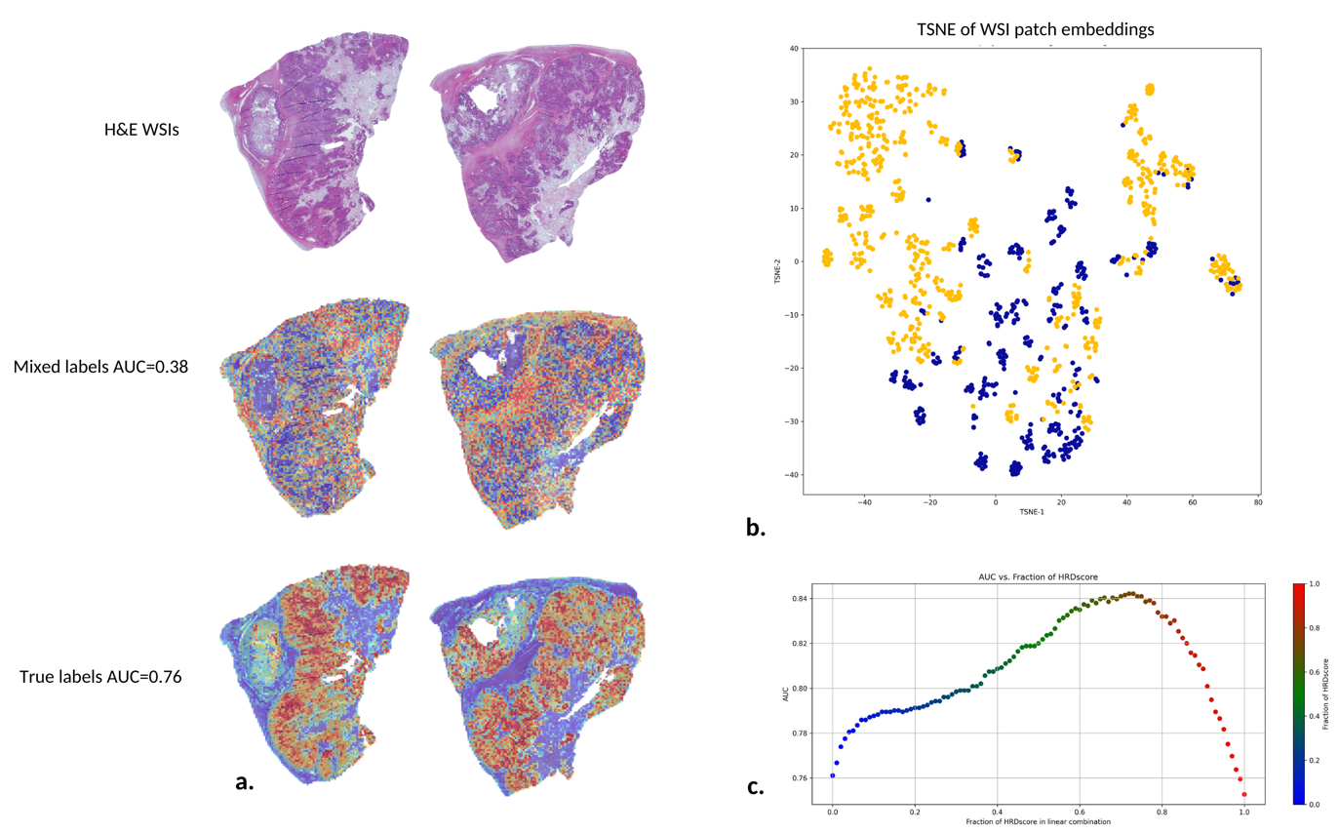
Figure S4. a. We retrained the MCAT model (same as in methods 3.7) with deliberately randomly mixed labels to assess how heatmaps would degrade with model performance. Heatmaps are dispersed in models trained with the deliberately mixed and therefore incorrect labels. They highlight meaningful areas of the WSI for trained models. b. TSNE of UNI top 1 embeddings for each sensitive and refractory groups clustering indicated the model found distinct morphologies for sensitive (yellow points) and refractory (blue points) patients. c. AUC variation with varying mixing of HRDscore and our WSI + proteomics model to create the “Ensemble” linear combination model (Figure 3a, Figure 3.b).

Supplementary methods

Multiple instance learning
Multiple instance learning (MIL) is a popular framework based on modeling set-based structures called "bags". Each bag has a label and "instances" inside this bag do not. A bag label is defined by the unknown labels of its containing instances. One or more instances in a bag define its label. The goal of classifying a bag from its instances is also known as “weakly supervised learning”. MIL is a natural modeling choice for WSIs which are gigapixel-sized images. Patching up the images into "instances" xi with dimensions (3×224×224) allows for the generation of bags with dimensions (n×3×224×224) where n is the number of patches in the whole slide image and 3 represents the RGB channels of the light microscopy high-resolution image. The objective of MIL is to learn a function that maps bags to labels with a model composed of instance-level functions that are aggregated with a symmetric, permutation-invariant aggregation function that pools the extracted features into a single bag-level feature embedding. This embedding can then be mapped to the WSI "bag" label ²¹.

F (X) = ξ (ρ ({ϕ(x_{i}) : x_{i} ∈ X}))
Where F is the function to learn, X is the bag data. ρ is the aggregation function and ϕ is the instance level function. ξ is a bag-level classifier that maps the whole WSI embedding to the clinical endpoint also known as the label in the learning task (sensitive or refractory in our case).

Multi-modal deep learning
The integration of multi-modal data such as Whole Slide Images (WSIs) and proteomics is achieved through the modeling of the joint probability distribution, P (WSIs, Proteomics). This framework underpins the ability to harness complementary and independent information from each modality, enhancing the predictive power of models. Specifically, by constructing a function f that leverages this joint distribution to map input data to a target variable Y, in our case treatment response (Y = f (WSIs, Proteomics)), we exploit the comprehensive insights provided by each data type. The modeling process involves probabilistic inference to estimate the posterior distribution P (Y WSIs, Proteomics), applying Bayes’ theorem to integrate prior knowledge with empirical data. This approach not only facilitates the extraction of nuanced, modality-specific features but also illuminates the complex interdependencies between different data types, advancing the precision and cross-modality interpretability of predictions in personalized medicine. The multimodal architectures we have used were built for WSI + RNAseq data but we have adapted them for WSI + proteomics.
|

Clustering-constrained Attention Multiple Instance Learning (CLAM)
CLAM²¹ is a framework to perform WSI-only MIL (supplementary 3.1) with an attention-based pooling function in the place of ρ.
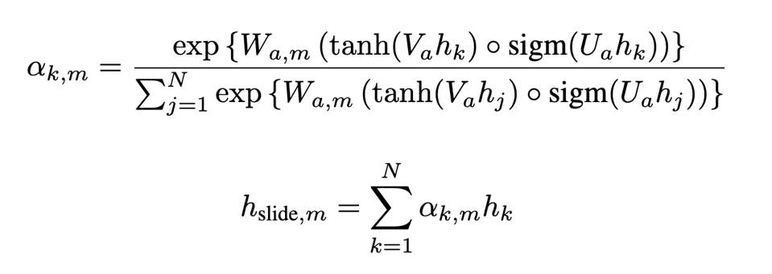

W1 is the first fully-connected layer that compresses each 1024-dimensional patch-level representation into a 512-dimensional vector. Ua is the first layer of the attention network, part of the attention backbone shared by all classes. Va is the second layer of the attention network, part of the attention backbone shared by all classes. Wa,1 to Wa,n are the n parallel attention branches in the attention network. Wc,1 to Wc,n are the n parallel, independent classifiers used to score each class-specific slide-level representation. α k,m is the attention score of the k-th patch for the m-th class. This model is also “fortified” with an Instance-level Clustering mechanism. This is designed to further encourage the learning of class-specific features. We used the SVM loss in our CLAM baseline. Full implementation can be found at https://github.com/mahmoodlab/CLAM .

Pathology-Omics Research Platform for Integrative Survival Estimation (PorpoiseMMF)
PorrpoiseMMF^{18,19} is a late fusion model that combines MIL and an omics vector channel to preform multimodal deep learning. WSI and Omics channels are encoded to fixed size internal representations. Then the Kronecker Product between WSI embeddings and proteomic embeddings is taken before the combined representation is passed through further layers. Full implementation can be found at https://github.com/mahmoodlab/PORPOISE.

Multi-modal Co-Attention Transformer (MCAT)

MCAT²⁰ is an early fusion model where patch embeddings and pathway embeddings are fused with a co-attention mechanism. This allows for sharing of information between various parts of the input early in the network. Unlike PorpoiseMMF, WSI patches and pathways may more directly interact and modulate one another. This is achieved by a cross-attention module to model the attention of histology patches (keys K, values V) toward gene sets (queries Q):
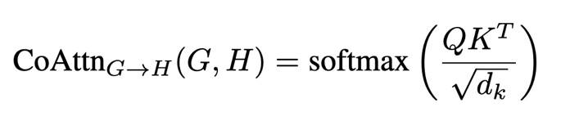
Full implementation can be found at https://github.com/mahmoodlab/MCAT .

Biological Pathways and Histology for Survival Prediction (SurvPath)
SurvPath¹⁹ is an early fusion model Early that can model dense multi-modal interactions between pathway and patch tokens. This model aims to build on MCAT. SurvPath allows for genes to patch interactions as well and patch to genes interactions as well as a more fine-grained tokenization process. This model employs a transformer attention ¹⁹ that can measure and aggregate pair-wise interactions between multi-modal tokens:
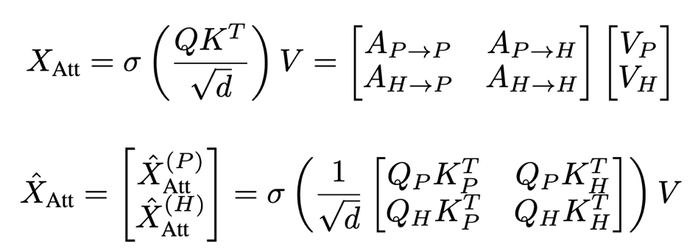

Where A values are self-attention, QP and QH denote the subset of pathway and histology queries and keys.

Full implementation can be found at https://github.com/mahmoodlab/SurvPath .

Integrated gradients for protein level importance
We used the gradient-based feature attribution method of Integrated gradients ²⁸ to understand which features (protein expression values) have the largest impact on the model output (tumor response). Larger values push to model to have larger outputs (more sensitive). We define x′ as the baseline input (zeros in the shape of the model input in our case) and x as the feature, F is the trained model. A "straight line path" from x′ to x is generated in steps α and we calculated all the gradients of F along this path. The Integrated gradients are defined as the path integral over all of these gradients accumulating them to generate an interpretable, sensitive, and implementation invariant importance value for each input. This method allows for further model interpretability and understanding of the learned importance of proteins as well as the extent to which they are implicated as relevant to the mechanism or pathway of tumor sensitivity.

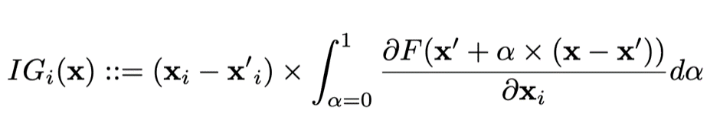

Feature extractors
    - SSL DINO-OV
Intending to optimally extract Ovarian WSI patch features for downstream learning, we trained a patch embedding network based on 5 open-source Ovarian cancer H&E WSI datasets with Y total images at maximum magnification "level 0" (20X magnification) to create a diverse dataset of 16.2 million images. These were used to train a ViT neural network with self-distillation with no labels (DINO) ⁴⁶ in a self-supervised manner. DINO is an algorithm for visual representation working to distill knowledge from a teacher network to a student network by minimizing the Kullback-Leibler (KL) divergence between their predicted probability distributions for various augmentations (global and local) of the same input image.

Supplementary discussion

Co-attention heatmaps
In a typical image recognition scenario, rather than being directly provided with a bounding box indicating the location of the animal, the machine learning model is given a collection of photographs with captions to learn to recognize different animals. Each photo might show an animal in various settings, and the caption briefly describes what’s happening in the image. During the training, from correlations between image features and captions, the model notices patterns. Every time the word "cat" appears in the caption, the photo features a furry creature with pointed ears and a tail. Over time, by associating words in the captions with visual features (textures, edges, corners, etc.) in the images, the model learns to identify cats in any photo, regardless of the setting or pose, without needing explicit annotations for "cat" within the image ⁴⁷.
In our study, we apply a similar approach to understand histopathology whole slide images of tissues stained with H&E, paired with corresponding proteomics data. Think of the histopathology images as the photographs and the proteomics data as the captions. The proteomics data describe the molecular "story" of the tissue, such as which proteins are present and in what abundance, indicating which molecular pathways are active. By training a multimodal AI network on these paired datasets, the network learns to associate specific visual patterns in the histopathology images (like the arrangement and characteristics of cells and tissues) with the active molecular pathways described by the proteomics data. Over time, just as a simple model learned to identify cats by their visual features from photos with captions, the AI learns to "see" which molecular pathways are active in different parts of the tissue by analyzing its visual features. The attention maps generated by the AI model are akin to highlighting the "cats" in our analogy; they color-code the tissue images to indicate where and which pathways are active, allowing us to visually interpret complex molecular activities in the context of tissue structure and morphology.

Extended discussion: Early vs late fusion?
To decide between early vs late fusion as the optimal choice, late fusion with a pre-defined proteomic signature seems to perform best, however early fusion models still perform very well and have the added benefit of a fully comprehensive interpretability analysis. In terms of how the input structured and model architectures can be chosen, these modeling choices are all interrelated and have complex effects on one another. For example, the choice of protein input and patch featurization model affects the number of model parameters. These covariances make it difficult to conclude the best choice of architecture, protein input, and embedding beyond pure empirical study. However, our results indicate that a proteomics machine-learning-based feature selection followed by the simplest late fusion concatenation model PorpoiseMMF led to the overall most robust performance. This may be as late fusion facilitates a more tailored feature extraction and representation learning for each separate modality. This may ensure that the model can leverage the strengths of each data source better handling disparities in the dimensionality, scale, and quality across modalities, leading to a more robust and accurate synthesis of information for decision-making. This finding is contrary to the publications of the methods ¹⁹. However, early fusion may outperform late fusion in the larger data regime. This is where the models were benchmarked at over 1000 samples per class, almost an order of magnitude larger scale than the available HGSOC response data we studied. Despite having lower AUC scores in our study, early fusion MCAT and SurvPath models as they allow for the in-depth interpretability analysis we present. Such interpretability advantages may help comply with GDPR-related tests that need to take place before clinical deployment.

