Bioinspired mechanical energy storage and nondissipative release in hierarchically swollen hydrogels
Henri Savolainen¹, Negar Hosseiniyan¹, Mario Piedrahita-Bello^{1*}, Olli Ikkala^{1*}
¹Department of Applied Physics, Aalto University, 02150 Espoo, Finland

Materials and Methods
Materials:
Acrylamide, acrylic acid, dimethylacrylamide, oligo ethylene glycol methyl ether acrylate (M_{n} = 500), N-isopropylacrylamide, N,N’-methylenebisacrylamide, and Irgacure 2959 were purchased from Sigma Aldrich and used without any further purification.
Synthesis poly(acrylamide) hydrogel
1.5 g acrylamide, 33 μL of 10 mg/mL N,N’-methylenebisacrylamide solution, and 0.3 mg 2-hydroxy-4’-(2-hydroxyethoxy)-2-methylpropiophenone (Irgacure 2959) were combined with 1 mL Milli-Q water and bubbled with nitrogen for 5 minutes. Then, the solution was injected into a mold consisting of two glass plates and a spacer. The mold was sealed with parafilm. Then, the sample was polymerized via irradiation for 3 hours in a UV chamber (8x 14 W, 350 nm, Rayonet, USA). After irradiation, the sample was immersed in a solution of the same composition overnight. Each increase in order of N consists of an additional cycle of immersion and irradiation for 1 hour.
Synthesis poly(acrylic acid) hydrogel
1.5 g acrylic acid, 30 μL of 10 mg/mL N,N’-methylenebisacrylamide solution, and 1 mg 2-hydroxy-4’-(2-hydroxyethoxy)-2-methylpropiophenone (Irgacure 2959) were combined with 1 mL Milli-Q water and bubbled with nitrogen for 5 minutes. Then, the solution was injected into a mold consisting of two glass plates, a spacer and clamps. The mold was sealed with parafilm. Then, the sample was polymerized via irradiation for 3 hours in a UV chamber (8x 14 W, 350 nm, Rayonet, USA). After irradiation, the sample was immersed in a solution of the same composition overnight. Each increase in order of N consists of an additional cycle of immersion and irradiation for 1 hour.
Synthesis poly(dimethylacrylamide) hydrogel
1.5 g dimethylacrylamide, 100 μL of 10 mg/mL N,N’-methylenebisacrylamide solution, and 0.3 mg 2-hydroxy-4’-(2-hydroxyethoxy)-2-methylpropiophenone Irgacure 2959) were combined with 1 mL Milli-Q water and bubbled with nitrogen for 5 minutes. Then, the solution was injected into a mold consisting of two glass plates, a spacer and clamps. The mold was sealed with parafilm. Then, the sample was polymerized via irradiation for 3 hours in a UV chamber (8x 14 W, 350 nm, Rayonet, USA). After irradiation, the sample was immersed in a solution of the same composition overnight. Each increase in order of N consists of an additional cycle of immersion and irradiation for 1 hour.
Synthesis poly(oligo ethylene glycol methyl ether acrylate) hydrogel
0.8 g oligo ethylene glycol methyl ether acrylate, 5 μL of 10 mg/mL N,N’-methylenebisacrylamide solution, and 0.3 mg 2-hydroxy-4’-(2-hydroxyethoxy)-2-methylpropiophenone (Irgacure 2959) were combined with 0.195 mL Milli-Q water and bubbled with nitrogen for 5 minutes. Then, the solution was injected into a mold consisting of two glass plates, a spacer and clamps. The mold was sealed with parafilm. Then, the sample was polymerized via irradiation for 3 hours in a UV chamber (8x 14 W, 350 nm, Rayonet, USA). After irradiation, the sample was immersed in a solution of the same composition overnight. Each increase in order of N consists of an additional cycle of immersion and irradi3ation for 1 hour.
Synthesis Poly(N-isopropylacrylamide) hydrogel
0.2 g N-isopropylacrylamide, 30 μL of 10 mg/mL N,N’-methylenebisacrylamide solution, and 0.3 mg 2-hydroxy-4’-(2-hydroxyethoxy)-2-methylpropiophenone (Irgacure 2959) were combined with 0.2 mL Mili-Q water and bubbled with nitrogen for 5 minutes. Then, the solution was injected into a mold consisting of two glass plates, a spacer and clamps. The mold was sealed with parafilm. Then, the sample was polymerized via irradiation for 3 hours in a UV chamber (8x 14 W, 350 nm, Rayonet, USA) in an ice water bath. After irradiation, the sample was immersed in a solution of the same composition overnight. Each increase in order of N consists of an additional cycle of immersion and irradiation for 1 hour.
Tensile tests
Samples were stamped with a stamp to a dumbbell shape with a width of 2 mm. The samples were glued at each end with Superglue to sandpaper, clamped onto an Instron 5966, and a thin layer of water was applied onto the samples. It was ensured that the humidity was at least 60% RH with a humidifier. The extension speed of the tensile tests was 2 (mm/mm) min⁻¹. Young’s Moduli were calculated from the Strain range of 0-0.5 (mm/mm) via neo-hookean fit¹.
Cyclic tensile tests
Samples were stamped with a stamp to a dumbbell shape with a width of 2 mm. It was ensured that the humidity was at least 60% RH with a humidifier when the sample was clamped onto an onto an Instron 5966 with a box and a humidifier. The extension speed of the tensile tests was 2 (mm/mm) min⁻¹. Long term tests were performed at a speed of 10 (mm/mm) min⁻¹.
Compression tests
Square samples with 1 cm x 1 cm were compressed with 1 (mm/mm) min⁻¹ compression speed to a strain of 0.75 (mm/mm).
Step strain tests
Samples were stamped with a stamp to a dumbbell shape with a width of 2 mm. The samples were glued at each end with Superglue to sandpaper and then clamped. . It was ensured that the humidity was at least 60% RH with a humidifier when the sample was clamped onto an onto an Instron 5966. The samples were extended to a strain of 0.5 (mm/mm). The extension speed of the tensile tests was 40 (mm/mm) min⁻¹.
SEM analysis
Swollen samples were shock frozen in a liquid propane bath, fractured in frozen state and then freeze dried. Samples were imagined with an Zeiss Sigma VP.
Weight percentage determination
Samples were weighted after polymerization. Then, swollen in Mili-Q water and weighted again. After weighing, the samples were shock frozen in liquid nitrogen and freeze dried overnight. Dried samples were weighed again. Based on the recorded weights, swelling degree, polymer weight percent, and swollen polymer weight percent were calculated.
Fabrication of JumperBot
The jumperbot was designed in Solidworks and printed with an Ultimaker S3 3D printer using PLA filament. Rings were cut with scissors from samples. A model of the jumper has been provided as supporting information.
Robotics analysis
Videos were recorded with a ZV-1 by Sony and with a framerate of 250 frames per second. The videos were analyzed via Tracker.
Determination of Energy Storage Efficiency
The energy storage efficiency was determined graphically by converting other publication cyclic tensile test graphs into shapes which cover the area below the curves. Then, the size of the curves were analyzed via ImageJ. Stored energy in our own cyclic tensile tests were determined by numerical approximation via the trapezoid method.
Determination of Energy density
We start with the neo-hookean model ¹ $σ=\frac{E}{3}\left(λ-\frac{1}{λ^{2}}\right)$ and integrate by $λ$ to gain the energy density U, $U=\frac{E}{3}\left(\frac{λ^{2}}{2}+\frac{1}{λ}\right)$. As biological systems operate in small strain ranges, the neo-hookean model is applicable²⁻⁴.
Young’s Modulus Determination of the literature
Either publications stated the Young’s Modulus or a linear fit was done to the cyclic tensile tests at small strains and therefore determined graphically.

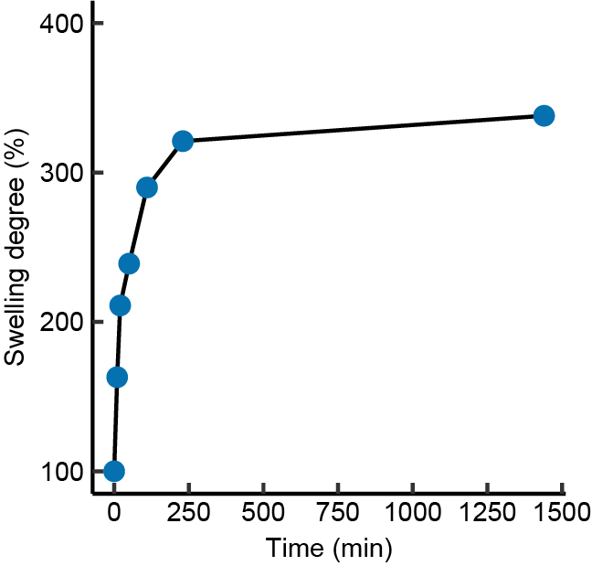
Supplementary Figure 1: Swelling degree over time of a PAAm of hierarchical level N = 2.

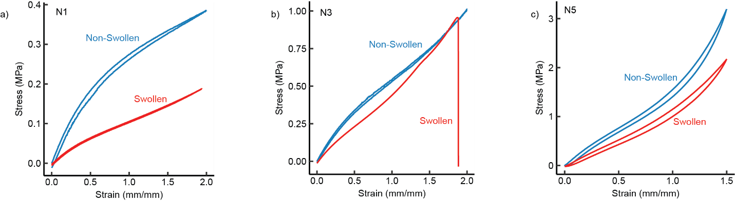
Supplementary Figure 2: Comparison of fully swollen and non-swollen samples of PAAm. a) Cyclic tensile test for N = 1. b) Cyclic tensile test for N = 3. c) Cyclic tensile test for N = 5.

Supplementary Table 1: Mechanical properties of PAAm based hydrogels.
Stage | Young's Modulus [MPa] | Ultimate Tensile Strength [MPa] | Maximum Strain  [mm/mm] | Cyclic Strain  [mm/mm] | Maximum cyclic stress [MPa] | Stored Energy [MJ/m³] | Energy  Storage  Efficiency (%)
N = 1 | 0.596 +- 0.065 | 0.679 +- 0.74 | 4.38 +- 0.78 | 2 | 0.387+- 0.044 | 0.487 +- 0.049 | 6+-1.18
N = 2 | 0.818 +- 0.055 | 0.957 +- 0.201 | 2.32 +- 0.51 | 2 | 0.726+- 0.052 | 0.83 +- 0.037 | 3.33+-2.47
N = 3 | 0.1.033 +- 0.112 | 1.499 +- 0.691 | 2.34 +- 0.48 | 2 | 0.960 +- 0.036 | 1.024+- 0.019 | 2.5+-0.76
N = 4 | 1.157 +- 0.188 | 1.935 +- 0.830 | 2.67 +- 0.77 | 1.5 | 1.648+- 0.451 | 1.021+- 0.136 | 8.4+-3.06
N = 5 | 1.836 +- 0.253 | 4.541 +- 1.697 | 1.71 +- 0.41 | 1.5 | 3.100 +- 0.792 | 1.625 +- 0.239 | 11.85+-4.05
N = 6 | 3.523 +- 0.536 | 4.334 +- 1.420 | 0.91 +-0.21 | 1 | 3.921 +- 0.396 | 1.275 +- 0.111 | 16.7+-0.5
N = 7 | 4.817 +- 1.416 | 5.249 +- 2.391 | 1.28 +- 0.47 | 1 | 4.798 +- 0.339 | 1.248 +- 0.081 | 50.8+-2.6

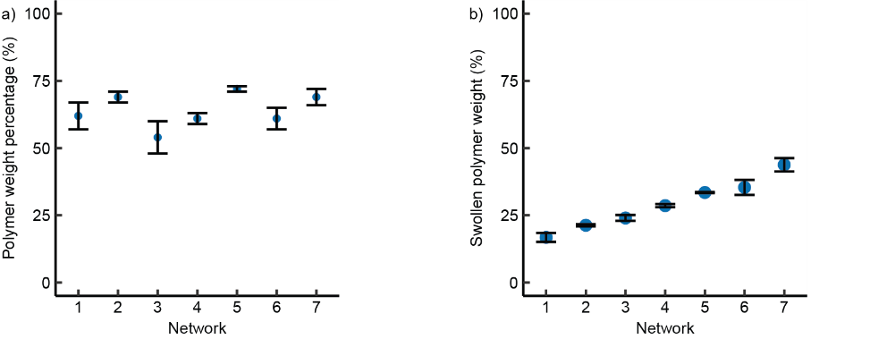
Supplementary Figure 3: Polymer weight percentage analysis for hierarchically swollen PAAm by level of network hierarchies N. a) Polymer weight percents. b) Polymer weight percent in swollen state. c) Swelling degree by number of networks.

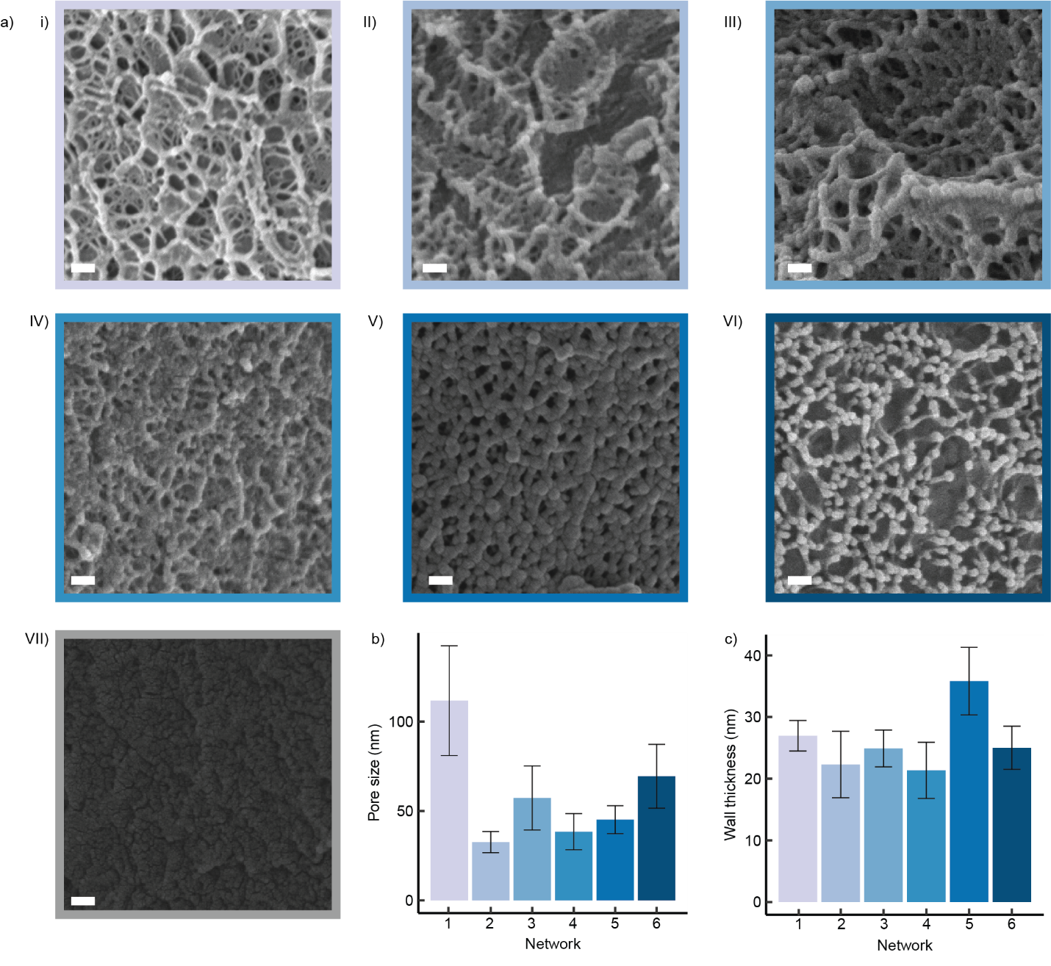
Supplementary Figure 4: Networks of hierarchical swollen PAAm hydrogels for hierarchical levels from N = 1 to N = 7. a) SEM micrographs. b) Pore sizes over number of networks. c) Wall thickness over number of networks.
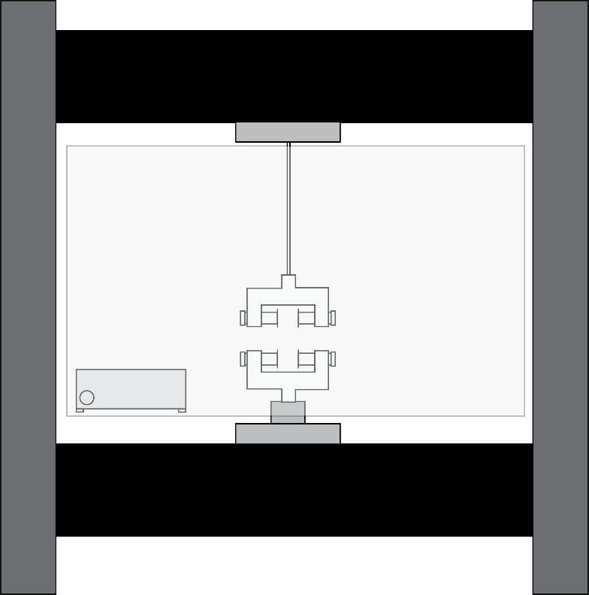
Supplementary Figure 5: Schematics of setup for long term cyclic testing of samples with a chamber and humidifier.

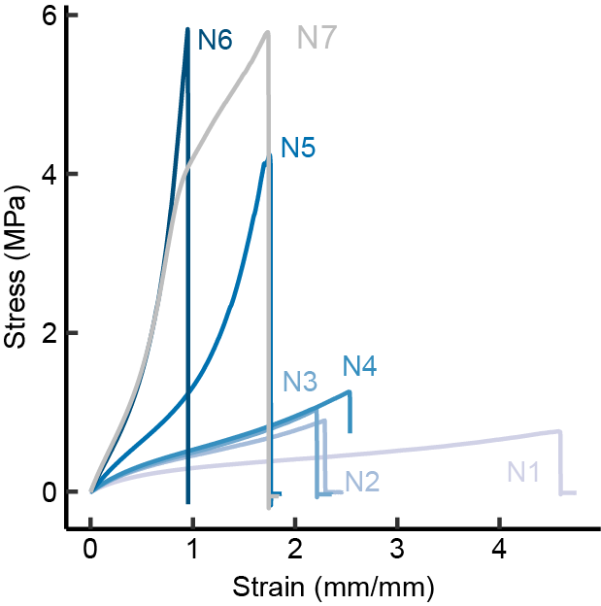
Supplementary Figure 6: Tensile tests of hierarchically swollen PAAm hydrogels for N = 1 to 7.

Supplementary Table 2: Data of the literature comparison. Graphically determined values in blue.
Polymer | Tensile Strength [kPa] |  | Young’s Modulus [kPa] | Energy Storage  Efficiency (%) | Source
PAAm | 20 | 15 |  | 95 | ⁵
PAAm | 36 | 16 |  | 98 | ⁶
PAAm | 150 | 60 |  | 94 | ⁷
PEG | 75 | 400 |  | 100 | ⁸
HEC | 150 | 200 |  | 100 | ⁸
PAAm | 85 | 100 |  | 100 | ⁹
PEG/PDMS | 65 | 35 |  | 98 | ¹⁰
PVP | 120 | 65 |  | 98 | ¹¹
PAAm | 110 | 60 |  | 100 | ¹²
PAAm/PEG | 120 | 100 |  | 96 | ¹³
PAAc/PAAm | 130 | 100 |  | 98 | ¹⁴
PAAm | 600 | 100 |  | 87 | ¹⁵
Natural resilin | 2942 | 640 |  | 90 | ^{16,17}
PAAm+CaCl2 | 450 | 30 |  | 99 | ¹⁸
PAAm | 40 | 37 |  | 99 | ¹⁹
PAAm/Alginate | 8 | 4 |  | 95 | ²⁰
PEG | 40 | 10 |  | 100 | ²¹
Silicone | 400 | 150 |  | 97 | ²²
PEG | 1750 | 130 |  | 100 | ¹
PVA | 30 | 60 |  | 100 | ²³
PAAm | 16 | 7.3 |  | 100 | ²⁴
PEG | 1000 | 60 |  | 90 | ²⁵
PAMPS/PAAm | 275 | 72 |  | 100 | ²⁶
Natural Elastin | 1500 | 1000 |  | 92 | ^{17,27}

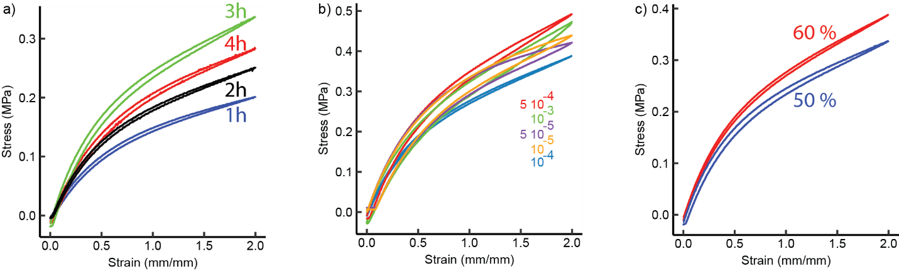
Supplementary Figure 7: Parameter optimization of hierarchically swollen PAAm hydrogels. a) Optimization of irradiation time on samples with 50 wt. % and 10⁻⁴ mol % crosslinker (BIS). b) Optimization of BIS concentration of 60 wt. % samples. c) Optimization of polymer weight percentage with 10⁻⁴ mol% BIS.

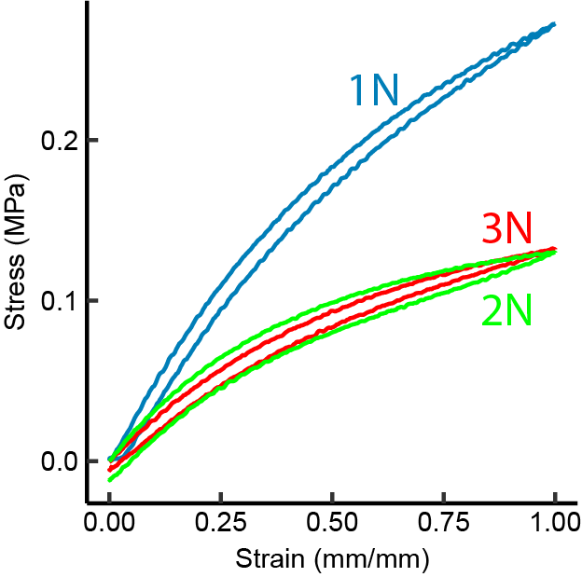
Supplementary Figure 8: Exploration of samples without crosslinkers and 60 wt.%. Each step swollen for 1 hour and then irradiated for 1 hour.

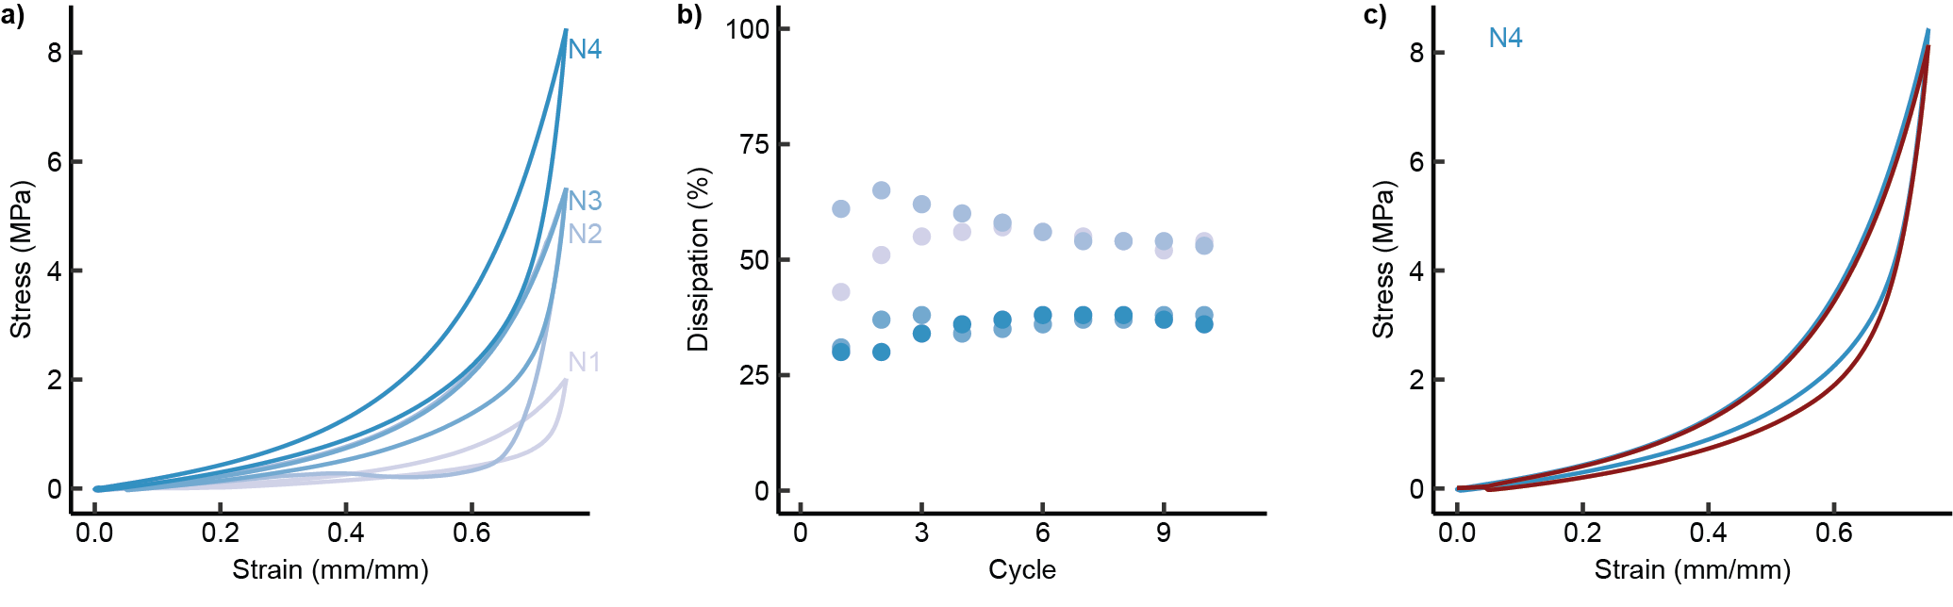
Supplementary Figure 9: Compression tests. a) Cyclic compression of samples N = 1 to N = 4 to a strain of 0.75. b) Dissipation of multiple cyclic tests for samples of N = 1 to N = 4. c) The first and tenth cyclic compression test of N = 4.

Supplementary Table 3: Mechanical properties of PNIPAm, POEGMA, PDMAA, and PAAc based hierarchically swollen hydrogels.
Polymer | Stage | Cyclic Strain [mm/mm] | Maximum cyclic Stress [kPa]
PNIPAm | 1 | 3 | 24.2 ± 1.2
PNIPAm | 2 | 3 | 57.6 ± 18.3
PNIPAm | 3 | 3 | 70.4 ± 21.8
POEGMA | 1 | 0.5 | 12.8 ± 1.06
POEGMA | 2 | 0.5 | 19.2 ± 1.7
POEGMA | 3 | 0.5 | 24.3 ± 4.1
PDMAA | 1 | 1 | 72.6 ± 6.8
PDMAA | 2 | 1 | 126.3 ± 23.1
PDMAA | 3 | 1 | 155.8 ± 40.6
PAAc | 1 | 1 | 182.2 ± 9.1
PAAc | 2 | 1 | 295 ± 16.3
PAAc | 3 | 1 | 348.5± 103.5

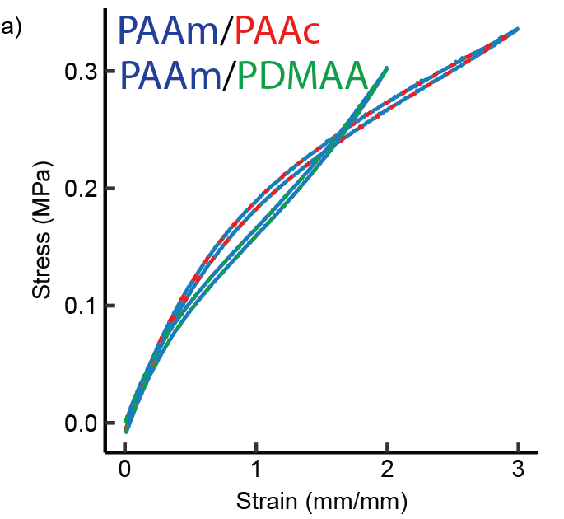
Supplementary Figure 10: Comparison of different polymers in cyclic testing. a) N = 2 samples based on PAAm and then PAAc and samples based on PAAm and PDMAA.

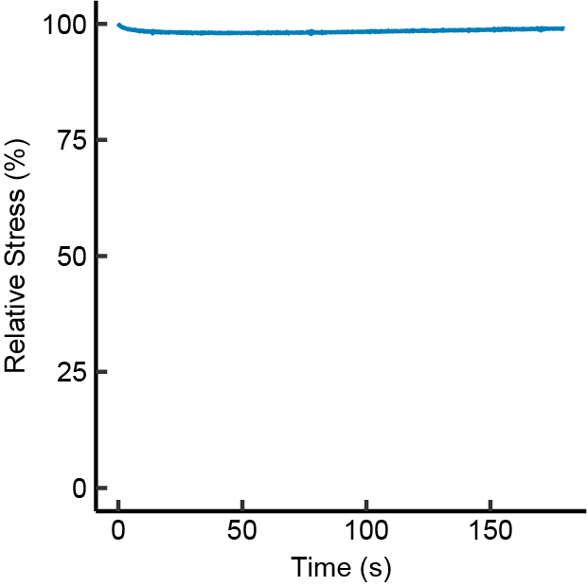
Supplementary Figure 11: Step strain test of PAAm sample of N = 4.

References:
1 Liu, C. et al. Tough hydrogels with rapid self-reinforcement. Science 372, 1078-1081 (2021). https://doi.org/10.1126/science.aaz6694
2 Astley, H. C. & Roberts, T. J. Evidence for a vertebrate catapult: elastic energy storage in the plantaris tendon during frog jumping. Biol Lett 8, 386-389 (2012). https://doi.org/10.1098/rsbl.2011.0982
3 Bennet-Clark, H. C. & Lucey, E. C. The jump of the flea: a study of the energetics and a model of the mechanism. J Exp Biol 47, 59-67 (1967). https://doi.org/10.1242/jeb.47.1.59
4 Kharazi, M., Bohm, S., Theodorakis, C., Mersmann, F. & Arampatzis, A. Quantifying mechanical loading and elastic strain energy of the human Achilles tendon during walking and running. Sci Rep 11, 5830 (2021). https://doi.org/10.1038/s41598-021-84847-w
5 Zhu, L., Zhang, X., Shao, Z. & Guo, M. Highly Stretchable, Compressible, Resilient, and Equilibrium Swelling Hydrogels with Elastic Nano Junctions. Macromolecular Materials and Engineering 305 (2020). https://doi.org/10.1002/mame.202000205
6 Ko, S., Chhetry, A., Kim, D., Yoon, H. & Park, J. Y. Hysteresis-Free Double-Network Hydrogel-Based Strain Sensor for Wearable Smart Bioelectronics. ACS Appl Mater Interfaces 14, 31363-31372 (2022). https://doi.org/10.1021/acsami.2c09895
7 Liu, R. et al. Highly tough, stretchable and resilient hydrogels strengthened with molecular springs and their application as a wearable, flexible sensor. Chemical Engineering Journal 415 (2021). https://doi.org/ARTN 128839
10.1016/j.cej.2021.128839
8 Nian, G., Kim, J., Bao, X. & Suo, Z. Making Highly Elastic and Tough Hydrogels from Doughs. Adv Mater 34, e2206577 (2022). https://doi.org/10.1002/adma.202206577
9 Kim, J., Zhang, G., Shi, M. & Suo, Z. Fracture, fatigue, and friction of polymers in which entanglements greatly outnumber cross-links. Science 374, 212-216 (2021). https://doi.org/10.1126/science.abg6320
10 Cui, J. et al. Synthetically simple, highly resilient hydrogels. Biomacromolecules 13, 584-588 (2012). https://doi.org/10.1021/bm300015s
11 He, C. et al. Tough and super-resilient hydrogels synthesized by using peroxidized polymer chains as polyfunctional initiating and cross-linking centers. Soft Matter 9 (2013). https://doi.org/10.1039/c2sm27605d
12 Wang, Y., Nian, G., Kim, J. & Suo, Z. Polyacrylamide hydrogels. VI. Synthesis-property relation. Journal of the Mechanics and Physics of Solids 170 (2023). https://doi.org/10.1016/j.jmps.2022.105099
13 Lei, H. et al. Stretchable hydrogels with low hysteresis and anti-fatigue fracture based on polyprotein cross-linkers. Nat Commun 11, 4032 (2020). https://doi.org/10.1038/s41467-020-17877-z
14 Prado, R. M. B. et al. Achieving High-Speed Retraction in Stretchable Hydrogels. ACS Appl Mater Interfaces 12, 40719-40727 (2020). https://doi.org/10.1021/acsami.0c08132
15 Li, W. et al. Nanoconfined polymerization limits crack propagation in hysteresis-free gels. Nat Mater 23, 131-138 (2024). https://doi.org/10.1038/s41563-023-01697-9
16 Weis-Fogh, T. Thermodynamic properties of resilin, a rubber-like protein. Journal of Molecular Biology 3, 520-531 (1961). https://doi.org/10.1016/s0022-2836(61)80018-1
17 Gosline, J. et al. Elastic proteins: biological roles and mechanical properties. Philos Trans R Soc Lond B Biol Sci 357, 121-132 (2002). https://doi.org/10.1098/rstb.2001.1022
18 Wang, J., Tang, F., Yao, C. & Li, L. Low Hysteresis Hydrogel Induced by Spatial Confinement. Advanced Functional Materials 33 (2023). https://doi.org/10.1002/adfm.202214935
19 Xu, K. et al. Ultradurable Noncovalent Cross-Linked Hydrogels with Low Hysteresis and Robust Elasticity for Flexible Electronics. Chemistry of Materials 34, 3311-3322 (2022). https://doi.org/10.1021/acs.chemmater.2c00093
20 Lin, S., Zhou, Y. & Zhao, X. Designing extremely resilient and tough hydrogels via delayed dissipation. Extreme Mechanics Letters 1, 70-75 (2014). https://doi.org/10.1016/j.eml.2014.11.002
21 Kamata, H., Akagi, Y., Kayasuga-Kariya, Y., Chung, U. I. & Sakai, T. "Nonswellable" hydrogel without mechanical hysteresis. Science 343, 873-875 (2014). https://doi.org/10.1126/science.1247811
22 Si, L. et al. Silicone-based tough hydrogels with high resilience, fast self-recovery, and self-healing properties. Chem Commun (Camb) 52, 8365-8368 (2016). https://doi.org/10.1039/c6cc02665f
23 Lin, S. et al. Anti-fatigue-fracture hydrogels. Sci Adv 5, eaau8528 (2019). https://doi.org/10.1126/sciadv.aau8528
24 Su, X., Mahalingam, S., Edirisinghe, M. & Chen, B. Highly Stretchable and Highly Resilient Polymer-Clay Nanocomposite Hydrogels with Low Hysteresis. ACS Appl Mater Interfaces 9, 22223-22234 (2017). https://doi.org/10.1021/acsami.7b05261
25 Fujiyabu, T. et al. Tri-branched gels: Rubbery materials with the lowest branching factor approach the ideal elastic limit. Sci Adv 8, eabk0010 (2022). https://doi.org/10.1126/sciadv.abk0010
26 Zhu, R., Zhu, D., Zheng, Z. & Wang, X. Tough double network hydrogels with rapid self-reinforcement and low hysteresis based on highly entangled networks. Nat Commun 15, 1344 (2024). https://doi.org/10.1038/s41467-024-45485-8
27 Aaron, B. B. & Gosline, J. M. Elastin as a random‐network elastomer: A mechanical and optical analysis of single elastin fibers. Biopolymers 20, 1247-1260 (2004). https://doi.org/10.1002/bip.1981.360200611

