The diagnostic performance of Cochlear Endolymphatic Hydrops and Perilymphatic Enhancement in Stratifying Ménière's Disease probabilities: A Meta-Analysis of semi-quantitative MRI-based grading systems

Supplementary Information

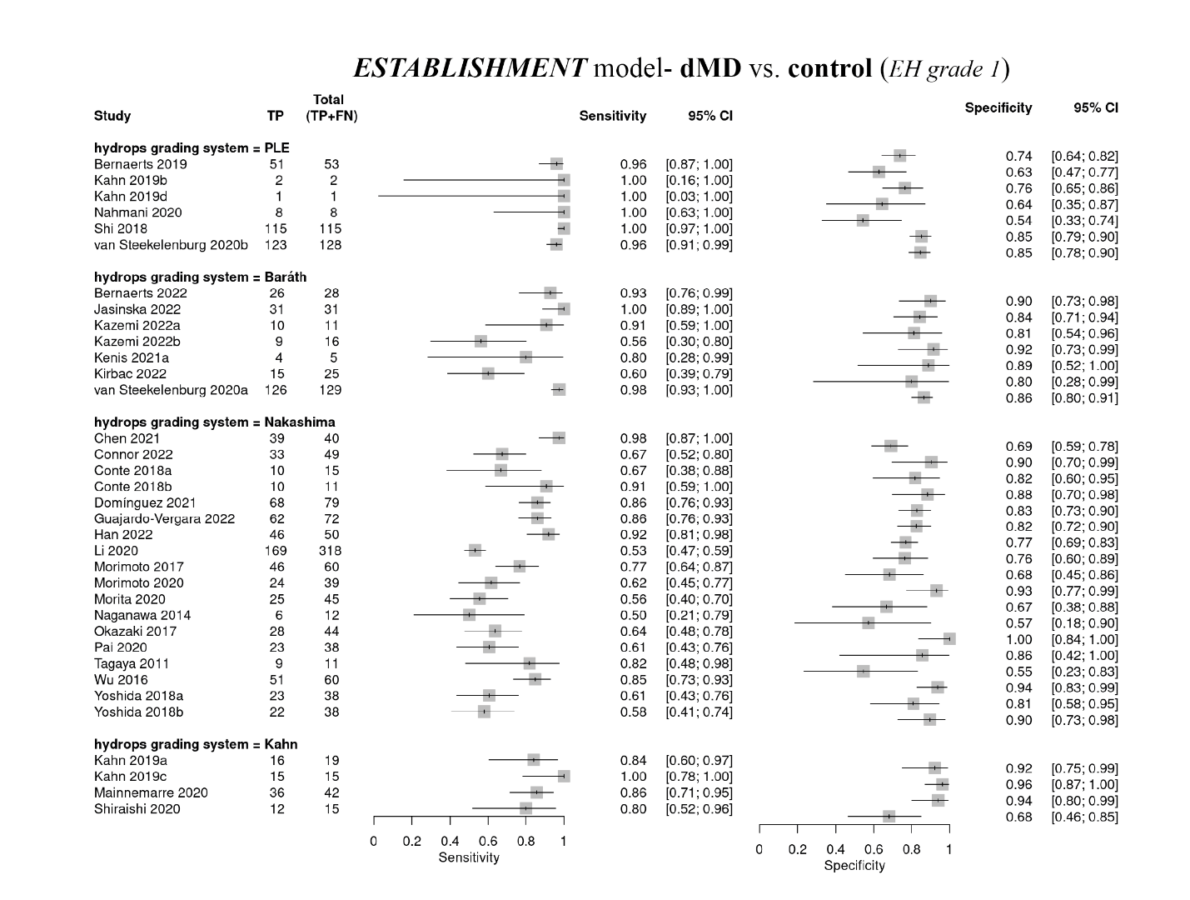
Figure S1: The forest plots of sensitivity and specificity of the dMD vs. control (grade 1) diagnostic model

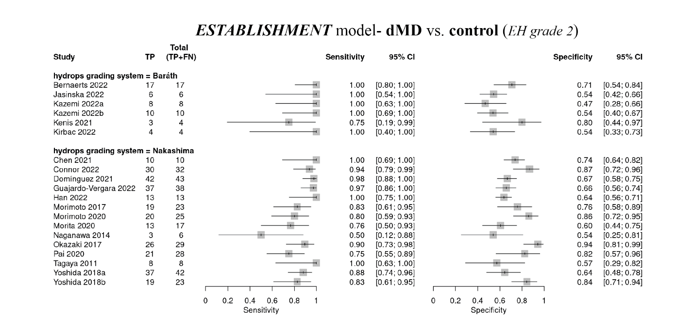
Figure S2: The forest plots of sensitivity and specificity of the dMD vs. control (grade 2) diagnostic model

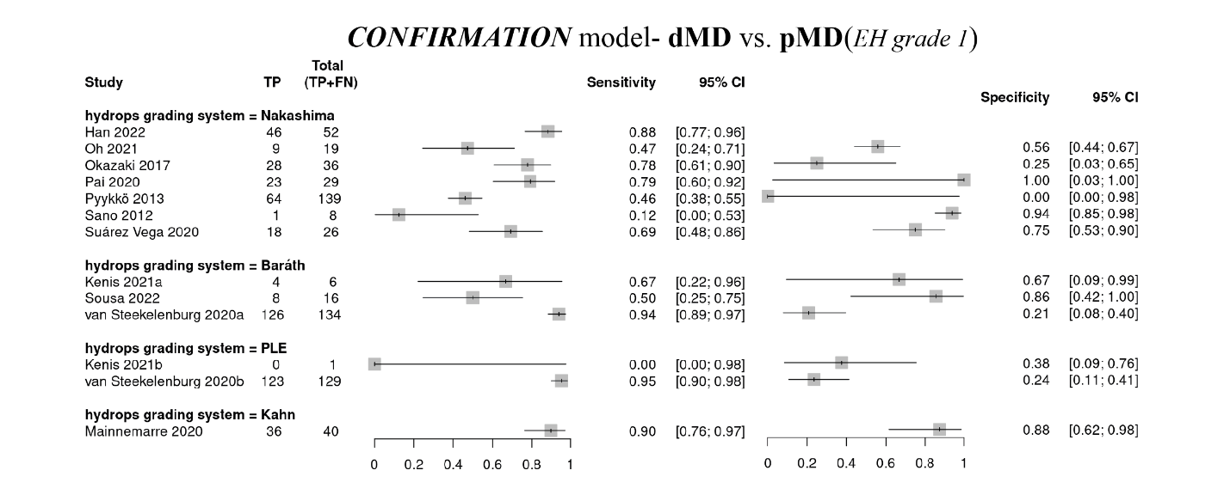
Figure S3: The forest plots of sensitivity and specificity of the dMD vs. pMD diagnostic model

Figure S4: The forest plots of sensitivity and specificity of the pMD vs. control diagnostic model
