Journal name: Environmental Science and Pollution Research
A new approach for risk assessment of pulmonary toxicants: a preliminary study using didecyldimethylammonium chloride

Jun Woo Kim¹, Yu Bin Han², Kyu Hyuck Chung³, Yong Joo Park^{3*}

¹Inhalation Toxicology Center for Airborne Risk Factors, Korea Institute of Toxicology, Jeongeup, 56212, Republic of Korea.
²School of Pharmacy, Sungkyunkwan University, Suwon 16419, Republic of Korea
³College of Pharmacy, Kyungsung University, Busan 48434, Republic of Korea

Corresponding authors.
* Tel.: +82 51 663 4886, E-mail address: yjpark@ks.ac.kr (Y. J. Park).

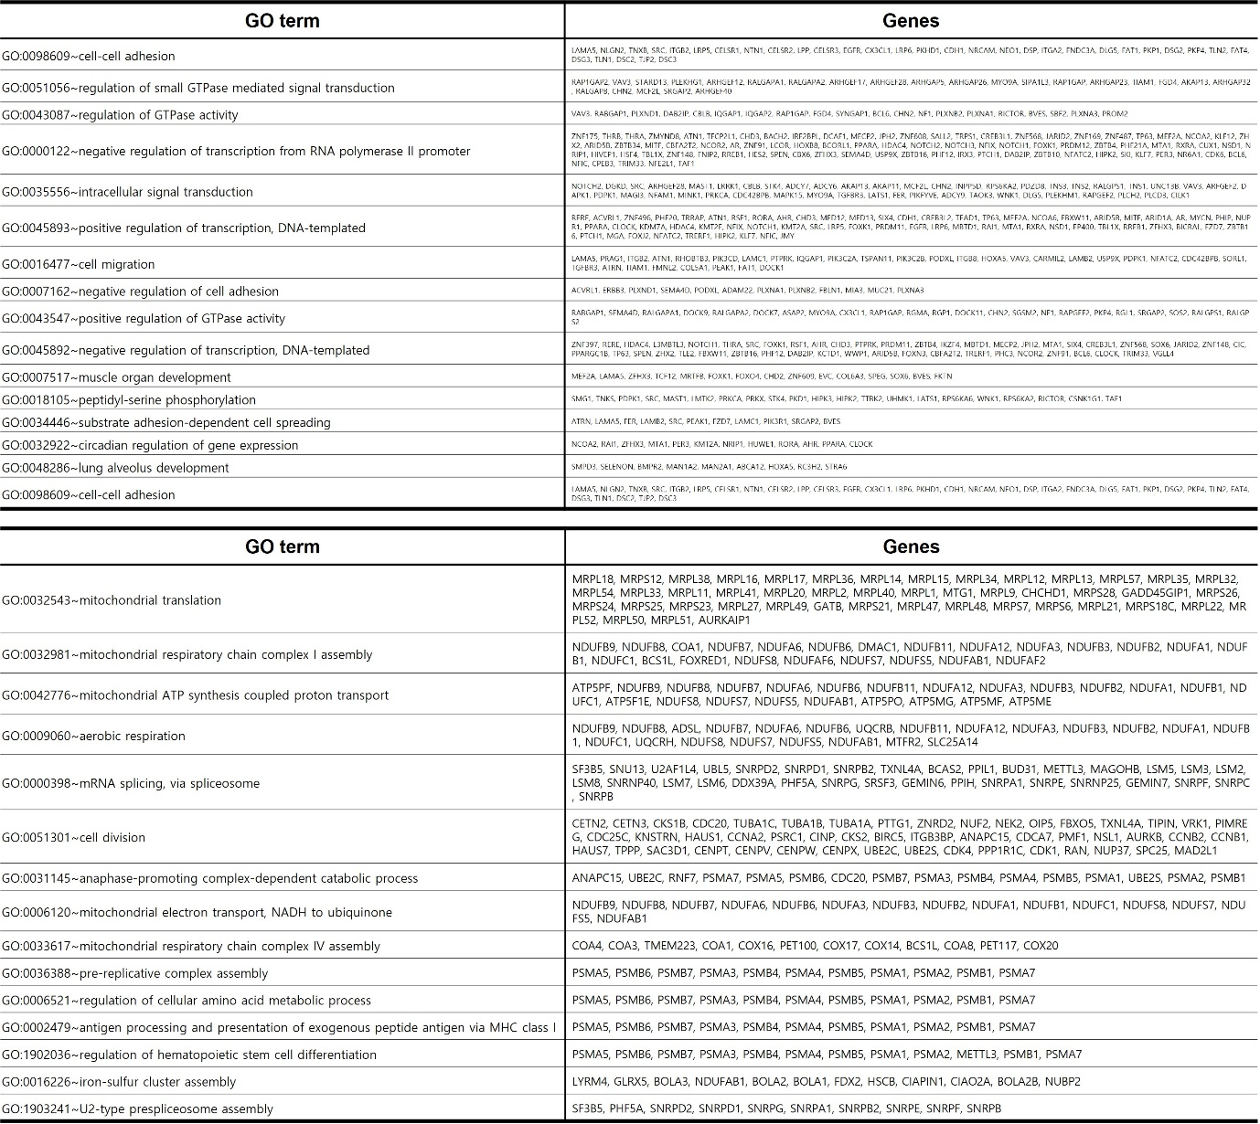
Supplementary Fig. 1. Table listing the genes included in the top 15 GO terms graphed in Fig. 3. Up-regulated genes (up) and down-regulated genes (down).

