Supplementary material

An emerging chemical fumigant: Two-sided effects of dazomet on soil microbial environment and plant response
Ran Chen¹, Weitao Jiang¹, Shaozhuo Xu¹, Hai Fan², Xuesen Chen¹, Xiang Shen¹, Chengmiao Yin¹, Zhiquan Mao¹*
¹State Key Laboratory of Crop Biology
College of Horticulture Science and Engineering
Shandong Agricultural University
Tai’an, Shandong 271018, China

²College of Chemistry and Material Science
Shandong Agricultural University
Tai’an, Shandong 271018, China

*Correspondence to: Zhiquan Mao, Professor, College of Horticulture Science and Engineering, Shandong Agricultural University, State Key Laboratory of Crop Biology, Tai’an, Shandong 271018, China. E-mail: mzhiquan@sdau.edu.cn.

Materials and Methods
Measurement of soil physicochemical properties and enzyme activity

Soil urease activity was determined by a colorimetric assay using sodium phenate–sodium hypochlorite (Du et al., 2017). First, 5-g, air-dried soil samples were weighed in a 50-mL triangulated flask, and 1 mL of toluene was added, followed by shaking until the contents were evenly mixed. After 15 min, 10 mL of 10% urea solution and citrate buffer solution was added, followed by shaking and incubation at 37℃ for 24 h. After culture, the filtrate was filtered, and 1 mL of filtrate was added into a 50-mL volumetric flask. Next, 4 mL of sodium phenol solution and 3 mL of sodium hypochlorite solution were added and shaken well. After 20 minutes, dilute the mixture to 50ml mark, the spectrophotometer was colorimetric at 578 nm (the blue of indophenol remained stable). Urease activity was calculated by subtracting the absorbance value of the sample from the difference in the absorbance value of the control sample, and the ammonia nitrogen content was calculated according to the standard curve.
The activity of urease (Ure) was represented by the ammonia-nitrogen content (mg) in 1 g of soil after 24 h. The formula for determining soil urease activity was as follows:
Ure=a*V*n/m (1)
where a is the concentration of ammonium-nitrogen obtained from the standard curve (mg/mL); V is the volume of the chromatic liquid (50 mL); n is the separation multiple; and m is the weight of the drying soil (g).
Soil phosphatase activity was determined by a colorimetric assay with disodium phenyl phosphate (Du et al. 2017). First, 5-g, air-dried soil samples were placed in a 200-mL triangulation flask, and 2.5 mL of toluene was added. After shaking for 15 min, 20 mL of 0.5% benzene-disodium phosphate was added. After shaking, the samples were placed in an incubator and cultured at 37℃ for 24 h. Next, 100 mL of 0.3% aluminum sulfate solution was added to the culture medium and filtered. Three mL of filtrate was then absorbed into 50-mL volumetric bottles, and 5 mL of buffer solution and four drops of chlorodibromo-p-benzoquinone imines reagent were added to each bottle. After color development, the solution was diluted to the scale, and the colorimetric determination was conducted 30 min later. The boric acid buffer was blue and colorimetric at 660 nm on the spectrophotometer. To draw the standard curves, 1, 3, 5, 7, 9, 11, and 13 mL of phenolic working fluids were taken for color development and volume determination. After color stability was achieved, the standard curve was drawn with the colorimetric method. Phosphatase activity was expressed in phenolic micrograms per gram of soil.
The activity of phosphatase (Pho) was represented by the phenol content (mg) in 1 g of soil after 24 h. The formula for determining soil phosphatase activity was as follows:
Pho=a*V*n/m (2)
where a is the concentration of phenol obtained from the standard curve (mg/ml); V is the volume of the chromatic liquid (50 mL); n is the separation multiple; and m is the weight of the drying soil (g).
Soil sucrase activity was determined by the colorimetric assay with 3,5-dinitrosalicylic acid (Du et al., 2017). First, 5-g, air-dried soil samples were placed in a 50-mL triangulated flask, and 10 mL of 1% starch solution was injected. This was followed by the addition of 10 mL of pH 5.6 phosphate buffer solution and five drops of toluene, shaking, and storage in an incubator. The samples were then cultured at 37℃ for 24 h. After culture, the suspension was filtered. Next, 1 mL of filtrate was poured into a 50-mL volumetric flask. Two mL of 3, 5-dinitrosalicylic acid solution was added and heated in a boiling water bath for 5 min; the solution was then moved to the volumetric flask to the running water to cool. After a constant volume of 50 mL was achieved, colorimetry was performed at 508 nm on a spectrophotometer. Glucose solution was used as the standard.
The activity of sucrase (Suc) was represented by the glucose content (mg) in 1 g of soil after 24 h. The formula for determining soil sucrase activity was as follows:
Suc=a*V*n/m (3)
where a is the concentration of glucose obtained from the standard curve (mg/mL); V is the volume of the chromatic liquid (50 mL); n is the separation multiple; and m is the weight of the drying soil (g).
Soil catalase activity was determined by potassium permanganate titration (Du et al., 2017). First, 2-g, air-dried soil samples were placed in a 100-mL trigonometric bottle and injected with 40 mL of distilled water and 5 mL of 0.3% hydrogen peroxide solution. A control (40 mL of distilled water and 5 mL of 0.3% hydrogen peroxide solution) was injected into a triangular bottle without the addition of soil samples. The triangular bottle was shaken on a shaking machine for 20 minutes, and 5 mL of 3N sulfuric acid was added to stabilize the undecomposed hydrogen peroxide. The suspension in the bottle was then filtered with a slow filter paper, followed by absorption of 25 mL of filtrate and titration with 0.1 N potassium permanganate to the light pink terminal point.
The activity of catalase (Cat) was represented by volume (mL) of 0.1 N potassium permanganate in 1 g of soil after 20 min. The formula for determining soil catalase activity was as follows:
Cat=(A-B) * T (4)
where B is the amount of potassium permanganate (mL) consumed for titrating the soil filtrate (mL); A is the amount of potassium permanganate (mL) consumed for titrating 25 mL of the original hydrogen peroxide mixture (mL); and T is the correction value for potassium permanganate titration.

Table S1. Basic characteristics of the soil

Soil texture | NO₃⁻-N  (mg·kg⁻¹) | NH4⁺-N  (mg·kg⁻¹) | Available K  (mg·kg⁻¹) | Available P  (mg·kg⁻¹) | Organic matter  (g·kg⁻¹) | pH
Brown  loam | 40.5 | 6.8 | 86.4 | 11.4 | 9.8 | 6.34
NO₃⁻-N = Nitrate nitrogen
NH4⁺-N = Ammonium nitrogen

Table S2. Costs of different fumigant treatments

Name of fumigant | Fumigation agents ($·hm⁻²) | Plastic film ($·hm⁻²) | Total ($·hm⁻²)
Dazomet (DZ) | 1837.2 | 459.3 | 2296.5

Table S3. Effects of dazomet fumigation on the biomass of M. hupeheusis Rehd. seedlings on two sampling dates

Date | Treatment | Plant height (cm) | Stem diameter (mm) | Fresh weight (g) | Dry weight (g)
9/2019 (B) | CK | 35.42 ± 1.24 | 3.62 ± 0.01 | 39.42 ± 1.24 | 19.04 ± 0.77
 | DZ | 60.19 ± 1.21** | 8.14 ± 0.06*** | 65.05 ± 1.47** | 31.49 ± 0.57**
9/2020 (C) | CK | 96.00 ± 3.03 | 11.39 ± 0.65 | 106.49 ± 3.24 | 56.04 ± 2.52
 | DZ | 124.49 ± 2.37* | 16.96 ± 0.21** | 143.84 ± 2.82* | 71.91 ± 1.11*
Note: A t-test was used to assess the significance of differences between the two treatments on a given date. *0.01< P ≤ 0.05, **0.001< P ≤ 0.01, ***P ≤ 0.001. Data are expressed as mean ± SE.

Table S4. The biomass of young apple trees on two sampling dates after dazomet fumigation

Date | Treatment | Plant height (cm) | Stem diameter (mm) | Number of branches | Branch length (cm)
7/2020 | CK | 149.83 ± 1.40 | 15.88 ± 0.29 | 9.33 ± 0.42 | 16.56 ± 0.68
 | DZ | 191.67 ± 0.67*** | 22.49 ± 0.47** | 22.00 ± 0.68* | 50.72 ± 2.00**
10/2020 | CK | 176.17 ± 1.90 | 19.68 ± 0.60 | 15.83 ± 0.60 | 22.83 ± 0.58
 | DZ | 219.83 ± 3.57** | 24.55 ± 0.41** | 26.00 ± 1.13* | 56.78 ± 1.45**
Note: A t-test was used to assess the significance of differences between the two treatments on a given date. *0.01< P ≤ 0.05, **0.001< P ≤ 0.01, ***P ≤ 0.001. Data are expressed as mean ± SE.

Table S5. Effects of dazomet fumigation on chlorophyll a, chlorophyll b, and carotene content in leaves of M. hupehensis seedlings

Date | Treatment | chlorophyll a/mg·g⁻¹ (FW) | chlorophyll b/mg·g⁻¹ (FW) | carotene /mg·g⁻¹ (FW)
9/2019 (B) | CK | 13.17 ± 0.09 | 6.67 ± 0.49 | 4.25 ± 0.27
 | DZ | 18.85 ± 0.73* | 11.96 ± 1.43* | 5.30 ± 0.19
9/2020 (C) | CK | 12.48 ± 0.65 | 6.11 ± 0.08 | 3.69 ± 0.53
 | DZ | 17.31 ± 0.71** | 11.83 ± 0.75** | 5.00 ± 0.12
FW = fresh weight. A t-test was used to assess the significance of differences between the two treatments on a given date. *0.01< P ≤ 0.05, **0.001< P ≤ 0.01, ***P ≤ 0.001. Data are expressed as mean ± SE.

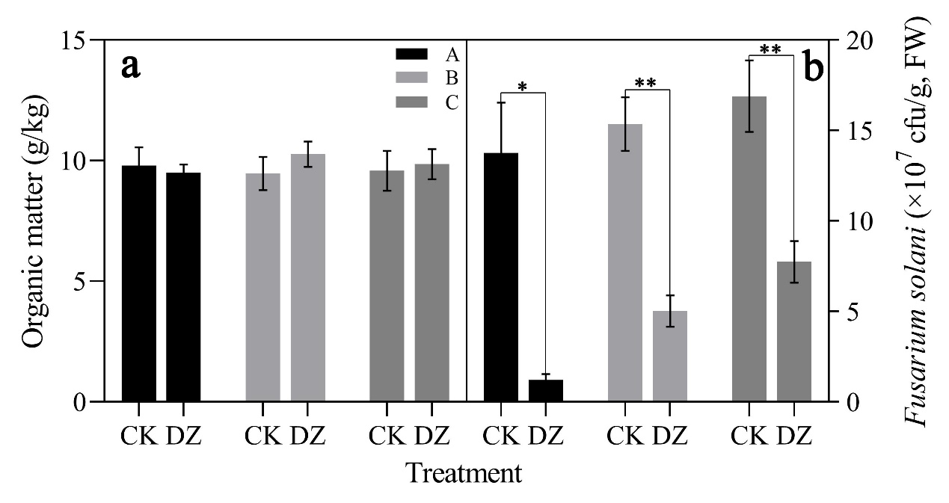
Figure S1. Organic matter content and gene copy number of Fusarium solani during three periods after dazomet (DZ) fumigation: (a) Organic matter content; (b) Gene copy number of F. solani. A = the sampling period on May 2, 2019; B = the sampling period on Sept. 10, 2019; C = the sampling period on Sept. 10, 2020; CK = untreated control (replant soil); DZ = dazomet fumigation. A t-test was used to assess the significance of differences between the two treatments on a given date. *0.01< P ≤ 0.05, **0.001< P ≤ 0.01, and ***P ≤ 0.001. Bars represent the mean ± SE of three replicates.
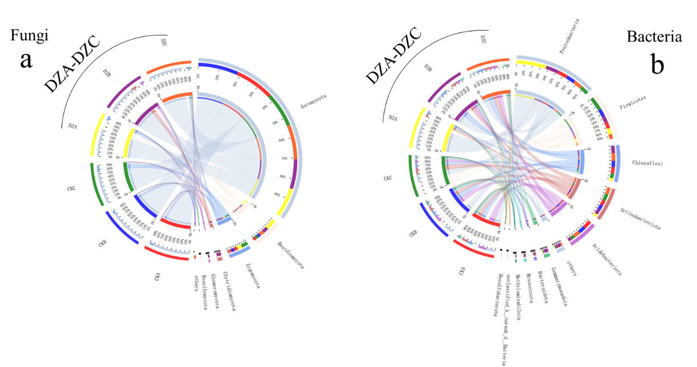
Figure S2. The relationship between Circos samples and species (a, Fungi; b, Bacteria). The small semicircle (left half circle) represents the species composition of the sample, the color of the outer ribbons represents the group from which they came, the color of the inner ribbons represents the species, and the length represents the relative abundance of the species in the corresponding sample. The large semicircle (right half circle) represents the distribution proportion of species in different samples at the taxonomic level. The outer ribbons represent species, the inner ribbons represent different groups, and the length represents the distribution proportion of the sample in a given species.
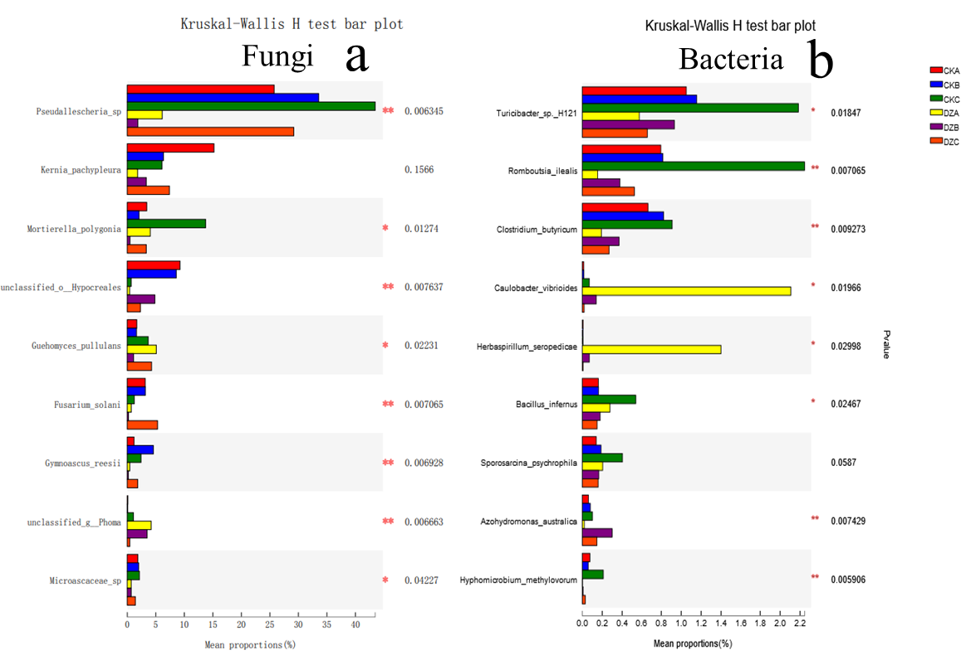
Figure S3. Relative bacterial abundance histograms of microbial species (a, Fungi; b, Bacteria) on three dates after dazomet (DZ) fumigation. Asterisks indicates significant differences between treatments according to a one-way ANOVA, Tukey-Kramer post-hoc test, and FDR=0.05 (false discovery rate) adjustment. *0.01 < P ≤ 0.05; **0.001 < P ≤ 0.01; ***P ≤ 0.001. The y-axis gives the species names, the x-axis represents the average relative abundance of different species groups, and P-values are given on the far right.
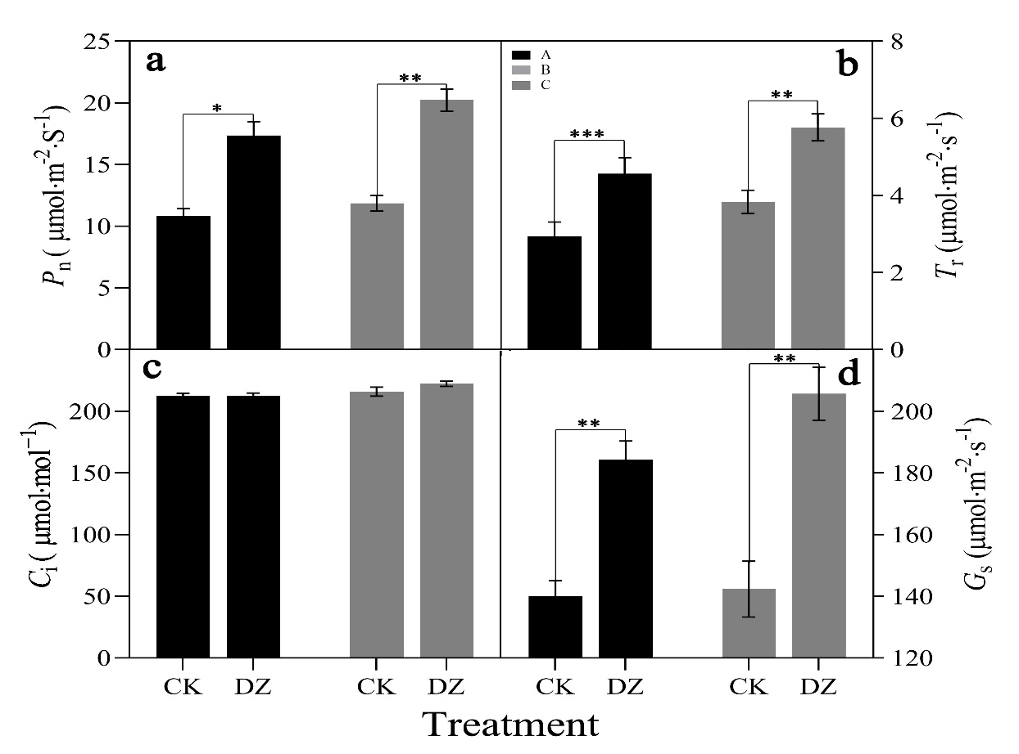
Figure S4. Values of P_{n}, C_{i}, T_{r} and G_{s} for leaves of M. hupehensis seedlings on three dates after dazomet (DZ) fumigation: (a) P_{n} = net photosynthetic rate; (b) T_{r} = Transpiration rate; (c) C_{i} = internal CO₂ concentration; (d) G_{s} = stomatal conductance.

