Supplementary materials

Investigating the stability of aromatic carboxylic acids in hydrated magnesium sulfate under UV irradiation to assist detection of organics on Mars

Andrew Alberini^{1,2} (andrew.alberini@inaf.it), Teresa Fornaro^{1*} (teresa.fornaro@inaf.it), Cristina García Florentino^{1,3} (cristina.garcia.florentino@gmail.com), Malgorzata Biczysko⁴ (biczysko@i.shu.edu.cn), Iratxe Poblacion³ (iratxe.poblacion@ehu.eus), Julene Aramendia³ (julene.aramendia@ehu.eus), Juan Manuel Madariaga³ (juanmanuel.madariaga@ehu.eus), Giovanni Poggiali^{1,5} (giovanni.poggiali@inaf.it), Álvaro Vicente-Retortillo⁶ (adevicente@cab.inta-csic.es), Kathleen C. Benison⁷ (kathleen.benison@mail.wvu.edu), Sandra Siljeström⁸ (sandra.siljestrom@ri.se), Sole Biancalani^{1,9,10,11} (sole.biancalani@inaf.it), Christian Lorenz^{1,12} (christian.lorenz@unina.it), Edward A. Cloutis¹³ (e.cloutis@uwinnipeg.ca), Dan M. Applin¹³ (daniel.m.applin@gmail.com), Felipe Gómez⁶ (gomezgf@cab.inta-csic.es), Andrew Steele¹⁴ (asteele@carnegiescience.edu), Roger C. Wiens¹⁵ (rwiens@purdue.edu), Kevin P. Hand¹⁶ (kevin.p.hand@jpl.nasa.gov) & John R. Brucato¹ (john.brucato@inaf.it)

¹ INAF- Astrophysical Observatory of Arcetri, L.go E. Fermi 5, 50125 Firenze, Italy
² Department of Physics and Astronomy, University of Florence, Via Giovanni Sansone 1, 50019 Sesto Fiorentino, Florence
³ Department of Analytical Chemistry, University of the Basque Country UPV/EHU, 48080 Bilbao, Spain
⁴ College of Science, Shanghai University, 99 Shangda Road, Shanghai 200444, China
⁵ LESIA - Observatoire de Paris, Université Paris Cité, Université PSL, Sorbonne Université, CNRS, 5 place Jules Janssen, 92190 Meudon, France
⁶ Centro de Astrobiología (CAB), CSIC-INTA, Torrejón de Ardoz, Spain
⁷ Department of Geology and Geography, West Virginia University, Morgantown, WV, USA
⁸ RISE Research Institutes of Sweden, Stockholm, Sweden
⁹ Department of Physics, University of Trento, Via Sommarive 14, 38123 Povo
¹⁰ Italian Space Angency (ASI), viale del Politecnico snc, 00133, Rome, Italy
¹¹Department of Earth Sciences, University of Florence, via G. La Pira 4, 50121, Florence, Italy
¹² Department of Biology, University of Naples Federico II, Via Cinthia, 80126 Naples, Italy
¹³ Centre for Terrestrial and Planetary Exploration, University of Winnipeg, Winnipeg, Manitoba R3B 2E9, Canada
¹⁴ Carnegie Institute for Science, Washington, DC, USA
¹⁵ Earth, Atmospheric, and Planetary Sciences, Purdue University, West Lafayette, IN, USA
¹⁶ Jet Propulsion Laboratory, California Institute of Technology, Pasadena, CA, USA
*Corresponding author

Table S1 – IR bands detectable both in pure phthalic acid spectrum and phthalic acid adsorbed on magnesium sulfate, with the vibrational mode assignment (in bold the main vibration) and intensity (w = weak; m = medium; s = strong), along with the wavenumber shifts with respect to the pure molecule.

Phthalic acid vibrational mode | Pure phthalic acid |  | $10$wt.% phthalic acid on magnesium sulfate
Phthalic acid vibrational mode | Wavenumber [cm⁻¹] | Intensity | Wavenumber [cm⁻¹] | Intensity | Shift [cm⁻¹]
1st overtone ring C-H stretching** | 6050 | s | 6050 | m | 0
1st overtone ring C-H stretching** | 6020 | m | 6018 | w | -2
Combination COO-H stretching + ring C-H bending** | 5979 | w | 5977 | w | -2
Combination ring C-H stretching + 1st overtone ring C-H in-plane bending** | 5962 | m | 5960 | w | -2
Combination ring C-H stretching + ring C-H in-plane bending** | 5836 | m | 5836 | w | 0
3rd overtone ring C-C stretching and ring C-H in-plane bending** | 4787 | m | 4791 | w | +4
Combination ring C-C stretching + ring C-H stretching* | 4677 | s | 4679 | m | +2
Combination ring C-H stretching and bending + ring C-C stretching** | 4639 | m | 4639 | w | 0
Combination ring C-H bending + ring C-H stretching* | 4582 | w | 4587 | w | +5
Combination COO-H stretching and out-of-plane bending + ring C-H and ring C-C out-of-plane bending** | 4540 | w | 4540 | w | 0
Combination C=O stretching + C=O bending** | 4505 | w | 4505 | w | 0
3rd overtone ring C-H in-plane bending and ring C-C stretching** | 4457 | w | 4457 | w | 0
Combination COO-H stretching and bending + ring C-C in-plane bending** | 4349 | m | 4349 | w | 0
Combination COO-H bending + COO-H stretching* | 4156 | s | 4156 | w | 0
Combination ring C-H and ring C-C in-plane bending and stretching + C-OOH stretching** | 4129 | m | 4127 | w | -2
Combination ring C-H stretching and bending + C-OOH stretching** | 4085 | m | 4085 | w | 0
Combination C=O stretching + COO-H in-plane bending + ring C-H in-plane bending** | 4046 | m | 4046 | w | 0
Combination molecule torsion + COO-H stretching* | 3910 | s | 3910 | m | 0
Combination COO-H stretching + COO-H bending and ring C-H bending + ring deformation** | 3746 | m | 3476 | w | 0
Combination COO-H bending + ring C-C stretching* | 2905 | m | 2905 | w | 0
Combination COO-H bending + COO-H stretching* | 2814 | w | 2814 | w | 0
Fundamental ring C-H stretching and COO-H stretching* | 2658 | s | 2656 | s | -2
1st overtone ring C-H in-plane bending** | 2529 | s | 2657 | s | -2
Combination ring C-H in-plane bending + COOH bending** | 2423 | w | 2419 | w | -4
Combination ring C-H in-plane and out-of-plane bending + COO-H bending** | 2253 | w | 2253 | w | 0
Combination COO-H bending + ring C-C and C-H in-plane bending** | 2214 | s | 2214 | w | 0
Combination ring C-H and C-C in-plane bending + C-OOH stretching** | 2099 | m | 2106 | w | +7
Combination COO-H bending and ring C-H in-plane bending + ring C-H out-of-plane bending** | 2050 | m | 2054 | m | +4
Combination ring C-C and C-H in-plane bending + whole molecule bending** | 2004 | m | 2006 | m | +2
1st overtone ring C-H out-of-plane bending and ring C-C out-of-plane bending** | 1969 | s | 1969 | m | 0
1st overtone ring C-H out-of-plane bending** | 1935 | m | 1931 | w | -4
3rd overtone ring C-C and C-H in-plane bending and COOH bending** | 1896 | w | 1896 | w | 0
Combination COO-H bending + ring C-H bending** | 1861 | m | 1859 | w | -2
Fundamental C=O stretching and COO-H bending** | 1730 | s | 1726 | w | -4
Fundamental C=O stretching* | 1693 | m | 1693 | w | 0
Fundamental ring C-C stretching and ring C-H in-plane bending** | 1663 | m | 1659 | m | -4
Fundamental ring C-C stretching* | 1589 | s | 1591 | m | +2
Fundamental ring C-C stretching* | 1535 | m | 1537 | w | +2
Fundamental ring C-C stretching* | 1499 | s | 1499 | m | 0
Fundamental ring C-H in-plane bending* | 1454 | m | 1454 | m | 0
Fundamental CO-O-H bending* | 1414 | s | 1410 | s | -4
Fundamental ring C-C stretching* | 1314 | s | 1312 | s | -2
Fundamental C-O stretching* | 1275 | m | 1275 | w | 0
Fundamental ring C-H in-pane bending and ring C-C stretching (both carbons linked to COOH groups)** | 1261 | w | 1261 | w | 0
Combination COOH + ring C-H and C-C out-of-plane bending** | 1213 | m | 1215 | w | +2
Fundamental ring C-H bending* | 1155 | s | 1155 | w | 0
Fundamental ring C-H in-plane bending* | 1142 | s | 1140 | w | -2
Fundamental ring C-H in-plane bending* | 1111 | m | 1111 | w | 0
Fundamental ring C-C in-plane bending* | 1074 | s | 1076 | w | +2
1st overtone COO-H bending and ring C-H out-of-plane bending** | 1066 | w | 1066 | w | 0
Fundamental ring C-H out-of-plane bending* | 1007 | s | 1007 | w | 0
Fundamental ring C-H out-of-plane bending* | 974 | m | 974 | w | 0
Fundamental ring C-C in-plane bending* | 831 | s | 831 | w | 0
Fundamental ring C-H and C-C out-of-plane bending** | 800 | s | 800 | w | 0
Fundamental ring C-H out-of-plane bending** | 787 | w | 789 | w | +2
Whole molecule bonds bending** | 750 | w | 750 | w | 0
Fundamental ring C-H out-of-plane bending* | 741 | s | 734 | w | -7
Out-of-plane whole molecule bonds bending** | 694 | s | 696 | w | +2
Fundamental ring C-C out-of-plane bending* | 679 | s | 683 | w | +4
Fundamental COO-H bending** | 669 | w | 669 | w | 0
Fundamental C=O and C-O in-plane bending* | 640 | s | 644 | w | +4
Fundamental ring C-C in-plane bending* | 559 | s | 563 | w | +4
* ^{1–5}
** DFT calculations, this work

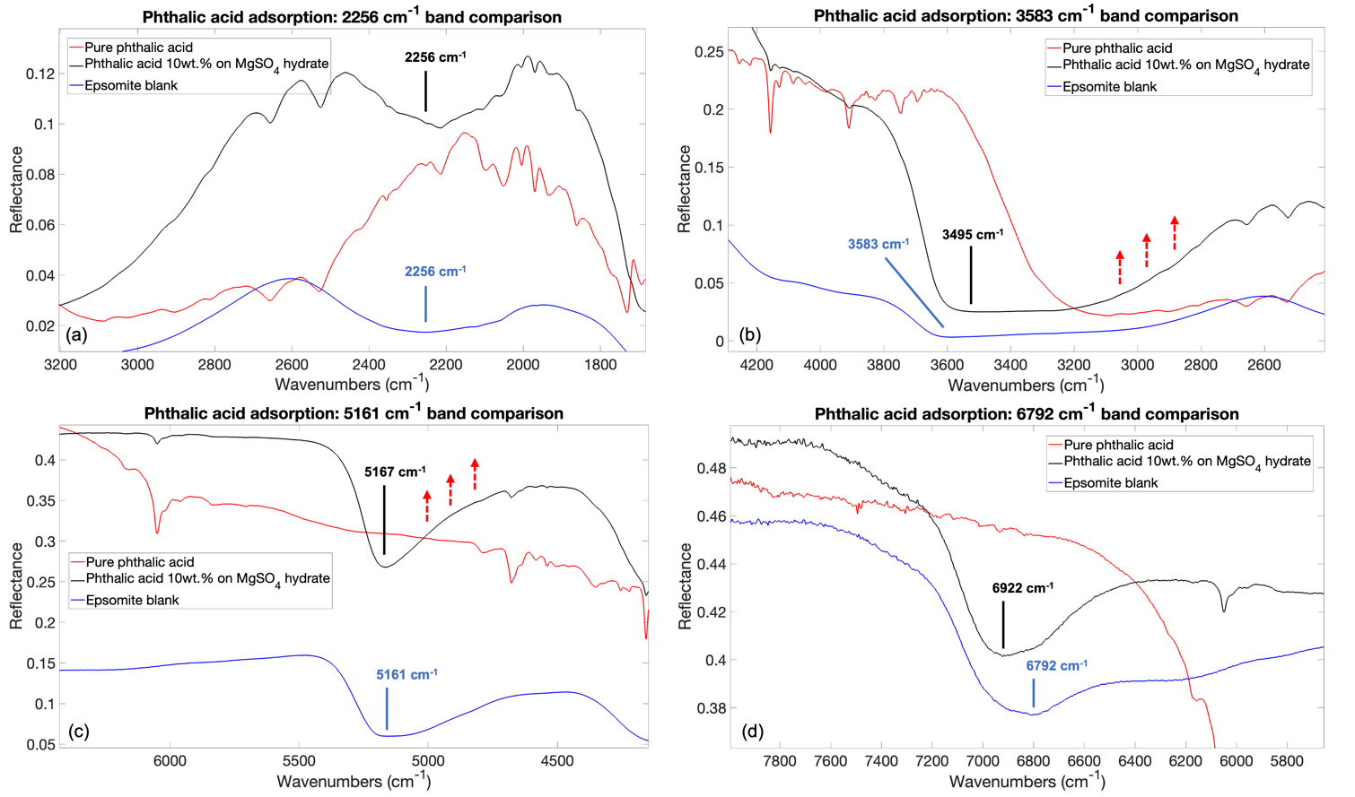
Figure S1: IR spectra comparison for pure phthalic acid, $10$ wt.$\%$ phthalic acid adsorbed on magnesium sulfate and epsomite blank regarding (a) hydrogen bonded water O-H stretching band at $2256$ ${cm}^{-1}$ ($4.4 μm$); (b) water O-H stretching band at $3583$ ${cm}^{-1}$ ($2.8 μm$); (c) $5163$ ${cm}^{-1}$ ($1.9 μm$) water O-H stretching and O-H bending combination band; (d) $6792$ ${cm}^{-1}$ ($1.5 μm$) $1$^{st} overtone of the water O-H stretching.

Table S2 – IR bands detectable both in pure mellitic acid spectrum and mellitic acid adsorbed on magnesium sulfate, with the vibrational mode assignment (in bold the main vibration) and intensity (w = weak; m = medium; s = strong), along with the wavenumber shifts with respect to the pure molecule.

Mellitic acid vibrational mode | Pure mellitic acid |  | $10$wt.% mellitic acid on magnesium sulfate
Mellitic acid vibrational mode | Wavenumbers [cm⁻¹] | Intensity | Wavenumbers [cm⁻¹] | Intensity | Shift [cm⁻¹]
Fundamental COO-H stretching* | 2667 | m | 2667 | w | 0
Fundamental COO-H stretching* | 2555 | m | 2555 | w | 0
Fundamental C=O stretching** | 1732 | m | 1730 | m | -2
Fundamental C=O stretching** | 1715 | w | 1711 | w | -4
Fundamental ring C-C stretching* | 1583 | s | 1585 | m | +2
Fundamental ring C-C stretching** | 1574 | s | 1574 | m | 0
Combination COO-H out-of-plane bending + ring C-C in-plane bending** | 1564 | s | 1564 | m | 0
Fundamental COO-H bending** | 1474 | s | 1474 | s | 0
Fundamental ring C-C stretching* | 1445 | m | 1445 | m | 0
Fundamental COOH in-plane bending and ring breathing** | 1366 | s | 1366 | m | 0
Fundamental COOH bending** | 1311 | w | 1311 | w | 0
Fundamental COOH vibrations* | 1288 | s | 1288 | m | 0
Fundamental COO-H bending** | 1199 | s | 1198 | m | -1
Fundamental COO-H in-plane bending** | 1190 | m | 1190 | m | 0
Fundamental COO-H in-plane bending and C-O stretching** | 1153 | s | 1151 | m | -2
Fundamental carboxylic C-COOH bending** | 872 | w | 872 | w | 0
Fundamental COO-H bending** | 858 | w | 858 | w | 0
Combination COOH bending + ring C-C out-of-plane bending** | 845 | w | 845 | w | 0
Fundamental COOH bending and ring C-C out-of-plane bending** | 795 | w | 793 | w | -2
Fundamental COO-H bending** | 665 | w | 667 | w | +2
Fundamental COO-H bending** | 596 | s | 600 | m | +4
* ⁶
** DFT calculations, this work

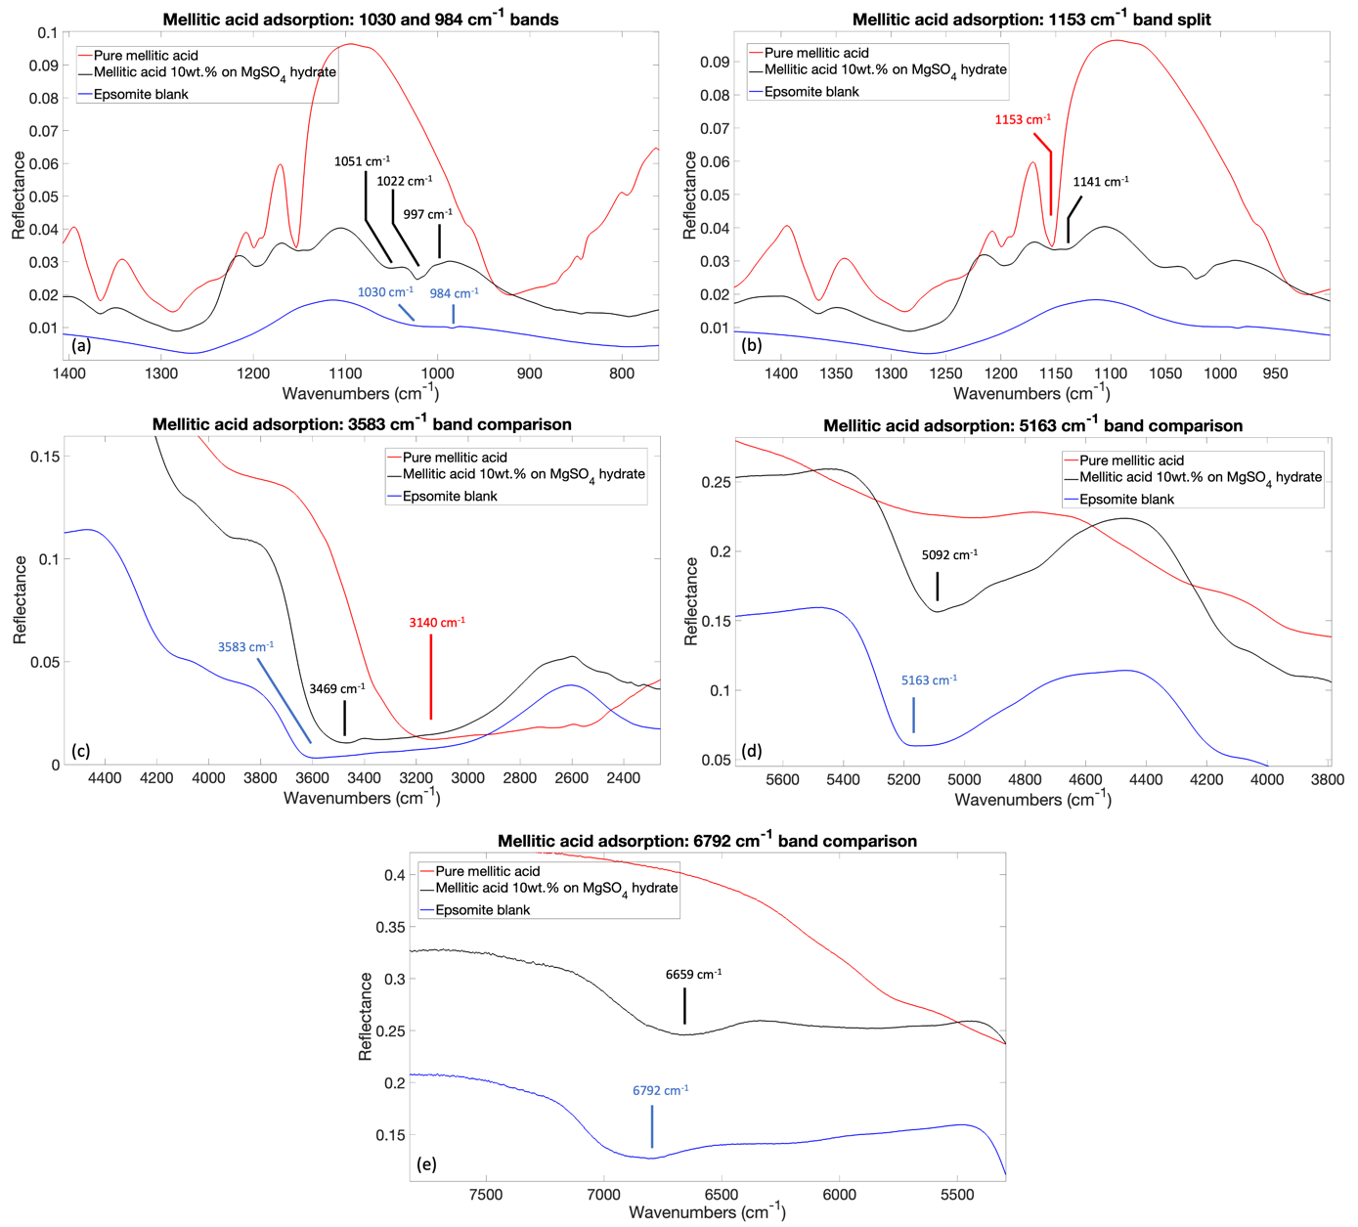
Figure S2: IR spectra comparison for pure mellitic acid, $10$ wt.$\%$ mellitic acid adsorbed on magnesium sulfate and epsomite blank regarding (a) symmetric sulfate vibration at $984$ ${cm}^{-1}$ ($10.2 μm$); (b) split (in post-adsorption) of the $1153$ ${cm}^{-1}$ ($8.7 μm$) band of pure mellitic acid associated computationally mainly with the fundamental COO-H in-plane bending vibration; (c) water O-H stretching at $3583$ ${cm}^{-1} (2.8 μm)$; (d) combination of water O-H stretching and O-H bending at $5163$ ${cm}^{-1} (1.9 μm)$; (e) 1st overtone of the water O-H stretching at $6792$ ${cm}^{-1} (1.5 μm)$.

Table S3 – Pure phthalic acid degradation results with A and C parameters.
Band [${cm}^{-1}$] | Vibrational mode | $$A$$ | $$C$$
4046 | Combination carboxylic C=O stretching + carboxylic COO-H in-plane bending + ring C-H in-plane bending | $$\left(2.9±0.5\right)∙{10}^{-2}$$ | $$\left(9.7±0.1\right)∙{10}^{-1}$$
2423 | Combination ring C-H in-plane bending + carboxylic COOH bending | $$\left(3.3±0.6\right)∙{10}^{-2}$$ | $$\left(9.4±0.1\right)∙{10}^{-1}$$
1969 | 1° overtone ring C-H out-of-plane bending and ring C-C out-of-plane bending | $$\left(3.3±0.2\right)∙{10}^{-2}$$ | $$\left(9.6±0.1\right)∙{10}^{-1}$$
1693 | Fundamental carboxylic C=O stretching | $$\left(2.6±0.3\right)∙{10}^{-2}$$ | $$\left(9.7±0.1\right)∙{10}^{-1}$$
1275 | Fundamental carboxylic C-O stretching | $$\left(6.6±0.5\right)∙{10}^{-2}$$ | $$\left(9.3±0.1\right)∙{10}^{-1}$$
1213 | Combination carboxylic COOH bending + ring C-H and C-C out-of-plane bending | $$\left(2.0±0.2\right)∙{10}^{-2}$$ | $$\left(9.8±0.1\right)∙{10}^{-1}$$
1155 | Fundamental ring C-H bending | $$\left(1.3±0.3\right)∙{10}^{-2}$$ | $$\left(9.9±0.3\right)∙{10}^{-1}$$
1142 | Fundamental ring C-H in-plane bending | $$\left(2.9±0.3\right)∙{10}^{-2}$$ | $$\left(9.70±0.03\right)∙{10}^{-1}$$
1111 | Fundamental ring C-H in-plane bending | $$\left(2.2±0.4\right)∙{10}^{-2}$$ | $$\left(9.74±0.05\right)∙{10}^{-1}$$
1074 | Fundamental ring C-C in-plane bending | $$\left(1.12±0.09\right)∙{10}^{-2}$$ | $$\left(9.87±0.01\right)∙{10}^{-1}$$
1007 | Fundamental ring C-H out-of-plane bending | $$\left(1.1±0.1\right)∙{10}^{-2}$$ | $$\left(9.89±0.01\right)∙{10}^{-1}$$
974 | Fundamental ring C-H out-of-plane bending | $$\left(1.9±0.3\right)∙{10}^{-2}$$ | $$\left(9.83±0.03\right)∙{10}^{-1}$$
800 | Fundamental ring C-H and C-C out-of-plane bending | $$\left(1.3±0.2\right)∙{10}^{-2}$$ | $$\left(9.90±0.02\right)∙{10}^{-1}$$
741 | Fundamental ring C-H out-of-plane bending | $$\left(2.3±0.5\right)∙{10}^{-2}$$ | $$\left(9.73±0.05\right)∙{10}^{-1}$$

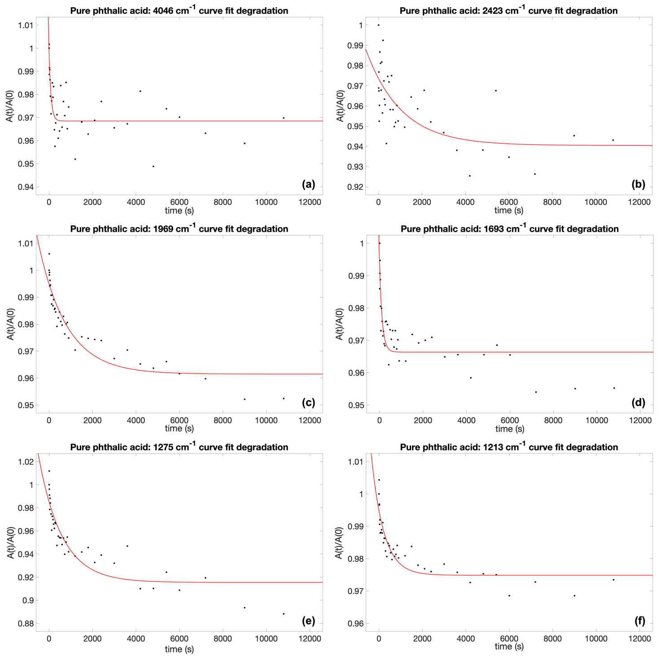
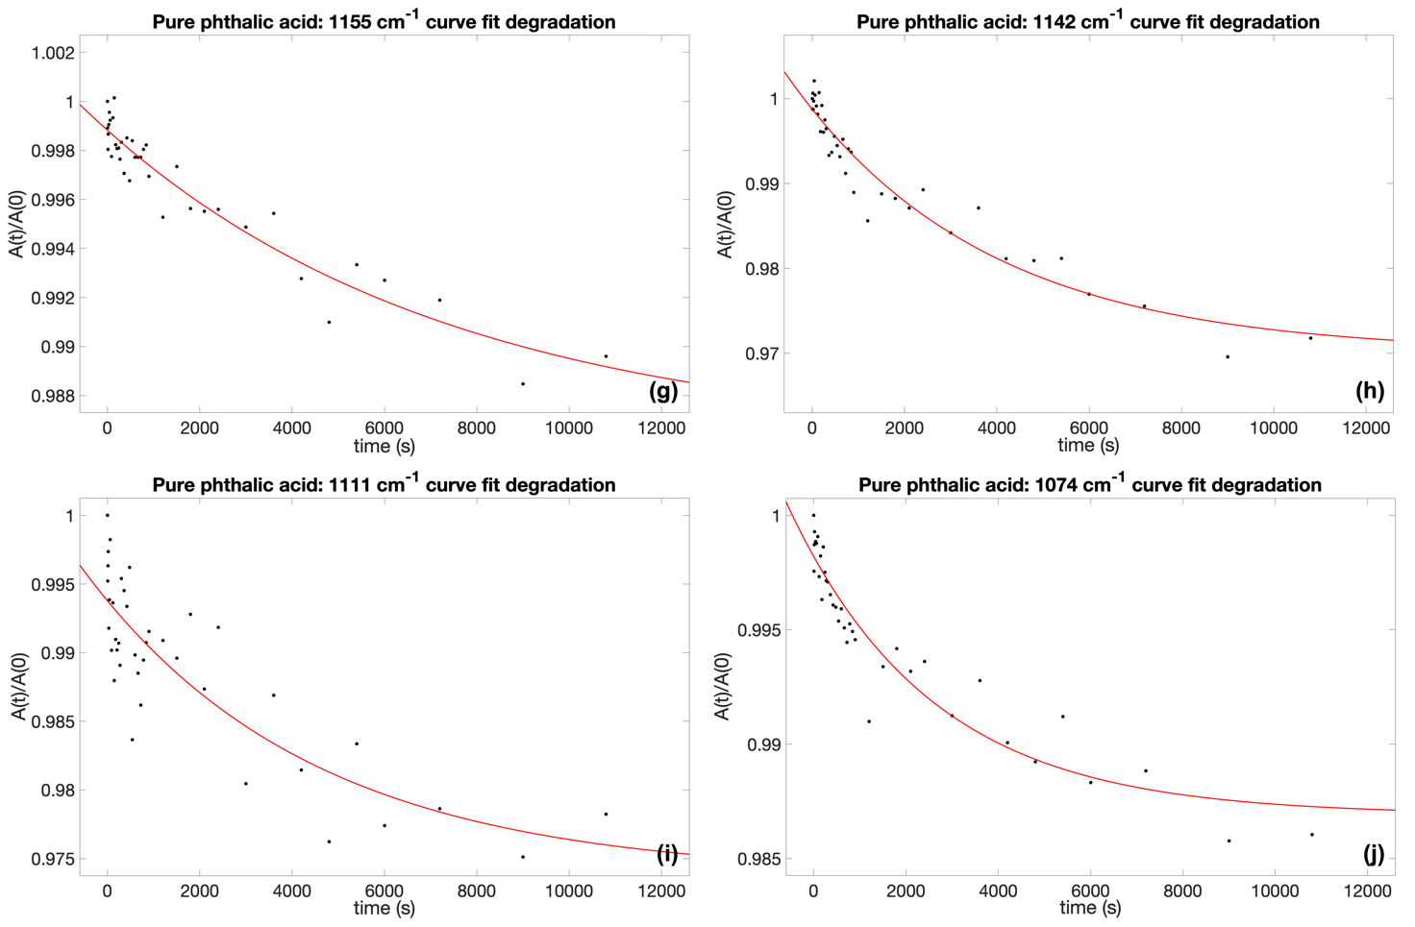
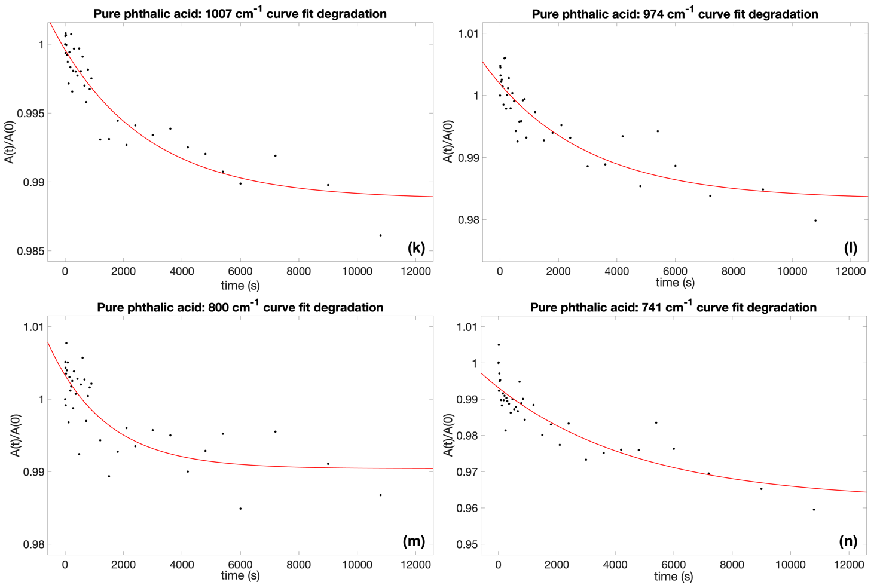

Figure S3: Curve fit degradation results for pure phthalic acid: (a) combination mainly assigned to carboxylic C=O stretching $4046 {cm}^{-1}$ band; (b) combination ring C-H in-plane bending + carboxylic COOH bending $2423 {cm}^{-1}$ band; (c) 1st overtone mainly assigned to ring C-H out-of-plane bending $1969 {cm}^{-1}$ band; (d) fundamental carboxyl C$=$O stretching at $1693 {cm}^{-1}$ band; (e) fundamental carboxyl C-O stretching at $1275 {cm}^{-1}$ band; (f) combination carboxylic COOH bending + ring C-H and C-C out-of-plane bending $1213$ ${cm}^{-1}$ band; (g) fundamental ring C-H bending $1155$ ${cm}^{-1}$ band; (h) fundamental ring C-H in-plane bending $1142$ ${cm}^{-1}$ band; (i) fundamental ring C-H in-plane bending $1111$ ${cm}^{-1}$ band; (j) fundamental ring C-C in-plane bending $1074$ ${cm}^{-1}$ band; (k) fundamental ring C-H out-of-plane bending $1007$ ${cm}^{-1}$ band; (l) fundamental ring C-H out-of-plane bending at $974$ ${cm}^{-1}$ band; (m) fundamental ring C-H and C-C out-of-plane bending $800$ ${cm}^{-1}$ band; (n) fundamental ring C-H out-of-plane bending $741$ ${cm}^{-1}$ band.

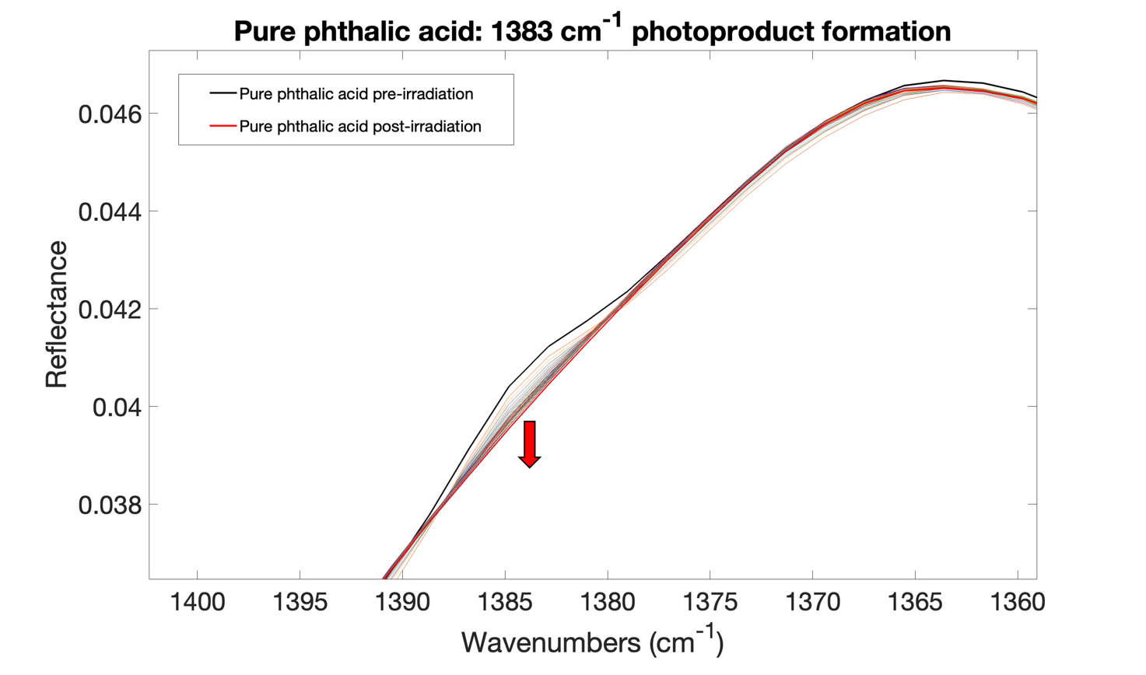
Figure S4: Pure phthalic acid photoproduct band at $1383 {cm}^{-1}$. IR spectra changing during irradiation experiment not integrable due to its low intensity.

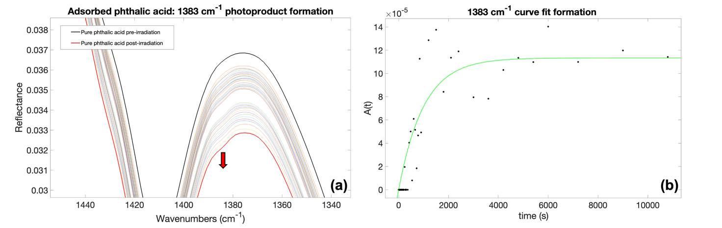
Figure S5: Photoproduct band at $1383 {cm}^{-1}$ appearing during UV irradiation of phthalic acid adsorbed on magnesium sulfate where (a) IR spectra changing during irradiation experiment; (b) curve fit formation with $α=\left(1.0±0.3\right)∙{10}^{-3}s^{-1}$ and formation cross section of $σ_{f}=\left(3.6±0.9\right)∙{10}^{-21}{cm}^{2}$.
.

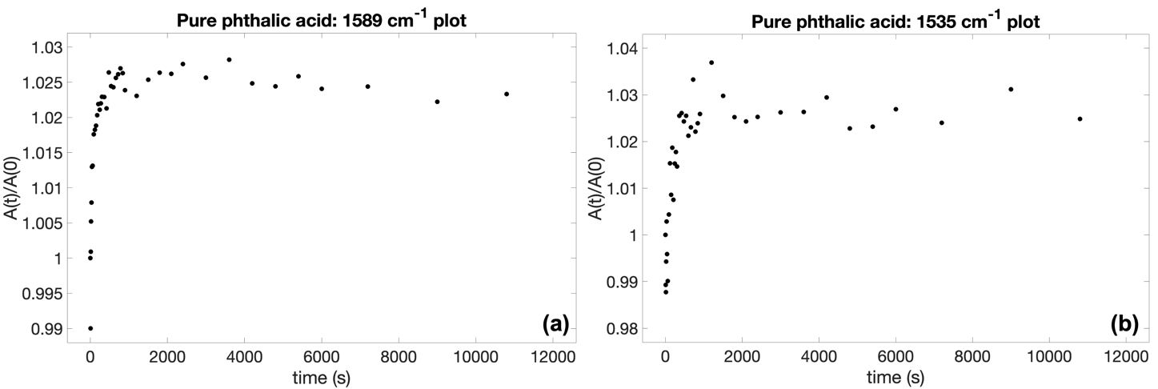

Figure S6: Pure phthalic acid ring C-C stretching increasing plots: (a) $1589$ ${cm}^{-1}$ band; (b) $1535 {cm}^{-1}$ band. Both not integrable with the fit model used.

Table S4 – Pure mellitic acid degradation results with A and C parameters.
Band [${cm}^{-1}$] | Vibrational mode | $$A$$ | $$C$$
1564 | Combination carboxylic COO-H out-of-plane bending + ring C-C in-plane bending | $$\left(1.3±0.1\right)∙{10}^{-2}$$ | $$\left(9.79±0.01\right)∙{10}^{-1}$$
1366 | Fundamental carboxylic COOH in-plane bending and ring ring breathing | $$\left(6±2\right)∙{10}^{-3}$$ | $$\left(9.89±0.02\right)∙{10}^{-1}$$
1153 | Fundamental carboxylic COO-H in-plane bending and C-O stretching | $$\left(6.2±0.4\right)∙{10}^{-3}$$ | $$\left(9.93±0.01\right)∙{10}^{-1}$$

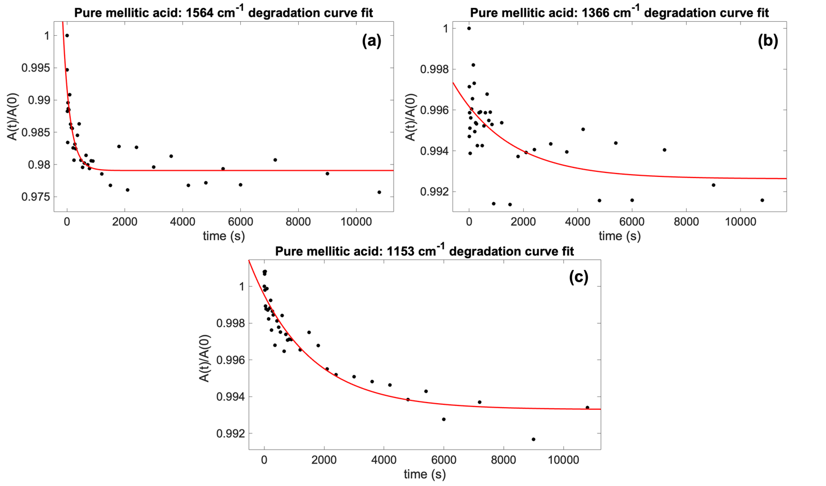
Figure S7: Curve fit degradation results for pure mellitic acid: (a) combination mainly assigned to carboxylic COO-H out-of-plane bending $1564 {cm}^{-1}$ band; (b) fundamental carboxylic COOH in-plane bending and ring breathing $1366 {cm}^{-1}$ band; (c) fundamental mainly assigned to carboxylic COO-H in-plane bending $1153 {cm}^{-1}$ band.

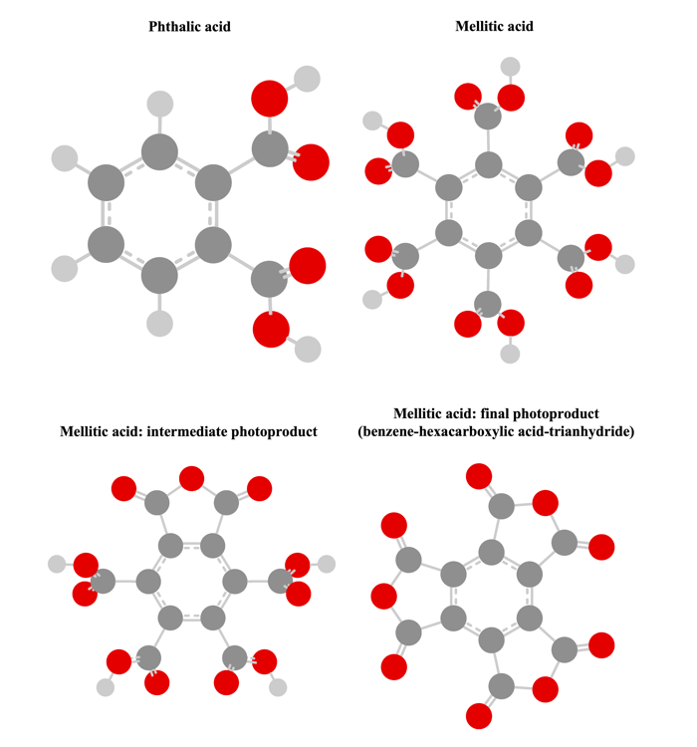

Figure S8: Structures of phthalic acid, mellitic acid, intermediate and final photoproduct (benzene-hexacarboxylic acid-trianhydride) of mellitic acid, optimized at the B3LYP-D3/SNSD level of theory.

Table S5 – Bands of phthalic acid when adsorbed on magnesium sulfate in the IR SuperCam spectral range ($7700-3850$ ${cm}^{-1}$, $1.3-2.6$ $μm$) with the vibrational mode assignment (in bold the main vibration) and intensity (w = weak; m = medium).

Phthalic acid vibrational mode | Wavenumber [cm⁻¹] | Wavelength [$μm$] | Intensity
1st overtone ring C-H stretching** | 6050 | 1.65 | m
1st overtone ring C-H stretching** | 6018 | 1.66 | w
Combination COO-H stretching + ring C-H bending** | 5977 | 1.67 | w
Combination ring C-H stretching + 1st overtone ring C-H in-plane bending** | 5960 | 1.68 | w
Combination ring C-H stretching + ring C-H in-plane bending** | 5836 | 1.71 | w
3rd overtone ring C-C stretching and ring C-H in-plane bending** | 4791 | 2.09 | w
Combination ring C-C stretching + ring C-H stretching* | 4679 | 2.14 | m
Combination ring C-H stretching and bending + ring C-C stretching** | 4639 | 2.16 | w
Combination ring C-H bending + ring C-H stretching* | 4587 | 2.18 | w
Combination COO-H stretching and out-of-plane bending + ring C-H and ring C-C out-of-plane bending** | 4540 | 2.20 | w
Combination C=O stretching + C=O bending** | 4505 | 2.22 | w
3rd overtone ring C-H in-plane bending and ring C-C stretching** | 4457 | 2.24 | w
Combination COO-H stretching and bending + ring C-C in-plane bending** | 4349 | 2.30 | w
Combination COO-H bending + COO-H stretching* | 4156 | 2.41 | w
Combination ring C-H and ring C-C in-plane bending and stretching + C-OOH stretching** | 4127 | 2.42 | w
Combination ring C-H stretching and bending + C-OOH stretching** | 4085 | 2.45 | w
Combination C=O stretching + COO-H in-plane bending + ring C-H in-plane bending** | 4046 | 2.47 | w
Combination molecule torsion + COO-H stretching* | 3910 | 2.56 | m
* ^{1–5}
** DFT calculations, this work

Table S6 – Vibrational wavenumbers and intensities calculated at anharmonic level using GVPT2 method and B3LYP-D3/SNSD level of theory for: phthalic acid, mellitic acid, intermediate photoproduct of mellitic acid, final mellitic photoproduct (benzene-hexacarboxylic acid-trianhydride). Legend: Mode (n) vibrational modes, E (harm) is the ${cm}^{-1}$ harmonic wavenumber, E (anharm) is the ${cm}^{-1}$ anharmonic wavenumber, I (harm) is the harmonic intensity in $km/mol$, I (anharm) is the anharmonic intensity in $km/mol$.

Phthalic acid fundamentals
Mode (n) | E (harm) | E (anharm) | I (harm) | I (anharm)
1(1) | 3748,15 | 3560,32 | 94,48 | 69,99
2(1) | 3747,68 | 3559,68 | 82,72 | 67,45
3(1) | 3210,24 | 3072,28 | 4,55 | 4,51
4(1) | 3207,01 | 3050,91 | 2,81 | 2,17
5(1) | 3193,60 | 3062,35 | 7,31 | 9,44
6(1) | 3179,74 | 3063,62 | 1,40 | 1,72
7(1) | 1812,83 | 1776,75 | 328,32 | 153,06
8(1) | 1793,49 | 1761,67 | 296,12 | 92,09
9(1) | 1640,97 | 1602,09 | 9,09 | 1,46
10(1) | 1623,98 | 1586,79 | 11,47 | 7,58
11(1) | 1526,72 | 1487,94 | 1,47 | 0,01
12(1) | 1475,48 | 1446,16 | 1,24 | 0,76
13(1) | 1370,76 | 1342,08 | 69,30 | 10,77
14(1) | 1367,35 | 1345,89 | 134,09 | 15,63
15(1) | 1351,07 | 1321,46 | 0,50 | 7,79
16(1) | 1300,83 | 1279,59 | 7,38 | 0,47
17(1) | 1218,96 | 1185,92 | 46,26 | 13,55
18(1) | 1209,35 | 1172,70 | 356,97 | 174,26
19(1) | 1187,12 | 1174,37 | 0,08 | 0,04
20(1) | 1158,11 | 1138,61 | 100,37 | 49,00
21(1) | 1122,22 | 1092,36 | 25,19 | 15,09
22(1) | 1066,93 | 1049,58 | 163,14 | 163,21
23(1) | 1063,62 | 1047,87 | 1,57 | 0,90
24(1) | 1012,86 | 986,36 | 0,68 | 0,62
25(1) | 982,74 | 960,52 | 5,23 | 5,81
26(1) | 908,36 | 892,64 | 0,19 | 0,05
27(1) | 811,98 | 797,37 | 19,73 | 17,64
28(1) | 811,85 | 802,15 | 4,68 | 2,26
29(1) | 803,82 | 796,27 | 8,65 | 3,29
30(1) | 752,34 | 739,14 | 21,67 | 13,34
31(1) | 751,19 | 728,84 | 120,57 | 31,53
32(1) | 712,93 | 699,70 | 0,61 | 0,74
33(1) | 637,57 | 631,24 | 24,36 | 19,70
34(1) | 636,03 | 629,43 | 61,22 | 63,90
35(1) | 605,37 | 582,93 | 105,53 | 107,41
36(1) | 600,94 | 586,00 | 20,26 | 12,69
37(1) | 565,77 | 556,97 | 17,90 | 14,47
38(1) | 547,88 | 534,83 | 14,73 | 25,88
39(1) | 410,58 | 408,08 | 1,58 | 1,25
40(1) | 403,61 | 396,68 | 5,03 | 5,30
41(1) | 348,20 | 343,31 | 0,19 | 0,17
42(1) | 337,48 | 334,05 | 5,18 | 4,94
43(1) | 237,97 | 237,69 | 0,02 | 0,02
44(1) | 167,10 | 166,32 | 0,05 | 0,04
45(1) | 158,88 | 156,96 | 3,24 | 3,15
46(1) | 111,99 | 111,99 | 0,03 | 0,03
47(1) | 86,29 | 86,29 | 2,33 | 2,33
48(1) | 6,46 | 6,46 | 3,09 | 3,09

Phthalic acid overtones
Mode(n) | E(harm) | E(anharm) | I(anharm)
1(3) | 11244,45 | 10438,89 | 0,056519
2(3) | 11243,05 | 10437,79 | 0,110929
3(3) | 9630,71 | 9109,19 | 0,001277
4(3) | 9621,02 | 9079,33 | 0,022992
5(3) | 9580,81 | 9079,15 | 0,014353
6(3) | 9539,21 | 8965,05 | 0,007645
1(2) | 7496,30 | 7125,63 | 0,000577
2(2) | 7495,37 | 6958,86 | 4,380673
3(2) | 6420,47 | 6147,31 | 0,002216
5(2) | 6387,21 | 6116,22 | 0,010078
4(2) | 6414,01 | 6070,10 | 0,074276
6(2) | 6359,47 | 5992,61 | 1,549737
7(3) | 5438,48 | 5311,51 | 0,019826
8(3) | 5380,47 | 5258,62 | 0,011407
9(3) | 4922,90 | 4809,78 | 0,006026
10(3) | 4871,94 | 4764,90 | 0,038396
11(3) | 4580,16 | 4448,71 | 0,002666
12(3) | 4426,45 | 4320,41 | 0,001130
13(3) | 4112,29 | 3988,28 | 0,000106
14(3) | 4102,04 | 3981,68 | 0,000262
15(3) | 4053,21 | 3952,04 | 0,000180
16(3) | 3902,49 | 3824,08 | 0,000591
7(2) | 3625,65 | 3552,86 | 0,911120
17(3) | 3656,87 | 3535,62 | 0,023558
19(3) | 3561,35 | 3532,91 | 0,000266
8(2) | 3586,98 | 3512,67 | 1,388540
18(3) | 3628,05 | 3489,63 | 0,013121
20(3) | 3474,34 | 3414,99 | 0,000577
21(3) | 3366,67 | 3266,90 | 0,000819
9(2) | 3281,93 | 3205,36 | 0,007705
10(2) | 3247,96 | 3175,75 | 1,825457
22(3) | 3200,79 | 3146,25 | 0,001813
23(3) | 3190,84 | 3136,52 | 0,077769
11(2) | 3053,44 | 2972,58 | 0,030734
24(3) | 3038,58 | 2946,17 | 0,000105
12(2) | 2950,97 | 2886,31 | 0,044544
25(3) | 2948,20 | 2875,60 | 0,000208
26(3) | 2725,09 | 2668,82 | 0,000001
13(2) | 2741,53 | 2662,89 | 0,367891
14(2) | 2734,70 | 2659,69 | 0,532370
15(2) | 2702,14 | 2635,99 | 0,218209
16(2) | 2601,66 | 2551,66 | 0,088967
28(3) | 2435,55 | 2406,48 | 0,000128
27(3) | 2435,94 | 2398,32 | 0,000022
29(3) | 2411,47 | 2365,38 | 0,001003
17(2) | 2437,91 | 2361,01 | 0,704320
19(2) | 2374,23 | 2352,01 | 0,355377
18(2) | 2418,70 | 2330,81 | 1,131574
20(2) | 2316,23 | 2276,97 | 0,038960
30(3) | 2257,03 | 2215,73 | 0,000054
31(3) | 2253,56 | 2207,30 | 0,001821
21(2) | 2244,44 | 2181,32 | 0,014455
32(3) | 2138,80 | 2100,06 | 0,000003
22(2) | 2133,86 | 2097,76 | 0,054852
23(2) | 2127,23 | 2092,39 | 0,011749
24(2) | 2025,72 | 1968,42 | 1,214037
25(2) | 1965,47 | 1919,06 | 0,346958
33(3) | 1912,70 | 1894,86 | 0,000062
34(3) | 1908,09 | 1888,96 | 0,000501
26(2) | 1816,72 | 1780,00 | 0,288295
36(3) | 1802,81 | 1726,69 | 0,000185
35(3) | 1816,12 | 1726,01 | 0,025882
37(3) | 1697,30 | 1672,96 | 0,057489
38(3) | 1643,63 | 1617,31 | 0,000115
28(2) | 1623,70 | 1604,68 | 0,050545
27(2) | 1623,96 | 1599,24 | 0,000393
29(2) | 1607,65 | 1577,43 | 0,771026
30(2) | 1504,69 | 1477,72 | 0,011743
31(2) | 1502,38 | 1471,90 | 0,353763
32(2) | 1425,87 | 1399,71 | 0,337937
33(2) | 1275,14 | 1262,86 | 0,037288
34(2) | 1272,06 | 1259,08 | 0,052503
39(3) | 1231,73 | 1223,98 | 0,016969
40(3) | 1210,83 | 1191,48 | 1,643087
36(2) | 1201,88 | 1164,70 | 1,233485
35(2) | 1210,75 | 1147,70 | 0,021902
37(2) | 1131,53 | 1114,62 | 2,851582
38(2) | 1095,75 | 1077,91 | 0,097286
41(3) | 1044,61 | 1029,39 | 0,000842
42(3) | 1012,44 | 1001,58 | 0,000917
39(2) | 821,16 | 816,07 | 0,020678
40(2) | 807,22 | 793,85 | 0,148976
43(3) | 713,90 | 715,54 | 0,000159
41(2) | 696,41 | 686,44 | 0,001546
42(2) | 674,96 | 667,92 | 0,060778
44(3) | 501,31 | 499,62 | 0,000016
43(2) | 475,93 | 476,20 | 0,000532
45(3) | 476,64 | 470,15 | 0,000026
44(2) | 334,21 | 332,86 | 0,006449
45(2) | 317,76 | 313,68 | 0,003045

Mellitic acid fundamentals
Mode(n) | E(harm) | E(anharm) | I(harm) | I(anharm)
1(1) | 31,18 | 31,18 | 0,57 | 0,57
2(1) | 36,49 | 36,49 | 1,05 | 1,05
3(1) | 37,76 | 37,76 | 2,50 | 2,50
4(1) | 69,48 | 69,48 | 0,22 | 0,22
5(1) | 75,85 | 75,85 | 1,30 | 1,30
6(1) | 76,16 | 76,16 | 0,16 | 0,16
7(1) | 88,31 | 88,31 | 6,19 | 6,19
8(1) | 96,67 | 96,67 | 0,01 | 0,01
9(1) | 100,67 | 100,67 | 1,41 | 1,41
10(1) | 136,22 | 131,92 | 4,23 | 4,69
11(1) | 154,91 | 152,01 | 1,50 | 1,43
12(1) | 155,25 | 151,62 | 1,57 | 1,70
13(1) | 158,18 | 154,76 | 0,09 | 0,00
14(1) | 160,18 | 156,41 | 1,29 | 1,21
15(1) | 169,09 | 165,44 | 0,36 | 0,34
16(1) | 190,55 | 187,11 | 1,11 | 1,38
17(1) | 192,06 | 188,78 | 0,60 | 0,55
18(1) | 264,37 | 260,85 | 0,24 | 0,26
19(1) | 265,33 | 261,92 | 0,89 | 0,98
20(1) | 300,53 | 298,48 | 0,40 | 1,49
21(1) | 304,02 | 301,76 | 2,87 | 2,62
22(1) | 307,10 | 302,32 | 1,00 | 1,04
23(1) | 308,51 | 306,34 | 3,88 | 3,42
24(1) | 321,08 | 318,78 | 0,41 | 0,51
25(1) | 364,39 | 366,52 | 0,01 | 0,02
26(1) | 446,62 | 438,89 | 8,42 | 7,27
27(1) | 447,49 | 440,86 | 0,76 | 0,00
28(1) | 546,72 | 520,46 | 92,47 | 104,94
29(1) | 557,62 | 526,49 | 1,22 | 19,06
30(1) | 558,15 | 541,05 | 0,82 | 51,91
31(1) | 581,30 | 557,16 | 28,83 | 136,42
32(1) | 590,65 | 562,60 | 101,10 | 808,01
33(1) | 594,31 | 584,83 | 175,36 | 6,38
34(1) | 597,57 | 573,26 | 180,36 | 33,13
35(1) | 599,27 | 592,91 | 114,02 | 141,18
36(1) | 634,74 | 618,13 | 78,74 | 227,31
37(1) | 637,13 | 630,88 | 0,07 | 0,13
38(1) | 642,41 | 632,81 | 44,09 | 1,74
39(1) | 671,80 | 663,55 | 5,70 | 2,86
40(1) | 682,30 | 672,48 | 0,25 | 0,50
41(1) | 683,18 | 675,13 | 3,66 | 2,94
42(1) | 692,65 | 683,95 | 1,53 | 1,31
43(1) | 730,72 | 730,72 | 0,03 | 0,03
44(1) | 734,71 | 721,35 | 12,52 | 8,42
45(1) | 735,70 | 723,78 | 8,43 | 2,14
46(1) | 800,03 | 793,16 | 0,06 | 0,02
47(1) | 800,14 | 793,02 | 0,21 | 0,09
48(1) | 833,46 | 833,46 | 0,02 | 0,02
49(1) | 846,18 | 832,68 | 52,40 | 36,99
50(1) | 846,79 | 832,64 | 54,24 | 37,37
51(1) | 884,26 | 872,35 | 50,54 | 43,08
52(1) | 966,51 | 949,09 | 5,41 | 5,03
53(1) | 967,20 | 949,27 | 1,31 | 0,94
54(1) | 1120,61 | 1094,15 | 42,40 | 38,82
55(1) | 1156,08 | 1126,16 | 10,07 | 6,25
56(1) | 1167,62 | 1131,26 | 575,27 | 420,37
57(1) | 1173,35 | 1137,23 | 516,84 | 390,13
58(1) | 1183,28 | 1145,00 | 65,06 | 1,52
59(1) | 1187,25 | 1148,68 | 596,51 | 199,27
60(1) | 1239,46 | 1200,66 | 22,59 | 3,18
61(1) | 1258,32 | 1216,81 | 17,60 | 2,78
62(1) | 1322,56 | 1297,69 | 0,02 | 1,22
63(1) | 1330,04 | 1298,73 | 77,17 | 31,87
64(1) | 1333,28 | 1297,29 | 94,55 | 50,89
65(1) | 1361,14 | 1319,69 | 5,88 | 0,01
66(1) | 1361,45 | 1319,15 | 59,67 | 10,94
67(1) | 1394,73 | 1347,80 | 11,47 | 3,25
68(1) | 1419,41 | 1378,88 | 90,20 | 20,28
69(1) | 1461,07 | 1429,36 | 140,09 | 78,42
70(1) | 1463,74 | 1430,77 | 65,80 | 2,13
71(1) | 1606,27 | 1571,23 | 4,08 | 0,65
72(1) | 1606,93 | 1575,33 | 7,79 | 3,10
73(1) | 1812,84 | 1782,56 | 285,59 | 103,88
74(1) | 1812,86 | 1783,53 | 101,03 | 15,33
75(1) | 1815,05 | 1790,88 | 286,83 | 677,40
76(1) | 1816,27 | 1787,00 | 4,56 | 45,08
77(1) | 1817,04 | 1787,28 | 828,98 | 1124,44
78(1) | 1827,07 | 1795,36 | 302,82 | 211,21
79(1) | 3739,68 | 3549,49 | 15,29 | 109,07
80(1) | 3740,45 | 3557,62 | 12,11 | 199,32
81(1) | 3740,68 | 3530,02 | 12,92 | 76,85
82(1) | 3741,00 | 3557,34 | 300,76 | 63,17
83(1) | 3741,42 | 3554,23 | 314,87 | 178,08
84(1) | 3742,29 | 3576,40 | 8,97 | 7,04

Mellitic acid overtones
Mode(n) | E(harm) | E(anharm) | I(anharm)
10(2) | 272,43 | 263,17 | 0,000849
11(2) | 309,82 | 303,86 | 0,000003
12(2) | 310,49 | 303,50 | 0,155707
13(2) | 316,36 | 309,56 | 0,025162
14(2) | 320,36 | 312,68 | 0,048489
15(2) | 338,17 | 330,81 | 0,001436
16(2) | 381,09 | 374,55 | 0,004155
17(2) | 384,11 | 377,83 | 0,017278
18(2) | 528,74 | 521,64 | 0,000236
19(2) | 530,65 | 523,79 | 0,000195
20(2) | 601,07 | 597,41 | 15,601242
21(2) | 608,04 | 603,98 | 3,629703
22(2) | 614,19 | 604,46 | 0,113029
23(2) | 617,03 | 612,94 | 0,006739
24(2) | 642,16 | 637,63 | 0,027189
25(2) | 728,78 | 735,01 | 0,008721
26(2) | 893,24 | 877,50 | 0,035152
27(2) | 894,98 | 881,45 | 0,015843
28(2) | 1093,44 | 1057,89 | 0,154334
29(2) | 1115,24 | 1060,38 | 1,123649
30(2) | 1116,29 | 1067,53 | 0,000053
31(2) | 1162,61 | 1108,38 | 0,010471
32(2) | 1181,30 | 1117,86 | 0,653345
33(2) | 1188,61 | 1169,47 | 5,776336
34(2) | 1195,13 | 1138,86 | 0,586848
35(2) | 1198,54 | 1179,86 | 0,000601
36(2) | 1269,48 | 1235,68 | 0,089680
37(2) | 1274,25 | 1262,01 | 0,080210
38(2) | 1284,82 | 1264,79 | 0,338694
39(2) | 1343,59 | 1327,75 | 2,384439
40(2) | 1364,59 | 1346,26 | 0,837780
41(2) | 1366,35 | 1351,10 | 0,041597
42(2) | 1385,30 | 1367,89 | 0,156851
44(2) | 1469,42 | 1442,84 | 0,701190
45(2) | 1471,40 | 1445,41 | 0,121513
46(2) | 1600,06 | 1586,83 | 0,008216
47(2) | 1600,28 | 1586,63 | 0,303491
49(2) | 1692,35 | 1664,63 | 0,764412
50(2) | 1693,57 | 1664,64 | 0,113521
51(2) | 1768,52 | 1744,39 | 0,390328
52(2) | 1933,03 | 1897,65 | 0,182872
53(2) | 1934,40 | 1898,00 | 0,473461
54(2) | 2241,22 | 2187,48 | 0,353627
55(2) | 2312,15 | 2250,62 | 0,133033
56(2) | 2335,25 | 2259,86 | 0,124031
57(2) | 2346,70 | 2271,34 | 0,063049
58(2) | 2366,56 | 2285,63 | 0,259286
59(2) | 2374,50 | 2292,87 | 0,223256
60(2) | 2478,93 | 2399,99 | 0,000055
61(2) | 2516,65 | 2439,66 | 0,047617
62(2) | 2645,11 | 2596,05 | 0,063327
63(2) | 2660,07 | 2591,86 | 0,103609
64(2) | 2666,56 | 2600,48 | 0,000039
65(2) | 2722,29 | 2659,53 | 0,024822
66(2) | 2722,91 | 2661,22 | 0,004634
67(2) | 2789,45 | 2706,39 | 0,022234
68(2) | 2838,81 | 2755,66 | 0,026583
69(2) | 2922,15 | 2855,51 | 0,015656
70(2) | 2927,49 | 2856,20 | 0,019515
71(2) | 3212,54 | 3136,30 | 0,095142
72(2) | 3213,86 | 3144,50 | 0,003714
73(2) | 3625,67 | 3556,00 | 1,244500
74(2) | 3625,72 | 3552,16 | 0,006295
75(2) | 3630,09 | 3564,30 | 0,004631
76(2) | 3632,54 | 3567,45 | 0,570358
77(2) | 3634,09 | 3564,96 | 0,483935
78(2) | 3654,15 | 3586,69 | 0,775807
79(2) | 7479,35 | 7017,25 | 3,548743
80(2) | 7480,89 | 7049,56 | 3,298906
81(2) | 7481,37 | 7106,77 | 0,001779
82(2) | 7482,00 | 7111,16 | 0,000259
83(2) | 7482,84 | 6943,55 | 0,578742
84(2) | 7484,59 | 7109,47 | 0,000030

Intermediate mellitic acid photoproduct fundamentals
Mode(n) | E(harm) | E (anharm) | I(harm) | I(anharm)
1(1) | 32,02 | 32,02 | 2,3414 | 2,3414
2(1) | 42,48 | 42,48 | 1,5845 | 1,5845
3(1) | 54,39 | 54,39 | 0,9355 | 0,9355
4(1) | 72,31 | 72,31 | 0,0003 | 0,0003
5(1) | 80,72 | 80,72 | 0,0013 | 0,0013
6(1) | 81,65 | 81,65 | 3,1369 | 3,1369
7(1) | 92,66 | 92,66 | 1,8432 | 1,8432
8(1) | 112,25 | 109,11 | 5,3865 | 5,4632
9(1) | 138,78 | 134,87 | 1,9641 | 1,7948
10(1) | 142,53 | 139,06 | 0,0142 | 0,0827
11(1) | 150,95 | 147,87 | 0,9605 | 1,3695
12(1) | 158,63 | 155,12 | 0,3786 | 0,4111
13(1) | 171,45 | 167,71 | 3,8233 | 4,0481
14(1) | 191,06 | 187,93 | 0,0161 | 0,0109
15(1) | 220,66 | 218,00 | 3,4893 | 3,4107
16(1) | 260,93 | 257,24 | 0,0355 | 0,0333
17(1) | 276,13 | 271,61 | 0,7564 | 0,8241
18(1) | 301,99 | 296,88 | 1,8350 | 2,0885
19(1) | 305,68 | 302,77 | 0,8175 | 0,6099
20(1) | 332,61 | 328,66 | 5,5456 | 5,7080
21(1) | 333,58 | 331,72 | 0,3799 | 0,3288
22(1) | 391,73 | 387,64 | 7,7273 | 7,5534
23(1) | 411,53 | 407,81 | 5,7896 | 3,1417
24(1) | 496,41 | 490,54 | 10,4158 | 10,6157
25(1) | 536,84 | 525,20 | 52,3220 | 67,6588
26(1) | 545,75 | 523,56 | 4,2053 | 16,7359
27(1) | 564,34 | 548,58 | 57,5200 | 59,6486
28(1) | 567,03 | 546,13 | 16,0947 | 17,7712
29(1) | 597,37 | 588,89 | 198,5509 | 174,6781
30(1) | 609,00 | 592,67 | 144,1720 | 110,3182
31(1) | 627,78 | 619,72 | 9,1038 | 27,6063
32(1) | 640,59 | 627,77 | 71,6513 | 89,1947
33(1) | 645,22 | 635,71 | 0,4940 | 0,2410
34(1) | 655,99 | 646,37 | 3,3177 | 1,6933
35(1) | 681,15 | 673,29 | 13,1678 | 11,3421
36(1) | 683,17 | 673,61 | 23,4508 | 21,2129
37(1) | 724,12 | 715,48 | 0,0321 | 4,5908
38(1) | 727,39 | 715,37 | 23,2332 | 13,6219
39(1) | 730,18 | 720,57 | 15,9833 | 16,3423
40(1) | 755,34 | 743,87 | 12,9173 | 9,9905
41(1) | 785,66 | 776,29 | 23,9392 | 19,2039
42(1) | 808,13 | 798,28 | 1,7583 | 1,2296
43(1) | 832,24 | 818,48 | 8,9408 | 4,0422
44(1) | 848,48 | 835,34 | 30,9943 | 28,3768
45(1) | 851,64 | 867,01 | 5,0303 | 0,8569
46(1) | 874,47 | 861,34 | 35,2348 | 26,7825
47(1) | 930,49 | 901,32 | 196,2067 | 165,1864
48(1) | 985,58 | 967,67 | 0,0019 | 0,1151
49(1) | 1007,38 | 986,58 | 11,2162 | 3,4058
50(1) | 1151,21 | 1121,53 | 26,4912 | 25,6899
51(1) | 1159,54 | 1130,29 | 7,3260 | 24,7814
52(1) | 1182,30 | 1143,95 | 287,3153 | 33,6045
53(1) | 1188,58 | 1148,87 | 997,3033 | 513,9179
54(1) | 1199,30 | 1166,17 | 108,4476 | 105,0619
55(1) | 1246,30 | 1210,88 | 1,8045 | 8,5608
56(1) | 1277,39 | 1228,29 | 104,5470 | 59,8020
57(1) | 1344,04 | 1317,43 | 16,5365 | 0,0447
58(1) | 1353,38 | 1317,11 | 203,2039 | 30,8753
59(1) | 1378,82 | 1350,90 | 0,1852 | 0,2152
60(1) | 1390,23 | 1358,29 | 1,7251 | 0,4667
61(1) | 1398,52 | 1367,31 | 36,5011 | 9,7905
62(1) | 1447,23 | 1412,78 | 47,4881 | 29,1038
63(1) | 1485,50 | 1447,24 | 79,5816 | 34,5356
64(1) | 1618,60 | 1587,67 | 0,1754 | 0,7436
65(1) | 1652,17 | 1618,57 | 12,3051 | 5,6102
66(1) | 1812,69 | 1780,57 | 257,8677 | 320,0764
67(1) | 1813,81 | 1782,22 | 2,4860 | 0,5911
68(1) | 1814,79 | 1777,42 | 670,1075 | 76,8362
69(1) | 1825,80 | 1791,93 | 308,0453 | 194,4674
70(1) | 1850,69 | 1817,87 | 569,8543 | 217,1293
71(1) | 1910,87 | 1899,16 | 213,8185 | 30,6346
72(1) | 3736,23 | 3552,01 | 182,6158 | 227,8309
73(1) | 3736,39 | 3552,26 | 32,7101 | 10,5780
74(1) | 3738,21 | 3556,44 | 152,8125 | 82,3252
75(1) | 3738,95 | 3557,03 | 127,5304 | 142,9096

Intermediate mellitic acid photoproduct overtones
Mode(n) | E(harm) | E(anharm) | I(anharm)
8(2) | 224,50 | 217,74 | 0,0029
9(2) | 277,55 | 269,74 | 0,0075
10(2) | 285,05 | 278,05 | 0,0057
11(2) | 301,90 | 295,69 | 0,0037
12(2) | 317,27 | 310,10 | 0,0034
13(2) | 342,91 | 334,70 | 0,0116
14(2) | 382,13 | 376,11 | 0,0000
15(2) | 441,33 | 436,10 | 0,0003
16(2) | 521,87 | 514,42 | 0,0002
17(2) | 552,26 | 543,26 | 0,0000
18(2) | 603,98 | 593,57 | 0,0047
19(2) | 611,36 | 605,62 | 0,0005
20(2) | 665,21 | 657,11 | 0,2086
21(2) | 667,15 | 663,16 | 0,0180
22(2) | 783,47 | 775,09 | 0,0411
23(2) | 823,05 | 815,45 | 0,1492
24(2) | 992,82 | 980,35 | 0,0975
25(2) | 1073,68 | 1049,71 | 0,0920
26(2) | 1091,49 | 1052,98 | 0,0241
28(2) | 1134,06 | 1088,53 | 0,3336
27(2) | 1128,68 | 1108,18 | 0,0479
29(2) | 1194,73 | 1161,48 | 12,1879
30(2) | 1218,00 | 1183,86 | 13,3826
31(2) | 1255,55 | 1239,22 | 1,6269
32(2) | 1281,18 | 1248,95 | 3,8733
33(2) | 1290,44 | 1270,93 | 4,3774
34(2) | 1311,97 | 1293,06 | 2,1779
35(2) | 1362,29 | 1346,61 | 0,0001
36(2) | 1366,35 | 1347,46 | 0,4041
38(2) | 1454,77 | 1430,37 | 0,3554
37(2) | 1448,25 | 1433,49 | 0,0608
39(2) | 1460,37 | 1441,08 | 0,0830
40(2) | 1510,69 | 1487,44 | 0,0448
41(2) | 1571,31 | 1552,32 | 0,0535
42(2) | 1616,26 | 1598,18 | 0,0002
43(2) | 1664,48 | 1636,40 | 1,1598
44(2) | 1696,96 | 1675,32 | 0,1023
46(2) | 1748,95 | 1722,12 | 0,6167
45(2) | 1703,28 | 1736,44 | 0,0002
47(2) | 1860,98 | 1792,51 | 4,4177
48(2) | 1971,16 | 1932,99 | 0,0676
49(2) | 2014,75 | 1973,44 | 1,9270
50(2) | 2302,42 | 2241,08 | 0,0749
51(2) | 2319,09 | 2258,10 | 0,0494
52(2) | 2364,60 | 2290,11 | 0,3016
53(2) | 2377,16 | 2294,44 | 0,2528
54(2) | 2398,61 | 2335,86 | 0,0006
55(2) | 2492,60 | 2426,35 | 0,0037
56(2) | 2554,77 | 2481,13 | 0,0081
57(2) | 2688,07 | 2628,33 | 0,0918
58(2) | 2706,76 | 2632,61 | 0,0080
59(2) | 2757,64 | 2692,63 | 0,3314
60(2) | 2780,46 | 2718,99 | 0,1570
61(2) | 2797,04 | 2732,36 | 0,0065
62(2) | 2894,45 | 2822,39 | 0,1424
63(2) | 2971,00 | 2892,20 | 0,0001
64(2) | 3237,20 | 3167,91 | 0,4461
65(2) | 3304,34 | 3228,36 | 0,1811
66(2) | 3625,38 | 3548,05 | 1,6644
68(2) | 3629,57 | 3548,49 | 0,8878
67(2) | 3627,61 | 3563,98 | 0,0030
69(2) | 3651,61 | 3578,83 | 0,6929
70(2) | 3701,37 | 3626,11 | 1,4160
71(2) | 3821,74 | 3756,55 | 1,1367
72(2) | 7472,46 | 6944,63 | 0,6030
75(2) | 7477,89 | 6970,45 | 5,1520
73(2) | 7472,78 | 7103,90 | 0,0035
74(2) | 7476,42 | 7114,12 | 0,0012

Final mellitic acid photoproduct fundamentals
Mode(n) | E(harm) | E(anharm) | I(harm) | I(anharm)
1(1) | 52,87 | 52,87 | 1,16E-05 | 1,16E-05
2(1) | 52,90 | 52,90 | 0 | 0
3(1) | 62,63 | 62,63 | 0 | 0
4(1) | 106,90 | 106,90 | 17,48 | 17,48
5(1) | 153,55 | 147,73 | 1,80E-07 | 1,59E-04
6(1) | 153,59 | 148,10 | 5,97E-05 | 4,67E-04
7(1) | 161,92 | 157,60 | 5,23 | 5,09
8(1) | 162,58 | 158,67 | 1,09 | 1,23
9(1) | 162,64 | 158,19 | 1,09 | 1,19
10(1) | 279,00 | 270,56 | 0 | 7,35E-05
11(1) | 279,03 | 269,03 | 3,00E-08 | 4,32E-03
12(1) | 299,03 | 293,73 | 2,29 | 2,21
13(1) | 299,05 | 293,51 | 2,41 | 2,26
14(1) | 299,06 | 292,68 | 0,12 | 0,03
15(1) | 304,30 | 299,71 | 3,00E-06 | 8,02E-04
16(1) | 443,85 | 441,06 | 28,31 | 22,76
17(1) | 443,89 | 440,64 | 28,31 | 24,13
18(1) | 504,36 | 494,82 | 0 | 0,02
19(1) | 504,41 | 494,94 | 0 | 1,02E-04
20(1) | 523,89 | 516,09 | 9,90E-07 | 0,28
21(1) | 635,89 | 625,98 | 2,70E-04 | 0,02
22(1) | 636,66 | 629,46 | 0 | 0,01
23(1) | 636,80 | 626,78 | 1,22 | 1,26
24(1) | 636,81 | 626,71 | 1,21 | 1,43
25(1) | 686,30 | 675,20 | 1,89E-04 | 0,01
26(1) | 689,94 | 681,63 | 11,85 | 13,92
27(1) | 689,97 | 681,06 | 11,84 | 15,67
28(1) | 728,18 | 715,12 | 74,60 | 70,84
29(1) | 762,10 | 745,01 | 1,00E-08 | 0,08
30(1) | 762,13 | 745,14 | 5,70E-07 | 0,04
31(1) | 815,37 | 801,86 | 19,52 | 24,31
32(1) | 815,39 | 801,57 | 19,54 | 26,72
33(1) | 821,92 | 803,49 | 4,49E-06 | 4,63E-03
34(1) | 821,96 | 804,52 | 0 | 9,82E-04
35(1) | 827,83 | 818,36 | 1,56E-05 | 0,01
36(1) | 869,64 | 860,12 | 0 | 0,18
37(1) | 936,69 | 907,83 | 302,80 | 13,79
38(1) | 936,71 | 904,06 | 302,60 | 70,71
39(1) | 937,18 | 909,80 | 0,20 | 56,86
40(1) | 1036,50 | 1015,56 | 1,10 | 0,23
41(1) | 1036,52 | 1015,65 | 1,10 | 0,07
42(1) | 1151,30 | 1127,90 | 1,39E-05 | 0,31
43(1) | 1220,44 | 1193,54 | 490,54 | 351,25
44(1) | 1220,48 | 1193,70 | 490,55 | 356,38
45(1) | 1270,95 | 1252,89 | 3,21E-05 | 0,01
46(1) | 1294,74 | 1268,25 | 5,28E-06 | 1,09
47(1) | 1444,98 | 1413,60 | 0,86 | 0,14
48(1) | 1445,04 | 1413,80 | 0,86 | 0,08
49(1) | 1453,73 | 1425,62 | 2,22E-05 | 0,50
50(1) | 1664,66 | 1635,15 | 13,02 | 5,35
51(1) | 1664,67 | 1635,79 | 13,00 | 4,67
52(1) | 1853,71 | 1827,91 | 9,40E-06 | 0,01
53(1) | 1868,14 | 1831,42 | 600,83 | 199,64
54(1) | 1868,15 | 1830,97 | 600,59 | 235,39
55(1) | 1916,92 | 1896,62 | 354,56 | 263,44
56(1) | 1916,94 | 1897,05 | 354,77 | 186,17
57(1) | 1933,60 | 1908,87 | 3,30E-05 | 0,91

Final mellitic acid photoproduct overtones
Mode(n) | E(harm) | E(anharm) | I(anharm)
5(2) | 307,10 | 295,91 | 4,09E-05
6(2) | 307,17 | 296,59 | 0,02
7(2) | 323,84 | 315,32 | 1,32E-03
8(2) | 325,16 | 317,66 | 3,20E-03
9(2) | 325,28 | 316,63 | 2,85E-05
10(2) | 558,01 | 540,93 | 0,02
11(2) | 558,06 | 537,87 | 0,02
12(2) | 598,05 | 587,21 | 0,01
13(2) | 598,09 | 587,02 | 3,40E-03
14(2) | 598,12 | 585,60 | 6,98E-04
15(2) | 608,59 | 599,41 | 2,28E-06
16(2) | 887,70 | 877,15 | 0,49
17(2) | 887,77 | 876,68 | 0,49
18(2) | 1008,72 | 989,26 | 0,31
19(2) | 1008,81 | 989,59 | 0,31
20(2) | 1047,78 | 1031,89 | 2,00E-08
21(2) | 1271,79 | 1251,17 | 1,00E-08
22(2) | 1273,33 | 1259,10 | 7,00E-08
23(2) | 1273,59 | 1253,00 | 0,62
24(2) | 1273,62 | 1252,84 | 0,68
25(2) | 1372,59 | 1349,98 | 3,20E-07
26(2) | 1379,88 | 1363,26 | 0,05
27(2) | 1379,94 | 1362,11 | 0,06
28(2) | 1456,36 | 1429,84 | 7,00E-08
29(2) | 1524,20 | 1490,03 | 0,06
30(2) | 1524,27 | 1489,34 | 0,06
31(2) | 1630,74 | 1602,49 | 0,72
32(2) | 1630,77 | 1601,90 | 0,72
33(2) | 1643,85 | 1604,80 | 0,23
34(2) | 1643,91 | 1605,83 | 0,23
35(2) | 1655,65 | 1633,55 | 2,84E-06
36(2) | 1739,28 | 1723,57 | 0
37(2) | 1873,39 | 1808,55 | 79,52
38(2) | 1873,42 | 1802,65 | 42,63
39(2) | 1874,36 | 1813,12 | 27,48
40(2) | 2073,01 | 2030,35 | 0,44
41(2) | 2073,04 | 2030,50 | 0,43
42(2) | 2302,61 | 2254,54 | 4,00E-08
43(2) | 2440,88 | 2384,57 | 0,06
44(2) | 2440,95 | 2384,88 | 0,06
45(2) | 2541,91 | 2505,12 | 3,00E-08
46(2) | 2589,47 | 2532,70 | 1,00E-08
47(2) | 2889,96 | 2822,35 | 0,01
48(2) | 2890,08 | 2822,39 | 0,01
49(2) | 2907,46 | 2845,32 | 1,52E-06
50(2) | 3329,33 | 3261,42 | 0,05
51(2) | 3329,35 | 3262,86 | 0,05
52(2) | 3707,41 | 3637,30 | 0
53(2) | 3736,28 | 3657,39 | 0,21
54(2) | 3736,30 | 3657,33 | 0,21
55(2) | 3833,85 | 3788,42 | 0,02
56(2) | 3833,88 | 3788,45 | 0,02
57(2) | 3867,21 | 3811,23 | 3,50E-07

1. Arenas, J. F. & Marcos, J. I. Infrared and Raman spectra of phtalic, isophtalic and terephtalic acids. Spectrochim Acta A 36, 1075–1081 (1980).
2. Colombo, L., Volovšek, V. & Lepostollec, M. Vibrational analysis and normal coordinate calculations of the o-phthalic acid molecule. Journal of Raman Spectroscopy 15, 252–256 (1984).
3. Loring, J. S., Karlsson, M., Fawcett, W. R. & Casey, W. H. Infrared spectra of phthalic acid, the hydrogen phthalate ion, and the phthalate ion in aqueous solution. Spectrochim Acta A Mol Biomol Spectrosc 57, 1635–1642 (2001).
4. Mishra, M. Fourier Transform Infrared Spectrophotometry (FTIR) Studies of Chromium Trioxide-phthalic Acid Complexes. Chem Eng Trans 5, (2016).
5. Fornaro, T. et al. UV Irradiation and Near Infrared Characterization of Laboratory Mars Soil Analog Samples. Frontiers in Astronomy and Space Sciences 7, (2020).
6. González-Sánchez, F. Infra-red spectra of the benzene carboxylic acids. Spectrochimica Acta 12, 17–33 (1958).

