Appendix

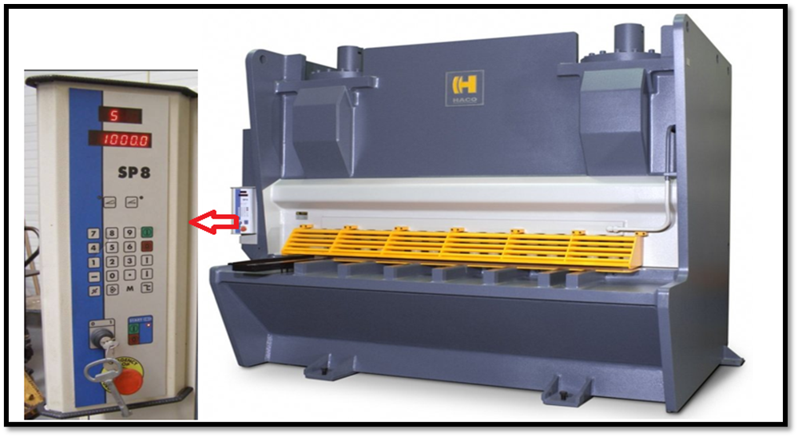
Figure 9: -control system component and control panel (Hydraulic Guillotine Shears., 2018).

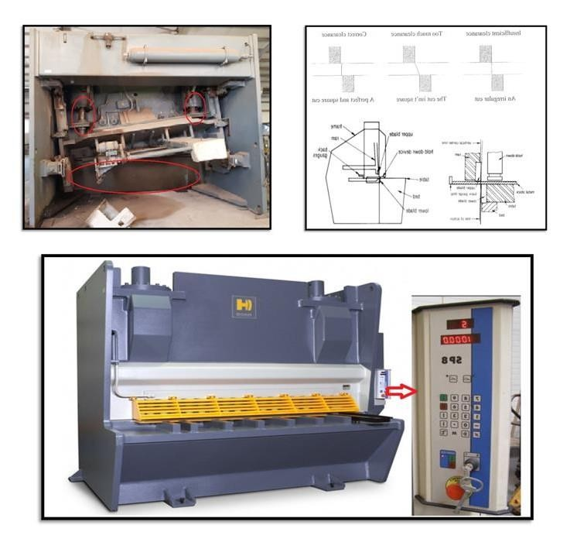
Figure 10: -hydraulic components.
The photo in the Figure 6 shown the hydraulic effected by errors of thickness data.
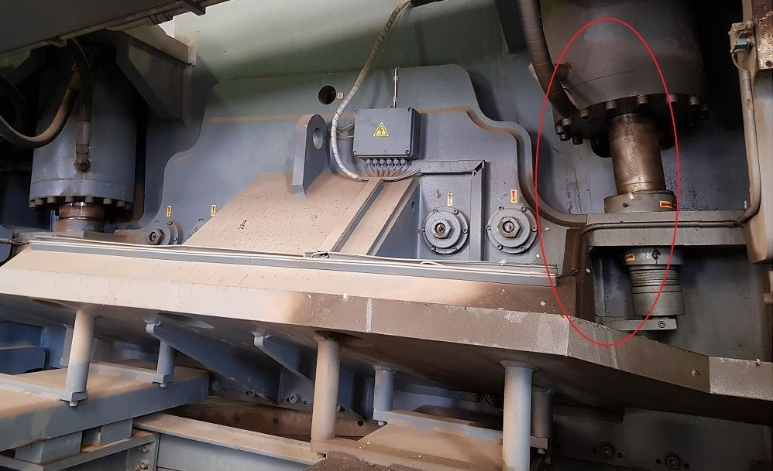

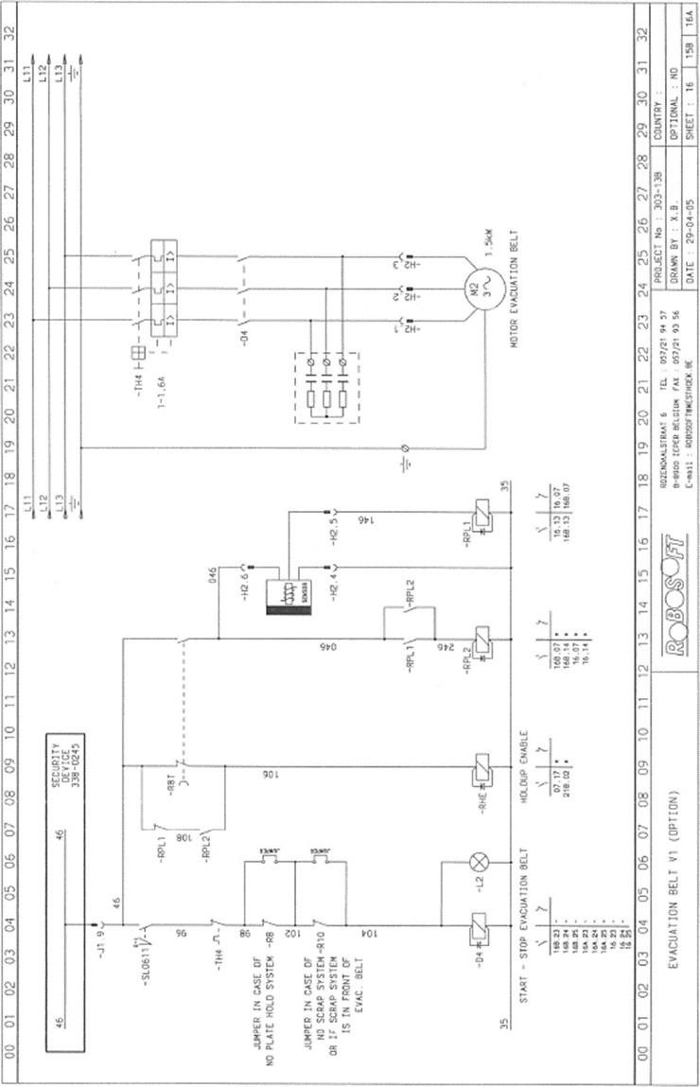
Figure 11: - diagram and drawing of control panel (Hydraulic Guillotine Shears., 2018) (HACO (PS 2532), 2008).

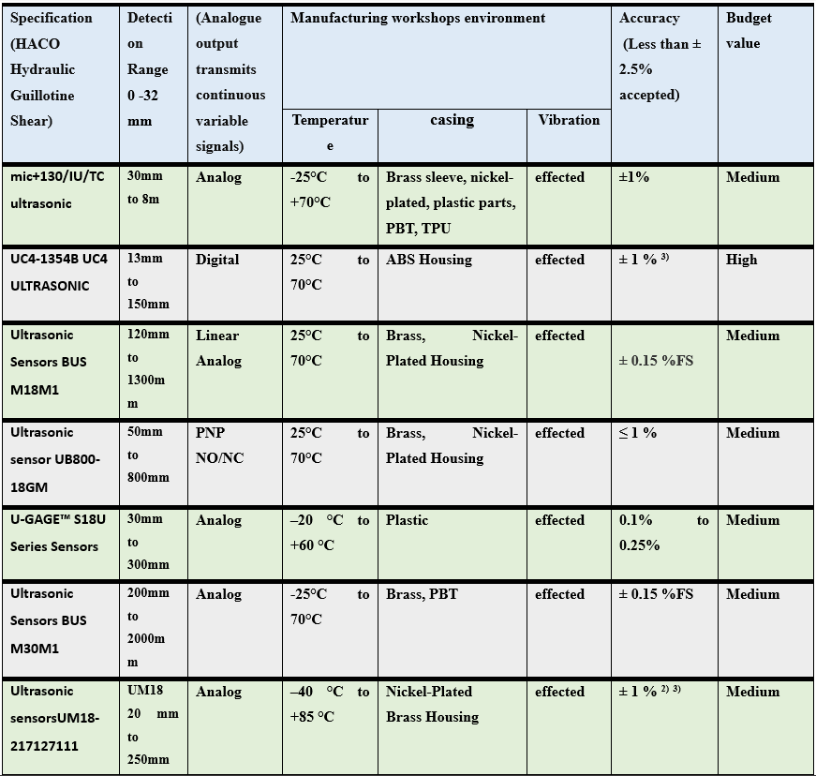
Figure 12: -Comparing between familiar ultrasonic sensor.

Table 3: - Programming control comparison.

Software and Programming | PLC | Arduino | LabVIEW
Language | Structured Text, Function Block | C/C++ | G
 | Diagrams, Ladder Logic, etc.
Purpose | Industrial Automation | Making microcontrollers | Graphical system design and
 | Programmable Logic Controller | and prototypes of them | data gathering
Real-Time | Made to be controlled in real | Limited real-time skills | Real-time data collection
Capability | time |  | and control
Cost | Depending on the type and | Not too expensive, and | Commercial software with
 | brand of PLC | there is open source | various licensing options
 |  | choices
Connectivity | Offers many ways to talk to | Different communication | There are many ways to
 | each other (e.g., Ethernet, RS- | methods are supported. | meet (e.g., Ethernet, USB,
 | 232, Fieldbus) | (e.g., UART, I2C, SPI) | Serial)
Application | Automation in industry, | Sensors, actuators, and | Data gathering, testing, and
 | production methods, and large- | small-scale robotics are | measuring, and automation
 | scale control systems | used in projects. | in study and business
Community | Well-established community | Strong and active | Large group of users with
Support | with a lot of information about the industry | community with a lot of tools online | online help and forums
Ease of Use | Needs specialized skills and | Easy for beginners to use | Because it uses graphical
 | knowledge | and has a simple | code, there is a learning
 |  | programming setting. | curve.
Hardware | PLC needs hardware | Compatible with various | needs a computer with the
 |  | microcontrollers and | LabVIEW program
 |  | development boards

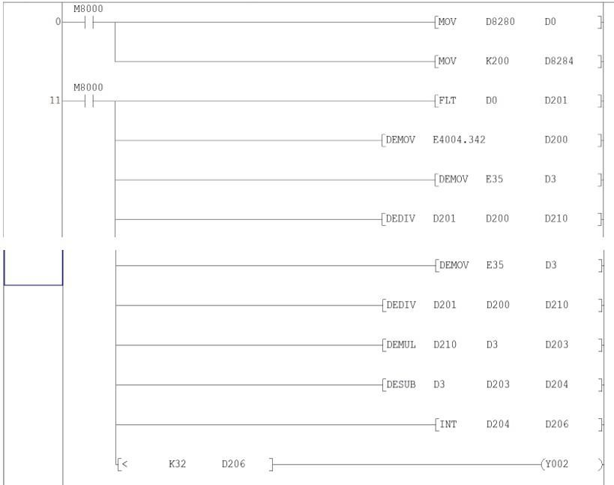
Figure 13: -Ladder diagram for the equation.

Group measurement 1

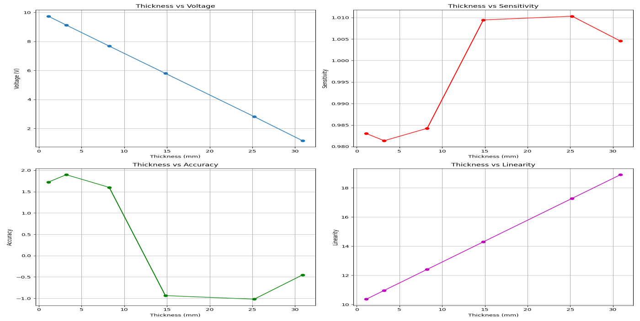
Figure 14: -Graphs for results of linearity, sensitivity, and accuracy to thickness measurements.

By the graves in figure 11 it could be resulted that the accuracy of this group measurements is high even in few points is little low, and it is more than an acceptable especially the linearity is perfect linearity range.
Group measurement 2

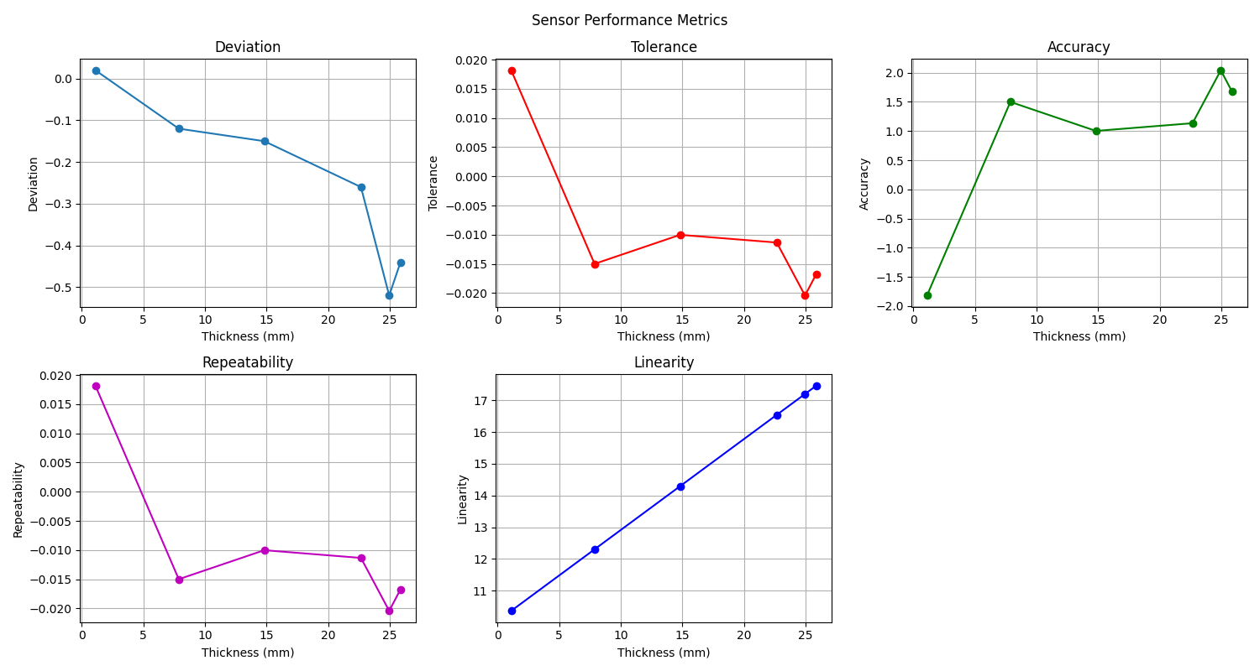
Figure 15: -Graphs for results of linearity, deviation, repeatability, tolerance, and accuracy to thickness measurements.
Figure 12shows that There is always a straight line between the voltage level and the thickness. But evaluations of accuracy show small differences from the standard thickness that are still within acceptable ranges. All these data show how accurate the added sensor system is. Capability studies show that the system is measuring every time and accurately. The traceability makes sure that things are in line with set standards, which makes them more reliable. Repeatability tests make sure that the same inputs lead to the same outputs, and tolerance tests make sure that changes stay within acceptable limits. The study shows that the system is linear, sensitive, repeatable, and traceable within acceptable levels of accuracy and error.

