Table 1：Variables after matching
Patient variables | nCT(n=131) | nCIT(n=131) | P-value
Age, years | 61.56±6.85 | 62.40±6.33 | 0.330
Sex
Male | 108 | 110 | 0.869
Female | 23 | 21 | 0.869
BMI, kg/m2 | 21.95±3.30 | 22.11±3.12 | 0.823
Tumor location
Upper-thoracic | 20 | 22 | 0.824
Middle-thoracic | 69 | 64 | 0.824
Lower-thoracic | 42 | 45 | 0.824
Clinical T stage
T1 | 7 | 2 | 0.176
T2 | 24 | 22 | 0.176
T3 | 88 | 100 | 0.176
T4 | 12 | 7 | 0.176
Clinical N stage
N0 | 18 | 18 | 0.877
N1 | 61 | 56 | 0.877
N2 | 47 | 53 | 0.877
N3 | 5 | 4 | 0.877
Clinical TNM stage
II | 18 | 18 | 0.874
III | 104 | 106 | 0.874
IVA | 9 | 7 | 0.874
Chemotherapy regimen
TP | 69 | 63 | 0.537
AP | 62 | 68 | 0.537
Neoadjuvant cycle
1 | 12 | 10 | 0.733
2 | 102 | 100 | 0.733
≥3 | 17 | 21 | 0.733
BMI, body mass index; nCT, neoadjuvant chemotherapy; ICIs, immune checkpoint inhibitors

Table 2. DFS in key patient subgroups after matching.
Subgroup | 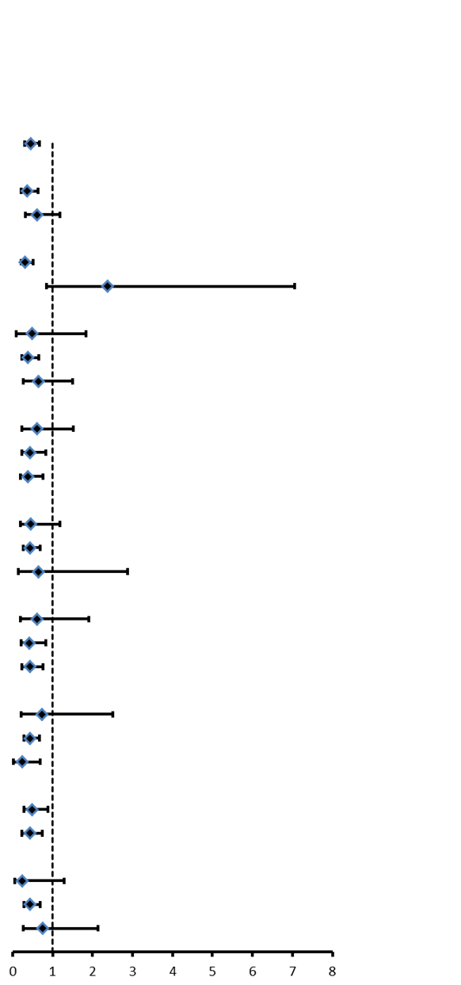  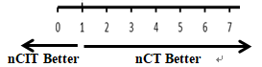  No.Events/No.Patients |  |  | Hazard ratio(95%CI)
Overall | 93/262 |  |  | 0.45(0.30-0.68)
Age
<65y | 56/161 |  |  | 0.36(0.22-0.63)
≥65y | 37/101 |  |  | 0.62(0.32-1.18)
Sex
Male | 79/218 |  |  | 0.31(0.21-0.51)
Female | 14/44 |  |  | 2.37(0.85-7.06)
BMI, kg/m2
<18.5 | 9/22 |  |  | 0.49(0.10-1.83)
18.5-24 | 63/177 |  |  | 0.38(0.24-0.65)
≥24 | 21/63 |  |  | 0.64(0.27-1.50)
Location
Upper-thoracic | 18/42 |  |  | 0.62(0.24-1.52)
Middle-thoracic | 40/133 |  |  | 0.44(0.24-0.84)
Lower-thoracic | 35/87 |  |  | 0.39(0.20-0.76)
Clinical T stage
T1/T2 | 18/55 |  |  | 0.45(0.19-1.18)
T3 | 68/188 |  |  | 0.44(0.27-0.70)
T4 | 7/19 |  |  | 0.64(0.14-2.87)
Clinical N stage
N0 | 12/36 |  |  | 0.61(0.19-1.90)
N1 | 34/117 |  |  | 0.42(0.22-0.84)
N2/N3 | 47/109 |  |  | 0.44(0.24-0.77)
Clinical TNM stage
II | 10/36 |  |  | 0.73(0.21-2.50)
III | 76/210 |  |  | 0.43(0.28-0.68)
IVA | 7/16 |  |  | 0.25(0.03-0.69)
Chemotherapy regimen
TP | 48/132 |  |  | 0.49(0.28-0.89)
AP | 45/130 |  |  | 0.43(0.23-0.75)
Neoadjuvant cycle
1 | 7/22 |  |  | 0.24(0.06-1.29)
2 | 72/202 |  |  | 0.43(0.28-0.70)
≥3 | 14/38 |  |  | 0.75(0.26-2.13)

Table 3：OS in key patient subgroups after matching.
Subgroup | 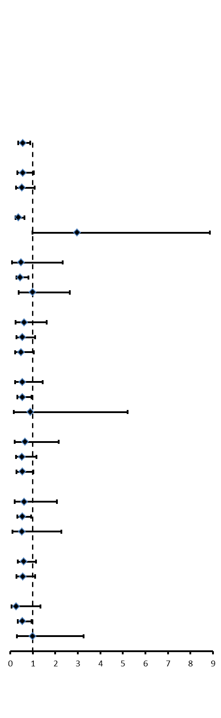  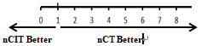  No.Events/No.Patients |  |  | Hazard ratio(95%CI)
Overall | 73/262 |  |  | 056(0.35-0.89)
Age
<65y | 43/161 |  |  | 0.57(0.31-1.04)
≥65y | 30/101 |  |  | 0.53(0.26-1.08)
Sex
Male | 60/218 |  |  | 0.37(0.23-0.64)
Female | 13/44 |  |  | 2.97(0.99-8.87)
BMI, kg/m2
<18.5 | 7/22 |  |  | 0.49(0.08-2.32)
18.5-24 | 50/177 |  |  | 0.45(0.27-0.81)
≥24 | 16/63 |  |  | 0.99(0.37-2.65)
Location
Upper-thoracic | 17/42 |  |  | 0.63(0.24-1.61)
Middle-thoracic | 31/133 |  |  | 0.54(0.27-1.11)
Lower-thoracic | 25/87 |  |  | 0.48(0.22-1.04)
Clinical T stage
T1/T2 | 17/55 |  |  | 0.54(0.21-1.44)
T3 | 51/188 |  |  | 0.54(0.31-0.94)
T4 | 5/19 |  |  | 0.89(0.15-5.22)
Clinical N stage
N0 | 11/36 |  |  | 0.66(0.20-2.15)
N1 | 26/117 |  |  | 0.53(0.25-1.17)
N2/N3 | 36/109 |  |  | 0.54(0.28-1.03)
Clinical TNM stage
II | 11/36 |  |  | 0.63(0.19-2.07)
III | 56/210 |  |  | 0.54(0.32-0.92)
IVA | 6/16 |  |  | 0.53(0.09-2.26)
Chemotherapy regimen
TP | 40/132 |  |  | 0.61(0.33-1.15)
AP | 33/130 |  |  | 0.56(0.28-1.10)
Neoadjuvant cycle
1 | 7/22 |  |  | 0.26(0.06-1.34)
2 | 45/202 |  |  | 0.55(0.33-0.94)
≥3 | 11/38 |  |  | 0.99(0.30-3.25)

