Supporting Information

Precise Generation of Conformational Ensembles for Intrinsically Disordered Proteins via Fine-tuned Diffusion Models
Junjie Zhu^{1,#}, Zhengxin Li^{1,#}, Zhuoqi Zheng¹, Bo Zhang¹, Bozitao Zhong¹, Jie Bai¹, Taifeng Wang^{2,*}, Ting Wei^{1,*}, Jianyi Yang^{3,*}, Hai-Feng Chen^{1,*}
¹State Key Laboratory of Microbial Metabolism, Department of Bioinformatics and Biostatistics, SJTU-Yale Joint Center for Biostatistics, National Experimental Teaching Center for Life Sciences and Biotechnology, School of Life Sciences and Biotechnology, Shanghai Jiao Tong University, 200240, Shanghai, China.
²BioMap,10 Beilun Industrial Park, Yongteng North Road, 100080, Beijing, China.
³MOE Frontiers Science Center for Nonlinear Expectations, Research Center for Mathematics and Interdisciplinary Sciences, Shandong University, 266237, Qingdao, China.

*Corresponding Author
Email: haifengchen@sjtu.edu.cn; yangjy@sdu.edu.cn; weitinging@sjtu.edu.cn; taifeng@biomap.com

Notes
The authors declare that there is no conflict of interest.

Author Contributions
#These authors contributed equally to this work.

Table S1. IDP systems in test set, $R_{g}^{exp}$ and experimental chemical shifts. Abbreviated forms of long system names are marked in bold.
System | $$R_{g}^{exp}$$ | Chemical Shift
Sic1 | 34.7¹ | $C_{α}$ chemical shifts¹
Aβ 42 | 12.4² | $C_{α}$ chemical shifts³
Aβ 40 | 12⁴ | $C_{α}$ chemical shifts³
RS1 | 12.62⁵ | $C_{α}$ chemical shifts⁶
Histatin5 | 13.8⁷ | N/A
p15^{PAF} | 28.1⁸ | $C_{α}$ chemical shifts⁸
FEZ1 monomer | 36⁹ | N/A
HIV-1 Tat₁₃₃ | 33¹⁰ | N/A
R17 | 22.9¹¹ | N/A
PIR domain | 26.5¹² | N/A
IB5 | 27.9¹³ | N/A
PaaA2 | 22.4¹⁴ | $C_{α}$ chemical shifts¹⁴
ACTR | 25¹⁵ | $C_{α}$ chemical shifts¹⁶
drkN SH3 | 16.7¹⁷ | $C_{α}$ chemical shifts¹⁸
Juxtanodin | 55.9¹⁹ | N/A
α Synuclein | 33²⁰ | $C_{α}$ chemical shifts²¹
β Synuclein | 49²² | N/A
γ Synuclein | 61²² | N/A
Tau K18 | 38²³ | N/A
Tau K19 | 35²³ | N/A
Prothymosin α | 37.8²⁴ | N/A
p53 (1-93) [p53] | 28.7²⁵ | $C_{α}$ chemical shifts²⁵
Human NCBD domain [NCBD] | 33²⁶ | N/A
Human Calpastatin (137-237) [Calpastatin] | 39²⁶ | N/A
N-term NRG1 type III [NtermNRG1] | 26.8²⁷ | N/A
N-term VS Virus phosphoprotein  [NtermVS] | 26²⁸ | N/A
E3 ubiquitin ligase RNF4 (32-82)  [RNF4] | 25.8²⁹ | N/A

Table S2. Performance of all 8 versions of AlphaFlow.
Methods | Validity (↑) | Fidelity
 |  | $$ε_{Rg}$$ | ${MAE}_{δC_{α}}$ (↓)
AF-PDB-base | 0.97 | $$-0.24$$ | 0.54
AF-PDB-distilled | 0.91 | $$-0.33$$ | 0.78
AF-MD-base | 0.94 | $$-0.32$$ | 0.54
AF-MD-distilled | 0.91 | $$-0.44$$ | 0.66
ESM-PDB-base | 0.94 | $$-0.24$$ | 0.64
ESM-PDB-distilled | 0.89 | $$-0.33$$ | 0.77
ESM-MD-base | 0.96 | $$-0.35$$ | 0.62
ESM-MD-distilled | 0.90 | $$-0.47$$ | 0.68

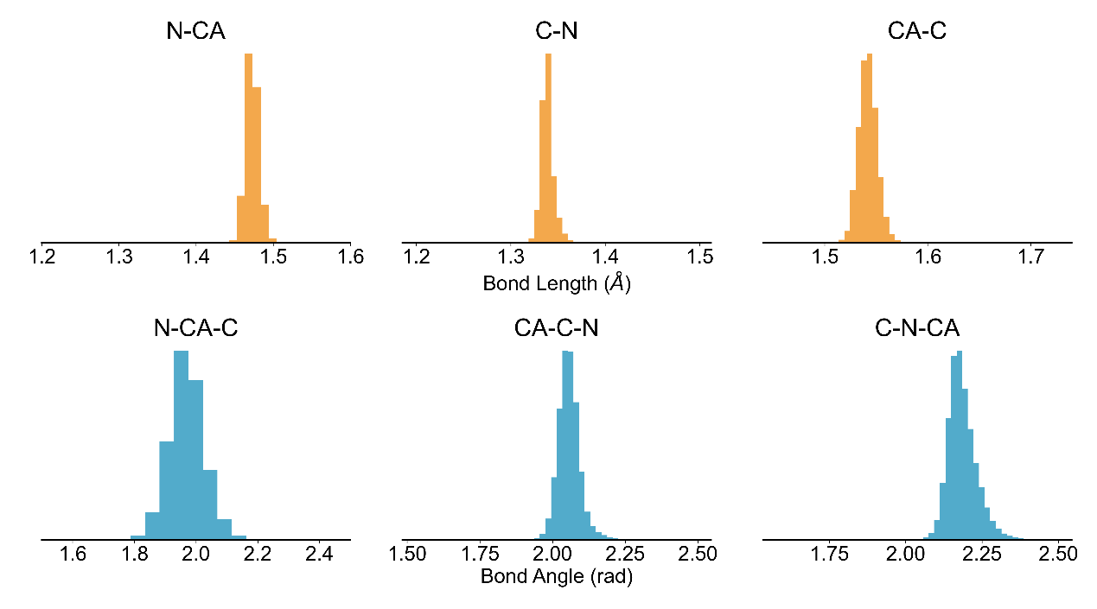
Figure S1. The bond lengths and angles of IDPFold generated conformations.

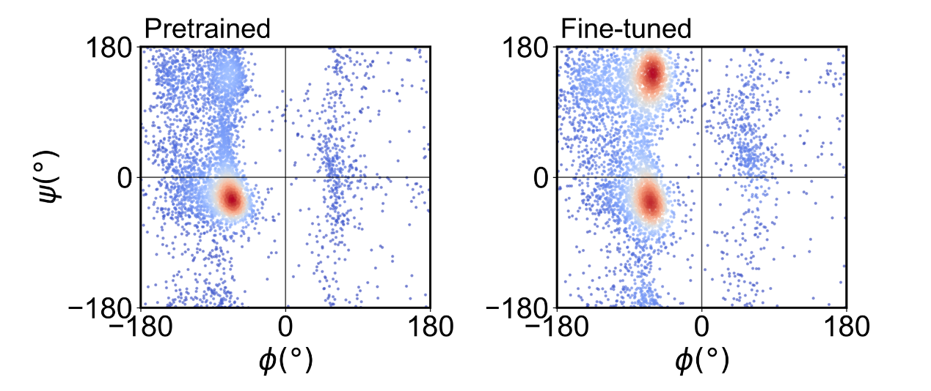
Figure S2. The Ramachandran plots of pretrained and fine-tuned IDPFold.

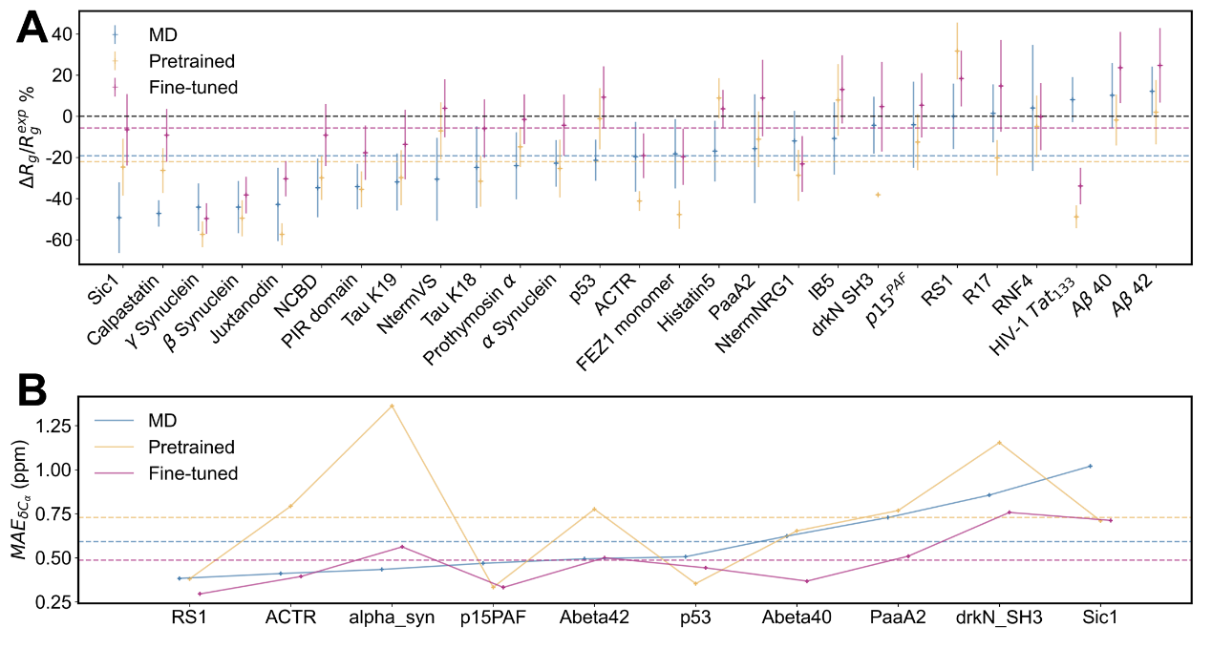
Figure S3. Differences between generated conformational ensembles and experimental observations. (A) Average Rg errors and their standard deviation on all 27 IDPs. (B) Mean average error on ensemble average $C_{α}$ chemical shift on all 10 IDPs.

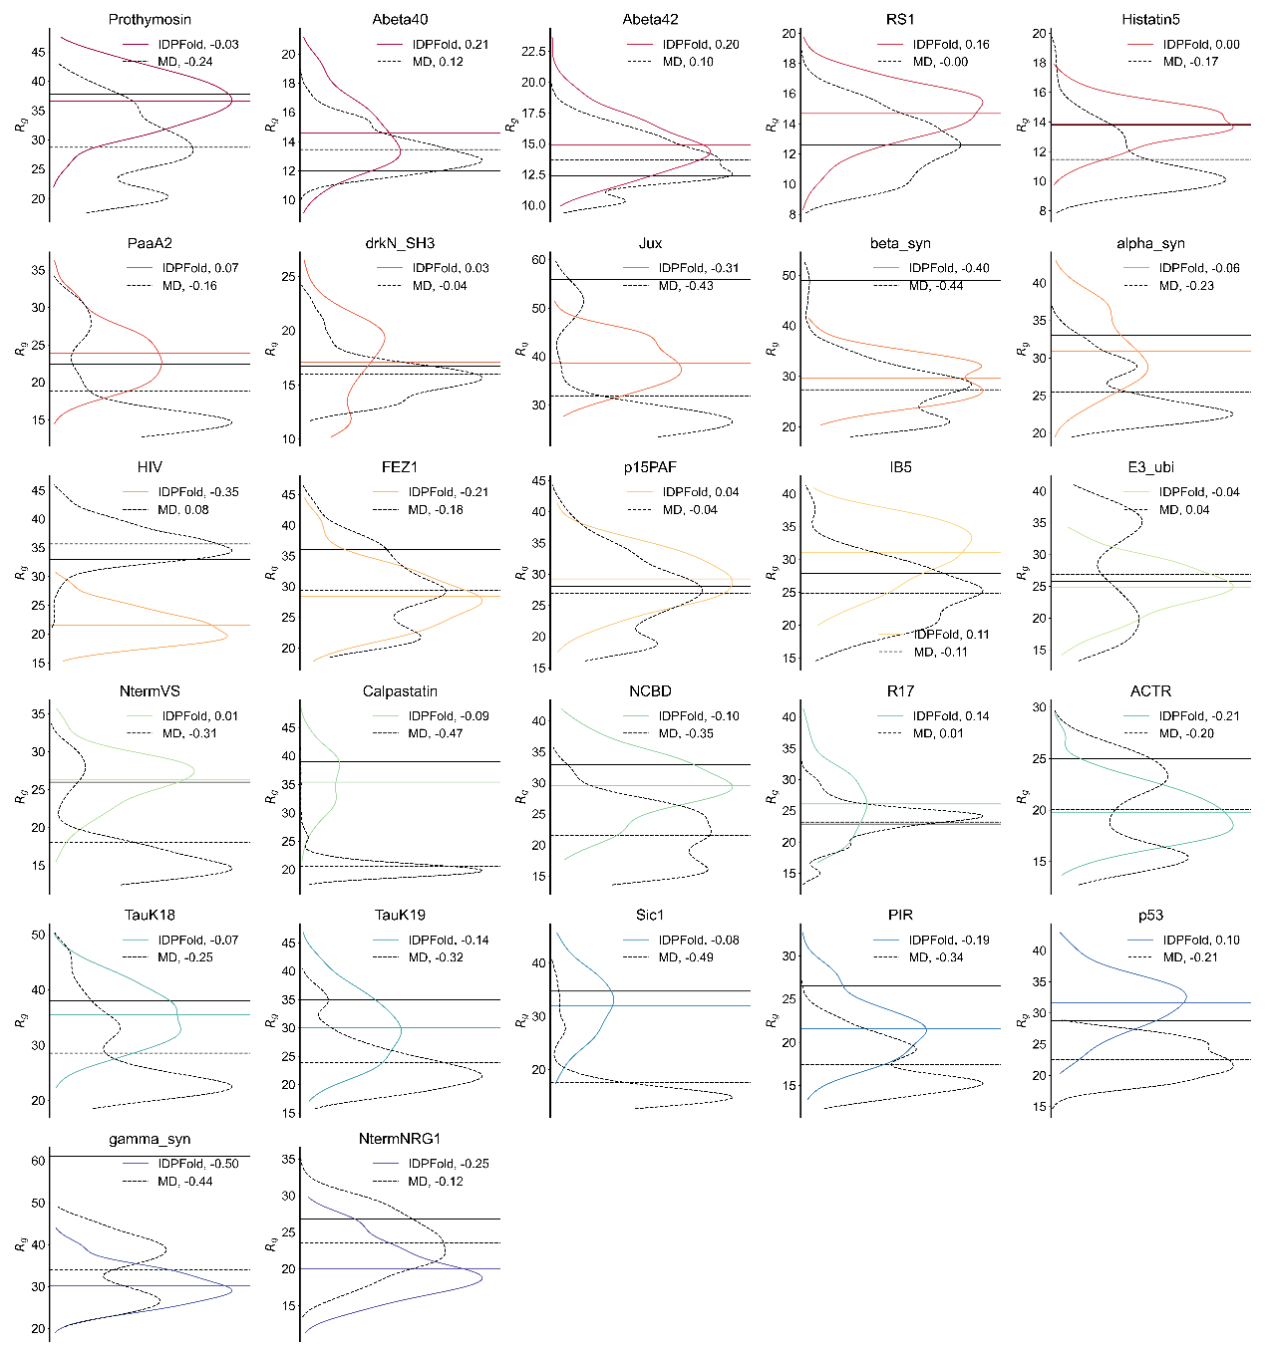
Figure S4. Rg distribution of IDPFold generated conformation ensembles (colored) and MD trajectories (black dashed) on 27 IDP systems. Experimental Rg values are plotted as black solid lines.

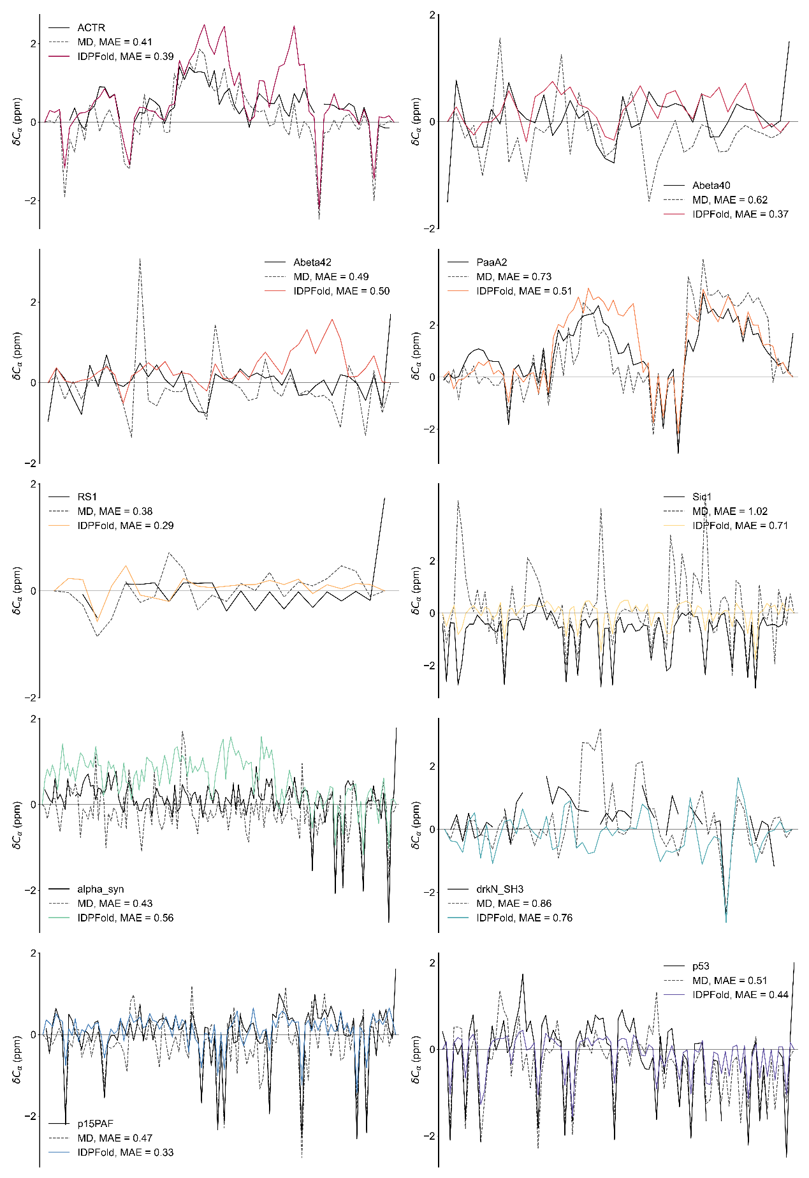
Figure S5. Ensemble average $C_{α}$ chemical shifts of IDPFold generated conformation ensembles (colored) and MD trajectories (black dashed) on 27 IDP systems. Experimental values are plotted as black solid lines.
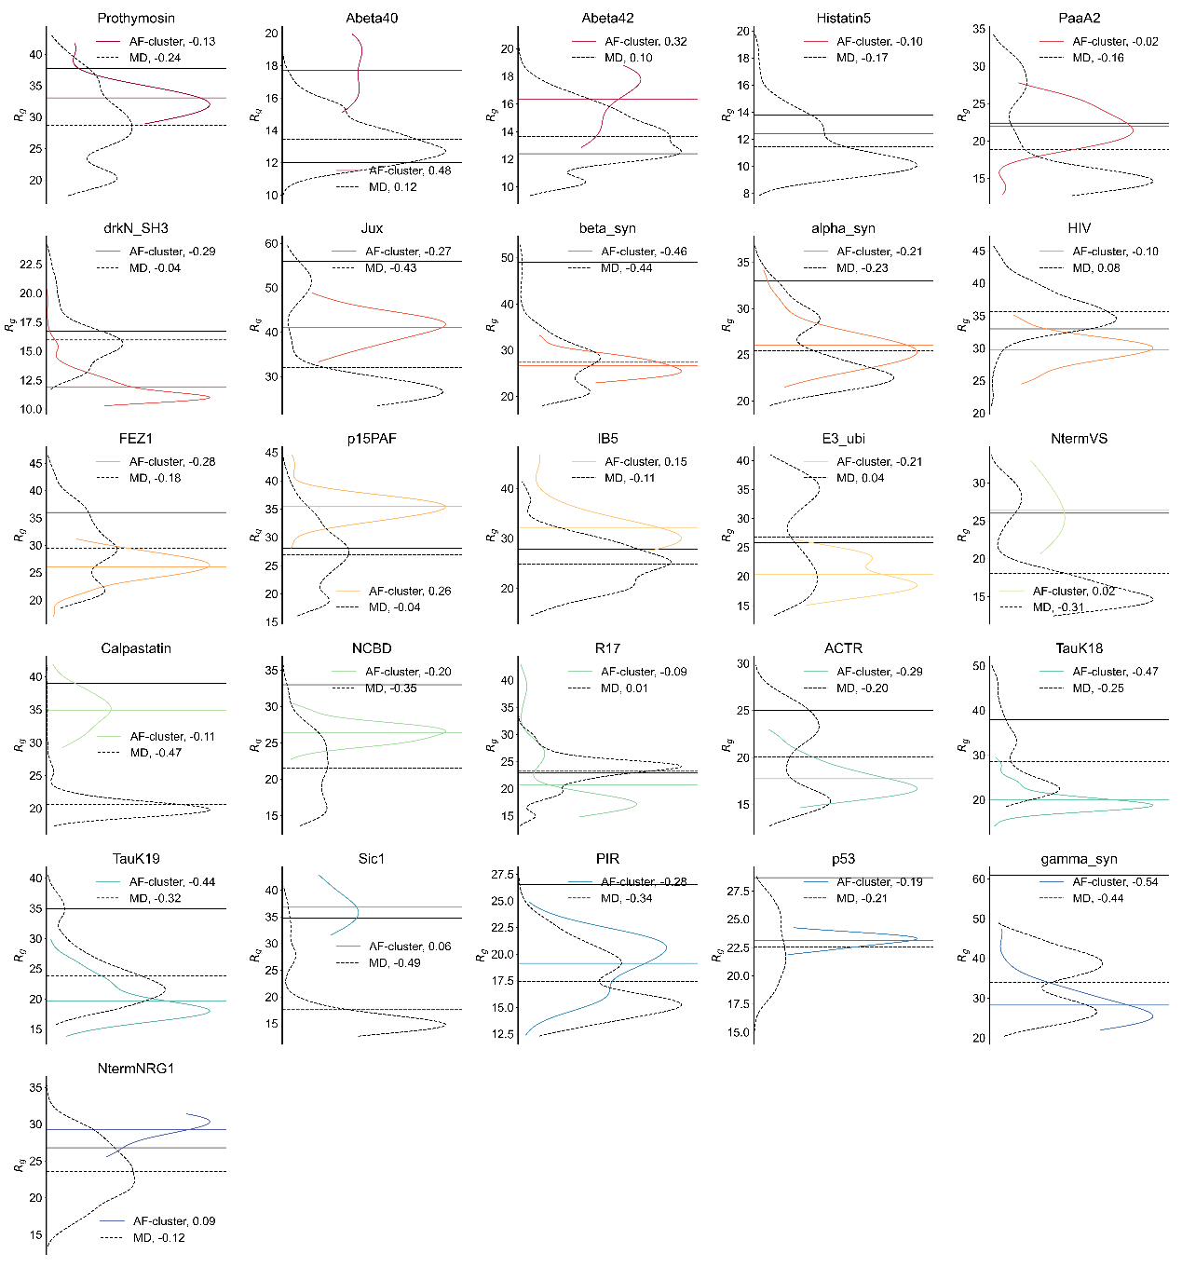
Figure S6. Rg distribution of AF-cluster generated conformation ensembles (colored) on 27 IDP systems. Experimental Rg values are plotted as black solid lines.

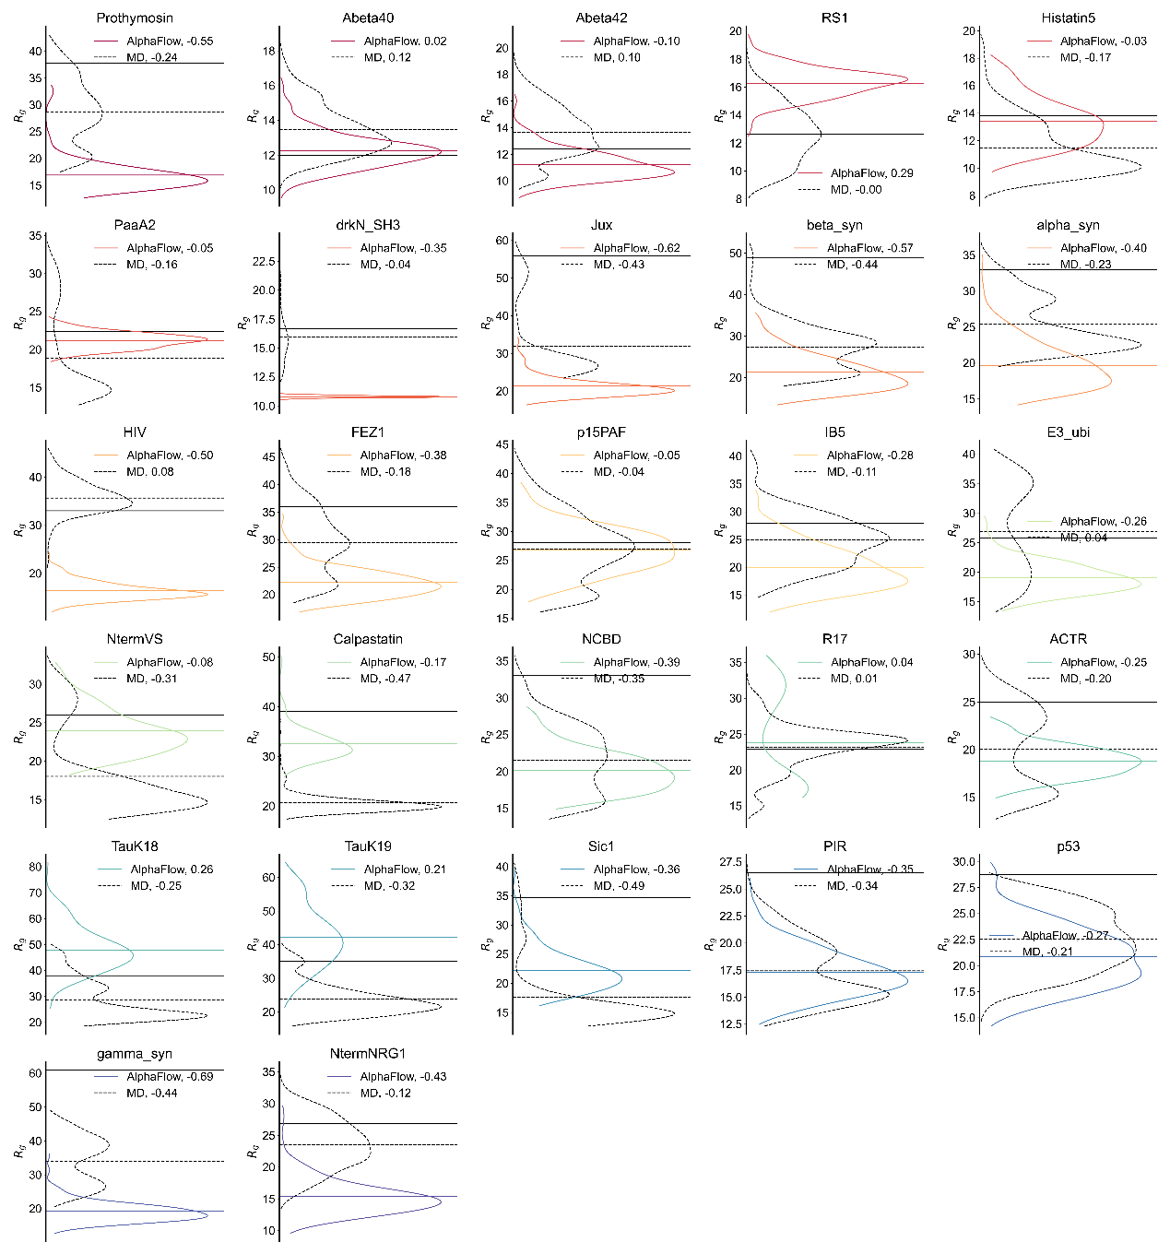
Figure S7. Rg distribution of AlphaFlow (PDB-base) generated conformation ensembles (colored) on 27 IDP systems. Experimental Rg values are plotted as black solid lines.

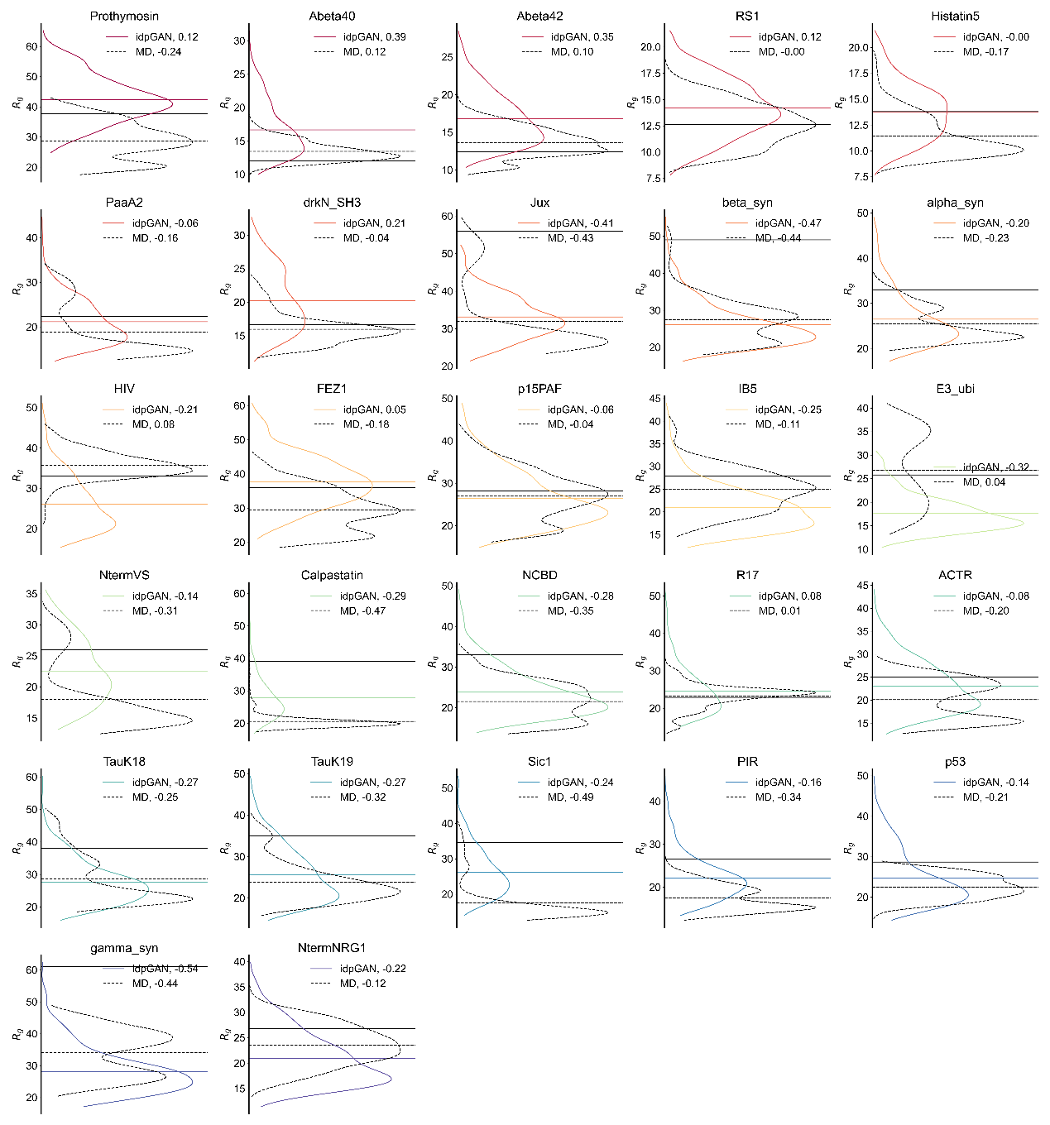
Figure S8. Rg distribution of idpGAN generated conformation ensembles (colored) on 27 IDP systems. Experimental Rg values are plotted as black solid lines.

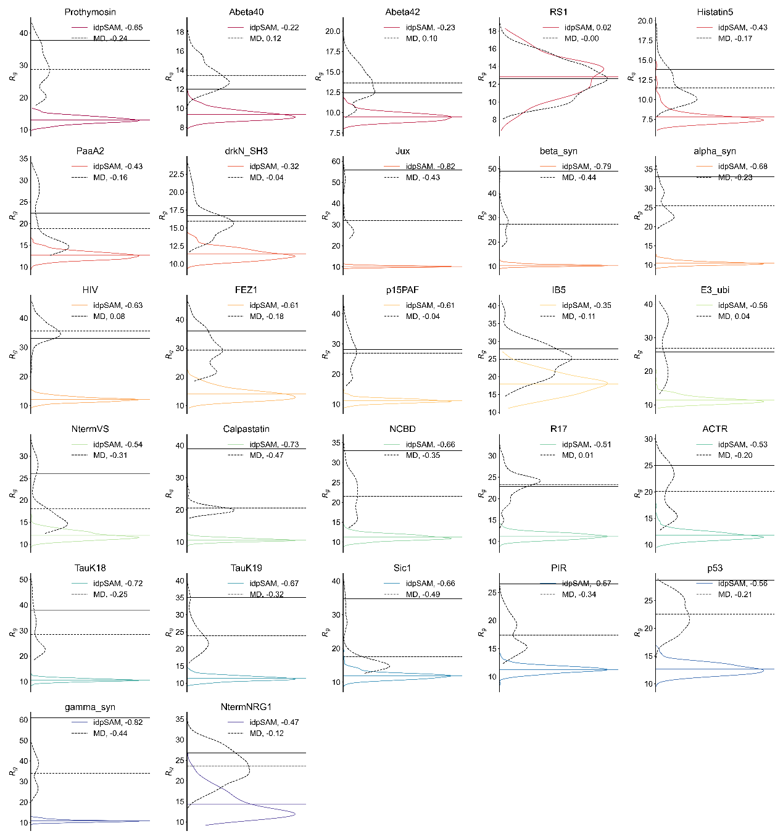
Figure S9. Rg distribution of idpSAM generated conformation ensembles (colored) on 27 IDP systems. Experimental Rg values are plotted as black solid lines.

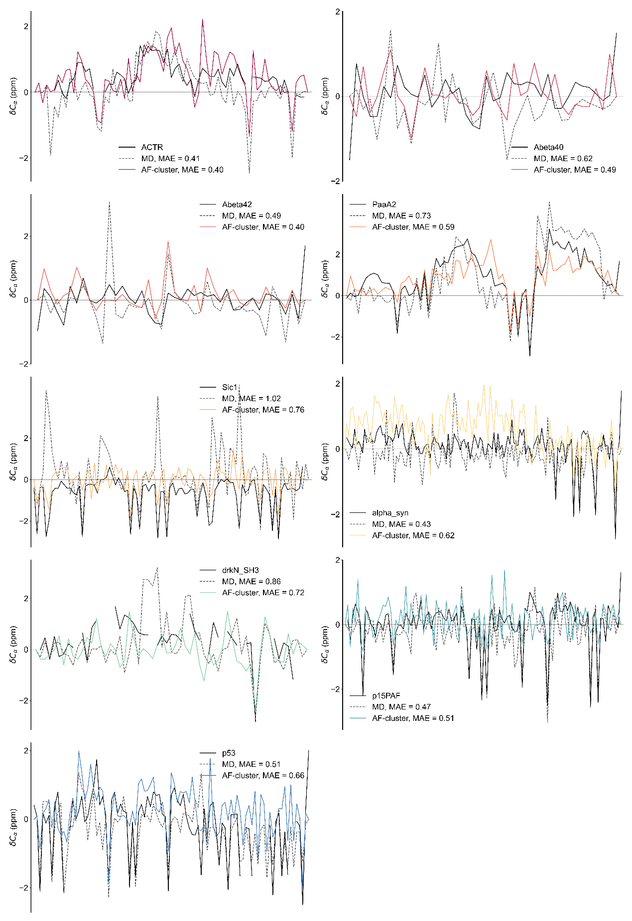
Figure S10. Ensemble average $C_{α}$ chemical shifts of AF-cluster generated conformation ensembles (colored) on 27 IDP systems. Experimental values are plotted as black solid lines.

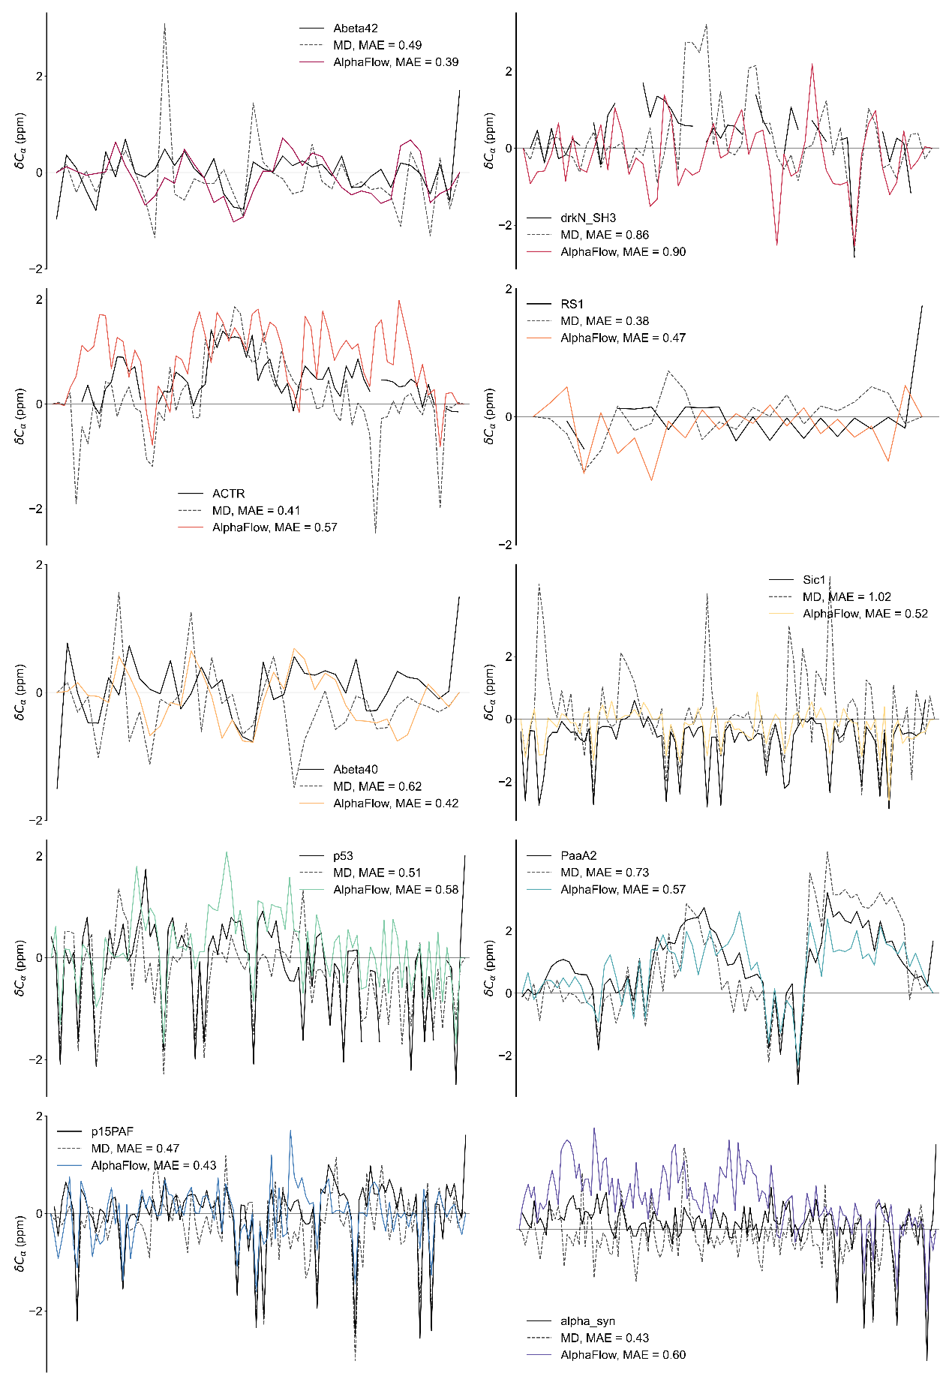
Figure S11. Ensemble average $C_{α}$ chemical shifts of AlphaFlow (PDB-base) generated conformation ensembles (colored) on 27 IDP systems. Experimental values are plotted as black solid lines.

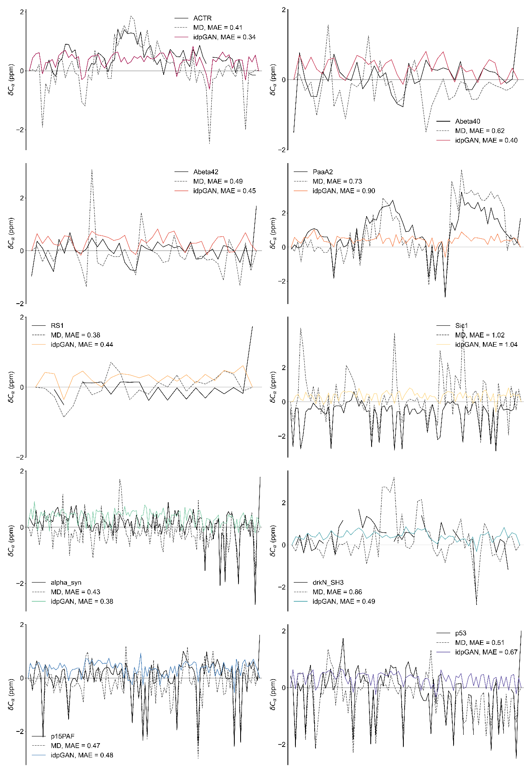
Figure S12. Ensemble average $C_{α}$ chemical shifts of idpGAN generated conformation ensembles (colored) on 27 IDP systems. Experimental values are plotted as black solid lines.

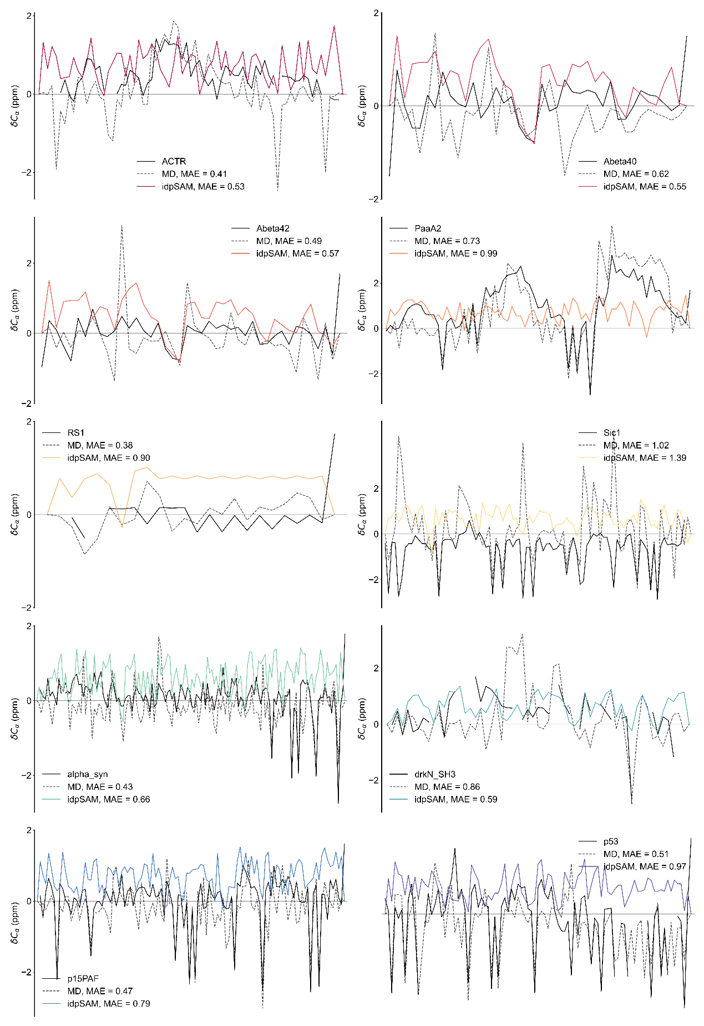
Figure S13. Ensemble average $C_{α}$ chemical shifts of idpSAM generated conformation ensembles (colored) on 27 IDP systems. Experimental values are plotted as black solid lines.

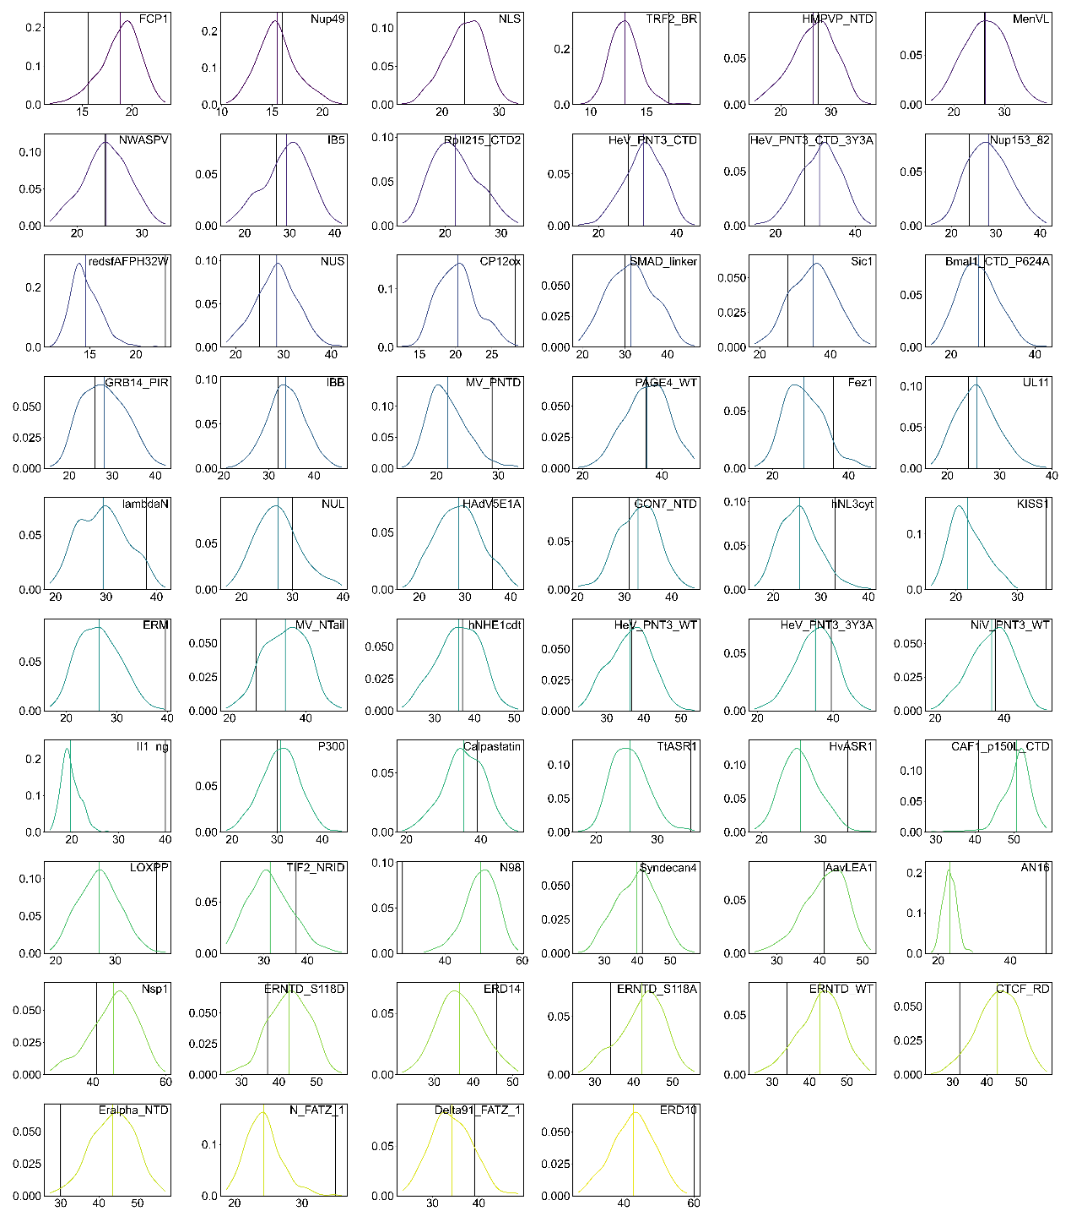
Figure S14. Rg distribution of IDPFold generated conformation ensembles (colored) on 58 IDP systems from IDRome. Experimental Rg values are plotted as black solid lines.

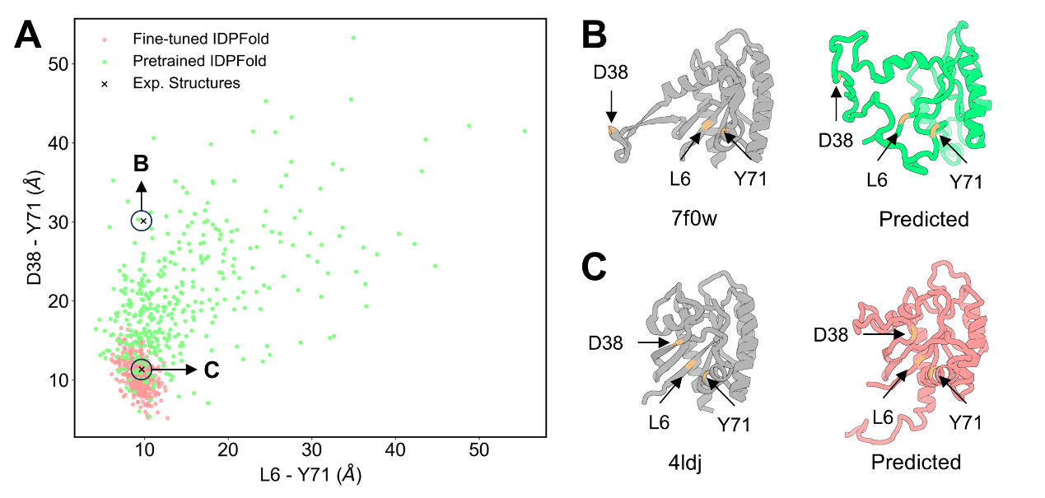
Figure S15. IDPFold generates a wide range of conformations for allosteric proteins. (A) IDPFold generated conformations mapped on L6-Y71-D38 distance plane. (B) Fine-tuned IDPFold generated conformation compared to X-ray structure (PDB ID: 7f0w). (C) Pretrained IDPFold generated conformation compared to X-ray structure (PDB ID: 4ldj)³⁰.

References
1. Mittag, T. et al. Structure/Function Implications in a Dynamic Complex of the Intrinsically Disordered Sic1 with the Cdc4 Subunit of an SCF Ubiquitin Ligase. Structure 18, 494–506 (2010).
2. Granata, D. et al. The inverted free energy landscape of an intrinsically disordered peptide by simulations and experiments. Sci. Rep. 5, 15449 (2015).
3. Hou, L. et al. Solution NMR Studies of the Aβ(1−40) and Aβ(1−42) Peptides Establish that the Met35 Oxidation State Affects the Mechanism of Amyloid Formation. J. Am. Chem. Soc. 126, 1992–2005 (2004).
4. Ball, K. A. et al. Homogeneous and Heterogeneous Tertiary Structure Ensembles of Amyloid-β Peptides. Biochemistry 50, 7612–7628 (2011).
5. Rauscher, S. et al. Structural Ensembles of Intrinsically Disordered Proteins Depend Strongly on Force Field: A Comparison to Experiment. J. Chem. Theory Comput. 11, 5513–5524 (2015).
6. Xiang, S. et al. Phosphorylation Drives a Dynamic Switch in Serine/Arginine-Rich Proteins. Structure 21, 2162–2174 (2013).
7. Cragnell, C., Durand, D., Cabane, B. & Skepö, M. Coarse-grained modeling of the intrinsically disordered protein Histatin 5 in solution: Monte Carlo simulations in combination with SAXS. Proteins Struct. Funct. Bioinforma. 84, 777–791 (2016).
8. De Biasio, A. et al. p15PAF Is an Intrinsically Disordered Protein with Nonrandom Structural Preferences at Sites of Interaction with Other Proteins. Biophys. J. 106, 865–874 (2014).
9. Alborghetti, M. R. et al. Human FEZ1 Protein Forms a Disulfide Bond Mediated Dimer: Implications for Cargo Transport. J. Proteome Res. 9, 4595–4603 (2010).
10. Foucault, M. et al. UV and X-ray structural studies of a 101-residue long Tat protein from a HIV-1 primary isolate and of its mutated, detoxified, vaccine candidate. Proteins Struct. Funct. Bioinforma. 78, 1441–1456 (2010).
11. Hofmann, H. et al. Polymer scaling laws of unfolded and intrinsically disordered proteins quantified with single-molecule spectroscopy. Proc. Natl. Acad. Sci. 109, 16155–16160 (2012).
12. Moncoq, K. et al. SAXS Study of the PIR Domain from the Grb14 Molecular Adaptor: A Natively Unfolded Protein with a Transient Structure Primer? Biophys. J. 87, 4056–4064 (2004).
13. Boze, H. et al. Proline-Rich Salivary Proteins Have Extended Conformations. Biophys. J. 99, 656–665 (2010).
14. Sterckx, Y. G. J. et al. Small-Angle X-Ray Scattering- and Nuclear Magnetic Resonance-Derived Conformational Ensemble of the Highly Flexible Antitoxin PaaA2. Structure 22, 854–865 (2014).
15. Kjaergaard, M. et al. Temperature-dependent structural changes in intrinsically disordered proteins: Formation of α‒helices or loss of polyproline II? Protein Sci. 19, 1555–1564 (2010).
16. Iešmantavičius, V. et al. Modulation of the Intrinsic Helix Propensity of an Intrinsically Disordered Protein Reveals Long-Range Helix–Helix Interactions. J. Am. Chem. Soc. 135, 10155–10163 (2013).
17. Choy, W.-Y. et al. Distribution of molecular size within an unfolded state ensemble using small-angle X-ray scattering and pulse field gradient NMR techniques1. J. Mol. Biol. 316, 101–112 (2002).
18. Lee, J. H. et al. Heterogeneous binding of the SH3 client protein to the DnaK molecular chaperone. Proc. Natl. Acad. Sci. 112, E4206–E4215 (2015).
19. Ruskamo, S. et al. Juxtanodin is an intrinsically disordered F-actin-binding protein. Sci. Rep. 2, 899 (2012).
20. Morar, A. S., Olteanu, A., Young, G. B. & Pielak, G. J. Solvent-induced collapse of α-synuclein and acid-denatured cytochrome c. Protein Sci. 10, 2195–2199 (2001).
21. Ebert, M.-O., Bae, S.-H., Dyson, H. J. & Wright, P. E. NMR Relaxation Study of the Complex Formed Between CBP and the Activation Domain of the Nuclear Hormone Receptor Coactivator ACTR†. Biochemistry 47, 1299–1308 (2008).
22. Uversky, V. N. et al. Biophysical Properties of the Synucleins and Their Propensities to Fibrillate: INHIBITION OF α-SYNUCLEIN ASSEMBLY BY β- AND γ-SYNUCLEINS*. J. Biol. Chem. 277, 11970–11978 (2002).
23. Mylonas, E. et al. Domain Conformation of Tau Protein Studied by Solution Small-Angle X-ray Scattering. Biochemistry 47, 10345–10353 (2008).
24. Uversky, V. N. et al. Natively Unfolded Human Prothymosin α Adopts Partially Folded Collapsed Conformation at Acidic pH. Biochemistry 38, 15009–15016 (1999).
25. Wells, M. et al. Structure of tumor suppressor p53 and its intrinsically disordered N-terminal transactivation domain. Proc. Natl. Acad. Sci. 105, 5762–5767 (2008).
26. Borysik, A. J., Kovacs, D., Guharoy, M. & Tompa, P. Ensemble Methods Enable a New Definition for the Solution to Gas-Phase Transfer of Intrinsically Disordered Proteins. J. Am. Chem. Soc. 137, 13807–13817 (2015).
27. Chukhlieb, M., Raasakka, A., Ruskamo, S. & Kursula, P. The N-terminal cytoplasmic domain of neuregulin 1 type III is intrinsically disordered. Amino Acids 47, 1567–1577 (2015).
28. Leyrat, C. et al. The N0-binding region of the vesicular stomatitis virus phosphoprotein is globally disordered but contains transient α-helices. Protein Sci. 20, 542–556 (2011).
29. Kung, C. C.-H. et al. Structural analysis of poly-SUMO chain recognition by the RNF4-SIMs domain. Biochem. J. 462, 53–65 (2014).
30. Hunter, J. C. et al. In situ selectivity profiling and crystal structure of SML-8-73-1, an active site inhibitor of oncogenic K-Ras G12C. Proc. Natl. Acad. Sci. U. S. A. 111, 8895–8900 (2014).

