Supplementary Information
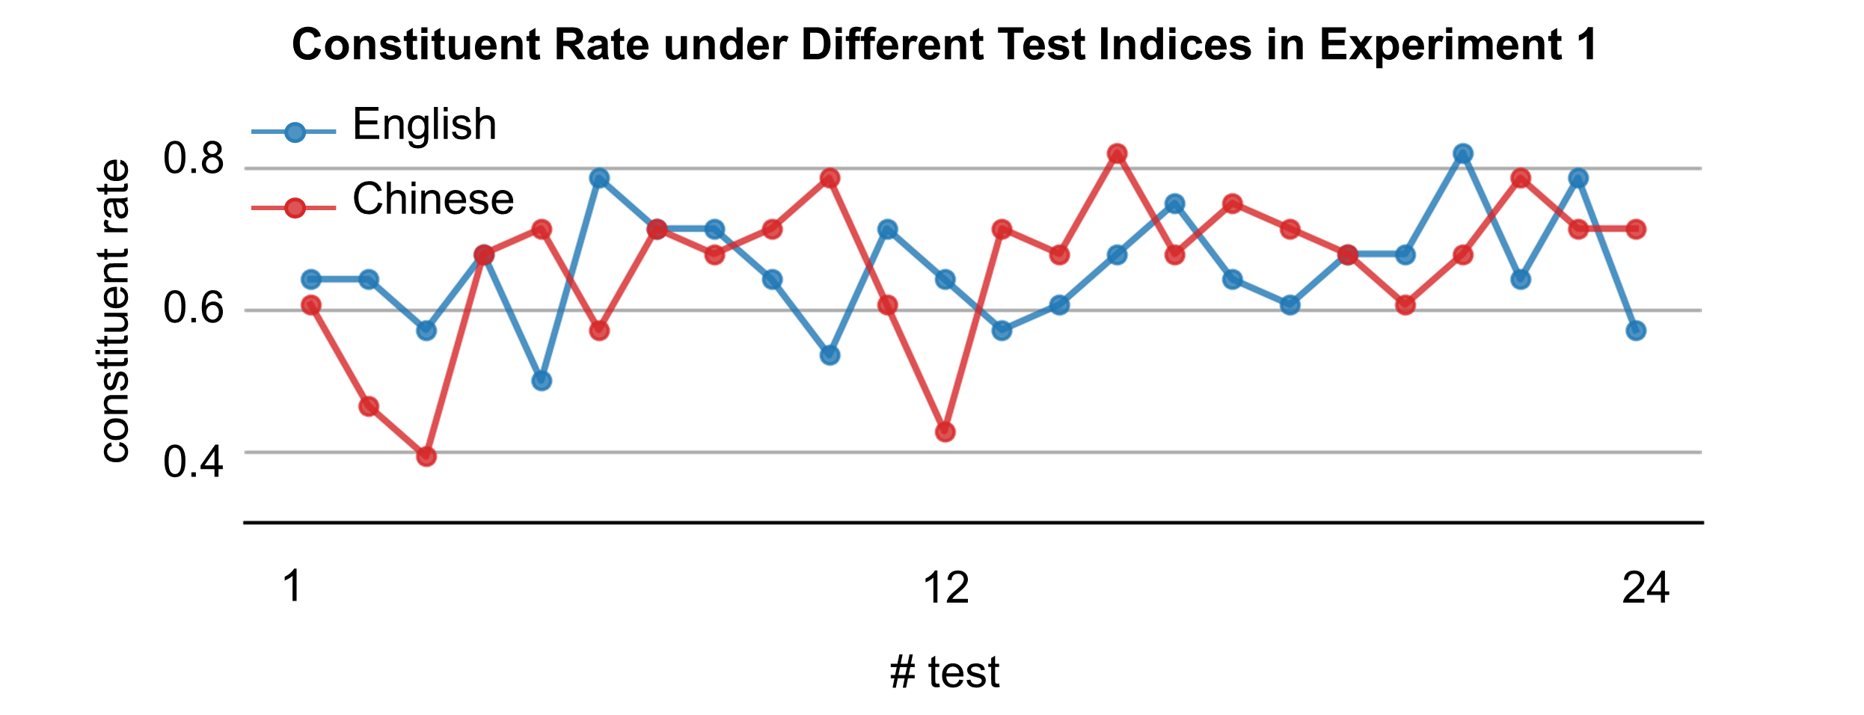
Figure S1. Constituent rate of human participants in each of the 24 tests in Experiment 1. The constituent rate does not significantly change across tests, suggesting no learning effect.

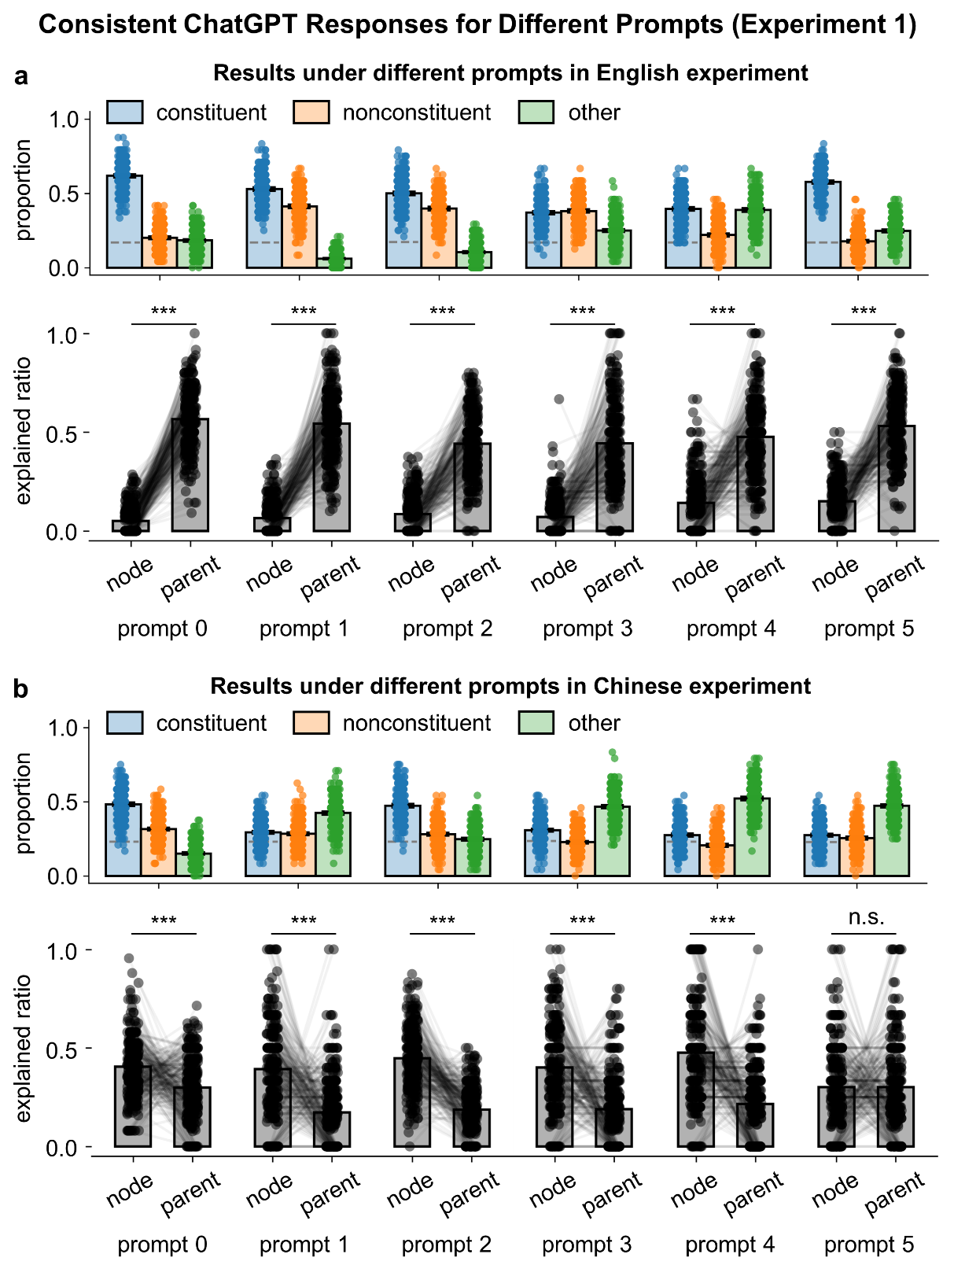
Figure S2. ChatGPT results in Experiment 1 under different prompts. Results of prompt 0 is reported in the main text. ab. Properties of the deleted word string and the explained ratio for Experiment 1. The prompt does not strongly affect the results. ***p < 0.001.

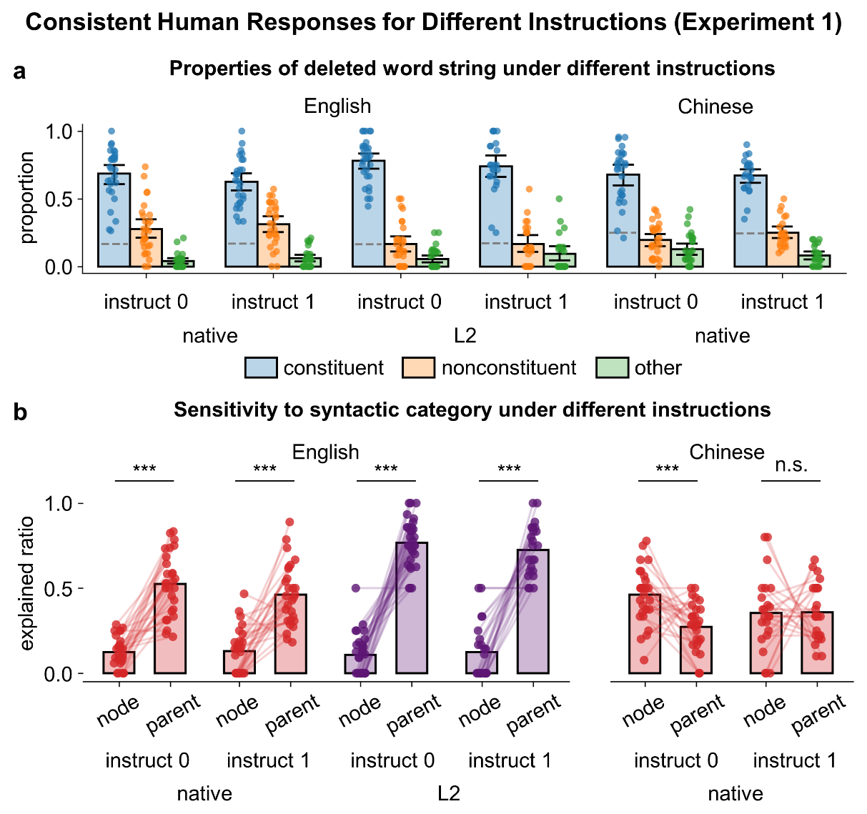
Figure S3. Human results in Experiment 1 under different instructions. The results using instruction 0 (the same as prompt 0 for ChatGPT) is reported in the main text. a. Properties of the deleted word string. b. The explained ratios of the node- and parent-category rules. Human behavior is not strongly affected by the prompt either. ***p < 0.001.

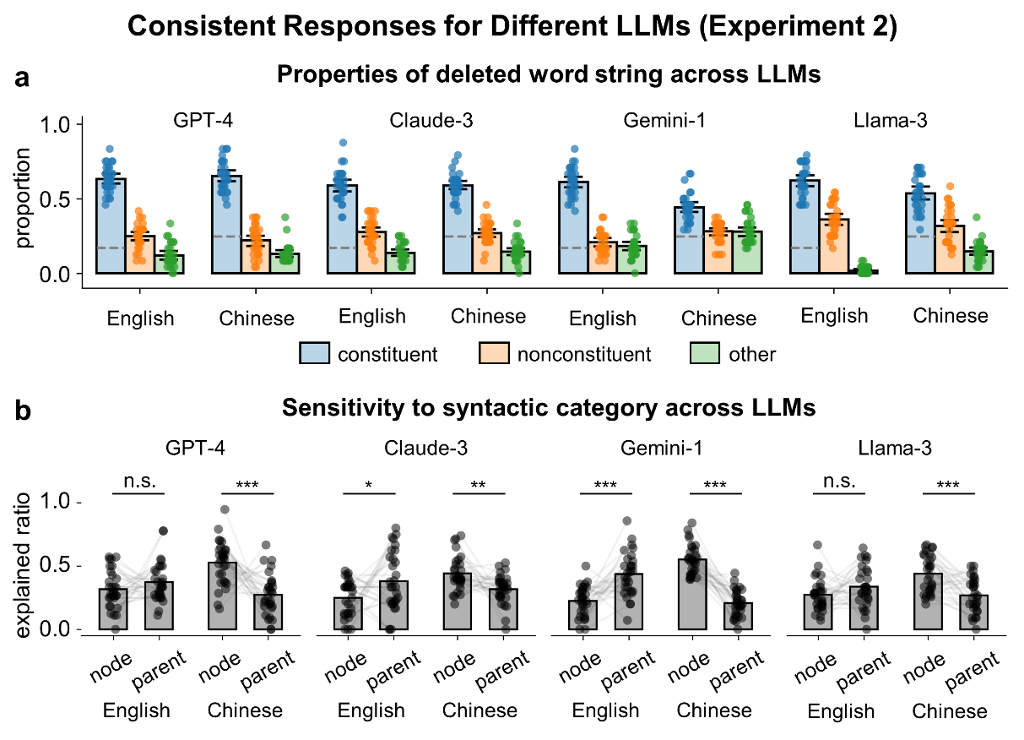
Figure S4. Results of Experiment 2 for different LLMs, including GPT-4, Claude-3, Gemini-1, and Llama-3. Each model receives 720 independent tests, which are divided into 30 runs and each run have the same number of tests (N = 24) as in the human experiment. a. Properties of the deleted word string. b. The explained ratios of the node- and parent-category rules. The results are generally consistent with the results of ChatGPT. *p < 0.05, **p < 0.01, ***p < 0.001.

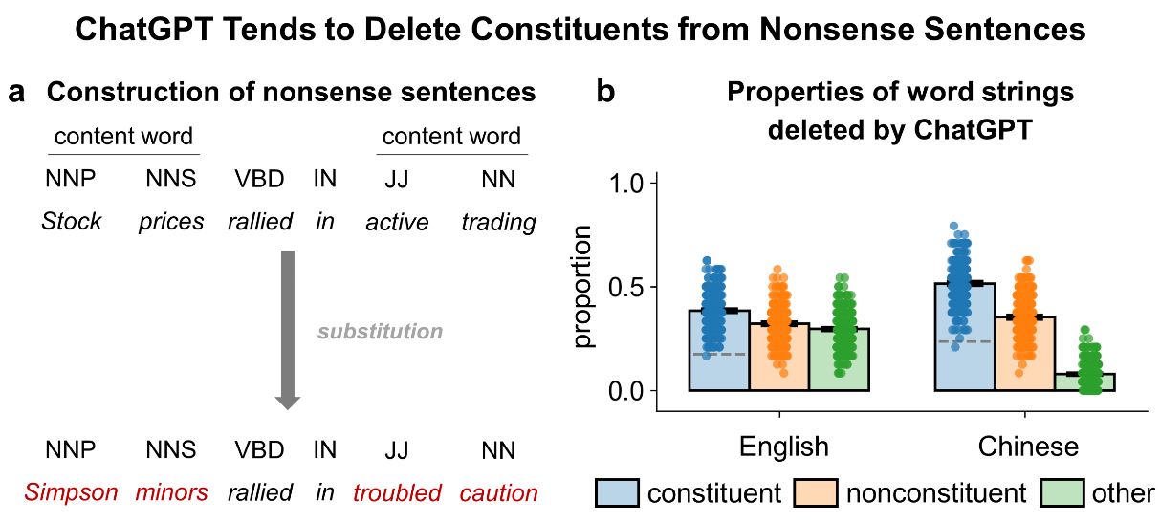
Figure S5. Results on syntactically correct nonsense sentences. a. We construct syntactically correct nonsense sentences based on sentences in Experiment 1, by replacing content words (except for verbs) with words of the same part of speech. Verbs are not replaced to avoid, e.g., “he looked at me” is transformed into “he ate at me”, which is syntactically incorrect. b. Properties of word strings deleted by ChatGPT. The constituent rate is significantly higher than chance, suggesting that ChatGPT can mainly rely on syntactic cues to delete word strings.

List of parallel sentences
Parallel sentences with the structure of [S [NP] [VP [NP]]]:
Accounting problems raise more knotty issues
会计问题引发更多棘手事件

Prospective competition is one problem
预期的竞争是一个问题

These people have different agendas
这些人有不同的议程

Pension reform was its main thrust
养老金改革是其主要推动力

Rising operating expenses are another problem
上升的运营费用是另一个问题

Some institutional traders loved the wild ride
一些机构交易员喜欢这种疯狂的旅程

The plan lacked a withdrawal timetable
该计划缺乏撤回时间表

Two election commission members opposed the matching plans
两名选举委员会成员反对配对计划

The suit seeks unspecified damages
该诉讼寻求未具体说明的损害赔偿

Many law firms sponsor their own programs
许多律师事务所赞助自己的项目

Hostile takeovers are quite a new phenomenon
恶意收购是一个相当新的现象

His father ran a construction company
他的父亲经营一家建筑公司

Potential side effects include high blood pressure
可能的副作用包括高血压

The federal judge granted a temporary restraining order
联邦法官授予临时限制令

This boy needs your help
这个男孩需要你的帮助

The young girl loves her new toy
那个年轻的女孩爱她的新玩具

The old man feeds the stray cat
那个老人喂那只流浪猫

The diligent student learns her lessons
勤奋的学生学习她的课程

My little brother enjoys this interesting game
我的小弟弟享受这个有趣的游戏

Local residents appreciate the beautiful park
当地居民欣赏美丽的公园

Your father deserves a vacation
你的父亲值得一个假期

Our friendly neighbor shares his delicious food
我们友好的邻居分享他美味的食物

Their enthusiastic coach trains the young team
他们热情的教练训练年轻的团队

The local community supports our fundraising event
当地社区支持我们的筹款活动

Her father protects the family
她的父亲保护家人

The urban children receive free education
城市的孩子接收免费的教育

City dwellers crave a quiet countryside life
城市居民渴望安静的乡村生活

Most people respect this great leader
大部分人尊敬这位伟大的领导者

My friends cherish our high school memories
我的朋友们珍惜我们的高中回忆

This beautiful painting evokes strong emotions
这幅美丽的画引发强烈的情感

Parallel sentences with the structure of [S [NP] [VP [PP [NP]]]]:
His father died of a heart attack
他的父亲死于一次心脏病

The accident happened on Saturday night
这场意外发生在周六晚上

His family lived in an old farmhouse
他们一家生活在一个老旧农舍里

Most people live in rural areas
大部分人生活在农村地区

the rest students sat on the ground
剩余学生坐在地上

the old man looked at the window
这个老人看向窗户

A surprising revelation happened on their wedding anniversary
一件惊讶的事情发生在他们的结婚纪念日上

A full moon appeared in the dark night sky
一轮圆月出现在漆黑的夜空

The students look at the complex equation
学生们看向复杂的方程式

The bird rests on the sturdy branch
小鸟们停在粗树枝上

A gentleman walks towards the bustling cafe
一位绅士走向繁忙的咖啡厅

The thick essay lies on the shelf
厚厚的论文摆放在书架上

A picture hangs at his study
一张照片挂在他的书房

The fresh linens lie in the laundry basket
干净的床单放在洗衣篮中

Many squirrels live in the oak tree
许多松鼠生活在橡树上

The road sign points to the nearest exit
路标指向最近的出口

The fragile vase stays on the top shelf
易碎的花瓶放在顶层书架

The little girl walks towards the living room
小女孩走向卧室

the old guests sat at the dinner table
年老的客人们坐在晚餐桌旁

The great artist died from a serious illness
这位伟大的艺术家死于一场重病

His glasses lie on the bedside table
他的眼镜放在床头柜上

The golden treasure lies in the dense jungle
黄金宝藏位于茂密的丛林

The old map points to a hidden treasure
旧地图指向隐藏的宝藏

The small boat stays in the calm lake
小船停在平静的湖面上

The young boy looks at the toy store window
小男孩看向玩具店的橱窗

A lost puppy walks towards the city park
一只迷路的小狗走向城市公园

The secret letter lies on the old wooden desk
这封秘密信放在旧木桌上

The rare artifact stays in the secured vault
这件稀有文物保存在安全保险库

His parents rushed to his side
他的父母冲到他身旁

The story begins in a small town
这个故事始于一个小镇

List of syntactically ambiguous sentences
Sentences with adjunct attachment:
The letter of the writer that had blonde hair arrived this morning
The writer of the letter that had blonde hair arrived this morning

The flowers of the valley that had the old castle excited the tourists
The valley of the flowers that had the old castle excited the tourists

The thesis of the editor that had the big nose made a lot of sense
The editor of the thesis that had the big nose made a lot of sense

The machine of the inventor that had the goatee was amazing
The inventor of the machine that had the goatee was amazing

The church of the bishop that had the funny eyebrows looked odd
The bishop of the church that had the funny eyebrows looked odd

The car of the driver that had the moustache was pretty cool
The driver of the car that had the moustache was pretty cool

The chef of the restaurant that had the blue tiles pleased us
The restaurant of the chef that had the blue tiles pleased us

The painter of the house that had the small windows looked odd
The house of the painter that had the small windows looked odd

The supplier of the drugs that had a nasty effect hurt everyone
The drugs of the supplier that had a nasty effect hurt everyone

The gang of the criminal that had a long scar disappeared last Monday
The criminal of the gang that had a long scar disappeared last Monday

The song of the singer that had long eyelashes was very smart
The singer of the song that had long eyelashes was very smart

The miner of the gold that had the impurities was worthless
The gold of the miner that had the impurities was worthless

Sentences with PP attachment:
The guy caught the rat with a scar
The guy caught the rat with a trap

Bill cut the paper with a very bright colour
Bill cut the paper with a very sharp knife

Dan entered the room with a window
Dan entered the room with a key

Charles runs a photo studio with two floors
Charles runs a photo studio with two friends

The police investigated the house with a garden
The police investigated the house with the permission

Jasmine sang the song with the romantic lyrics
Jasmine sang the song with the lovely students

Queen Elizabeth II ate the cake with a red rose
Queen Elizabeth II ate the cake with a silver fork

Michelle watched the movie with English subtitles
Michelle watched the movie with her boyfriend

The basketball player won the game with lots of audience
The basketball player won the game with his team

The professor recruited the students with black eyes
The professor challenged the students with his projects

The doctor noticed the boy with big headphones
The doctor saved the boy with a pacemaker

Van Gogh drew the paintings with starry night
Van Gogh sold the paintings with a broken heart

The cook ate the meal with some cauliflowers
The cook made the meal with a cleaver

The magician thanked the participant with a big nose
The magician amazed the participant with a fancy scene

The coach led the team with three members
The coach motivated the team with inspiring words

The comedian saw the crowd with fresh flowers
The comedian entertained the crowd with witty jokes

Mom ate the chocolate with chopped nuts
Mom melted the chocolate with an iron pot

Bruce likes the rock band with different instruments
Bruce leads the rock band with his voice

List of demonstration sentences for syntactically ambiguous sentences
Demonstration sentences for adjunct attachment:
The collection of the store fascinated the students
The house of the painter looked odd
The plains of the tribe looked strange
The attorney of the company bothered me
The forest of the animals pleased us
The manager of the factory was efficient
The king of the mountain impressed Arthur
The director of the orchestra played well
The dog of the officer came back this evening
The designer of the dress took a bow
The photographer of the exhibition sold his favorite piece
The artist of the mural completed his work
The sailor of the ship arrived this afternoon
The dancer of the troupe dazzled the audience
The library of the school attracted many scholarse
The exhibit of the museum intrigued the historians
The park of the city delighted the children
The song of the player is really popular
The beach of the island mesmerized the couples
The lake of the area enchanted the swimmers
The festival of the village entertained the guests
The castle of the kingdom awed the tourists
The bakery of the district tempted the locals
The plaza of the metropolis energized the crowd
The gallery of the center impressed the critics
The alley of the town fascinated art lovers
The orchard of the farm tempted the foodies
The market of the city attracted the collectors
The observatory of the institute amazed the astronomers
The mansion of the celebrity excited the fans

Demonstration sentences for PP attachment:
The photographer adjusted the lens
The bird sang a melody
The chef cooked the meal
The teacher explained the concept
The gardener watered the plants
The fisherman caught the trout
The student solved the equation
The carpenter built the house
The programmer wrote the code
The dancer performed the routine
The singer composed a song
The pilot flew the airplane
The detective solved the mystery
The baker baked the cake
The journalist reported the news
The hiker climbed the mountain
The lawyer argued the case
The baker kneaded the dough
The musician tuned the guitar
The mechanic fixed the engine
The architect designed the building
The librarian sorted the books
The jeweler polished the diamond
The sculptor chiseled the statue
The chef seasoned the soup
The tailor altered the coat
The student read the book
The gamer played the game
The driver steered the car
The actor memorized the script

Prompts for and LLMs
Prompt 0 was employed in the main text, and the experiments conducted with GPT-4, Claude-3, Gemini-1, Llama-3 were also employed prompt 0. The remained prompts 1-5 were employed on Experiment 1 with ChatGPT (see results on Fig. S2). For Chinese experiments, the prompts were the translated version of the English prompts.

Prompt 0
John developed a very special way of speaking. For ‘{demonstration sentence}’, he would say ‘{deleted sentence}’.

Please carefully examine John's speaking style, and guess what he would say for the sentence: ‘{test sentence}’.

Prompt 1
A man speaks in a really weird way after a stroke. For ‘{demonstration sentence}’, he would say ‘{deleted sentence}’.

What will he say for the sentence: ‘{test sentence}’? Do not add any extra word. Please think step by step and give out the most possible answer you think.

Prompt 2
An alien is learning our language, but he tends to omit some words in his sentences. For ‘{demonstration sentence}’, he would say ‘{deleted sentence}’.

Please guess how the alien would express the following sentence: ‘{test sentence}’.

Prompt 3
A young child is facing difficulties in language acquisition, often forgetting to say certain words. When he tries to say ‘{demonstration sentence}’, he ends up saying ‘{deleted sentence}’.

Can you anticipate what he would say for the sentence: ‘{test sentence}’?

Prompt 4
A robot has been programmed to communicate in a unique way. When it tries to say ‘{demonstration sentence}’, it outputs ‘{deleted sentence}’.

Can you predict how the robot would express the sentence: ‘{test sentence}’?

Prompt 5
In a parallel universe, the language construct is slightly different. The sentence ‘{demonstration sentence}’ would be communicated as ‘{deleted sentence}’.

How would the sentence ‘{test sentence}’ be conveyed in this universe?

Prompt 0
小张有一种非常奇特的说话方式。对于“{demonstration sentence}”，他会说成“{deleted sentence}”。

请你认真分析小张的说话方式，然后猜测他会如何表达“{test sentence}”这个句子。

Prompt 1
这个人中风后的讲话方式真的很奇怪。对于“{demonstration sentence}”，他会说成“{deleted sentence}”。

那么对于句子“{test sentence}”，这个人会怎么说呢？请不要添加额外的新词，给出你觉得最有可能的答案。

Prompt 2
一个外星人正在学习我们的语言，但他总是在句子中删掉一些词。对于“{demonstration sentence}”，他会说成“{deleted sentence}”。

请你猜测这个外星人会如何表达“{test sentence}”这个句子。

Prompt 3
一个小孩在学习语言的时候遇到了困难，经常忘记说某些词。当他试图说“{demonstration sentence}”时，他却说成了“{deleted sentence}”。

你能预测他会如何表达“{test sentence}”这个句子吗?

Prompt 4
一个机器人被编程为用一种独特的方式进行交流。当它尝试说“{demonstration sentence}”时，它会输出“{deleted sentence}”。

你能预测这个机器人如何表达“{test sentence}”这句话吗？

Prompt 5
在一个平行宇宙中，语言结构有些不同。“{demonstration sentence}”这个句子会被表达为 “{deleted sentence}”。

在这个宇宙中“{test sentence}”应该如何表达呢？

Instruction for human participants
Human participants were provided a task instruction before experiments. All English versions of experiments employed the instructions below:

In this experiment, you will be presented with some texts followed by questions. Your task is to answer the questions based on the information provided in the text. Each question should only be answered based on the current text, please do not refer to the previous text or questions. Some trials may feel very complex or difficult. Just try your best.

All Chinese versions of experiments employed the instructions below:

在实验中，您需要回答一些以中文形式呈现的问题。实验中的每个问题都是独立的，与之前或之后的问题无关。您对当前问题的回答不应受到先前或后续问题的影响。即使有些单词或表达方式您不熟悉，也请尽力而为。大多数情况下，不认识题目中所有单词并不影响回答问题。

During the human experiments, instruction 0 (the same as prompt 0 for LLMs) was employed in the main text, and instruction 1 (the same as prompt 1 for LLMs) was employed on Experiment 1 (see results on Fig. S3).

