Supplementary Data
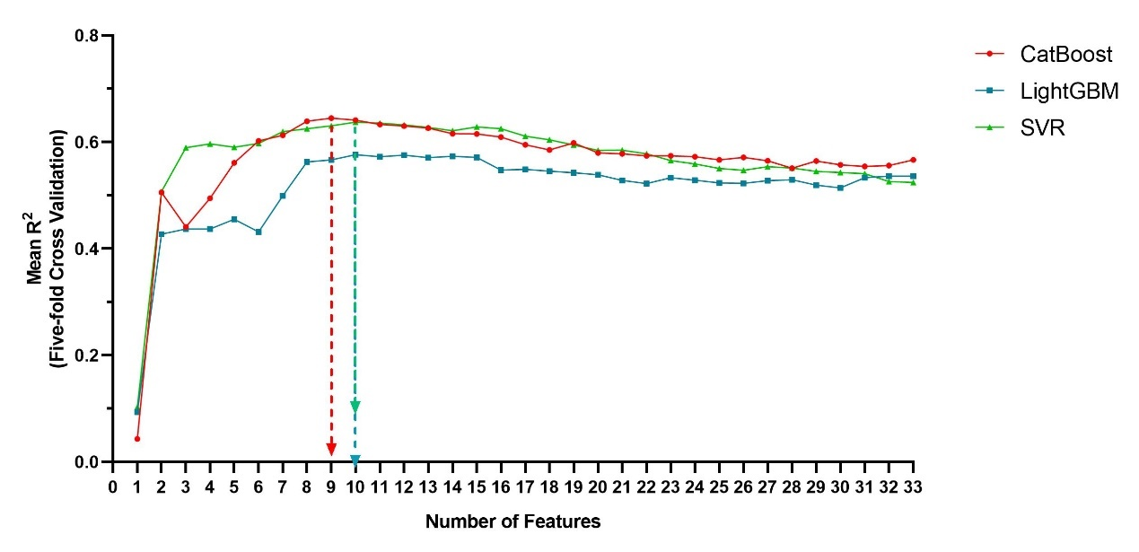

Figure S1. Feature inclusion.
Based on the SHAP importance ranking of single algorithms, features were gradually included in order of importance until the R² value reached a plateau. The feature combination at this point was considered the important feature set for the algorithm. As is shown, the highest R² value was achieved when CatBoost included 9 features, LightGBM and SVR included 10 features. The union of the important feature sets from the three algorithms was taken as the final important feature set for the model.

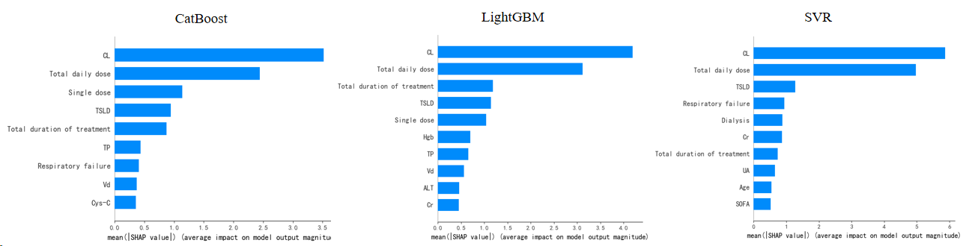

Figure S2. The important feature set mined by three algorithms.
Abbreviations: CatBoost, categorical boosting; LightGBM, light gradient boosting; SVR, support vector regression.
CL, clearance; TSLD, time since last dose; Cr, creatinine; UA, uric acid; Hgb, hemoglobin; SOFA, sequential organ failure assessment; Vd, volume of distribution; TP, total protein; ALT, alanine aminotransferase; Cys-C, cystatin C.

A

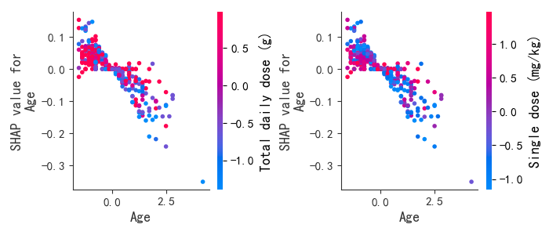
B
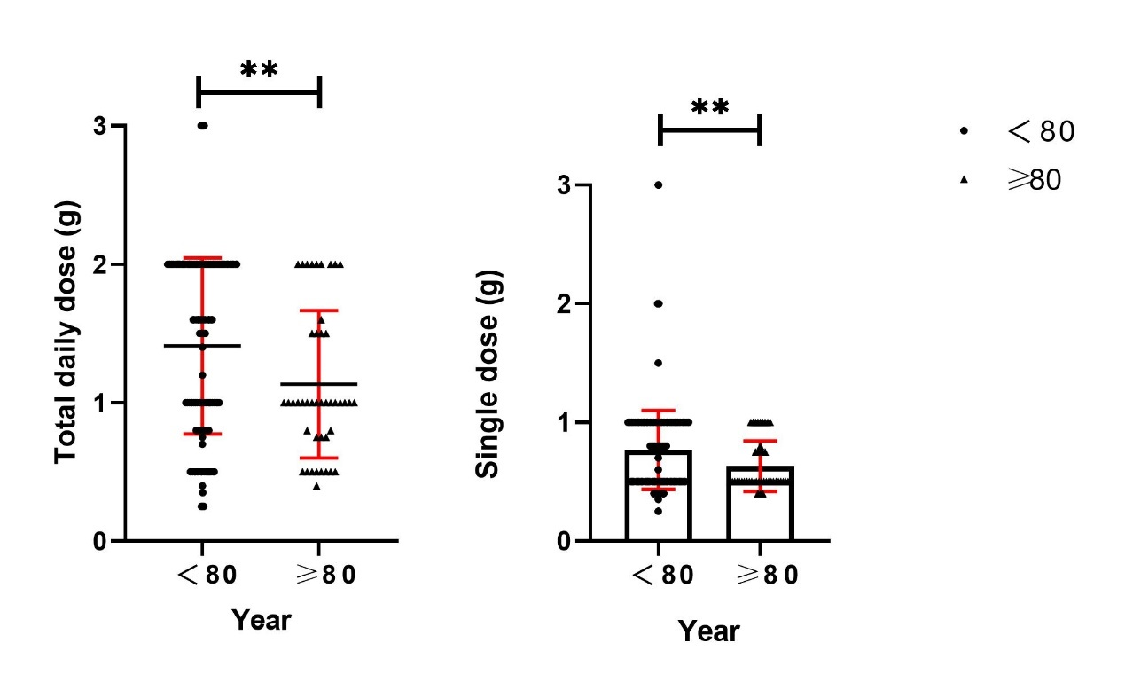

Figure S3. The SHAP dependence plot of age and dose.
A: The x-axis represents the age value range, while the y-axis corresponds to its shap value. Additionally, the color indicates how the dose feature changes with respect to age.
B: The x-axis represents the age, while the y-axis represents the dose. There were significant differences in single dose (P=0.008) and total daily dose (P=0.0059) between patients < 80 years old and ≥ 80 years old.

