Supporting information for
Ion-exchange induced multiple effects to promote uranium uptake from nonmarine water by micromotors
Linhui Fu, Kai Feng, Xinle Zhang, Ling Chen, Jiang Gong, Jinping Qu, Ran Niu*
Key Laboratory of Material Chemistry for Energy Conversion and Storage, Ministry of Education, State Key Laboratory of Materials Processing and Die & Mould Technology, Hubei Key Laboratory of Material Chemistry and Service Failure, Hubei Engineering Research Center for Biomaterials and Medical Protective Materials, Semiconductor Chemistry Center, School of Chemistry and Chemical Engineering, Huazhong University of Science and Technology, Wuhan 430074, China.
*Corresponding author.
E-mail address:niuran@hust.edu.cn

Table of content

1. Materials ······················································································1
2. Characterization··············································································1
3. pH and flow characterization for the mIEX pump ········································1
4. Uranium adsorption ··········································································2
5. Uranium desorption···········································································3
6. Kinetics studies ···············································································3
7. Isotherm studies ··············································································4
8. Effect of temperature on the adsorption ···················································4
Figure S1. Hysteresis loop of Fe₃O₄ NPs·····················································5
Figure S2. Calibration curves of (a) mAIEX and (b) mCIEX······························6
Figure S3. The standard uranium concentration-absorbance dependence curve ········6
Figure S4. pH map generated by mCIEX·····················································7
Figure S5. (a) Speed of the mAIEX-MMS versus mAIEX size. (b) Speed of the mCIEX-MMS versus mCIEX size. Error bars show the mean ± SD (n = 30 data points)·····························································································7
Figure S6. Rolling speed of the mCIEX-MMS as a function of (a) the field intensity (f= 4 Hz) and (b) the field frequency (B₀= 100 Gs). Error bars show the mean ± SD (n = 30 data points) ····························································································7
Figure S7. The uranium adsorption capacity of (a) PM and (b) ZP in uranium solutions of different pH values···········································································8
Figure S8. (a) Uranium uptake of mAIEX-MMS versus initial uranium concentration. (d) Langmuir and Freundlich fitting of the uranium adsorption of mAIEX-MMS in uranium solution·················································································8
Figure S9. Numerical simulation of ion diffusion driven by pure diffusion and flow-accelerated diffusion from mCIEX. Uranium concentration at (b) line 1 and (c) line 2 as a function of length to the right edge. (f) Flow field in the presence of uranyl ions ································································································9
Figure S10. Temperature curves of the mAIEX-MMS (mass ratio: mAIEX: PM = 2:1) suspension under different NIR irradiation intensities ······································9
Figure S11. Plot of ln K versus 1/T for the calculation of adsorption thermodynamic parameters·······················································································10
Figure S12. SEM and EDS-mapping images of U-uptake ZP·····························10
Figure S13. (a) O 1s spectra and (b) FTIR spectra of PM before and after uranium adsorption ······················································································10
Figure S14. The survey XPS spectra of mCIEX-MMS before and after uranium adsorption·······················································································11
Figure S15. The uranium adsorption capacity and desorption rate of the self-driven mCIEX-MMS (mass ratio: 2) in five adsorption-desorption cycles (elution solution: 1 M Na₂CO₃)······················································································11
Figure S16. Dimensions of the miniplant····················································12
Table S1. Parameters for pseudo-first-order and pseudo-second-order models for uranium adsorption of mAIEX-MMS with different ratios ·······························12
Table S2. Parameters for pseudo-first-order and pseudo-second-order models for uranium adsorption of mCIEX-MMS with different ratios ·······························13
Table S3. Parameters for Langmuir and Freundlich isotherm models of PM ···········13
Table S4. Thermodynamic parameters for uranium adsorption by mAIEX-MMS and mCIEX-MMS ··················································································14
Table S5. Comparison of uranium adsorption capacity ···································14
Table S6. Cost for the preparation of PM ···················································15
Table S7. Cost for the preparation of ZP ····················································15
Table S8. Cost for the preparation of mIEX················································16
Note S1. Simulation of the diffusion field and fluid flow around the mAIEX by COMSOL Multiphysics software····························································17
Note S2. Simulation of the fluid flow accelerated ion diffusion around mIEX resins by COMSOL Multiphysics software····························································18
Video 1. The flow field and self-propulsion of the mAIEX-MMS ······················20
Video 2. Magnetic actuation, NIR-actuation and letter written of mAIEX-MMS ·····20
Video 3. Self-propelled motion of mAIEX-MMS in uranium solution and numerical simulation of ion diffusion ····································································20
Supporting References·········································································20

1. Materials
The IEX used for this study were commercial cationic ion-exchange resin particles (CK10S, Mitsubishi Chemical Corporation, Japan) and anionic ion-exchange resin particles (CA08S, Mitsubishi Chemical Corporation, Japan) with average diameters of 15-60 μm. The tracer particles were negatively charged polystyrene spheres of diameter 2.4 μm (PS/Q-F-L1488, MicroParticles GmbH, Germany). Polyacrylonitrile (PAN, 99%, M_{w}≈150 000), Hydroxylamine hydrochloride (NH₂OH·HCl, 99%), Fe₃O₄ nanoparticle solution were purchased from Macklin Biochemical Co., Ltd. Acrylamide (AM), acrylic acid (AA), N, N'-methylenebis(acrylamide) (BIS), cyclohexane, Span 80, paraffin oil, FeCl₃·6H₂O, FeSO₄·7H₂O, Zn(NO₃)₂·6H₂O, Fe(NO₃)₃·9H₂O, UO₂(NO₃)₂⋅6 H₂O, Arsenazo(III) and 2-methyl imidazole were provided from Sinopharm Chemical Reagent Company. 2-Hydroxy-2-methylpropiophenone (HMPP) was obtained from TCI Shanghai. All reagents were used directly without further purification.
2. Characterization
Scanning electron microscope (SEM, ESCAN MIRA LMS) with energy dispersive spectrometry (EDS) was used to characterize the microstructure and the composition of samples. The magnetic properties of mIEX were evaluated by a vibrating sample magnetometer (VSM) (America, LakeShore7404). Fourier Transform Infrared (FTIR) spectroscopy (INVENIO-R, Bruker, Germany) was applied to analyze the functional groups of samples. Surface element composition was analyzed by X-ray photoelectron spectroscopy (XPS, Thermo ESCALAB 250XI). The spectra peaks were fitted by using XPSPEAK41 software.
3. pH and flow characterization for the mIEX pump
The pH gradient generated by the mIEX micropump was characterized by micro-photometry method¹. Typically, two commercial indicators (pH 0-5 and pH 4-10, Sigma Aldrich, Inc., volume ratio= 1:5) were used to measure the pH gradient. The indicator mixture was placed in an oven at 60 ℃ to evaporate 98% of the alcohol, followed by adding the same volume of deionized water for further use. A single mIEX was fixed on the glass substrate with a tiny amount of hydrolytically inert epoxy glue and then dried for 24 h. Afterward, 0.3 mL of deionized water and 0.1 mL of indicator solution were placed in the sample cell (inner diameter: 20 mm, height: 1 mm) containing mIEX, once the covering glass touched the liquid, the recording of photos was started. For RGB color images, we mounted a consumer DSLR (D700, Nikon, Japan) on an inverted scientific microscope (DMIRBE, Leica, Germany). As a bridge between these two instruments, a LM-Scope tube of 0.63× magnification was inserted. Then, two calibration curves (pH 1.9-9.0 and 6.0-10.0) were constructed by adding 0.3 mL of homemade buffer solute and 0.1 mL indicator solution into the same sample cell (Fig. S2). The pH gradient of mIEX was obtained using home-written Python scripts.
Tracer velocimetry method was used to characterize the flow field generated by the mIEX. Typically, 340 μL of deionized water and 20 μL of tracer particle solution (polystyrene sphere, diameter: 2.4 μm, 2 mg mL⁻¹) were added to the sample cell, which was quickly covered with another glass slide to avoid contamination by dust. Samples were observed on an upright optical microscope (Axioscope 5, Carl Zeiss, Germany) at different heights. Videos were recorded at a frame rate of 30 fps via a charge-coupled device (CCD) camera and analyzed with Tracker 4.9x software. 60-80 trajectories of tracers were tracked at each depth layer to get the statistical data.
4. Uranium adsorption
A stock solution of 100 ppm was prepared by dissolving UO₂(NO₃)₂⋅6 H₂O (0.042 mg) in ultra-pure water (100 mL). Uranium removal experiments were carried out by a batch method at room temperature. Typically, 75 μL mIEX-MMS dispersion of 10 mg mL⁻¹ was added into uranium solution (15 mL, pH 6.5) of different concentrations, reaching an adsorbent concentration of 0.05 mg mL⁻¹, followed by mechanical stirring, magnetic or NIR actuation. The concentration of uranium before and after adsorption was measured by UV-vis spectrometer (UV-6100 s, METASH). Arsenazo (III) was used as the color-developing agent as it can coordinate with uranyl ions, and the resulting complex has a specific absorption peak at 652 nm. Specifically, 0.06 mL uranium solution treated with 0.22 μm filter was mixed with 0.06 mL 0.1 mol L⁻¹ HCl, 0.12 mL 500 mg L⁻¹ arsenazo aqueous solution and 0.36 mL ultrapure water. The absorbance increases linearly with the concentration of uranium, from which the standard curve was obtained (Fig. S3). The equilibrium adsorption capability at different conditions were obtained after 50 min of adsorption. The adsorption capability of the adsorbent was calculated on the basis of Eqs. (1) and (2):
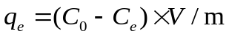 (1)
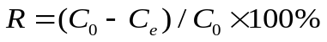 (2)
where q_{e} (mg g⁻¹) is the amount of adsorbed uranium at equilibrium, V (L) refers to the volume of the sample solution, C₀ (mg L⁻¹) and C_{t} (mg L⁻¹) are the original and the equilibrium concentrations of uranium, respectively. m (g) is the amount of used adsorbent, and R is the removal rate (%). For uranium adsorption capacity measurements, specimens were taken after 50 min of adsorption and passed through 0.22 μm filter before detected by UV-vis spectra.

5. Uranium desorption
The U-uptake mIEX-MMS was dispersed in the desorption solution (0.1 mol L⁻¹ Na₂CO₃ for PM and 1 mol L⁻¹ Na₂CO₃ for ZP, 15 mL) and shaked for 12 h. The concentration of uranyl ion in the supernatant was determined by UV-Vis spectra, from which the desorption efficiency was calculated by Eq. (3):
Desorption efficiency= 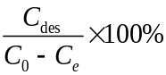 (3)
where C_{des} is the concentration of uranium in the eluent. Afterwards, they were regenerated with 1 M NaOH (for mAIEX) or 1 M HCl (for mCIEX) before washed with water and reuse.
6. Kinetics studies
To investigate the adsorption kinetics of mIEX-MMS, a certain amount of mIEX-MMS (the mass ratio of mAIEX to PM (or FZP) is changed from 0 to 0.5, 1 and 2) was added to a U(VI) solution (15mL, 30 mg L⁻¹) with a pH of 6.5. The incubation time varied across intervals of 1 min, 3 min, 5 min, 7 min, 10 min, 20 min, 30 min, 40 min, and 50 min while fixing a constant temperature of 298 K. The pseudo-first-order kinetic and pseudo-second-order kinetic models (Eqs. S1 and S2) are employed for fitting of the adsorption kinetic process:
Pseudo-first-order model 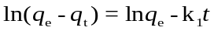 (S1)
Pseudo-second-order model 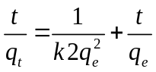 (S2)
where q_{t} (mg g⁻¹) refers to the uranium adsorption amount of adsorbent at time t (min), and q_{e} (mg g⁻¹) is the adsorption amount of adsorbent at equilibrium time. k₁ (min⁻¹) and k₂ (g mg⁻¹ min⁻¹) are pseudo-first-order and pseudo-second-order kinetic constants, respectively.

7. Isotherm studies
The equilibrium data are analyzed using the Langmuir and Freundlich equilibrium models to reveal the adsorption mechanism of the adsorbent. The two adsorption models can be expressed by the following equations:
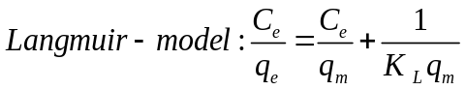 (S3)
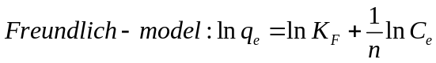 (S4)
in which C_{e} (mg L⁻¹) and q_{e} are the uranium concentration after equilibrium and adsorption capacity, respectively. q_{m} is the maximum adsorption capacity of the adsorbent, K_{L} (L mg⁻¹) is the Langmuir constant corresponding to the free energy of adsorption. K_{F} ((mg g⁻¹) (L mg⁻¹)^{1/n}) is the Freundlich constant corresponding to the adsorption capacity of the adsorbent, and n is the factor related to the adsorption intensity of the adsorbent.

8. Effect of temperature on the adsorption
To study the effect of photothermal conversion of the Fe₃O₄ nanoparticles on uranium adsorption under NIR irradiation, the values of the thermodynamic parameters, such as entropy (ΔS₀), enthalpy (ΔH₀), and Gibb’s free energy (ΔG₀) are used to express the solution temperature effects. Thermodynamic functions such as ΔH₀ (kJ mol⁻¹) and ΔS₀ (J (K mol) ⁻¹) were obtained from the plot of lnK_{d} versus 1/T according to Eqs. (S5) and (S6), the result as shown in Fig. S8, and the ΔG₀ (kJ mol⁻¹) was calculated by Eq. (S7), the results are listed in Table S3 and S4.
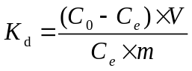 (S5)
where C₀ and C_{e} are the initial and equilibrium concentrations of uranium, respectively. V and m are the volume of the solution and mass of the adsorbent, respectively.
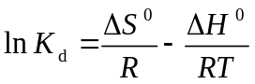 (S6)
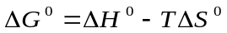 (S7)
where K_{d} (mL g⁻¹) is the distribution coefficient of U(VI), T (K) is the Kelvin temperature and R=8.314 J mol⁻¹ K⁻¹.

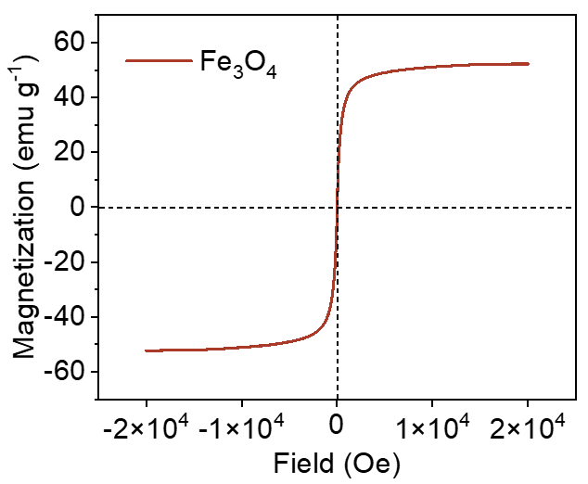
Fig. S1 Hysteresis loop of Fe₃O₄ NPs.

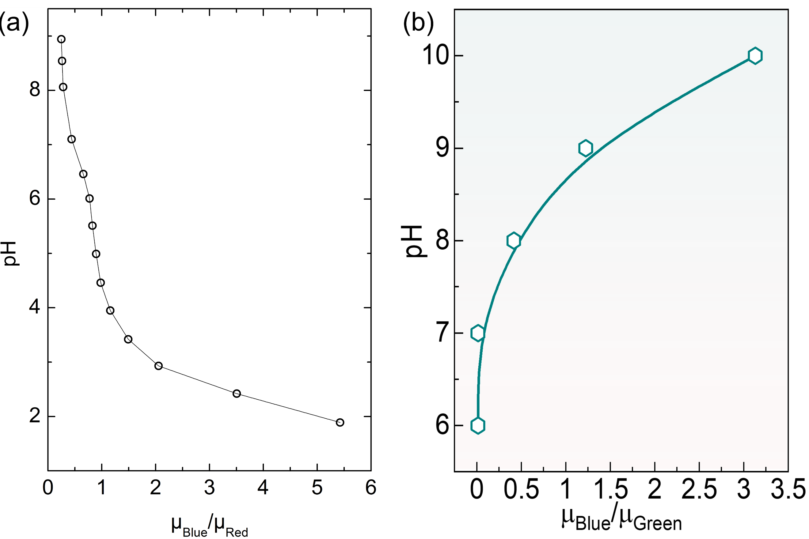
Fig. S2 Calibration curves of (a) mAIEX and (b) mCIEX.

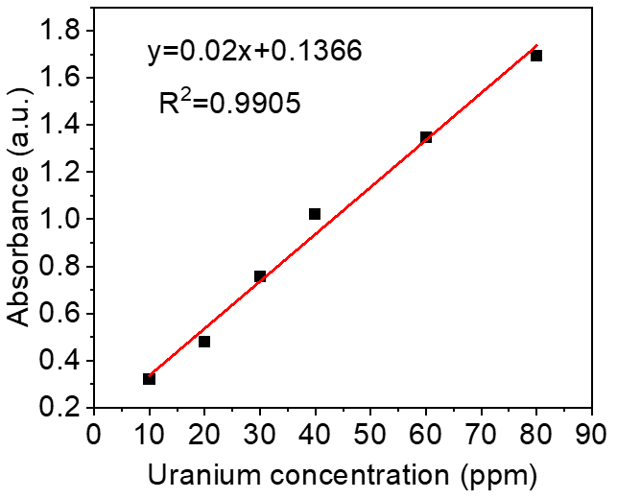
Fig. S3 The standard uranium concentration-absorbance dependence curve.

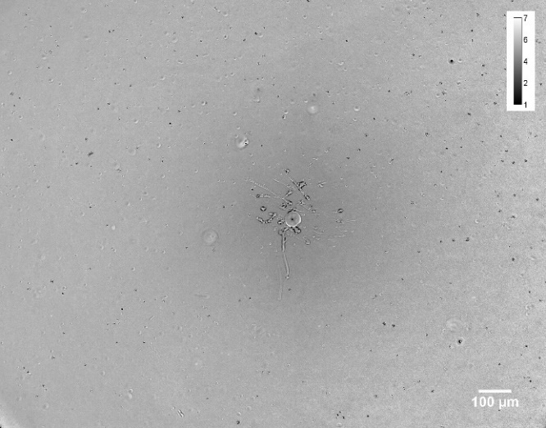
Fig. S4 pH map generated by mCIEX.

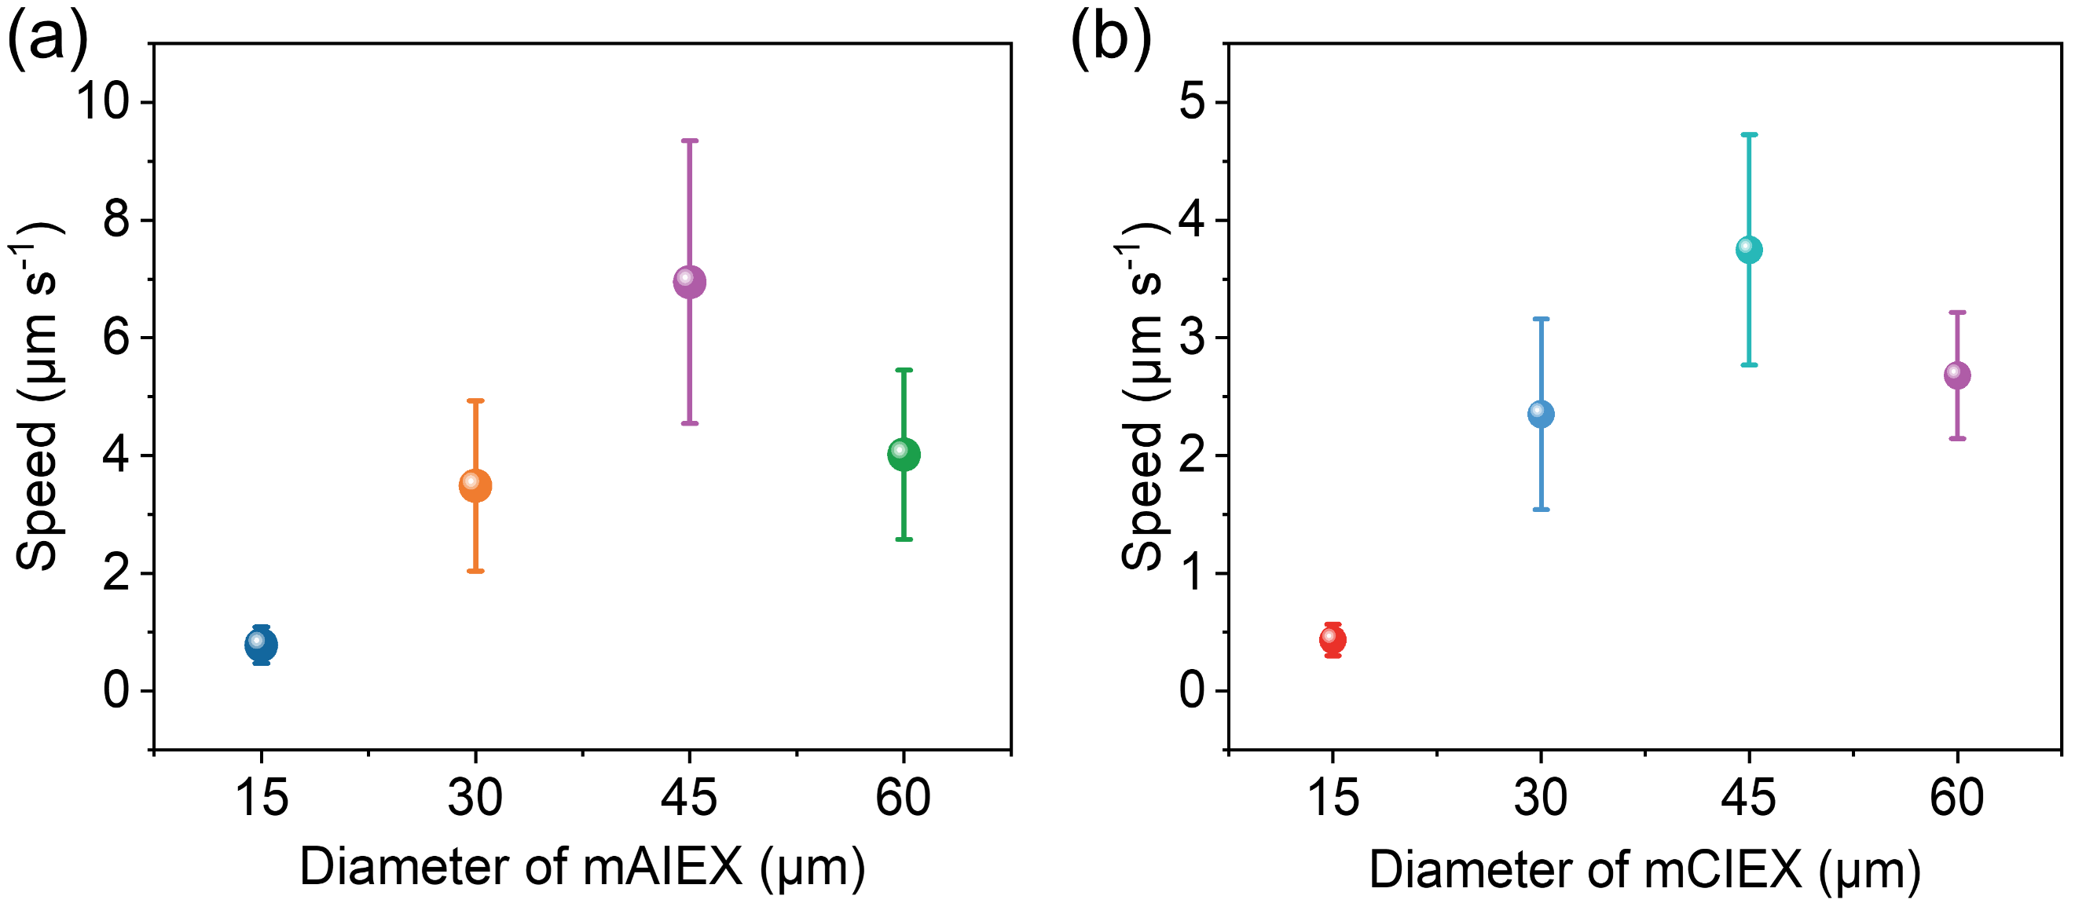
Fig. S5 (a) Speed of the mAIEX-MMS versus mAIEX size. (b) Speed of the mCIEX-MMS versus mCIEX size. Error bars show the mean ± SD (n = 30 data points).

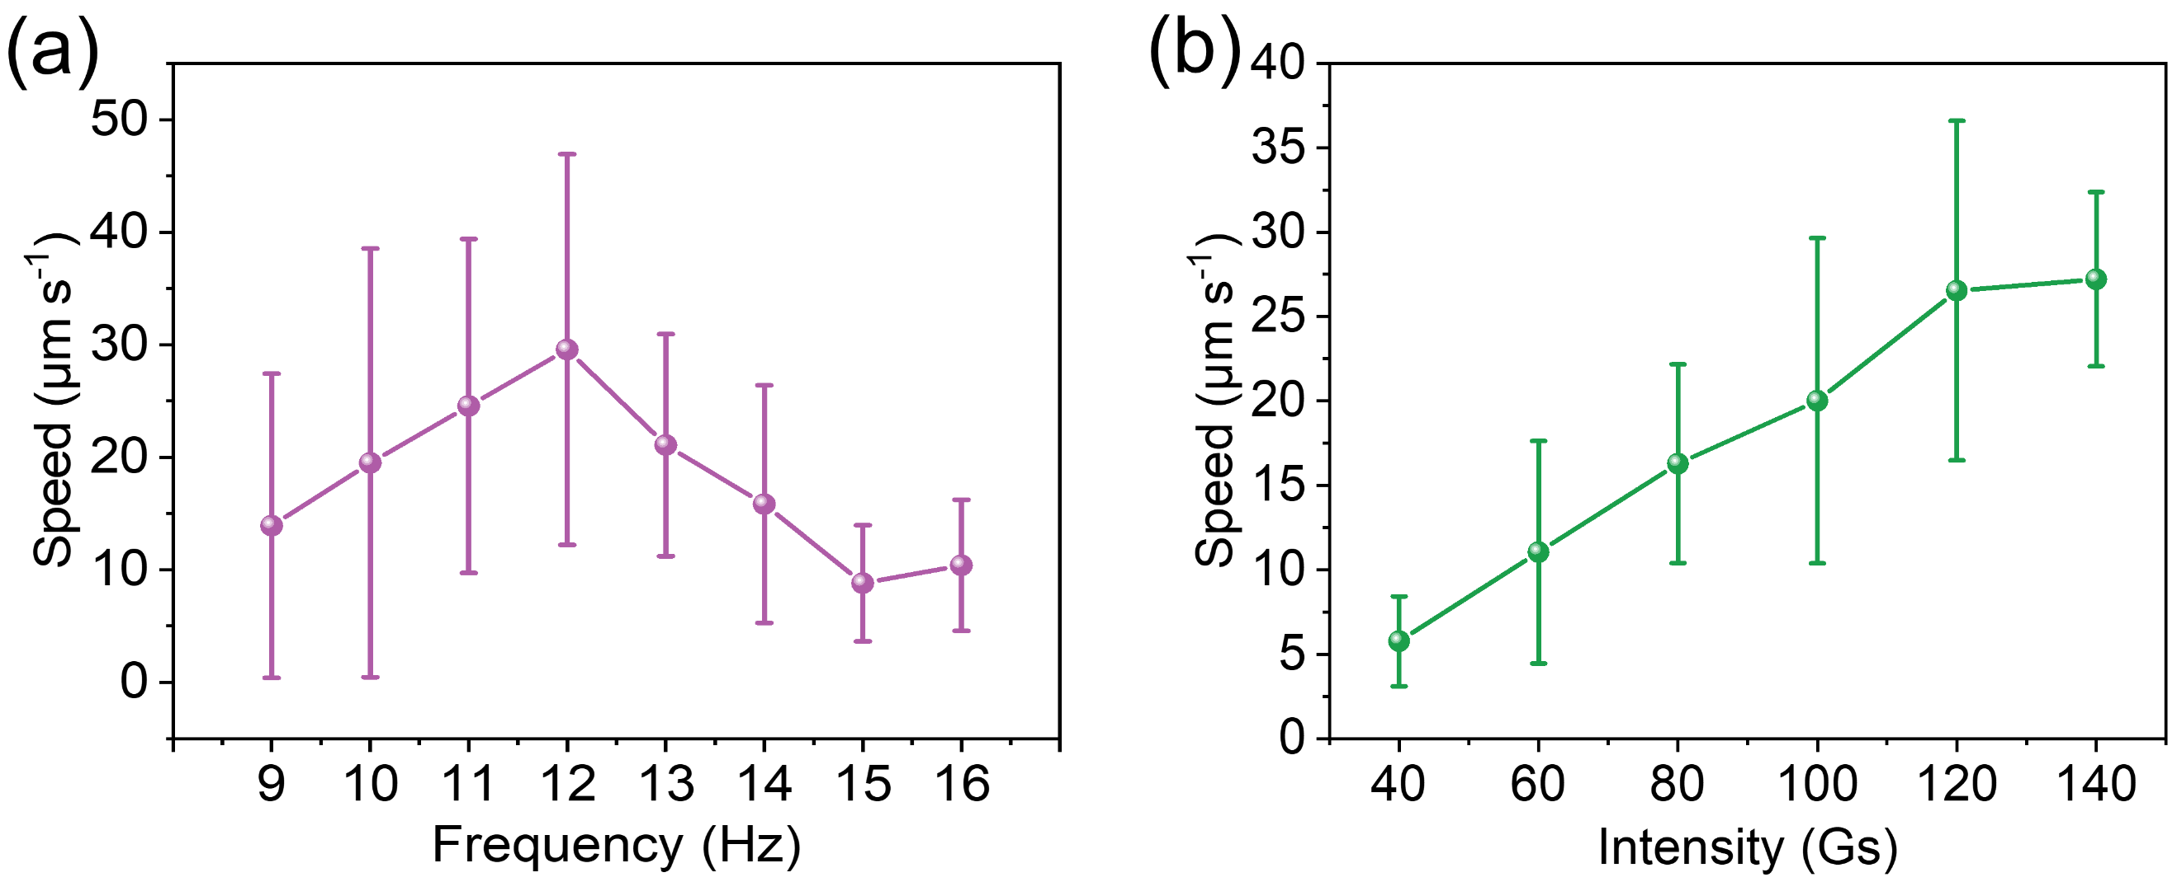
Fig. S6 Rolling speed of the mCIEX-MMS as a function of (a) the field intensity (f= 4 Hz) and (b) the field frequency (B₀= 100 Gs). Error bars show the mean ± SD (n = 30 data points).
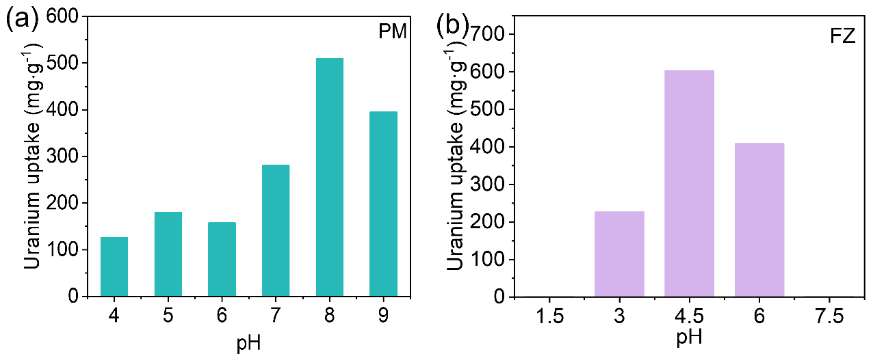
Fig. S7 The uranium adsorption capacity of (a) PM and (b) ZP in uranium solutions of different pH values.

Fig. S8 (a) Uranium uptake of PMversus initial uranium concentration. (d) Langmuir and Freundlich fitting of the uranium adsorption of PM in uranium solution.
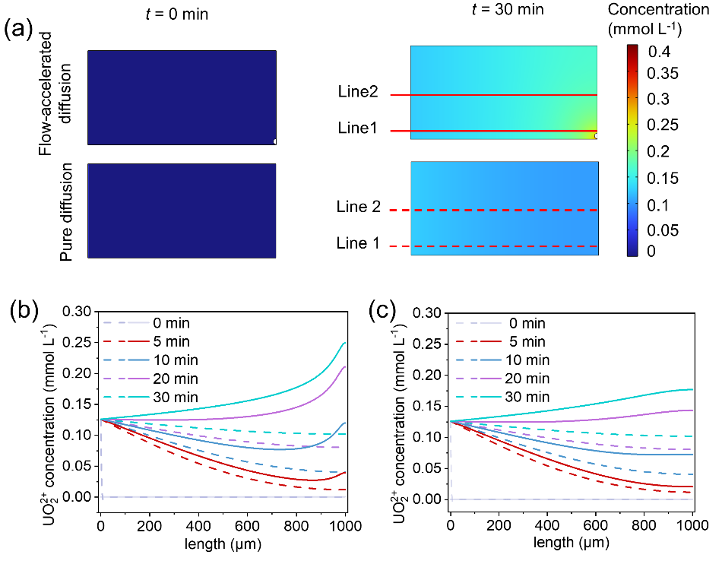
Fig. S9 Numerical simulation of ion diffusion driven by pure diffusion and flow-accelerated diffusion from mCIEX. Uranium concentration at (b) line 1 and (c) line 2 as a function of length to the right edge. (f) Flow field in the presence of uranyl ions.

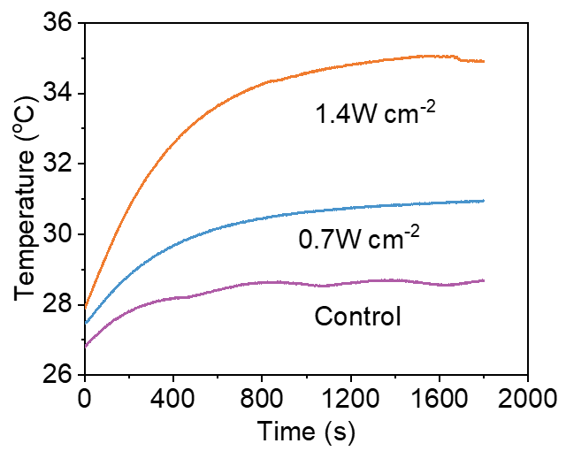
Fig. S10 Temperature curves of the mAIEX-MMS (mass ratio: mAIEX: PM = 2:1) suspension under different NIR irradiation intensities.

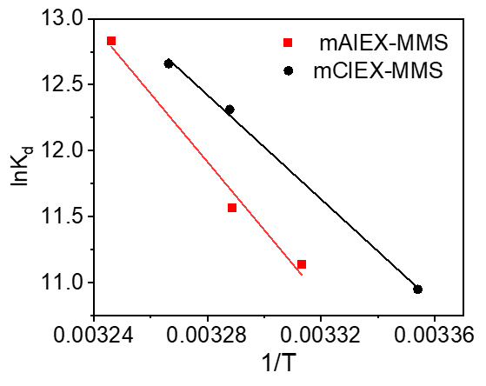
Fig. S11 Plot of ln K versus 1/T for the calculation of adsorption thermodynamic parameters.

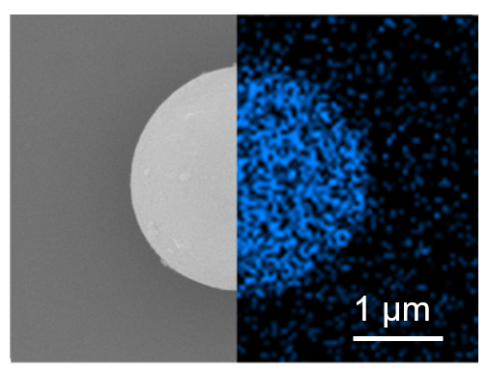
Fig. S12 SEM and EDS-mapping images of U-uptake ZP.
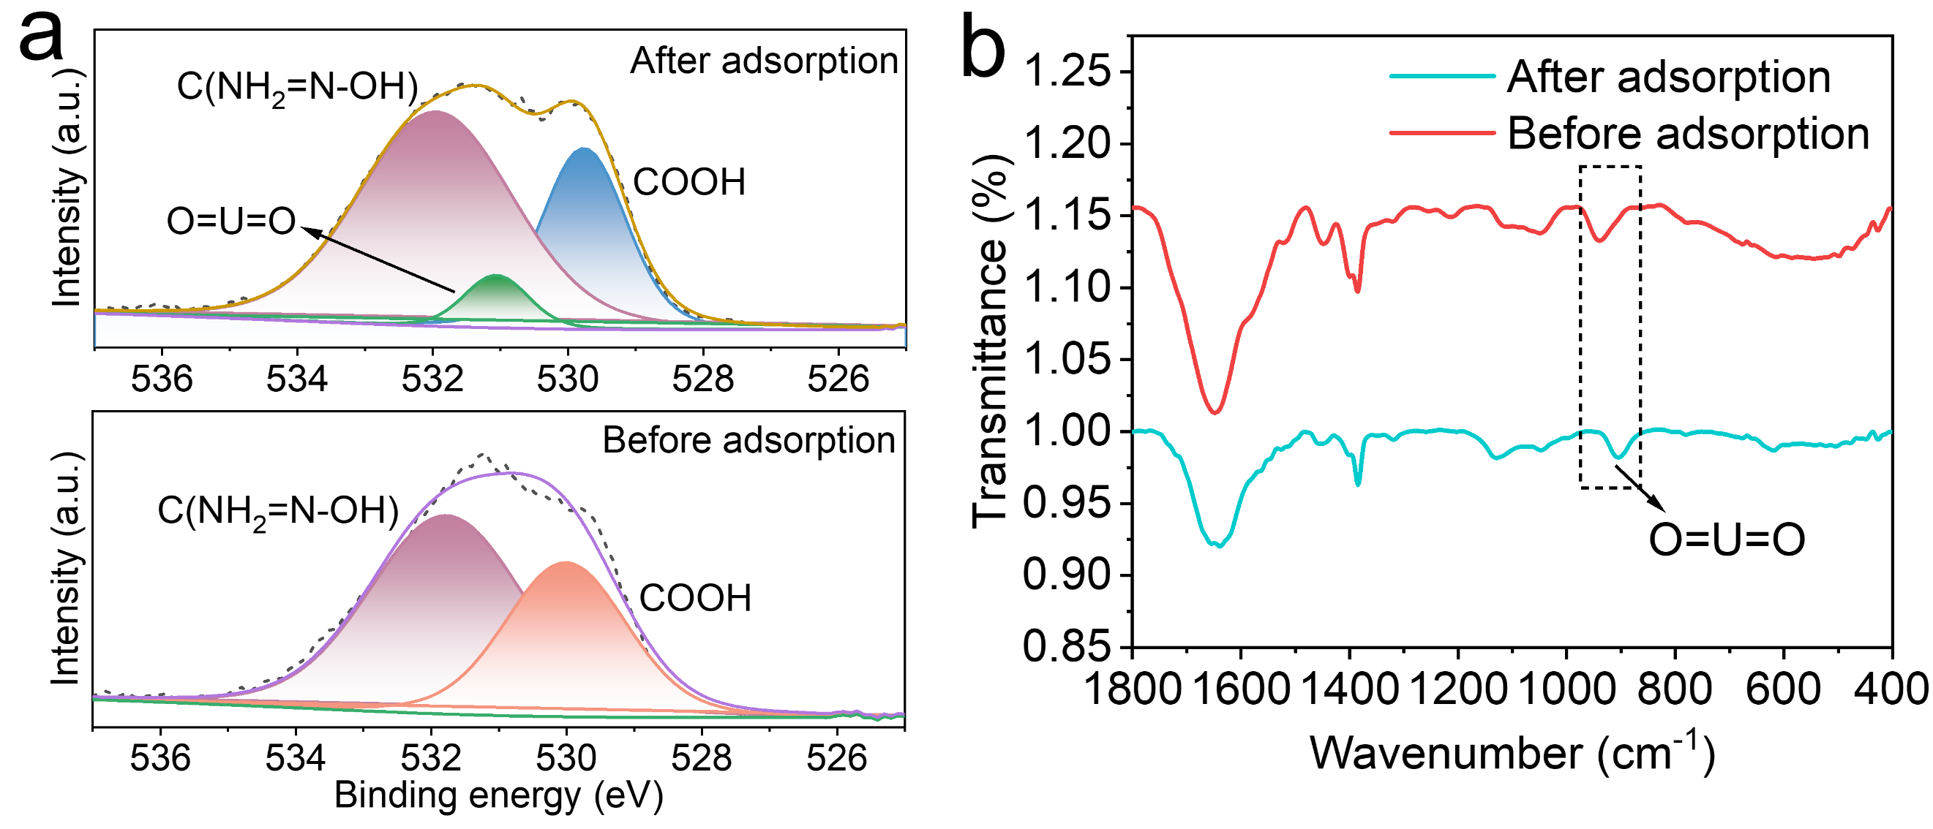
Fig. S13 (a) O 1s spectra and (b) FTIR spectra of PM before and after uranium adsorption.
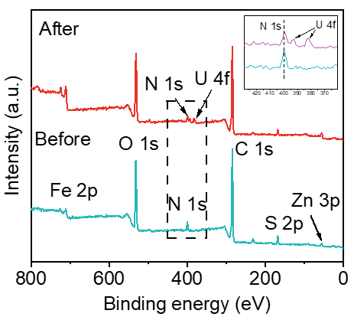
Fig. S14 The survey XPS spectra of mCIEX-MMS before and after uranium adsorption.

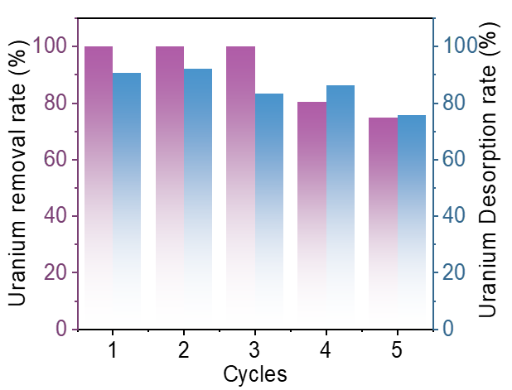
Fig. S15 The uranium adsorption capacity and desorption rate of the self-driven mCIEX-MMS (mass ratio: 2) in five adsorption-desorption cycles (elution solution: 1 M Na₂CO₃).

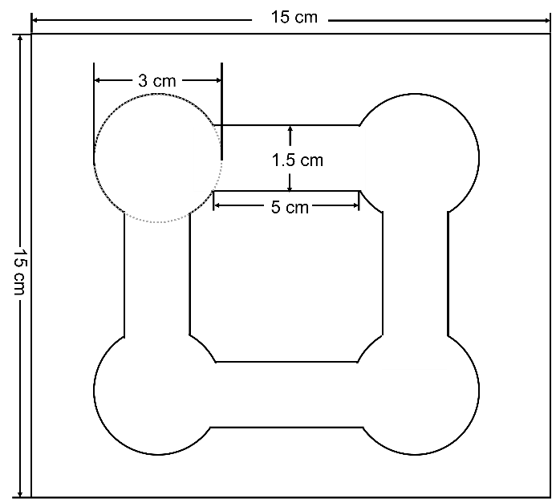
Fig. S16 Dimensions of the miniplant.

Table S1 Parameters for pseudo-first-order and pseudo-second-order models for uranium adsorption of mAIEX-MMS with different ratios.
Kinetic models | Parameters |  | Adsorption conditions
Kinetic models | Parameters | Pure PM | mAIEX:PM  (0.5:1) | mAIEX:PM  (1:1) | mAIEX:PM  (2:1)
Pseudo-first-order | Q_{e} (mg g⁻¹) | 233.28 | 421.67 | 493.86 | 608.65
Pseudo-first-order | k₁ (min⁻¹) | 0.16395 | 0.42676 | 0.72954 | 0.96346
Pseudo-first-order | R² | 0.96538 | 0.99447 | 0.99542 | 0.98891
Pseudo-second-order | Q_{e} (mg g⁻¹) | 228.71 | 451.4 | 513.27 | 626.14
Pseudo-second-order | k₂ (g min⁻¹ mg⁻¹) | 0.00101 | 0.00148 | 0.00279 | 0.00423
Pseudo-second-order | R² | 0.9984 | 0.9992 | 0.99948 | 0.99564

Table S2 Parameters for pseudo-first-order and pseudo-second-order models for uranium adsorption of mCIEX-MMS with different ratios.
Kinetic models | Parameters |  | Adsorption conditions
Kinetic models | Parameters | Pure FZP | mCIEX: FZP  (0.5:1) | mCIEX: FZP  (1:1) | mCIEX: FZP  (2:1)
Pseudo-first-order | Q_{e} (mg g⁻¹) | 245.99 | 327.40 | 383.57 | 417.19
Pseudo-first-order | k₁ (min⁻¹) | 0.36681 | 0.47740 | 0.67927 | 0.77792
Pseudo-first-order | R² | 0.97178 | 0.9944 | 0.99518 | 0.98914
Pseudo-second-order | Q_{e} (mg g⁻¹) | 267.58 | 347.89 | 400.35 | 433.58
Pseudo-second-order | k₂ (g min⁻¹ mg⁻¹) | 0.00198 | 0.00225 | 0.00317 | 0.00348
Pseudo-second-order | R² | 0.99379 | 0.99487 | 0.99964 | 0.99739

Material | T (K) | Langmuir model |  |  | Freundlich model
PM | 298K | q_{m} | K_{L} | R² |  |  | K_{F} | n | R²
PM | 298K | 865.14 | 0.059 | 0.99 |  |  | 146.61 | 2.61 | 0.98
Table S3 Parameters for Langmuir and Freundlich isotherm models of PM.

Table S4 Thermodynamic parameters for uranium adsorption by mAIEX-MMS and mCIEX-MMS.
Kinetic models | T (K) | ΔGº (kJ mol⁻¹) | ΔHº (kJ mol⁻¹) | ΔSº (J K⁻¹ mol⁻¹)
mAIEX-MMS | 298.15 | -27.9475 | 214.78 | 803.53
mAIEX-MMS | 304.05 | -29.2364
mAIEX-MMS | 308.05 | -32.8645
mCIEX-MMS | 298.15 | -27.1492 | 164.226 | 641.957
mCIEX-MMS | 304.15 | -31.1336
mCIEX-MMS | 306.15 | -32.2203

Table S5 Comparison of uranium adsorption capacity.
Adsorbents | Capacity (mg g⁻¹) | C₀ (ppm) | Reference
mAIEX-MMS | 629.3 | 30 | This work
PPA/SA | 114.0 | 10 | 2
AO-Fe₃O₄@C&mSiO₂ | 62.12 | 10 | 3
PHCP-2 | 297.14 | 60 | 4
CQDs@PAFP | 147.6 | 90 | 5
POP-oNH₂-AO | 530 | 7.56 | 6
PAN-P4-A6 | 200 | 50 | 7
PAO-h-PAMAM | 465.33 | 20 | 8
GCZ8A | 361.01 | 150 | 9
Zn²⁺-PAO hydrogel | 1188 | 32 | 10
MSSA-AO | 221.5 | 10 | 11

Table S6 Cost for the preparation of PM
Material | Cost ($) | Remarks
PAO | 0.087 g⁻¹ | In this process, 5.56 g NH₂OH·HCl, 5.73 g Na₂CO₃, 1.44 g NaOH, 4.24 g PAN and 60 mL DMF are needed.
MIL-88B | 0.013 g⁻¹ | In this process, 25.25 g Fe(NO₃)₃·9H₂O, 12 g PET, and 5 g NaOH are needed.
PM | 0.115 g⁻¹ | 30 mL water phase, and 100 mg MIL-88B are needed. The cost for the electricity in the whole process is estimated as $ 0.056.

Table S7 Cost for the preparation of ZP
Material | Cost ($) | Remarks
ZIF-8 | 0.87 g⁻¹ | In this process, 0.585 g Zn(NO₃)₂·6H₂O, 11.35 g 2-methylimidazole 44 mL deionized water and 15 mL methanol are needed.
Water phase | 0.11mL⁻¹ | In this process, 0.25 mL of the mixture solution including AA monomer (0.645 g), AM monomer (0.709 g), BIS (0.015 g) and HMPP (0.1 g) and deionized water (1.9 g), 0.2 mL deionized water and 60 mg ZIF-8 are needed.
Oil phase | 0.0012 mL⁻¹ | In this process, 0.3 g Span 80 and 30 mL liquid paraffin are needed.
ZP | 01.345 g⁻¹ | In this process, 0.5 mL water phase, 30 mL oil phase, 15 mL cyclohexane and 15 mL ethanol are needed. The cost for the electricity in the whole process is estimated as $ 0.056.

Table S8 Cost for the preparation of mIEX.
Material | Cost ($) | Remarks
Fe₃O₄ | 5.49 Kg⁻¹ | In this process, 5.56 g FeCl₃·6H₂O, 5.73 g FeSO₄·7H₂O, 5 mL 28 wt% ammonia solution and 4.4 g sodium citrate are needed.
IEX | 0.706 Kg⁻¹ | In this process, 200 mg Dowex 1 × 8 chloride chromatography resin and 10 g NaOH are needed.
mAIEX-MMS | 0.143 g⁻¹ | In this process, 12.5 mg Fe₃O₄ and 200 mg AIEX are needed. The cost for the electricity in the whole process is estimated as $ 0.056.
mCIEX-MMS | 0.115 g⁻¹ | In this process, 12.5 mg Fe₃O₄ and 200 mg CIEX are needed. The cost for the electricity in the whole process is estimated as $ 0.056.

Note S1
COMSOL Multiphysics package was used to simulate the diffusion field and fluid flow around the mAIEX using Transport of Diluted Species, Electrostatics, and Creeping Flow modules. The fluid flow around the mAIEX was simulated using an electrokinetic numerical model, where we consider three ionic solute species in the fluid, i.e., H⁺, OH⁻ and HCO₃⁻. The ion exchange reaction of the mAIEX can be represented by the exchange of OH⁻ to HCO₃⁻ at the mAIEX surface. A self-generated electric field is created by ions diffusion. The detailed equations and boundary conditions are listed below:
In our simulation model, it is resolved with the continuity equation at steady state in Transport of Diluted Species module:
$∇∙J_{i}=u∙∇c_{i}-D_{i}∇^{2}c_{i}-\frac{z_{i}FD_{i}∇∙(c_{i}∇φ)}{RT}$ (S8)
where 𝑱_{𝒊} is the flux of ion 𝒊, 𝒖 is the fluidic velocity, 𝐹 is the Faraday constant, 𝜑 is the electrostatic pots the gas constant, 𝑇 is the temperature. 𝐶_{𝑖}, 𝐷_{𝑖}, and z_{𝑖} are the concentration, diffusion coefficient, 𝑅 int, and charge of species 𝒊, respectively.
The electric field E (E= - ∇φ) from Eq. S8 can be calculated using the Poisson equation:
$-ε_{0}ε_{r}∇^{2}φ=ρ_{e}=F\sum_{i}{z_{i}C_{i}}$ (S9)
where 𝜀₀ is the vacuum permittivity and 𝜀_{𝑟} is the relative permittivity of water, 𝜌_{𝑒} is the volumetric charge density, 𝐹 is the Faraday constant, $C_{i}$ is the concentration of protons.
The inertial effect is ignored in our study because of the low Reynolds number (R_{e} <<1). Thus, the fluid flow outside the electric double layer is governed by the Stokes equations at steady state.
$-∇p+μ∇^{2}u=ρ_{e}∇φ$ (S10)
and the continuity equation for the incompressible fluid,
$∇u=0$ (S11)
where 𝜇, 𝒖, 𝑝 and $ρ_{e}∇φ$ are the fluid dynamic viscosity, velocity vector, pressure and electrical body force, respectively. The initial values of 𝒖 and 𝑝 are set as zero in our simulation.
The ions release or consumption is expressed as a boundary condition, representing the continuity of ions flux at the reactive surface,
$n∙J_{i}=J_{0,i}$ (S12)
where 𝑱_{𝒊} is defined in S1, 𝒏 is the unit vector normal to the surface, and 𝐽_{0,𝑖} is the ion flux density, representing the local surface reaction rate. At the mAIEX surface, OH⁻ will be released and diffused away. Hence, at the mAIEX surface, 𝐽_{0, OH}⁻ was set positive. In our 2D simulations model, we use a 400×400 µm simulation space, where four boundaries are set to be open without viscous forces. The AIEX is 30 µm in diameter. The measured zeta potential values of AIEX (-35 mV) are used in the simulation. For the substrate, the zeta potential is set to -100 mV. The diffusion coefficient of H⁺, OH⁻, and HCO₃⁻ are set to be 9.31 × 10⁻⁹ m² s⁻¹, 5.27 × 10⁻⁹ m² s⁻¹ and 1.18 × 10⁻⁹ m² s⁻¹. The bulk concentrations of ions are chosen to be c(H⁺) = 4.0 × 10⁻⁶ mol L⁻¹ (pH = 5.4), c(OH⁻) = 0 mol L⁻¹ and c(HCO₃⁻) = 4.0 × 10⁻⁶ mol L⁻¹, respectively. The flux of ion H⁺, OH⁻ and HCO₃⁻ are set to be 0 mol/(m² s), 2 × 10⁻¹¹ mol/(m² s) and -2 × 10⁻¹¹ mol/(m² s). We assume the inward and outward ions flux at the surface of mAIEX is only dependent on the ion concentration.

Note S2
COMSOL Multiphysics software was used to simulate fluid flow accelerated ion diffusion around mIEX resins. The electrokinetic numerical model was used in simulations, which coupled three equations, i.e. Nernst–Planck equation, Poisson equation, and Stokes equation. We used an adaptive time-stepping algorithm to calculate the distribution of ion concentration and fluid flow fields. The detailed numerical modeling procedures are given below.
We considered a quasi-2D axisymmetric domain to simulate a 3D cylindrical geometry that contains an mIEX resin located on the symmetry axis of the cylindrical fluid domain. Typically, a 1000 μm × 500 μm simulation box with open boundary was used. The diameter of mIEX resin was 45 μm, which was located at right corner of box and 400 nm above the glass substrate. The zeta potential values of mIEX resin and substrate were set as -45 and -100 mV. The fluid water had a mass density of 1.0 × 10³ kg m⁻³, viscosity of 8.9 × 10⁻⁴ Pa s, and relative permittivity of 78.4 (T = 298.15 K). The fluid domain contains default concentration of K⁺ and Cl⁻ ions. For mCIEX resin, we impose no-penetration conditions for Cl⁻. The exchange of H⁺ and K⁺ is modeled via out- and influx on the CIEX resin, respectively. For mAIEX resin, we imposed no-penetration conditions for K⁺. The exchange of OH⁻ and Cl⁻ is modeled via out- and influx on the mAIEX resin, respectively. As we assumed before, the mCIEX resin had absorbed all of UO₂²⁺ in the simulated fluid domain, and the AIEX had absorbed all of UO₂(CO₃)₂²⁻ or UO₂(CO₃)₃⁴⁻ in the simulated fluid domain for the different pH around IEXs. Then the left boundary of domain is set with default U(VI) species and its counter ions to simulate fluid flow accelerated ion-diffusion process (Fig. 16a). To be specific, for the mCIEX, the left boundary of domain is set with default concentration of UO₂²⁺ and NO₃⁻, and for the mAIEX, the left boundary is set with default concentration of UO₂(CO₃)₂²⁻ and H⁺.
The diffusion coefficient of H⁺, K⁺, Cl⁻, UO₂⁺, NO₃⁻ and UO₂(CO₃)₂²⁻ were set to be 9.31 × 10⁻⁹, 1.96 × 10⁻⁹, 2.03 × 10⁻⁹, 0.426 × 10⁻⁹, 1.9 × 10⁻⁹ and 0.14 × 10⁻⁹ m² s⁻¹, respectively. The bulk concentration of ions was chosen to be c(H⁺) = 0 mol L⁻¹, c(K⁺) = 4.0 × 10⁻¹ mol L⁻¹, and c(Cl⁻) = 4.0 × 10⁻¹ mol L⁻¹, respectively. For the mCIEX resin, the flux of H⁺, K⁺ and Cl⁻ at the boundary of mCIEX were set as 1 × 10⁻⁵, -1 × 10⁻⁵ and 0, respectively. The default concentration of UO₂⁺ and NO₃⁻ at the left boundary of simulation box were set as 0.126 and 0.252 mol L⁻¹. For the mAIEX resin, the flux of OH⁻, K⁺ and Cl⁻ at the boundary of mCIEX were set as 1 × 10⁻⁵, 0 and -1 × 10⁻⁵, respectively. The default concentration of c(UO₂(CO₃)₂²⁻) and c(H⁺) at the left boundary of simulation box were set as 0.126 and 0.252 mol L⁻¹.

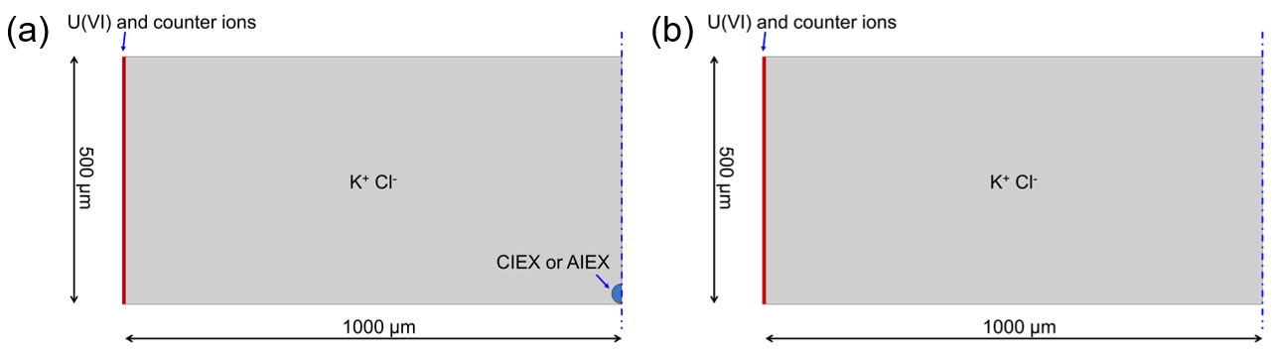
Fig. S17 Schematic of the rotationally symmetric simulation domain with IEX (a) and without IEX (b). The fluid domain is full of KCl with the left boundary placed U(VI) species and their counter ions. The blue dashed line shows the symmetry axis.

For the control numerical model without mIEXs, the schematic simulation box is shown in Fig. S16b. To be specific, the fluid domain contains default concentration of K⁺ (4.0 × 10⁻¹ mol L⁻¹) and Cl⁻ (4.0 × 10⁻¹ mol L⁻¹) ions. For the CIEX, the default concentration of c(UO₂⁺) and c(NO₃⁻) at the left boundary of simulation box were set as 0.126 and 0.252 mol L⁻¹. And for the mAIEX, the default concentration of c(UO₂(CO₃)₂²⁻) and c(H⁺) at the left boundary of simulation box were set as 0.126 and 0.252 mol L⁻¹.

Supporting Movies
Video 1 The flow field and self-propulsion of the mAIEX-MMS.
Video 2 Magnetic actuation, NIR-actuation and letter written of mAIEX-MMS.
Video 3 Self-propelled motion of mAIEX-MMS in uranium solution and numerical simulation of ion diffusion.

Supporting References
1. Niu R, Khodorov S, Weber J, Reinmüller A, Palberg T. Large scale micro-photometry for high resolution pH-characterization during electro-osmotic pumping and modular micro-swimming. New J. Phys. 19, 115014 (2017).
2. Yang K, Wu F, Yan X, Pan J. Self-locomotive composites based on asymmetric micromotors and covalently attached nanosorbents for selective uranium recovery. Sep. Purif. Technol. 308, (2023).
3. Zhu P, Luo S, Li H, Pan J. Spatially isolated magnetic-mesoporous units in one anisotropic Janus nanoparticle for rapid and selective extraction of uranium. Sep. Purif. Technol. 317, 123715 (2023).
4. Tian Y, et al. Synthesis of phosphorylated hyper-cross-linked polymers and their efficient uranium adsorption in water. J. Hazard. Mater. 419, 126538 (2021).
5. Mahmoud ME, Fekry NA, Abdelfattah AM. Removal of uranium (VI) from water by the action of microwave-rapid green synthesized carbon quantum dots from starch-water system and supported onto polymeric matrix. J. Hazard. Mater. 397, 122770 (2020).
6. Sun Q, et al. Bio-inspired nano-traps for uranium extraction from seawater and recovery from nuclear waste. Nat. Commun. 9, 1644 (2018).
7. Cheng Y, et al. Polyamine and amidoxime groups modified bifunctional polyacrylonitrile-based ion exchange fibers for highly efficient extraction of U(VI) from real uranium mine water. Chem. Eng. J. 367, 198-207 (2019).
8. He N, et al. Enhanced marine applicability of adsorbent for uranium via synergy of hyperbranched poly(amido amine) and amidoxime groups. Chem. Eng. J. 395, 125162 (2020).
9. Guo X, et al. A chitosan-graphene oxide/ZIF foam with anti-biofouling ability for uranium recovery from seawater. Chem. Eng. J. 382, 122850 (2020).
10. Yan B, Ma C, Gao J, Yuan Y, Wang N. An ion-crosslinked supramolecular hydrogel for ultrahigh and fast uranium recovery from seawater. Adv. Mater. 32, e1906615 (2020).
11. Chen X, Li H, Yang K, Haleem A, Sun Y, Pan J. Significantly enhanced uranium extraction by intelligent light-driven nanorobot catchers with precise controllable moving trajectory. J. Hazard. Mater. 469, 133908 (2024).

