Supplementary Data
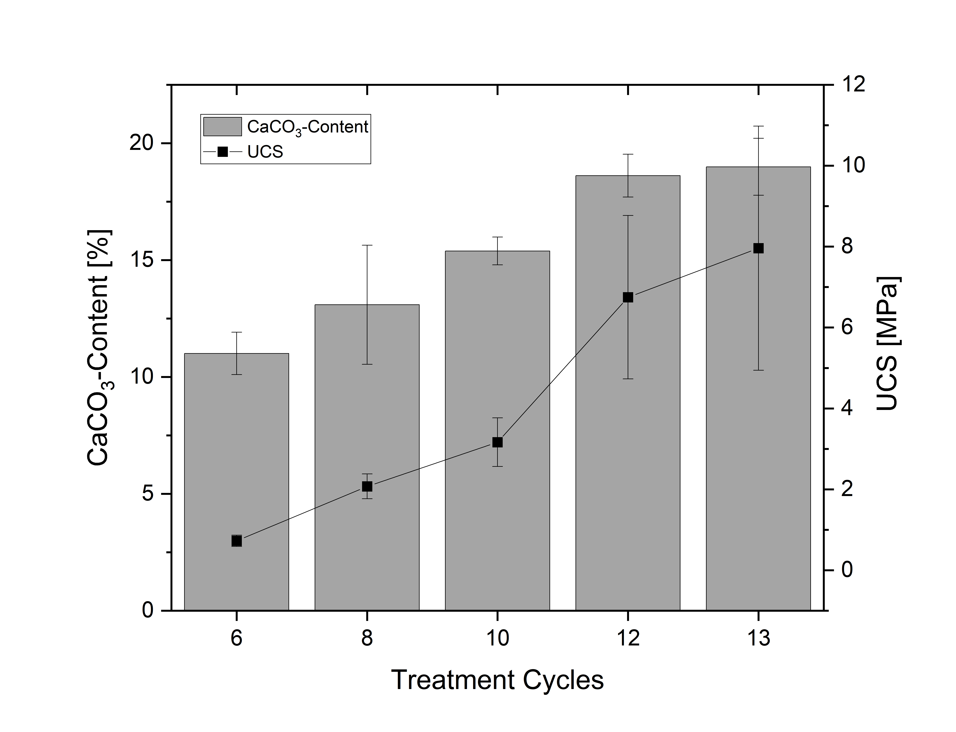
Supplement 7: Calcium carbonate content and UCS of sand SH treated with MICP

Supplement 8: Tasklist 1 - without filter
Step | Plug-in | Parameters
1 | Reload image
2 | Reload Region of Interest
3 | Reload Clipboard
4 | Comment: Sand and calcite material
5 | Filtering | Contrast enhancement (3D space)
6 | Threshold | Lower grey threshold: 50; upper grey threshold: 255
7 | Despeckle | Sweep (3D Space); Remove all except the largest object
8 | Despeckle | Remove black spackles (3D space); volume: less than 16 voxels; apply to: image
9 | Despeckle | Remove black speckles (2D space); area: less than 2 pixels); apply to: image
10 | Save bitmaps
11 | 3D analysis
12 | Comment: extract pore system
13 | Bitwise operations | Image = NOT Image
14 | Mode: Shrink-wrap (3D space)
15 | Save bitmaps

Supplement 9: Tasklist 1 – gauss filter
Step | Plug-in | Parameters
1 | Reload image
2 | Reload Region of Interest
3 | Reload Clipboard
4 | Comment: Sand and calcite material
5 | Filtering | Gaussian blur (3D space); Kernel: round; radius 1.0
6 | Filtering | Contrast enhancement (3D space)
7 | Threshold | Lower grey threshold: 50; upper grey threshold: 255
8 | Despeckle | Sweep (3D Space); Remove all except the largest object
9 | Despeckle | Remove black spackles (3D space); volume: less than 16 voxels; apply to: image
10 | Despeckle | Remove black speckles (2D space); area: less than 2 pixels); apply to: image
11 | Save bitmaps
12 | 3D analysis
13 | Comment: extract pore system
14 | Bitwise operations | Image = NOT Image
15 | Mode: Shrink-wrap (3D space)
16 | Save bitmaps

Supplement 10: Tasklist 1 – non local means filter. non-local means filtering was applied before use in CTAn by using Fiji and NLM plug-in. There sigma=15 was applied
Step | Plug-in | Parameters
1 | Reload image
2 | Reload Region of Interest
3 | Reload Clipboard
4 | Comment: Sand and calcite material
5 | Filtering | Contrast enhancement (3D space)
6 | Threshold | Lower grey threshold: 50; upper grey threshold: 255
7 | Despeckle | Sweep (3D Space); Remove all except the largest object
8 | Despeckle | Remove black spackles (3D space); volume: less than 16 voxels; apply to: image
9 | Despeckle | Remove black speckles (2D space); area: less than 2 pixels); apply to: image
10 | Save bitmaps
11 | 3D analysis
12 | Comment: extract pore system
13 | Bitwise operations | Image = NOT Image
14 | Mode: Shrink-wrap (3D space)
15 | Save bitmaps

Supplement 11: Tasklist 2- all samples
Step | Plug-in | Parameters
1 | Comment: Analysis pore system
2 | Thresholding: global | Lower grey threshold: 1; Upper grey threshold: 255
3 | Despeckle | Remove white speckles (2D space); Area: more than 350 000 pixels; apply to: image
4 | Despekle | Remove white speckles (3D); Volume: less than 50 voxels; Apply to: image
5 | Save bitmaps
6 | Comment: Conneced ore system
7 | Bitwise operations | Clipboard = COPY Image
8 | Despeckle | Sweep (3D Space); Remove: all exept the largest object; Apply to: Image
9 | 3D-Analysis
10 | Save bitmaps
11 | Comment: Analysis not connected pores
12 | Bitwise operations | Image = COPY Clipboard
13 | Despeckle | Sweep (3D Space); Remove: the largest object; Apply to: image
14 | Save bitmaps
15 | Individual object analysis

