Supplementary Information for:
Perceptual Attention and Subjective Belief about Risk Alters Heartbeat-evoked Response
Su Hyun Bong¹, Dayoung Yoon¹, Jaewon Kim¹, Bumseok Jeong^{1, 2}*
¹Graduate School of Medical Science and Engineering, Korea Advanced Institute of Science and Technology (KAIST), Daejeon, South Korea
²KI for Health Science and Technology (KIHST), Korea Advanced Institute of Science and Technology (KAIST), Daejeon, Republic of Korea

Contents:
- Supplementary Figures
- Supplementary Tables
- Supplementary Methods & Results
- Supplementary References
1. Supplementary Figures
Fig. S1. Psychometric parameter estimates and fitted psychometric functions (Heart rate discrimination task). Our results are similar to that of Legrand et al. (2022), which shows that participants underestimate their heart rate on average. (a) The raincloud plot illustrates threshold and slope parameters estimated from post-hoc fitting. The grey lines connect each individual. (b) The grey lines show individual subject fits. The red and blue lines show psychometric functions. Figures were created using the cardioception package.

Fig. S2. HDI plot of five parameters of the “EWMV” model. The inclusion of zero within the Highest Density Interval (HDI) is interpreted as indicative of a lack of significant difference between the two distributions under examination.
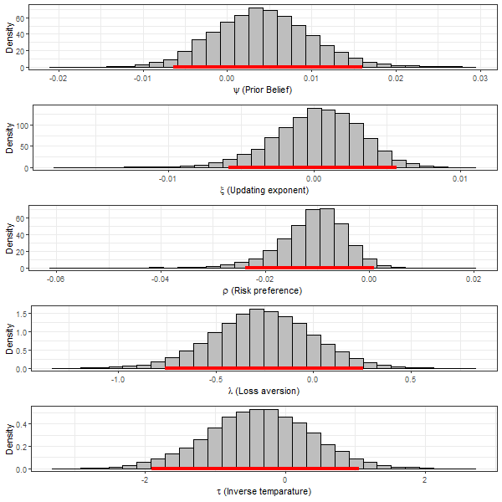

Fig. S3. Correlation matrix. The figure shows a map of Pearson’s correlation between PHQ-9, MAIA total score, and parameters estimated from the computational modeling of Balloon analogue risk task (BART) through HBA (hierarchical Bayesian analysis). phi=ψ (Prior belief), eta=ξ (Updating exponent), rho=ρ (Risk preference), lambda=λ (Loss aversion), tau=τ (Inverse temperature) from EWMV model. The number represents Pearson’s correlation coefficients. Bold: Corrected P < 0.05 under Bonferroni correction.
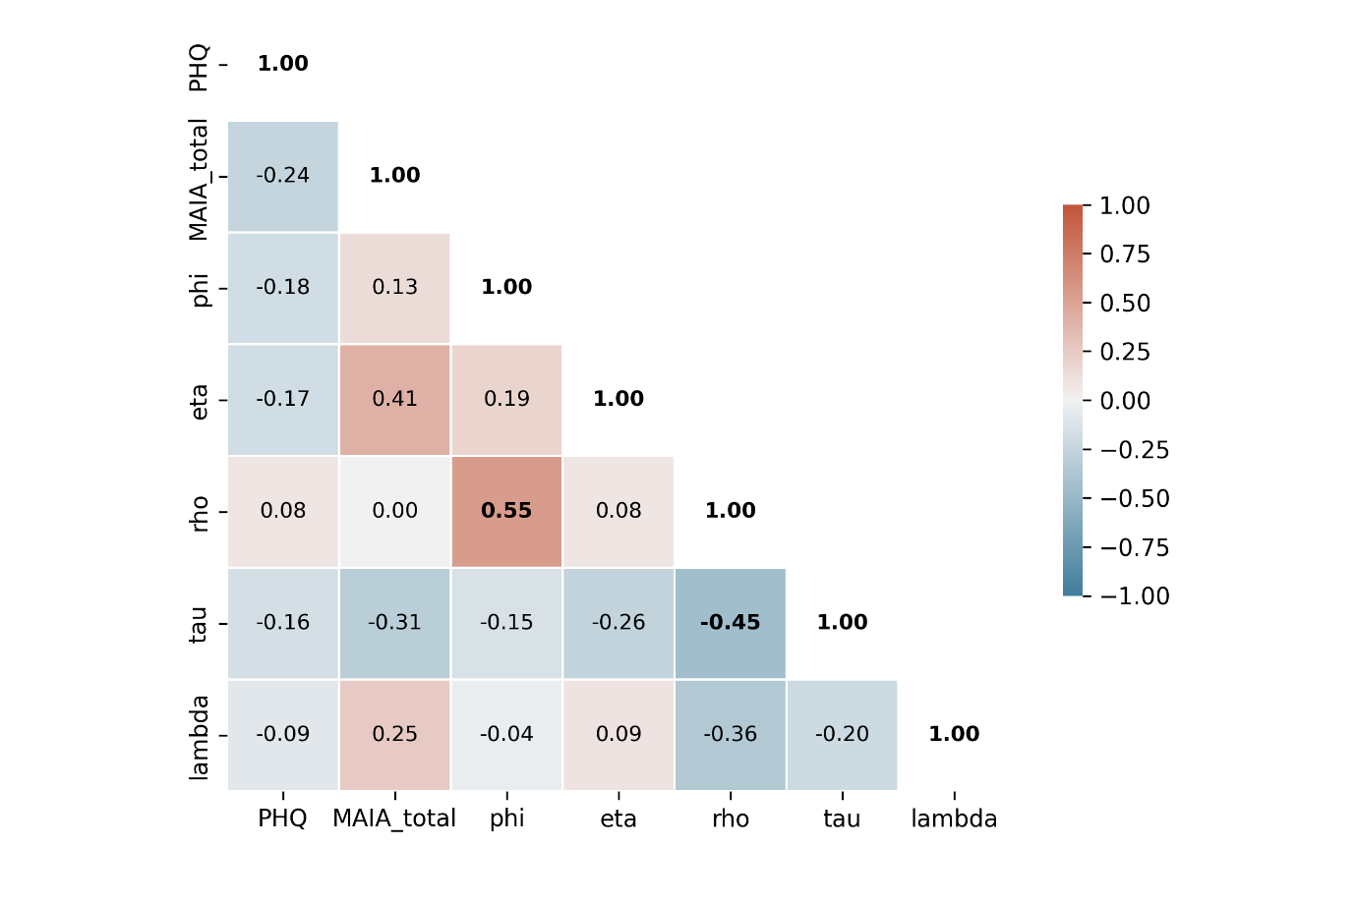

Fig. S4. Parameter simulation and recovery of the “EWMV” model. $phi=ψ\left(Prior belief\right), eta=ξ\left(Updating exponent\right), rho=ρ\left(Risk preference\right), lambda=λ\left(Loss aversion\right), tau=τ(Inverse temperature)$
Fig. S5. Posterior predictive of the “EWMV” model in BART. Blue line is the same as y = x, for comparing the regression line (red).
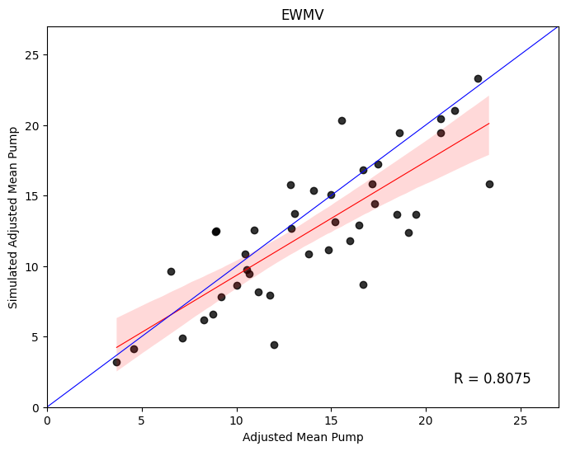

Fig. S6. Spatiotemporal map of the GLM result (Post-hoc analysis on ERP during BART and “One more step” task). The red(t>0) / Blue(t<0) zone appears significant after clustering correction

Fig. S7. Correlation analysis between individual mean heart rate and mean HER amplitude across 3 tasks. The red line represents the regression line.

2. Supplementary Tables
Table S1. Leave-one-out information criterion for each model and task
Model | BART | “One more step” task
Par4 | 4127.399 | 3799.772
Bias | 4278.095 | 3872.087
EWMV | 4125.168 | 3727.82

Table S2. Difference between BART and the “One more step” task on five parameters of the “EWMV” model. The inclusion of zero within the Highest Density Interval (HDI) is interpreted as indicative of a lack of significant difference between the two distributions under examination.
 | 95% HDI
Prior belief | [-0.006, 0.016]
Updating exponent | [-0.006, 0.006]
Risk preference | [-0.024, 0.001]
Loss aversion | [-0.758, 0.253]
Inverse temperature | [-1.908, 1.059]

Table S3. GLM analysis on HER(ERP) difference during HRD (“Exteroception” – “Interoception”) and 8 sub-scales of K-MAIA. Bold marks the electrodes that had the highest stat value.
 | Number of significant clusters | Latency for maximum t value (ms) | Time window for significant clusters (ms) | Maximum t value | Corrected p value | Electrodes within clusters
Attention regulation | Cluster 1 | 256 | 252–272 | 8.083 | 0.017 | T7 TP7 CP5 P7 P5 PO7 PO5 PO3 CB1 O1
 | Cluster 2 | 340 | 332–348 | 8.520 | 0.004 | C5 C3 C6 T8 TP7 CP3 CP1 CP6 TP8 P7 P5 PZ P2 P4 P6 P8 PO7 PO5 PO3 POZ PO4 PO6 PO8 CB1 O1 OZ O2 CB2
Emotional awareness | Cluster 1 | 200 | 200–236 | 11.039 | 0.001 | FP1 FPZ FP2 AF3 AF4 F7 F5 F1 FZ F2 F4 F6 F8 FC5 FC3 FC1 FCZ FC2 FC4 FC6 FT8 C5 C3 C1 CZ C2 C4 C6 T8 CPZ CP2 CP4 TP8 P1 P2 P4 P6 P8 PO7 PO5 PO3 POZ PO4 PO6 PO8 CB1 O1 OZ O2 CB2
 | Cluster 2 | 272 | 264–276 | 6.244 | 0.042 | TP8 P4 P6 P8 POZ PO4 PO6 PO8 OZ O2 CB2
Not distracting | Cluster 1 | 376 | 356–384 | 10.5523 | 0.001 | CP1 CPZ CP2 CP4 CP6 P3 P1 PZ P2 P4 P6 PO5 PO3 POZ PO4 PO6 PO8 OZ O2 CB2
Noticing | Cluster 1 | 228 | 208–256 | 12.598 | 0.05 | FPZ FP2 AF4 F2 F4 F6 F8 FCZ FC2 FC4 FC6 FT8 C1 CZ C2 C4 C6 T8 TP7 CP3 CP1 CPZ CP2 CP4 CP6 TP8 P7 P5 P3 P1 PZ P2 P4 P6 P8 PO7 PO5 PO3 POZ PO4 PO6 PO8 CB1 O1 OZ O2 CB2
 | Cluster 2 | 540 | 532–540 | 6.340 | 0.001 | CZ CP1 CPZ CP2 CP4 CP6 P1 PZ P2 P4 P6 POZ PO4 PO6 PO8 OZ O2 CB2
Self-regulation | Cluster 1 | 340 | 320–348 | 8.913 | 0.001 | CP2 CP4 CP6 TP8 P7 P5 P1 PZ P2 P4 P6 P8 PO7 PO5 PO3 POZ PO4 PO6 PO8 CB1 O1 OZ O2 CB2
Body listening | NA
Not worrying | NA
Trusting | NA

Table S4. GLM analysis on HER(ERSP) during BART and “One more step” task, with regressor “Belief.” Bold marks the electrodes & frequency which had the highest stat value.
 | Number of significant clusters | Latency for maximum t value (ms) | Time window for significant clusters (ms) | Frequency window for significant clusters (Hz) | Maximum t value | Corrected p value | Electrodes within clusters
“Pump” | Cluster 1 | 500 | 476–548 | 7–8(7) | 3.451 | 0.035 | FC2 FC6 CZ C2 C4 C6 CP3 CP1 CPZ CP2 CP4 CP6 TP8 P7 P5 P3 P1 PZ P2 P4 P6 P8 PO7 PO5 PO3 POZ PO4 PO6 CB1 O1
 | Cluster 2 | 276 | 204–312 | 13–26(19) | -4.155 | > 0.001 | FP1 FPZ FP2 AF3 F5 F3 F1 FZ F2 F4 F6 F8 FT7 FC5 FC3 FC1 FCZ FC2 FC4 FC6 FT8 T7 C5 C3 C1 CZ C2 C4 C6 T8 TP7 CP5 CP3 CP1 CPZ CP2 CP4 CP6 TP8 P7 P5 P3 P1 PZ P2 P6 P8 PO7 PO5 PO3 POZ PO4 PO6 PO8 CB1 O1 OZ O2 CB2
 | Cluster 3 | 440 | 428–448 | 26–30(26) | 4.128 | > 0.001 | FP1 FPZ FP2 AF3 F7 F1 FZ F2 F4 F6 F8 FT7 FC5 FC3 FC1 FCZ FC2 FC4 FC6 FT8 T7 C5 C3 C1 CZ C2 C4 CP5 CP3 CP1 CPZ CP2 CP4 CP6 P3 P1 PZ P2 P4 P6 P8 POZ PO4 PO6 PO8 OZ O2 CB2

Table S5. Post-hoc analysis on ERP during BART and “One more step” task. Bold marks the electrodes having the highest stat value.
Contrast | Number of significant clusters | Latency for maximum t value (ms) | Time window for significant clusters (ms) | Maximum t value | Corrected p value | Electrodes within clusters
“Pump”- “Explosion” | Cluster 1 | 64 | 40–272 | -5.399 | 0.034 | FP1 FPZ FP2 AF3 AF4 F7 F5 F3 F1 FZ F2 F4 F6 F8 FT7 FC5 FC3 FC1 FCZ FC2 FC4 FC6 FT8 T7 C5 C3 C1 CZ C2 C4 C6 T8 TP7 CP5 CP3 CP1 CPZ CP2 CP4 CP6 TP8 P7 P5 P3 P1 P2 P4 P6 P8 PO7 PO5 PO3 POZ PO4 PO6 PO8 CB1 O1 OZ O2 CB2
 | Cluster 2 | 552 | 276–696 | -6.578 | 0.01 | FP1 FPZ FP2 AF3 AF4 F7 F5 F3 F1 FZ F2 F4 F6 F8 FT7 FC5 FC3 FC1 FCZ FC2 FC4 FC6 FT8 T7 C5 C3 C1 CZ C2 C4 C6 T8 TP7 CP5 CP3 CP1 CPZ CP2 CP4 CP6 TP8 P7 P5 P3 P1 PZ P2 P4 P6 P8 PO7 PO5 PO3 POZ PO4 PO6 PO8 CB1 O1 OZ O2 CB2
“Pump”-“Cash out” | Cluster 1 | 368 | 4–700 | -7.021 | 0.003 | FP1 FPZ FP2 AF3 AF4 F7 F5 F3 F1 FZ F2 F4 F6 F8 FT7 FC5 FC3 FC1 FCZ FC2 FC4 FC6 FT8 T7 C5 C3 C1 CZ C2 C4 C6 T8 TP7 CP5 CP3 CP1 CPZ CP2 CP4 CP6 TP8 P7 P5 P3 P1 PZ P2 P4 P6 P8 PO7 PO5 PO3 POZ PO4 PO6 PO8 CB1 O1 OZ O2 CB2
“Pump”-  “One more step” | Cluster 1 | 140 | 108–332 | -5.883 | 0.017 | FP1 FPZ FP2 AF3 AF4 F7 F5 F3 F1 FZ F2 F4 F6 F8 FT7 FC5 FC3 FC1 FCZ FC2 FC4 FC6 FT8 T7 C5 C3 C1 CZ C2 TP7 CP5 CP3 CP1 CPZ CP2 CP4 CP6 TP8 P7 P5 P3 P1 PZ P2 P4 P6 P8 PO7 PO5 PO3 POZ PO4 PO6 PO8 CB1 O1 OZ O2 CB2

3. Supplementary Results- Computational modeling of BART and “One more step” task
In this section, we describe the results of model selection, parameter estimation, and simulation-based parameter recovery, along with posterior predictive checks conducted through Hierarchical Bayesian Analysis (HBA) on behavioral data from the Balloon Analogue Risk Task (BART) and the “One more step” task. The “One more step” task is a variant of BART, designed to predict an individual's response to the exposure of an unavoidable additional risk factor. Specifically, in the conventional BART, if a participant chooses to stop pumping the balloon, they cannot observe the subsequent state of the balloon, and the next trial begins. However, in the “One more step” task, participants are provided with the opportunity to safely obtain information about what state the balloon would have been in had they chosen to pump it once more.
In the analysis of behavioral data from the 42 participants, the “Exponential-Weight Mean-Variance” (EWMV) model was found to be the best fitting model for both BART and ‘One more step’ task (see Table S1). The EWMV model employs five parameters: ψ (Prior belief), ξ (Updating exponent), ρ (Risk preference), λ (Loss aversion), and τ (Inverse temperature) to describe individual behaviors. We aimed to investigate whether the loss aversion tendency and subjective belief about risk have been associated with interoceptive neural computation and whether the decision-making process according to utility is linked to Event-Related Potentials (ERP). Therefore, parameters estimated from the "EWMV" model, specifically loss aversion (λ), belief, and utility regressors, were used in subsequent analyses.
Subsequently, to examine the impact of the “One more step” process on the parameters of the EWMV model, we calculated the difference in the posterior distributions of group-level parameters estimated from the BART and the “One more step” task and computed the 95% Highest Density Interval (HDI) for these differences. The HDIs for all parameters encompassed zero, indicating that there were no significant differences in the parameters between conducting BART and the “One more step” task (see Table S2 & Fig. S2). Lastly, the inferred parameters did not show a correlation with either Depression (PHQ-9) or Interoceptive Awareness (K-MAIA) scales (See Fig. S3).
For parameter recovery testing and posterior predictive checks, simulated data were generated based on the individual posterior mean values estimated from the EWMV model as individual parameters. To conduct the parameter recovery simulation, separate simulated data were generated for BART and “One more step” tasks. This data was then used to refit the model and attempt to recover the parameters. Simulations were conducted based on the same max pump numbers and trial counts as the actual experiment. Correlation analysis between “recovered parameters” and “true parameters” was performed to evaluate performance. Fair parameter recovery performance was observed for both tasks (see Fig. S4).
For the posterior predictive check, a correlation analysis was conducted between the observed adjusted mean pump for each participant and the adjusted mean pump calculated from the simulation data. The adjusted mean pump is calculated as the average number of pumps in trials where the balloon did not burst. The EWMV model showed good prediction capability (Pearson’s R = 0.8075, see Fig. S5).

