Supplementary Material (Supp. Fig 1-3)
Genomic variation in Plasmodium relictum (lineage SGS1) and its implications for avian malaria infection outcomes: insights from experimental infections and genome-wide analysis

Kalbskopf V, Aželytė J2, Palinauskas* and Hellgren O*

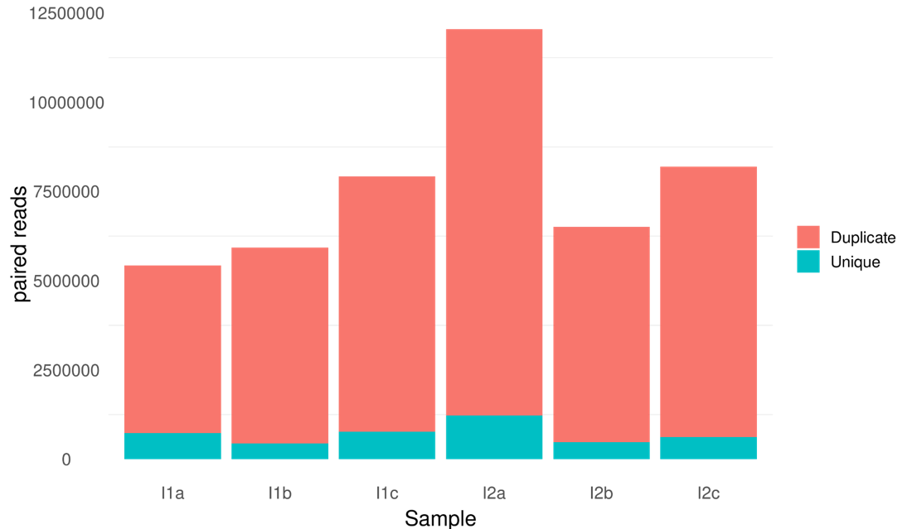
Supplementary Figure 1. Graph of parasite reads present in each sample after filtering, representing table 1.

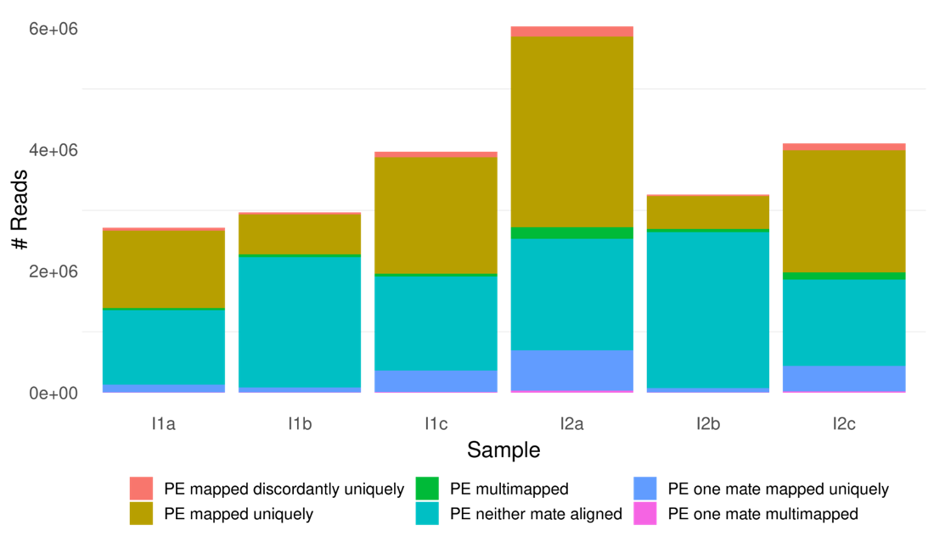
Supplementary Figure 2. Graph of mapping statistics for each sample. Discordant mappings occur when one read in a pair maps further away than the expected insert size, especially when they map to different chromosomes. Multimapping is caused by a lack of unique mapping coordinates.

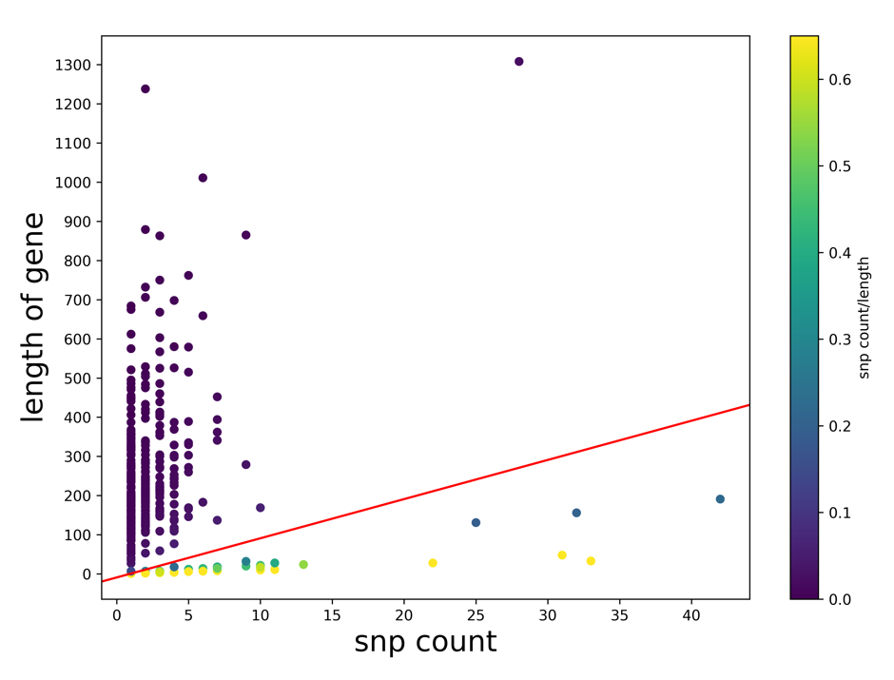
Supplementary Figure 3. Plot of the length of each alignment vs the number of SNPs in that alignment. Alignments with a ratio of 0.1 SNPs per nucleotide or greater (below the red line) were removed from further analysis as they were considered to be uninformative.

