

Participant Information Sheet - CONSULTEE
Final Version 3.0 6th March 2020

IRAS Project ID: 256110

Title of Study: Pilot Randomised Evaluation of Singing in Dementia

Name of Chief Investigators: Professor Justine Schneider & Professor Martin Orrell

Invitation
Your relative (it could also be a friend or someone you care for, but for brevity this document will use the term ‘relative’) is being invited to take part in a research study. Before you decide whether you agree to their participation it is important for you to understand why the research is being done and what it will involve. One of our team will go through the information sheet with you and answer any questions you have. Talk to others about the study if you wish. Ask us if there is anything that is not clear or if you would like more information.

Who can act as a consultee?
Where people cannot take the decision to consent to be involved in a research project then a consultee must be appointed. A consultee can either be ‘personal’ or ‘nominated’. A personal consultee is someone unconnected with the research who knows the potential research participant in a personal capacity and is able to advise on the person’s wishes or feelings. This can be a friend, family member or court appointee. A ‘nominated’ consultee’ is someone unconnected with the research, appointed by the researcher, to advise the researcher about the person’s wishes and feeling in relation to the project. This can be another health-care worker but they must not have any connection with the study. Before a nominated consultee is appointed, the researcher will take all reasonable steps to identify a personal consultee.

What is the role of the consultee?
The consultee advises the researcher on what the participant’s wishes and feelings would be if they were able to consent for themselves, and on whether they should take part. The consultee does not give consent, only advice. The responsibility to decide whether the participant should be entered into the research lies ultimately with the researcher. Consultees will be provided with information about the research project and will be given the opportunity to discuss it and their role as consultee. All consultees must be able to understand their role and be willing to undertake it.

When your relative first started taking part in the study, they had capacity to provide their own informed consent. Assessing capacity is a process rather than a one-time decision, and the researcher has judged that your relative does not currently have capacity to decide to continue taking part in the study. Consequently, we are seeking your advice as consultee.

What is the purpose of the study?
The purpose of the study is to investigate whether group singing has benefits for people with dementia and their carers. This is a feasibility study, which means that the data we collect will be used to plan a larger-scale study in the future. We want to find out whether this study design will work in the real world.

Why has my relative been chosen?
Your relative was invited to take part because they have been diagnosed with dementia, and they have a carer who can attend singing group sessions with them. We are inviting 80 participants like your relative to take part, along with their carers.

Does my relative have to take part?
We would like you to think very carefully about whether or not this person would have wanted to continue in the study. If your opinion is that he/she would have decided to continue to take part, you would be given this information sheet to keep and be asked to sign a declaration form indicating your view allowing your relative to continue to participate in the study. You can either sign the declaration form straight away or take some time to decide, and return the form by post. If you don’t return the form, a researcher will give you a call to see whether we should collect the form in person, or if you think your relative would prefer not to take part. If you later decide that he/she no longer wishes to take part, please inform us and he/she will be withdrawn from the study. You do not need to give a reason and it will not affect the standard of care your relative receives.

Your relative does not have to have any experience of singing to take part in this study and they will not be judged on their voice or musical abilities.

What will happen to my relative if they take part?
If your relative takes part in the study, a researcher will arrange to come and visit them at a time that is convenient to them. The researcher will collect some information, such as their age and diagnosis. The researcher will also ask them to complete some questionnaires about things like their quality of life, mood, memory, and ability to do everyday activities. These will be completed at a pace that suits your relative, with time for breaks if they are needed. In total this visit will take approximately two hours.
Everyone who takes part in the study will be invited to attend a singing group once a week for 10 weeks. Your relative and their carer will either be invited to attend a singing group straight away, or will be asked to wait for 12 weeks before starting. Whether your relative attends straight away or waits will be decided randomly, so they will not get to choose. If they are asked to wait for 12 weeks, we will also ask them not to go to any other organised singing activities during that time (with the exception of religious services or meetings).
The singing group sessions will be free to attend and will take place weekly. Each session will last approximately two hours, but not all of this time will be spent singing as there will be time for refreshments and socialising. The sessions will be led by someone who has a lot of experience of leading similar groups. Your relative will have the chance to join in singing familiar songs as well as new ones, and to suggest songs they would like to sing. Your relative can take part in whatever way suits them, and join in as much or as little as they like.
Although every effort will be made to hold the singing groups in places and at times which are convenient for participants, there is a possibility that coming to the group will not be convenient for everyone.
If your relative can’t attend one of the sessions for some reason (for example, they are unwell or have another appointment) that’s fine, and they can just come to the session the next time they are able to. The researcher may ask why your relative couldn’t attend but they do not have to say if they don’t want to. Once your relative and their carer have attended the singing group for 10 weeks, they do not have to keep on attending but they both can if they want to.
Your relative will receive two more visits from a researcher, three months and six months after the first visit. The researcher will ask them to complete the same questionnaires as at the first visit. Each of these visits will also last approximately two hours.
The flowchart below shows what will happen during the study.

Flowchart showing participant timeline in study
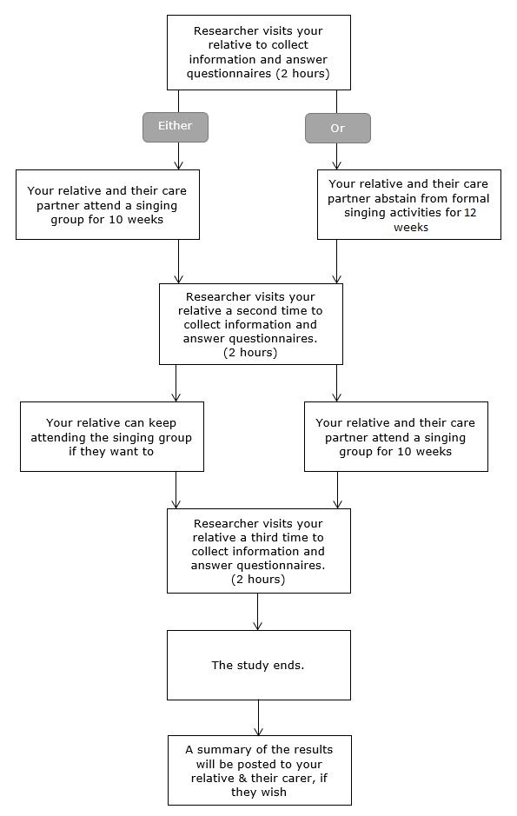

Expenses and payments
Your relative will not be paid to participate in the study. The singing groups will be free to attend during the study.

What are the possible disadvantages or risks of taking part?
The questionnaires which will be used in the study can be time-consuming, which your relative may find burdensome or inconvenient. Some people find that answering certain kinds of question causes distress, especially questions about memory problems and dementia.

Some people will attend the singing group immediately, and others will wait for 12 weeks before attending. This means that if your relative is in the waiting group, they will not experience any potential benefits of singing as soon as those who attend straight away. However, everyone who participates in the study will eventually have the opportunity to attend a singing group.

People respond to singing in different ways, and there is a possibility that your relative may find the singing group disagreeable. For example, they might find it overstimulating or have a strong emotional response to the singing. Your relative is free to leave the group at any time during the session should this be the case, and we will try to provide a quiet space for this purpose.

What are the advantages of taking part?
We cannot promise the study will help your relative but the information we get from this study may help us to understand the benefits which singing has for people with dementia. This will contribute to making singing more accessible to other people with dementia in the future.

Many people find that singing is a fun and enjoyable activity, and research has shown that coming to a singing group may have benefits for the mood and cognition of people with dementia. There is also evidence that group singing strengthens the relationship between people with dementia and carers.

What happens when the research study stops?
After they have attended the singing group for 10 weeks, your relative is free to stop coming if you wish. Although we cannot continue to fund them we aspire to keep the singing groups running after the study so that so that those who wish to keep on coming may do so. However, the continuation of the groups is not guaranteed. If you consent to us holding your contact information until the study is complete, we will send you a summary of the study results by post. Please tell us if you do not want us to retain your contact information for this purpose.
What if there is a problem?
If you have a concern about any aspect of this study, you should ask to speak to the researchers who will do their best to answer your questions. The researchers contact details are given at the end of this information sheet. If you remain unhappy and wish to complain formally, you can do this by contacting the Patient Experience Team:

Patient Experience Team (PALs)
Moorgreen House
Highbury Hospital
Highbury Vale
Bulwell
Nottingham
NG6 9DR

Tel: 0115 9934542
Mon – Friday 8.30am – 4.30pm (excluding bank holidays)

Email: complaints@nottshc.nhs.uk

Will their taking part in this study be kept confidential?
We will follow ethical and legal practice and all information about your relative will be handled in confidence.

If your relative joins the study, we will use information collected about them during the course of the research. This information will be kept strictly confidential, stored in a secure and locked office, and on a password protected database at the University of Nottingham. Under UK Data Protection laws the University is the Data Controller (legally responsible for the data security) and the Chief Investigator of this study (named above) is the Data Custodian (manages access to the data). This means we are responsible for looking after the information and using it properly. Rights to access, change or move your information are limited as we need to manage the information in specific ways to comply with certain laws and for the research to be reliable and accurate. To safeguard your relatives ‘s rights we will use the minimum personally – identifiable information possible. Complete confidentiality about your relative’s participation in the study cannot be guaranteed because the study will involve attending groups which take place in a public environment.

The University of Nottingham is committed to safeguarding the wellbeing of research participants.

You can find out more about how we use your relative’s information and to read our privacy notice at:

https://www.nottingham.ac.uk/utilities/privacy.aspx.

What will happen to data which is collected during the study?
The data collected for the study will be looked at and stored by authorised persons from the University of Nottingham who are organising the research. They may also be looked at by authorised people from regulatory organisations to check that the study is being carried out correctly. All will have a duty of confidentiality to you as a research participant and we will do our best to meet this duty.

All information which is collected about your relative during the course of the research will be kept strictly confidential, stored in a secure and locked office, and on a password protected database. Any information about your relative which leaves the hospital will have your relative’s name and address removed (anonymised) and a unique code will be used so that they cannot be recognised from it.

As part of the study we will be video recording some of the singing group sessions. We will ask for your permission to be recorded at the start of the session. It will not be possible to anonymise video recorded material. All video recordings will be kept securely on University of Nottingham servers and will only be viewed by members of the research team.

Will the data be shared with anyone else?
Your relative’s personal data (address, telephone number) will be kept for 1 year after the end of the study. All other data (research data) will be kept securely for 7 years. After this time your relative’s data will be disposed of securely. During this time all precautions will be taken by all those involved to maintain your relative’s confidentiality, only members of the research team will have access to their personal data.

In accordance with the University of Nottingham’s, the Government’s and our funders’ policies we may share our research data with researchers in other Universities and organisations, including those in other countries, for research in health and social care. Sharing research data is important to allow peer scrutiny, re-use (and therefore avoiding duplication of research) and to understand the bigger picture in particular areas of research. Data sharing in this way is usually anonymised (so that you could not be identified) but if we need to share identifiable information we will seek your consent for this and ensure it is secure. You will be made aware if the data is to be shared with countries whose data protection laws differ to those of the UK and how we will protect your confidentiality.

What will happen if I do not want my relative to carry on with the study?
Your relative’s participation is voluntary and you are free to withdraw them at any time, without giving any reason, and without their legal rights being affected. If you withdraw your relative, then the information collected so far cannot be erased and this information may still be used in the project analysis.

Involvement of the General Practitioner/Family doctor (GP)
We do not need to inform your relative’s GP about their participation in this study. The only reason we would contact your relative’s GP would be if we believed that there was a risk of harm to them or someone else.

What will happen to the results of the study?
The results of the study will be published in an academic journal after the study has ended. The results will also be shared at a conference. When the results are published, any references to participants will be anonymised so your relative will not be identified in any report or publication. If you consent to us retaining your contact details, we will send you a summary of the results.

Who is organising and funding the research?
This research is being organised by the University of Nottingham and is being funded by the Alzheimer’s Society (Grant Reference: 400)

Who has reviewed this study?
All research in the NHS is looked at by independent group of people, called a Research Ethics Committee, to protect participant’s interests. This study has been reviewed and given favourable opinion by Social Care Research Ethics Committee (reference number: 19/IEC08/0056).

Further information and contact details

Study email address: Preside.Research@nottingham.ac.uk

Research associate:
Becky Dowson
D Floor, Institute of Mental Health
University of Nottingham
Triumph Road
Nottingham
NG7 2TU
Email: Becky.Dowson@nottingham.ac.uk
Tel: 0115 74 84315

Chief investigators:
Justine Schneider
Professor of Mental Health and Social Care
School of Sociology & Social Policy and Institute of Mental Health
University of Nottingham
Law & Social Sciences Building
University Park
Nottingham
NG7 2RD
Email: Justine.Schneider@nottingham.ac.uk
Tel: 0115 846 7307

Professor Martin Orrell
Room D07 Institute of Mental Health
Innovation Park
Triumph Road
Nottingham
NG7 2TU
Email: M.Orrell@nottingham.ac.uk
Tel: 0115 8231291

Thank you for reading this

