- The full uncropped Gels and Blots images
TNF-α:
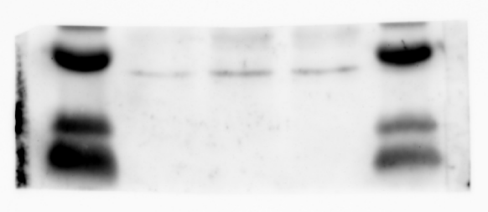
IL-1β:
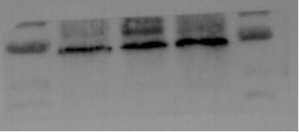
Β-actin:
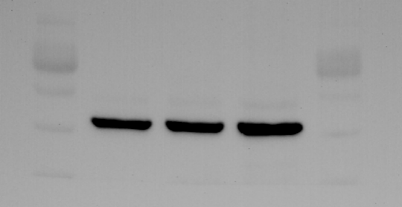
- Availability of data and materials
The authors confirm that the data supporting the findings of this study are available within the article.

