Disrupting Notch signaling related HES1 in myeloid cells reinvigorates antitumor T cell responses

Myung Sup Kim,^{1, 2,} Hyeokgu Kang,¹ Jung-Hwan Baek,^{1, 2} Moon-Gyu Cho,¹ EunJoo Chung,³ Seok-Jun Kim,^{4,5} Joon-Yong Chung,⁶ and Kyung-Hee Chun^{1, 2, *}

¹Department of Biochemistry & Molecular Biology, Graduate School of Medical Science, Brain Korea 21 Project, Yonsei University College of Medicine, Seodaemun-gu, Seoul 03722, Republic of Korea, ²Institute of Genetic Science, Yonsei University College of Medicine, Seodaemun-gu, Seoul 03722, Republic of Korea, ³Radiation Oncology Branch, Center for Cancer Research, National Cancer Institute, National Institutes of Health, Bethesda, MD, 20892, USA, ⁴Department of Biomedical Science, Chosun University, Gwangju 61452, Republic of Korea, ⁵Department of Integrative Biological Sciences & BK21 FOUR Educational Research Group for Age-associated Disorder Control Technology, Chosun University, Gwangju 61452, Republic of Korea, ⁶Molecular Imaging Branch, Center for Cancer Research, National Cancer Institute, National Institutes of Health, Bethesda, MD, 20892, USA.

*Correspondence to: Kyung-Hee Chun, Kyung-Hee Chun, Department of Biochemistry & Molecular Biology, Yonsei University College of Medicine, 50 Yonsei-ro, Seodaemun-gu, Seoul 03722, Korea. Phone: 82-2-2228-1699, E-mail: khchun@yuhs.ac

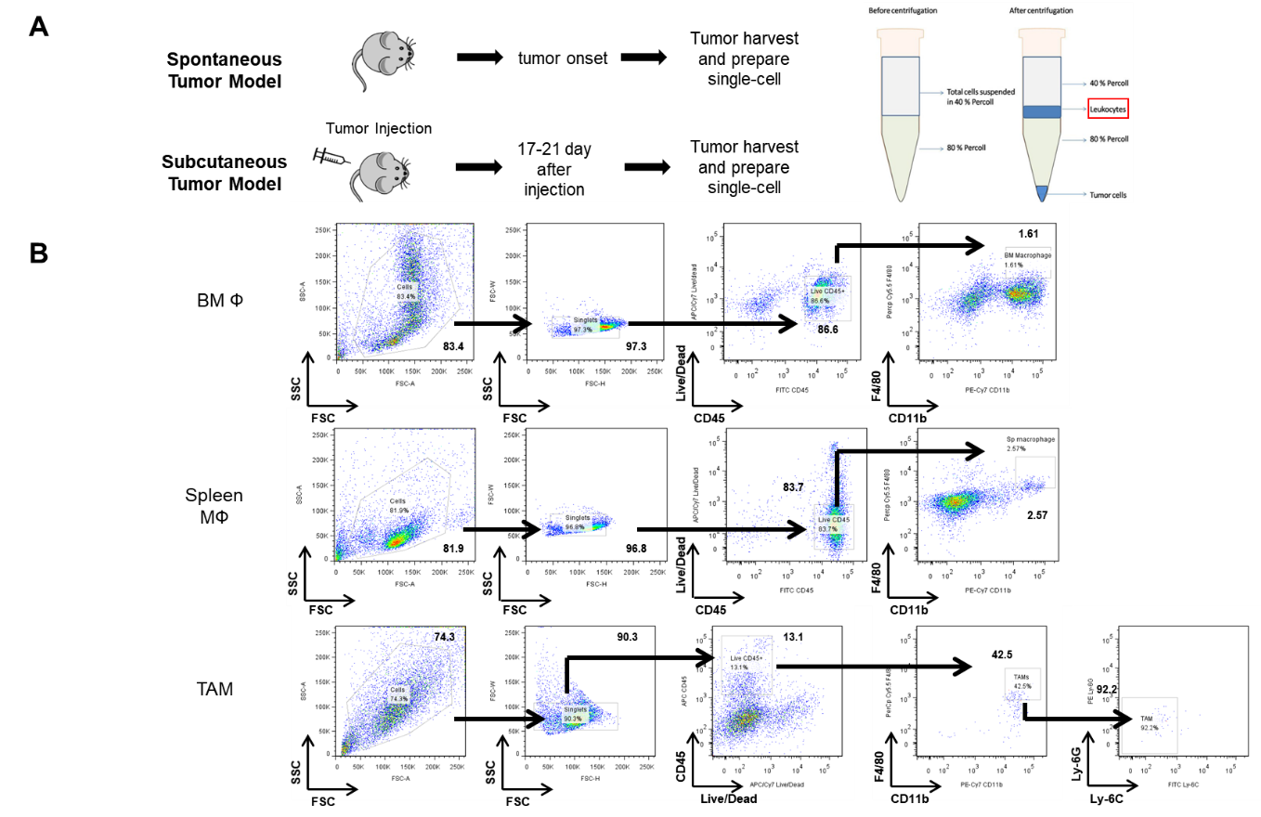
Supplemental Figure S1 The schematic outlines of the process for isolating macrophages from bone marrow, spleen, or tumors. A Single cells are isolated from tumors obtained from either the spontaneous or the subcutaneous murine model and then enriched using a Percoll gradient. B The gating strategy for the isolation of macrophages from bone marrows, spleen, or tumors using flow cytometry.

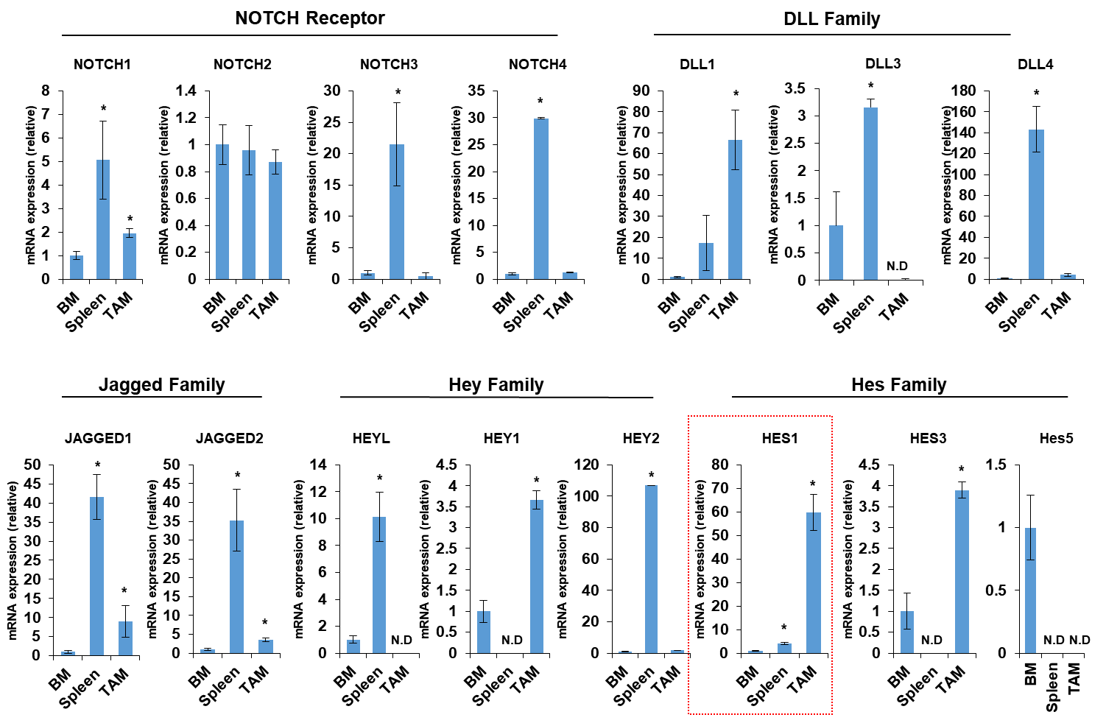
Supplemental Figure S2 Hes1 expression induction in macrophages sorted from tumors of MMTV-PyMT mice. Macrophages are sorted form bone marrow, spleen, or tumors of MMTV-PyMT mice to analyze the differential expression of the genes related to Notch signaling by qRT-PCR.

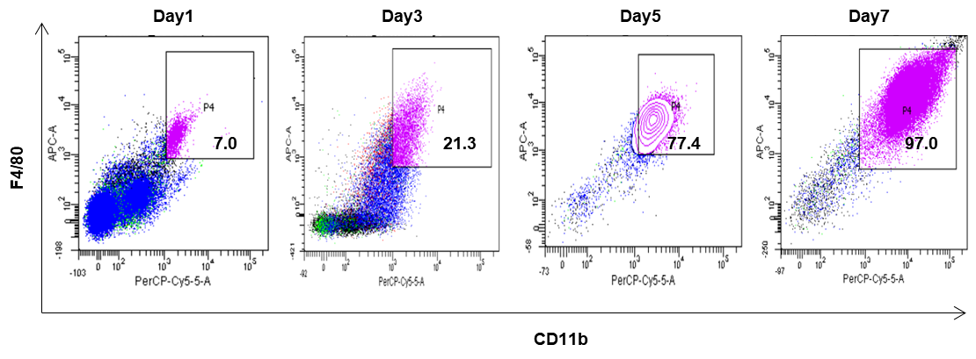
Supplemental Figure S3 Macrophage differentiation from the bone marrow. The bone marrow obtained from normal mice and its differentiation into BMDMs. This data was used to quantify BMDM differentiation in Figure 1D.

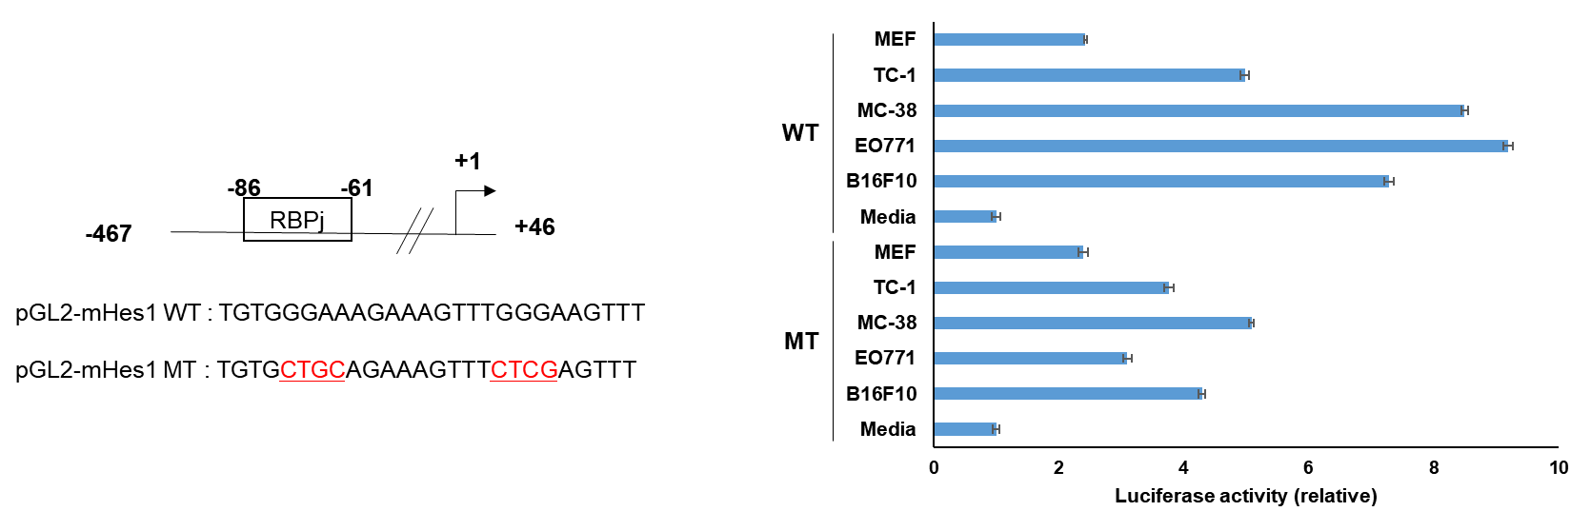
Supplemental Figure S4 The Hes1 promoter sequence is depicted with either the wild-type or mutant RBPJ binding sequence. Consensus RBPJ binding motif was cloned into the pGL2 vector followed by site-directed mutagenesis on the consensus sequence. BMDMs were transfected with appropriate vectors and treated with or without CMs obtained from various murine tumor cell lines. Luciferase activity was normalized to the β-galactosidase activity present in the cell lysate.

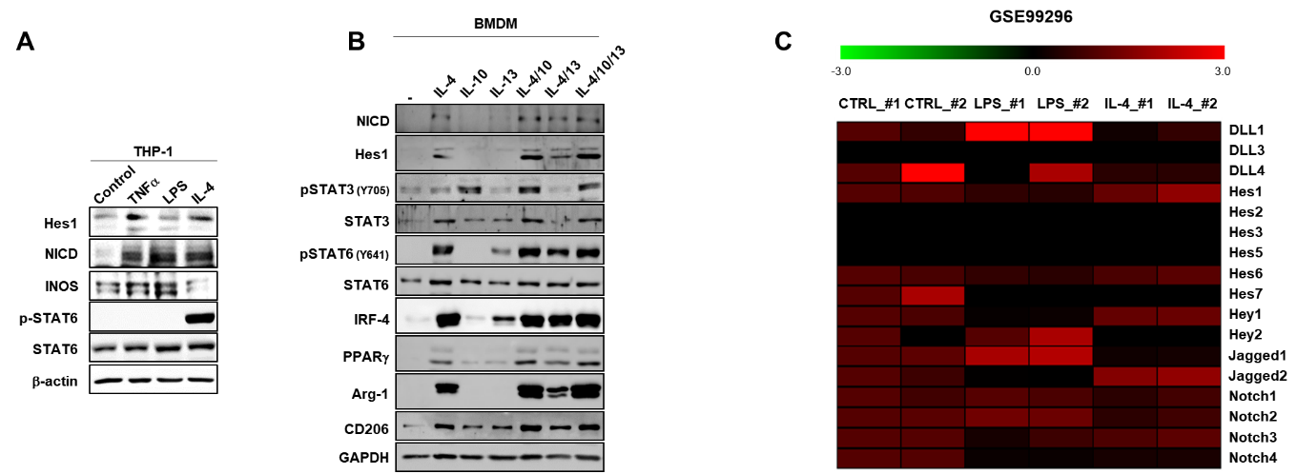
Supplemental Figure S5 The response of HES1 expression in BMDMs to different stimuli. A Western blot analysis of HES1, NICD, INOS, p-STAT6 (Y641) and STAT6 in THP-1 cells stimulated with LPS alone (100 ng/ml), TNF-α (10 ng/ml), or IL-4 (50 ng/ml) for 18 hours. β-actin was used as a loading control. B BMDMs were treated with murine recombinant IL-4 (20 ng/ml), IL-10 (10 ng/ml), IL-13 (20 ng/ml), alone or in combination for 24 hours. Protein levels were detected by Western blotting. GAPDH was used as a loading control. C The expression of the Notch signaling pathway genes was analyzed using RNA sequencing data from GSE99296, which involved treating BMDMs with either LPS or IL-4.

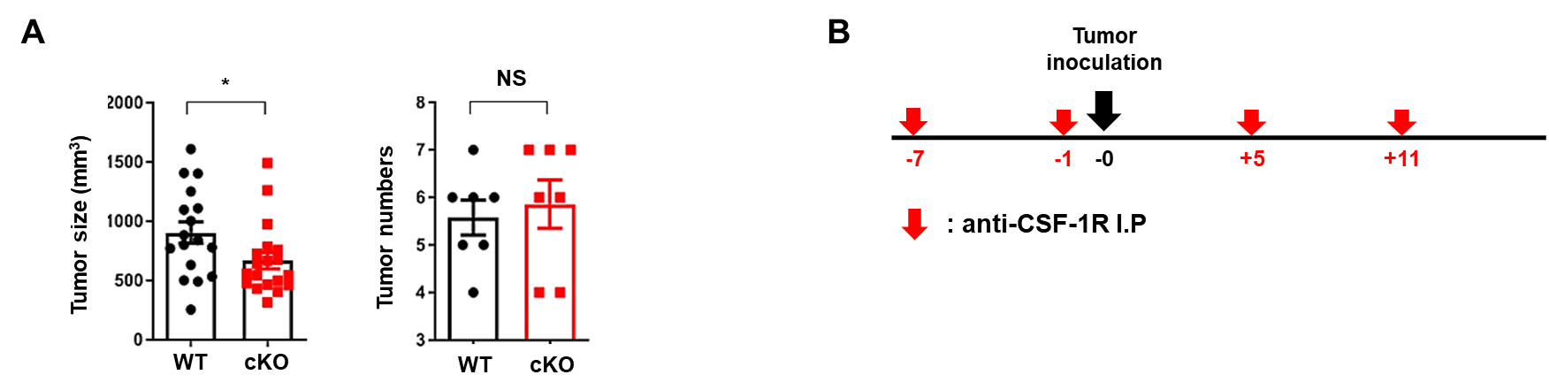
Supplemental Figure S6 Measurement of tumor size and number of spontaneously generated tumors in the MMTV-PyMT mouse model. A LysM-Hes1^{+/+} PyMT (n=4) and LysM-Hes1^{fl/fl} PyMT mice (n=4) were used to measure the size and number of tumors. B Intraperitoneal injection of α-CSF1R antibody with subcutaneous injection of TC-1 tumors.

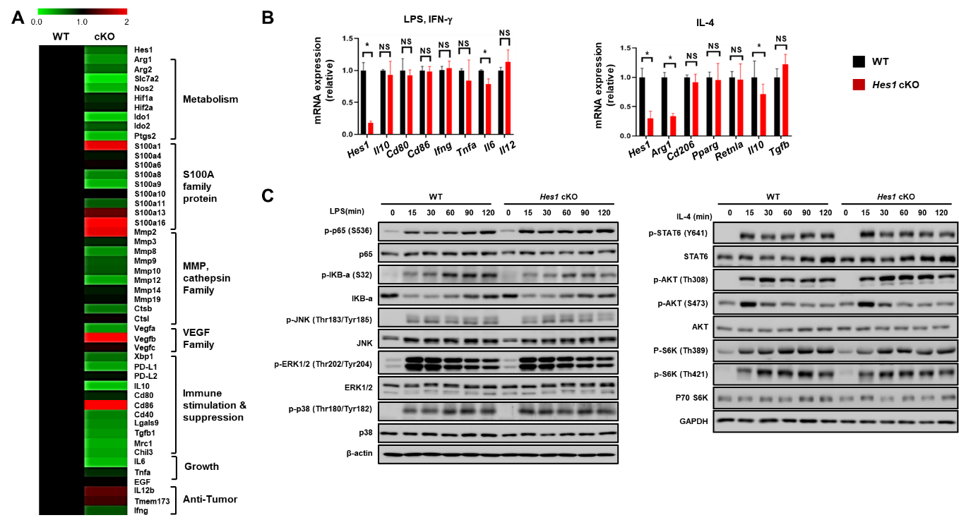
Supplemental Figure S7 HES1 regulates TAM function. A Extended RNA sequencing results from Figure 5A. TAMs are sorted from WT or Hes1 cKO mice with TC-1 tumors. Six to eight-week-old mice were used. B BMDMs were treated with either inflammatory stimuli (100 ng/mL LPS and 20 ng/mL IFNγ) or anti-inflammatory stimuli (20 ng/mL IL-4) for 6 hours. Gene expression levels are analyzed by qRT-PCR and β-actin was used as a loading control. C BMDMs were polarized with either 100 ng/ml LPS or 20 ng/ml IL-4 for 8 hours to measure canonical polarization markers. Protein levels are analyzed by Western blotting and β-actin was used as a loading control.

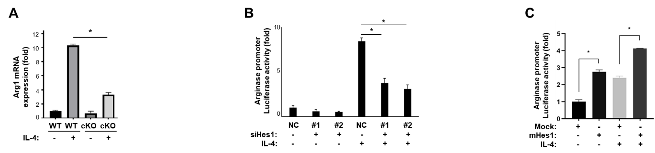
Supplemental Figure S8 Arg1 is regulated by HES1 in IL-4 induced BMDMs. A BMDMs obtained from WT or Hes1 cKO were treated with IL-4 (20 ng/mL) for 8 hours. mRNA for Arg1 was measured by qRT-PCR. B The luciferase activity of BMDMs transfected with the putative HES1 binding sites on the Arg1 promoter was measured after treating them with 20 ng/ml IL-4 for 8 hours. C BMDMs were transfected with Hes1 plasmid and incubated for 24 hours prior to treatment with 20 ng/ml IL-4 for 8 hours.

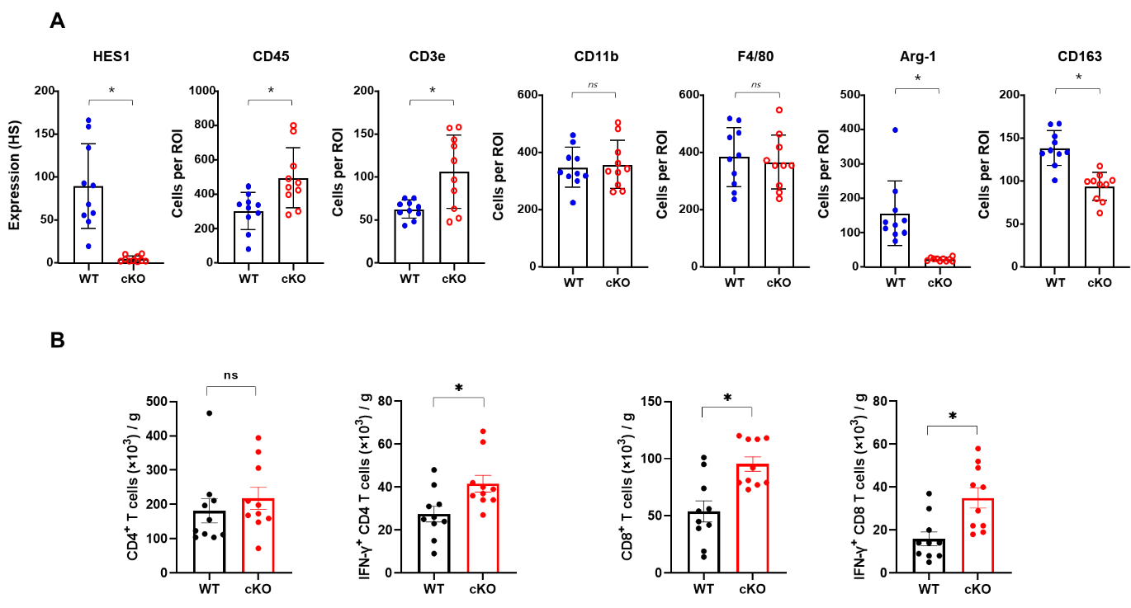
Supplemental Figure S9 The conditional knockout of Hes1 resulted in increased infiltration of cytotoxic T cells into the tumor microenvironment. A Quantified H-score of stained epitopes in Figure 7A analyzed by ImageJ. B The absolute numbers of CD4⁺ T cells, CD8⁺ T cells, IFNγ⁺CD4⁺ T cells, and IFNγ⁺CD8⁺ T cells isolated from TC-1 tumors by flow cytometry

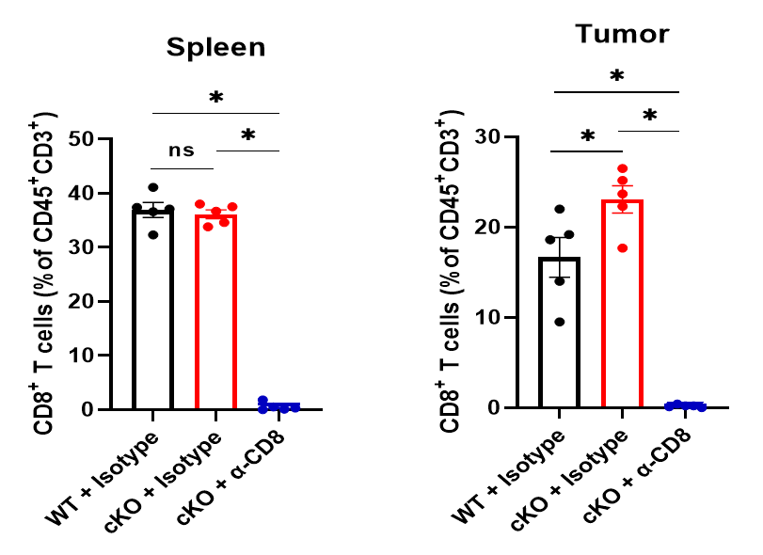
Supplemental Figure S10 Depletion of CD8⁺ T cells by αCD8 antibodies from spleen and TC-1 tumors. Anti-CD8 antibodies effectively deplete CD8⁺ T cells from spleens or tumors of TC-1 tumor-bearing mice.

Authorship notes: Myung Sup Kim and Hyeokgu Kang are co–first authors.

