Supplementary Table 1. Clinical and laboratory features in 80 patients with MDS.
Variables | Patients with MDS (n = 80)
Age in years; median (IQRs) | 60 (48-66)
WBC (×10E+9/L); median (IQRs) | 2.58 (1.63-3.57)
ANC (×10E+9/L); median (IQRs) | 1.04 (0.59-1.57)
Hemoglobin (g/L); median (IQRs) | 78 (65-90)
MCV (fL); median (IQRs) | 95.05 (90.33-99.38)
RDW-CV (%), median (IQRs) | 16.45 (15.03-19.48)
RDW-SD (fL), median (IQRs) | 57.6 (50.6-64.4)
RET (×10E+12/L); median (IQRs) | 0.0324 (0.0153-0.0734)
Platelets (×10E+9/L); median (IQRs) | 56 (30-102)
MPV (fL), median (IQRs) | Evaluable = 48
MPV (fL), median (IQRs) | 11.65 (10.60-12.40)
PDW (fL), median (IQRs) | Evaluable = 50
PDW (fL), median (IQRs) | 13.15 (11.00-16.80)
Blasts in PB (%); median (IQRs) | 0 (0-2.0)
Blasts in BM (%); median (IQRs) | 3.5 (1.0-6.0)
reticulin fibrosis grade ≥ 2; n (%) | 41 (51.2)
Cytogenetics | Evaluable = 77
Abnormal karyotype; n (%) | 54 (67.5)
Complex karyotype; n (%) | 36 (45.0)
TP53 mutation; n (%) | 36 (45.0)
IPSS-R risk category
Very low | 2 (2.6)
low | 12 (15.6)
Intermediate | 14 (18.2)
High | 15 (19.5)
Very high | 34 (44.2)
GATA1 scores (points); median (IQRs) | 7.0 (3.0-12.0)
Abbreviations: MDS, myelodysplastic syndromes; IQRs, interquartile ranges WBC, white blood cell count; ANC, absolute neutrophil count; MCV, mean corpuscular volume; femtoliter, fL; RDW-CV, red cell distribution width-coefficient of variation; RDW-SD, red cell distribution-standard deviation; RET, reticulocyte count; MPV, mean platelet volume; PDW, platelet distribution width; PB, peripheral blood; BM, bone marrow; IPSS-R, revised International Prognostic Scoring System.

Supplementary Table 2. Diagnosis and Karyotypes of 6 patients with MDS.

Subjects | Diagnosis | Karyotype | DNA probes
1 | MDS-EB2 | 46, XX, del(20)(q11.2q13.3)[19]/46,XX[1] | 20p13/D20S108
2 | MDS-EB1 | 46, XX, del(20)(q11.2q13.3)[20] | 20p13/D20S108
3 | MDS-EB2 | 46, XX, t(6;9)(p23;q24),-7,+mar[15]/46,XX[5] | CEP7/D7S486
4 | MDS-EB2 | 38, XX, del(5)(q13q33),-6,-8,-9,-13,-13,-14,-15,-21[1] | D5S721, D5S23/EGR1
5 | MDS-MLD | 46, XY, -3, -5, +8, der(?) t(?;3)(?;q12)[18]/46, XY[2] | D5S721, D5S23/EGR1
6 | MDS-EB2 | 47, XY, +8[20] | CEP8

Abbreviations: MDS-MLD, MDS with multilineage dysplasia; MDS-EB1/2, MDS with excess blasts type 1/2.

Supplementary Table 3. Univariable and multivariable analyses of OS in 80 patients with MDS.
Variable | Univariable analyses |  | Multivariable analyses
Variable | HR (95% CI) | P value | HR (95% CI) | P value
IPSS-R higher risk category* | 3.149 (1.292-7.678) | 0.012 | 3.206 (1.306-7.873) | 0.011
GATA1 scores | 0.883 (0.812-0.960) | 0.004 | 0.886 (0.814-0.965) | 0.005
*IPSS-R higher risk category, IPSS-R scores > 3.5 points.
Abbreviations: OS, overall survival; MDS, myelodysplastic syndromes; IPSS-R, revised International Prognostic Scoring System; HR, hazard ratio; CI, confidence interval.

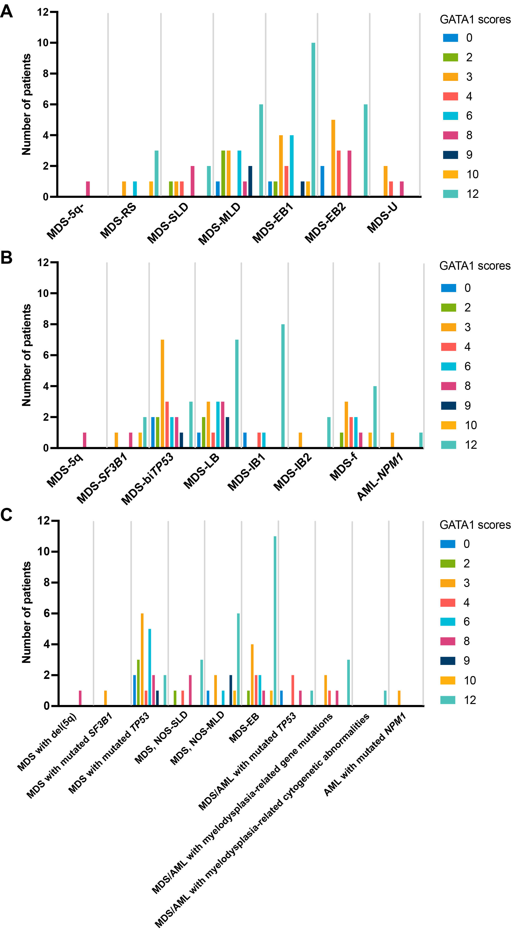
Figure 1. GATA1 scores of patients with different MDS subtypes. A GATA1 scores of patients with different MDS subtypes classified by 2016 WHO classification. B GATA1 scores of patients with different MDS subtypes classified by 2022 WHO classification. C GATA1 scores of patients with different MDS subtypes classified by 2022 ICC.
Abbreviations: MDS, myelodysplastic syndromes; WHO, World Health Organization; ICC, International Consensus Classification; MDS-5q-, MDS with isolated 5q deletion; MDS-RS, MDS with ring sideroblasts; MDS-SLD, MDS with single lineage dysplasia; MDS-MLD, MDS with multilineage dysplasia; MDS-EB1/2, MDS with excess blasts type 1/2; MDS-U, MDS unclassiﬁable; MDS-5q, MDS with low blasts and isolated 5q deletion; MDS-SF3B1, MDS with low blasts and SF3B1 mutation; MDS-biTP53, MDS with biallelic TP53 inactivation; MDS-LB, MDS with low blasts; MDS-IB1/2, MDS with increased blasts type1/2; MDS-f, MDS with ﬁbrosis; AML-NPM1, acute myeloid leukemia with NPM1 mutation; ICC, International Consensus Classification; NOS, not otherwise specified; NOS-SLD, NOS with single lineage dysplasia; NOS-MLD, NOS with multilineage dysplasia; MDS-EB, MDS with excess blasts; MDS/AML, myelodysplastic syndrome/acute myeloid leukemia.

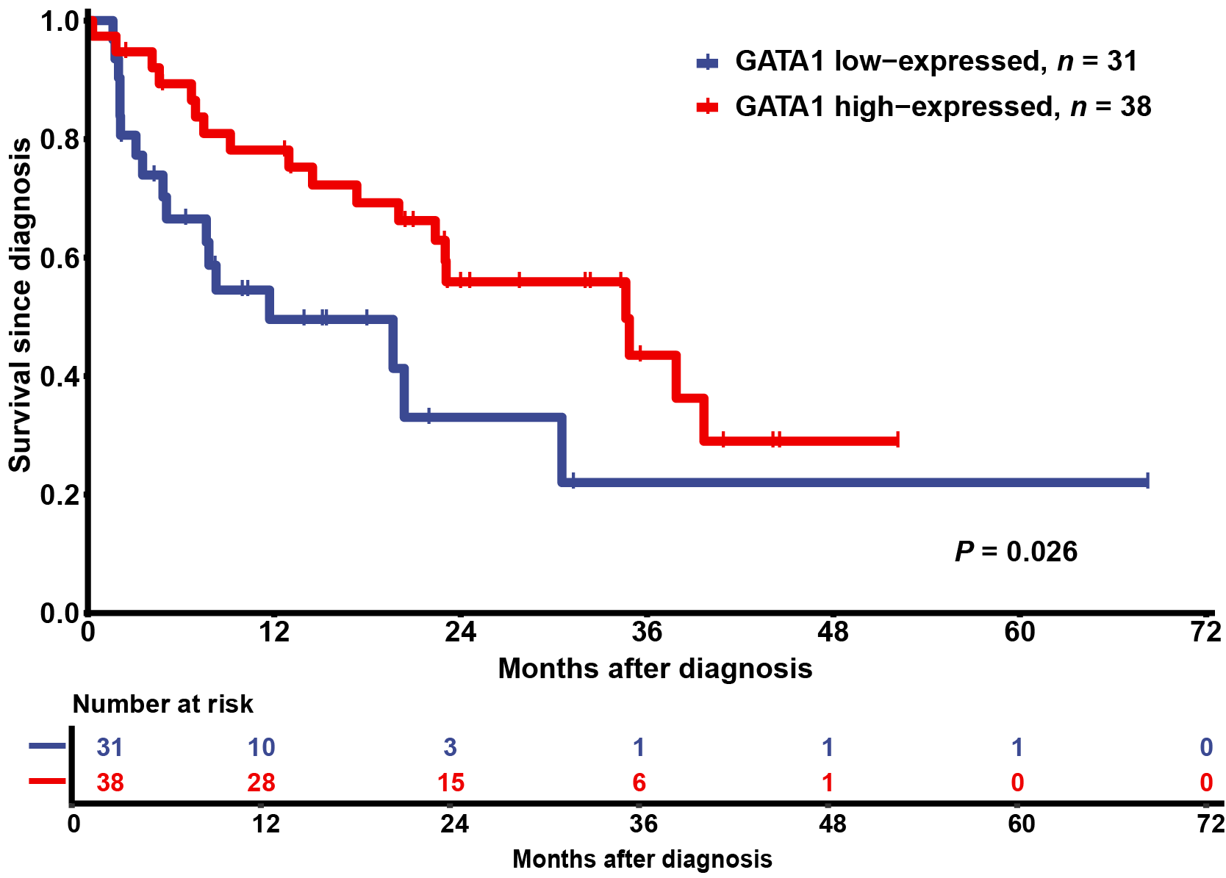
Figure 2. Comparison of overall survival between patients in GATA1 low-expressed* and GATA1 high-expressed group*.
*GATA1 low-expressed group, GATA1 scores < 7 points; GATA1 high-expressed group, GATA1 scores ≥ 7 points.

