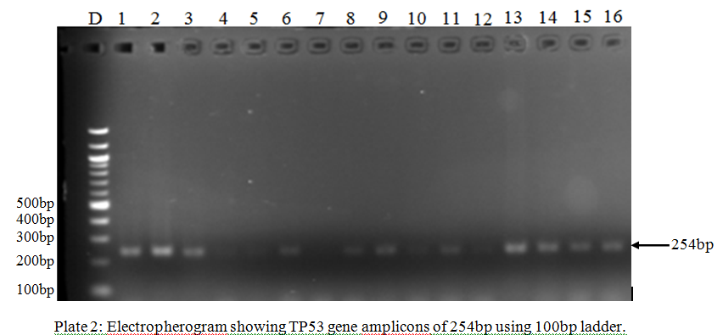
PLATE 1: Electropherogram showing TP53 gene amplicons of 254bp using 1000bp ladder
