Supplementary information for
Atomic-level direct imaging for Cu(Ⅰ) multiple occupations and migration in 2D ferroelectric CuInP₂S₆

Table of content
Figure S1. CIPS nanosheet along a-axis 3
Figure S2. Atomic STEM images at different scales and different regions 4
Figure S3. Result of Atoms by Optimized Multiple-Ellipse Fitting 6
Figure S4. Atomic column, the intensity profile, and its 2D intensity distribution of Cu 8
Figure S5. Atomic column, the intensity profile, and its 2D intensity distribution of In 9
Figure S6. Atomic column, the intensity profile, and its 2D intensity distribution of P 10
Figure S7. Atomic column, the intensity profile, and its 2D intensity distribution of S 11
Figure S8. Elemental Mapping and Statistical Distribution of Elements 12
Figure S9 Dynamic and stability of Cu_{x}InP₂S₆ local structure 13
Table S1 Fitting parameters of CalAtom v1.2 software 14
Table S2. EDS elements quantify result of Figure 4a 15
Table S3. EDS elements quantify result of Figure 4c 16
Reference 17

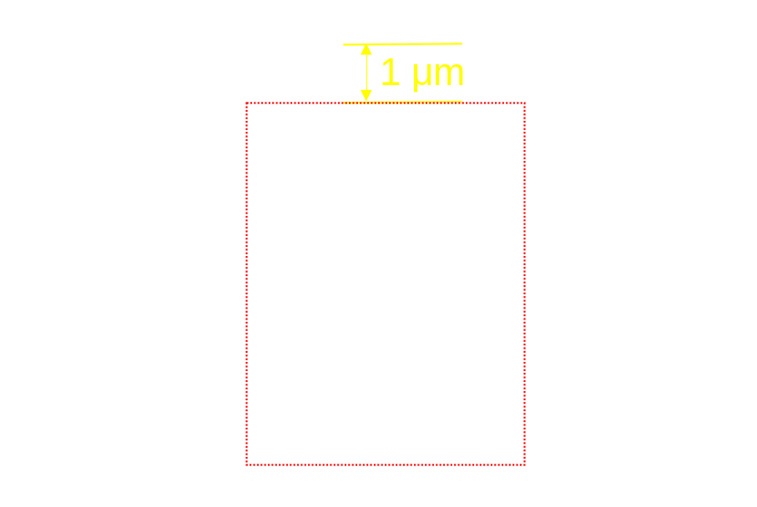
Figure S1. CIPS nanosheet along a-axis. In order to protect the sample from stress during preparation and cutting, as well as protect the surface, the Pt is covered over the CIPS as a protective layer. After multiple machining, the thickness of the CIPS is less than 50 nm along the a-axis (red dotted box part) and about 1 micron thick Pt (yellow marked section) is retained. A sample less than 50 nm thick is extremely favorable for STEM atomic resolution observation, and the cutting orientation along a-axis was confirmed in subsequent STEM.

Figure S2. Atomic STEM images at different scales and different regions. All of the iDPC-STEM images are based on the (100) plane. The images show the unique layered characteristics of Van der Waals materials. Cu(I) ions have multiple occupancies between the InS₆ octahedral skeletons in all areas of electron irradiation, indicating the universality of Cu(I) ions' multi-occupancy. (e-f) Enlarged view of the regions in red dotted boxes of (c-d). The red dashed chamfered rectangular boxes in Figure S2 (a-f) show demo of the Cu_{x}InP₂S₆ (x=2-3) local structure.

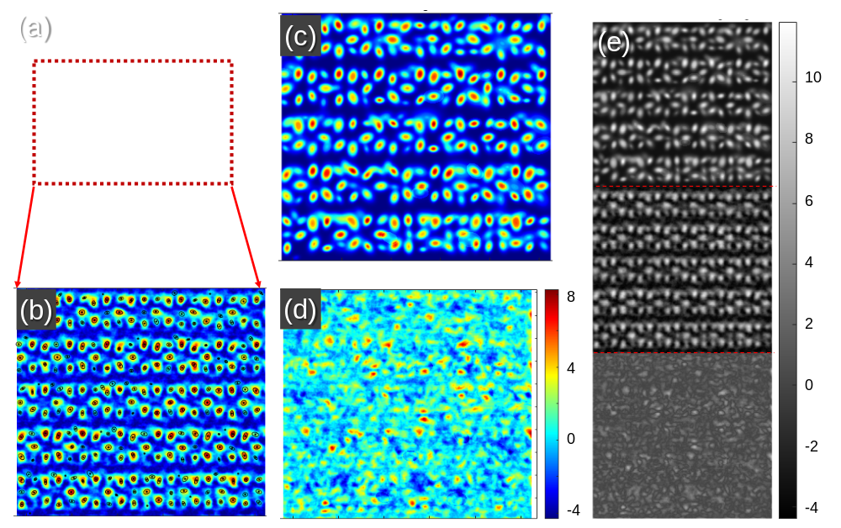
Figure S3. Result of Atoms by Optimized Multiple-Ellipse Fitting. (a) iDPC-STEM image after image filter fitting. The red dashed box is the area where the Multiple-Ellipse Fitting. (b) Raw image. (c) Fitting image. (d) Intensity difference between the fitting image and raw image. (e) Grayscale representation of images b, c, and d. The raw iDPC image was filtered by Background Estimation (to eliminate the nonuniform background of the image), Gaussian filter (a rotationally symmetric Gaussian lowpass filter of size with standard deviation sigma), and BM3D (the block-matching and 3D filtering algorithm and the estimated signal-to-noise ratio (SNR)). Then the initial atom positions are obtained by using the threshold method. In this calculation, the image will be normalized, and the pixels at which the normalized intensities are greater than the threshold value and are local maximum will be approximated to be the round centers of the atomic columns. After that, the shape of atomic column in the red dashed box of Figure S3a was fit by the optimized Multiple-ellipse Fitting (MEF) method.¹ The error is obtained by making the difference in image intensities between the fitting result and the raw image. All the data analysis was realized by CalAtom software.² All of the details of the fitted parameters of Figure S3 to Figure S6 can be seen in Table S1.
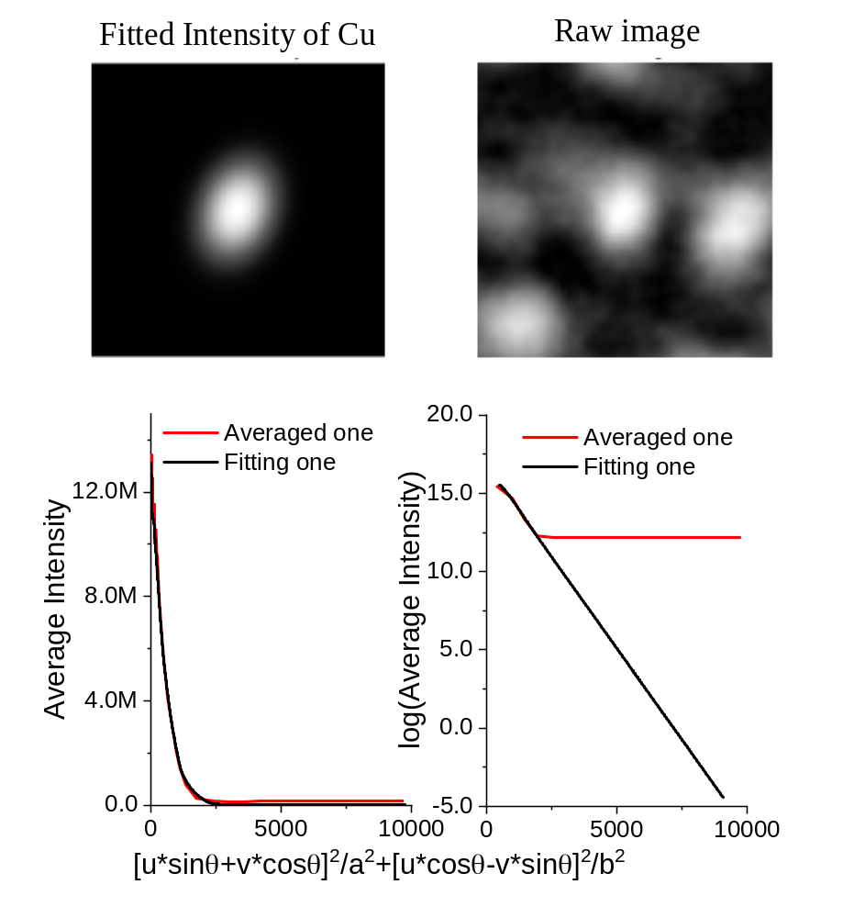
Figure S4. Atomic column, the intensity profile, and its 2D intensity distribution of Cu. The fitted intensity was obtained from the intensities of the selected atomic column in the raw image. The averaged line based on its elliptical shape obtained in the MEF method, the elliptically-rotational average will be performed to get the 1D intensity profile. During this operation, only the lower half of the intensities on each ellipse are averaged to obtain one data point on the IDP of the atomic column. Two graphs left and right for each element corresponding to the normal coordinate system and the natural logarithmic coordinate system. Compared with the original data, the fitted graphs and curves have a perfect fit, which indicates that the fitting results are accurate and reliable.

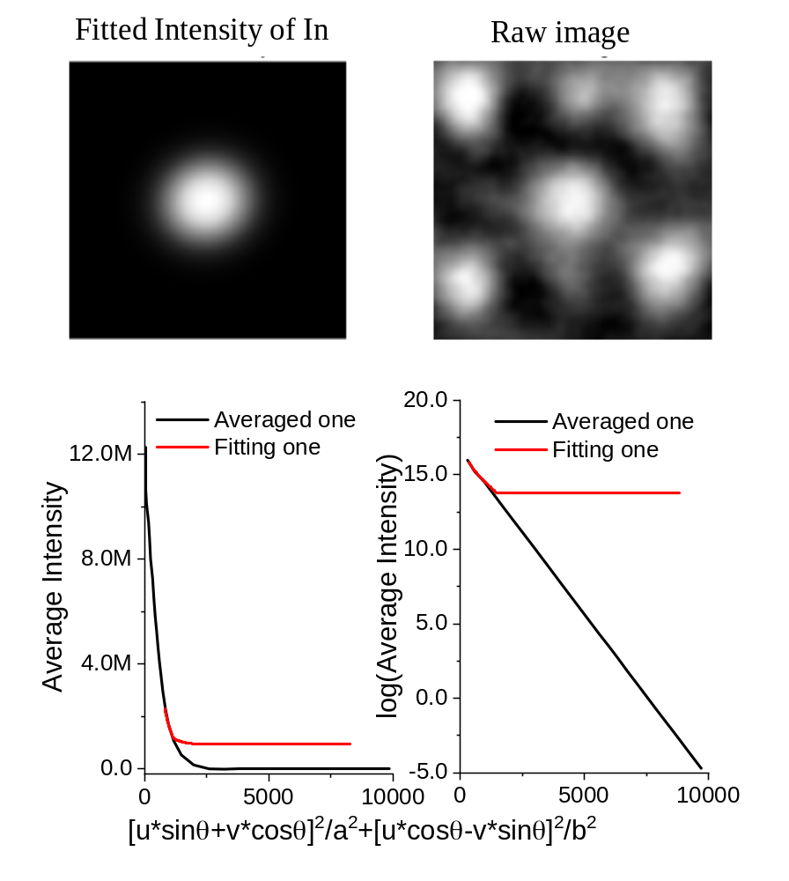
Figure S5. Atomic column, the intensity profile, and its 2D intensity distribution of In.

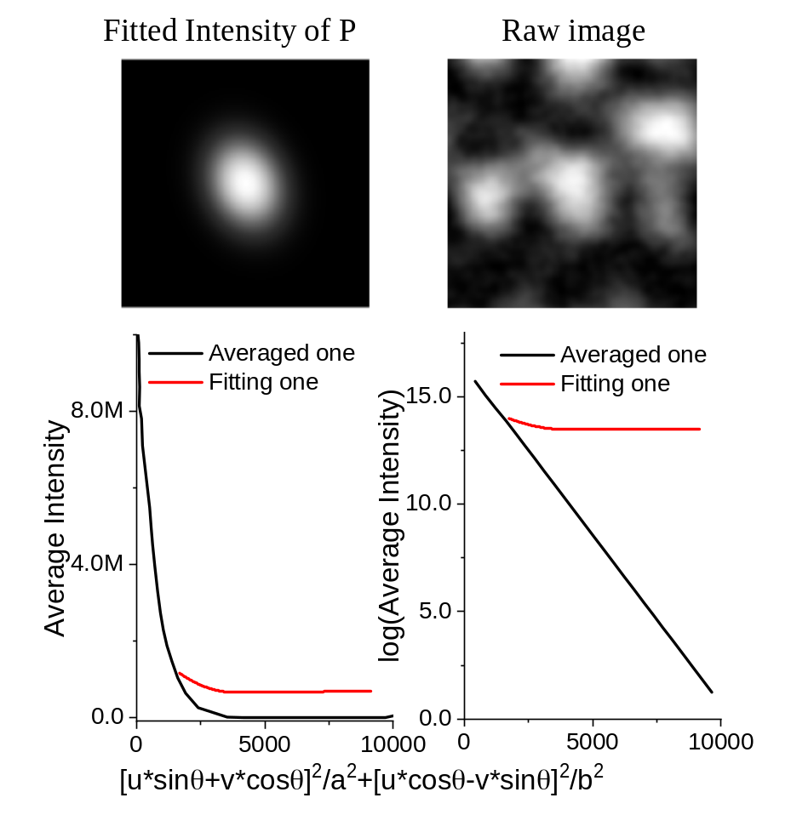
Figure S6. Atomic column, the intensity profile, and its 2D intensity distribution of P.

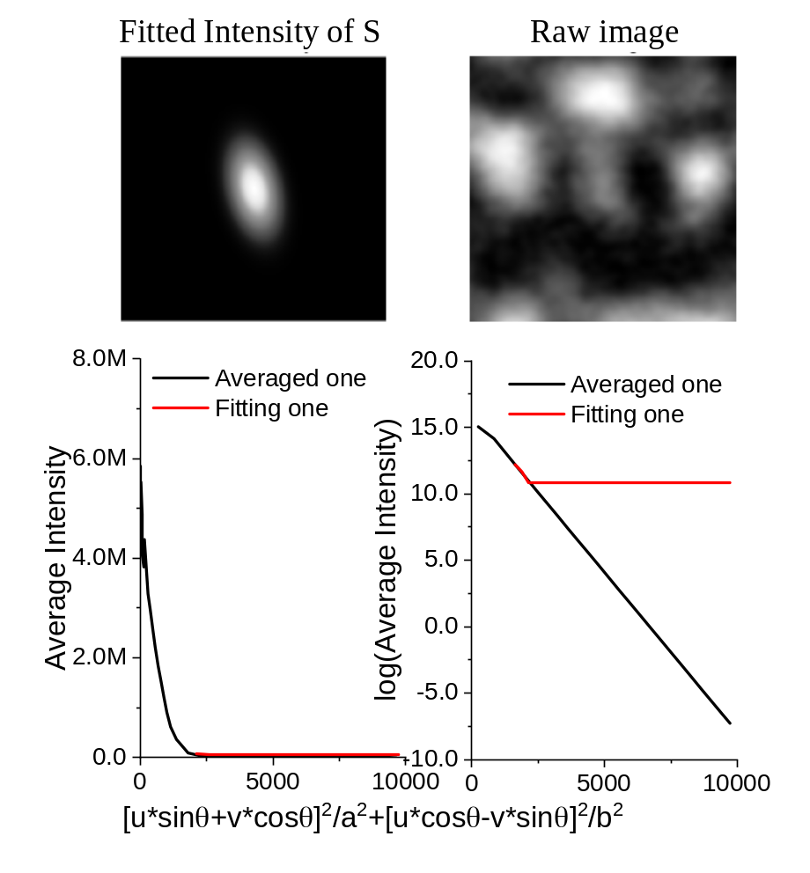
Figure S7. Atomic column, the intensity profile, and its 2D intensity distribution of S.

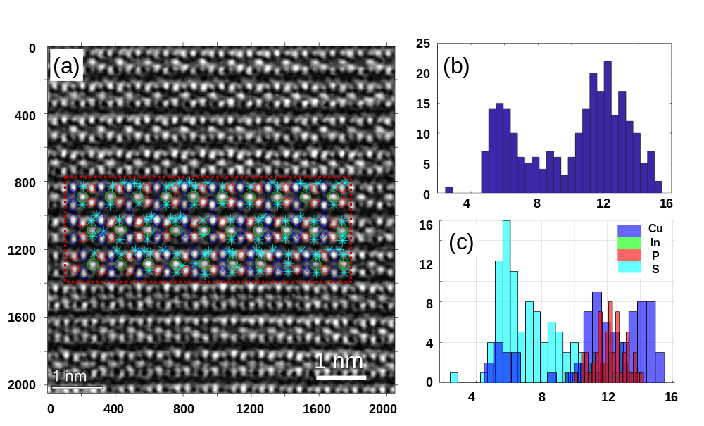
Figure S8. Elemental Mapping and Statistical Distribution of Elements. After measuring the positions of atomic columns, a new dialog elemental mapping is launched, on which the atomic columns can be marked by different markers to get the element map. Intensity distribution statistics and element calibration were carried out for the part in the red box in Figure S8a. The result of the intensity statistical distribution is shown in Figure S8b, the horizontal axis represents the intensity of light and dark in megabytes and the vertical axis represents the corresponding quantity. The coordinates of Figure S8c are the same as those of Figure S8b, the division is made according to the type of elements, and the results of the division are mapped in Figure S8a.

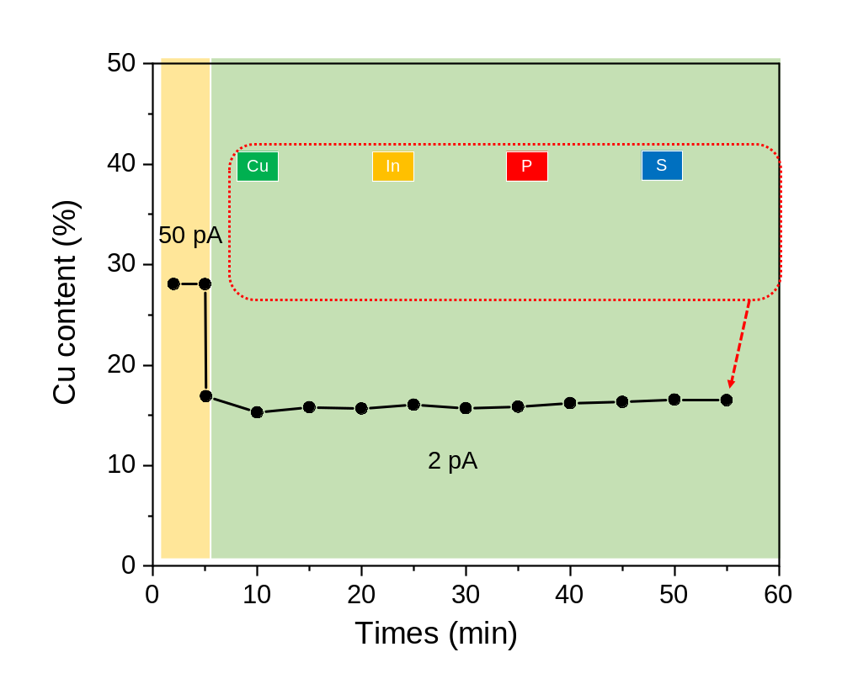
Figure S9 Dynamic and stability of Cu_{x}InP₂S₆ local structure. The curve on behalf of Cu content changes with time and different current does. The Cu content keep a high level (~28%) at the current of 50 pA (yellow region). Drop the current from 50 pA to 2 pA and restart the elemental acquisition by EDS. The Cu content drops from ~28% to ~16% in a few seconds. We collected the signal for about 50 minutes to ensure the reliability of the data due to low current. The insert pictures are the elements mapping at the end time. It can be considered that the distribution of elements is uniform and the amount collected is sufficient. The Cu content is ~16% from start to finish under the current of 2 pA (green region), which inferred that no obvious Cu(I) ions migration can be detected under such a low current.
Table S1 Fitting parameters of CalAtom v1.2 software.

operation |  |  | parameter
Magnification in Refinement |  |  | 4
Image filters | Background Elimination | The background smooth radius (integral values) | 30
Image filters | Gaussian filter | Gaussian filter size  (integral values) | 9
Image filters | Gaussian filter | Gaussian filter sigma (integral values) | 2
Image filters | BM3D | SNR | 30
Initial positions | Threshold method | The threshold (0-1) | 0.05
Edit positions | Merge |  | 40
Calc. Positions | Multiple-Ellipse Fitting method | The atoms' Average Radius | 30
Calc. Positions | Multiple-Ellipse Fitting method | Minimum percentage value | 0.6
Calc. Positions | Multiple-Ellipse Fitting method | Contour's number | 5
Calc. Positions | Optimized MEF method | The atoms' Average Radius | 30
Calc. Positions | Optimized MEF method | Minimum percentage value | 0.6
Calc. Positions | Optimized MEF method | Contour's number | 5
Calc. Positions | Optimized MEF method | Number of Neighbour Atoms | 3
Calc. Positions | Optimized MEF method | Contribution from Atoms themselves (0-1) | 0.8

Table S2. EDS elements quantify result of Figure 4a.

Z | Element | Family | Atomic Fraction (%) | Atomic Error (%) | Mass Fraction (%) | Mass Error (%) | Fit Error (%)
15 | P | K | 17.02 | 1.70 | 11.35 | 0.96 | 1.17
16 | S | K | 49.23 | 5.03 | 33.97 | 4.58 | 0.70
29 | Cu | K | 26.01 | 3.66 | 35.57 | 4.06 | 0.28
49 | In | L | 7.74 | 1.10 | 19.12 | 2.32 | 0.35

Table S3. EDS elements quantify result of Figure 4c.

Z | Element | Family | Atomic Fraction (%) | Atomic Error (%) | Mass Fraction (%) | Mass Error (%) | Fit Error (%)
15 | P | K | 17.62 | 1.65 | 11.12 | 0.91 | 1.94
16 | S | K | 43.28 | 4.96 | 28.27 | 4.15 | 1.01
29 | Cu | K | 29.52 | 3.84 | 38.21 | 4.06 | 0.77
49 | In | L | 9.58 | 1.31 | 22.40 | 2.59 | 1.34

Reference
1 Zhang, Q. et al. Multiple-ellipse fitting method to precisely measure the positions of atomic columns in a transmission electron microscope image. Micron 113, 99-104, doi:10.1016/j.micron.2018.06.016 (2018).
2 Zhang, Q., Zhang, L. Y., Jin, C. H., Wang, Y. M. & Lin, F. CalAtom: A software for quantitatively analysing atomic columns in a transmission electron microscope image. Ultramicroscopy 202, 114-120, doi:10.1016/j.ultramic.2019.04.007 (2019).

