Suplementar Material

Figure S1. Correlation matrix of predictor predictors used in the Models
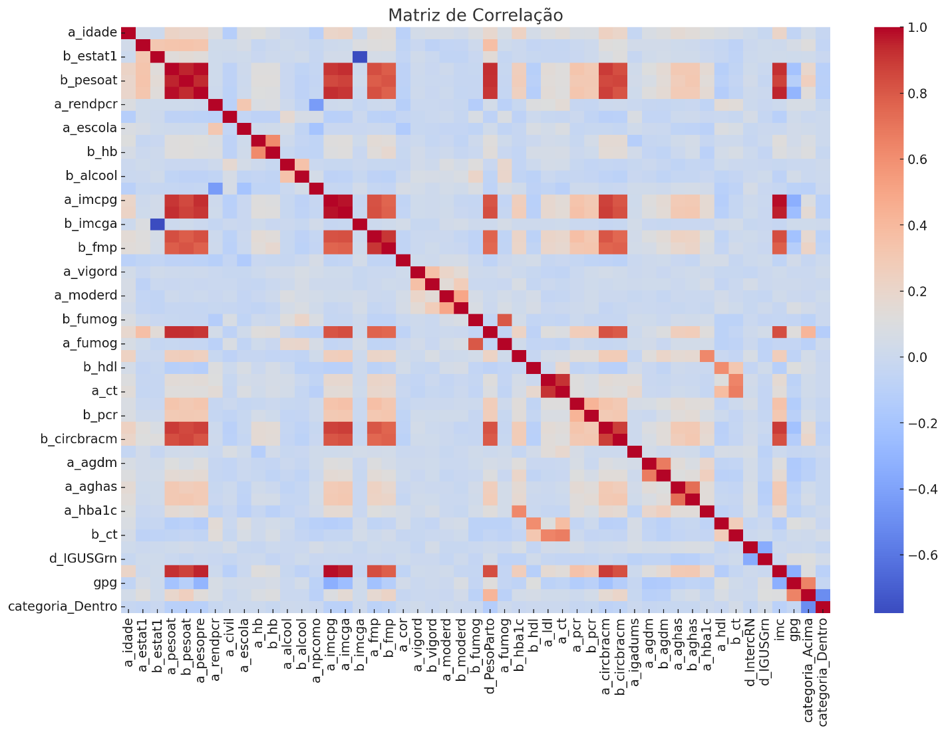

S2. Table of Predictive performance of the best algorithm for each outcome with default models
Model | Accuracy | AUC-ROC | Recall | Specificity | Precision | F1 | MCC
Random Forest (GWG Below) | 0.72 | 0.26 | 0.55 | 0.68 | 0.57 | 0.56 | 0.36
Random Forest (GWG Within) | 0.68 | 0.75 | 0.73 | 0.68 | 0.58 | 0.64 | 0.37
Random Forest (GWG Above) | 0.68 | 0.46 | 0.30 | 0.59 | 0.43 | 0.35 | 0.16
LightGBM (GWG Below) | 0.74 | 0.24 | 0.59 | 0.70 | 0.59 | 0.59 | 0.40
LightGBM (GWG Within) | 0.69 | 0.77 | 0.69 | 0.68 | 0.59 | 0.64 | 0.38
LightGBM (GWG Above) | 0.69 | 0.46 | 0.34 | 0.60 | 0.45 | 0.39 | 0.19
AdaBoost (GWG Below) | 0.69 | 0.30 | 0.46 | 0.63 | 0.51 | 0.48 | 0.26
AdaBoost (GWG Within) | 0.66 | 0.70 | 0.60 | 0.65 | 0.57 | 0.58 | 0.30
AdaBoost (GWG Above) | 0.64 | 0.49 | 0.39 | 0.56 | 0.37 | 0.38 | 0.12
CatBoost (GWG Below) | 0.75 | 0.26 | 0.59 | 0.71 | 0.61 | 0.60 | 0.41
CatBoost (GWG Within) | 0.69 | 0.75 | 0.67 | 0.68 | 0.59 | 0.63 | 0.37
CatBoost (GWG Above) | 0.68 | 0.47 | 0.37 | 0.60 | 0.43 | 0.40 | 0.18
XGBoost (GWG Below) | 0.72 | 0.26 | 0.59 | 0.69 | 0.57 | 0.58 | 0.38
XGBoost (GWG Within) | 0.67 | 0.73 | 0.66 | 0.66 | 0.57 | 0.61 | 0.33
XGBoost (GWG Above) | 0.67 | 0.48 | 0.30 | 0.58 | 0.41 | 0.34 | 0.14

Figure S3. Predictive performance of default algorithm models based on AUC-ROC
