Development of systolic blood pressure model

Model architecture description
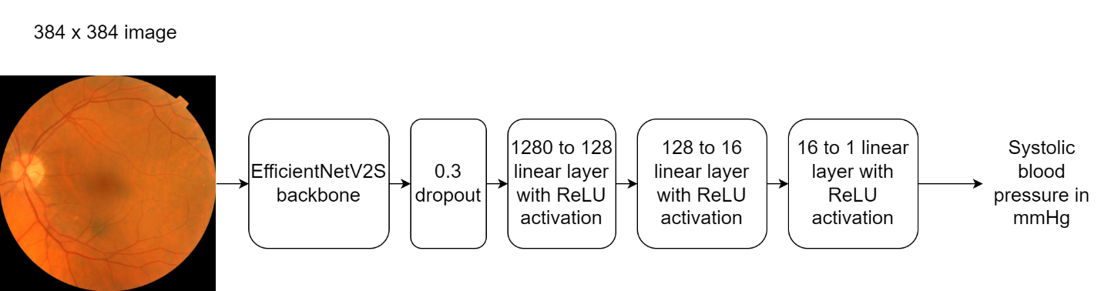
Figure 1 -

Training configurations
Table 2 -
Parameter | Value
Optimizer | Adam  - Initial learning rate: 1e-3  - Learning rate decay: 1e-6
Loss function | Huber loss
Batch size | 32
Maximum epochs | 150
Image augmentation | - Random horizontal and vertical flip  - Random rotation up to 45 degrees

Model performance
Table 3 -
Metric | Value
R squared | 0.3267
MSE | 228.04
MAE | 11.65

