Appendix A. Supplementary data
Supplementary data associated with this article can be found at appendix
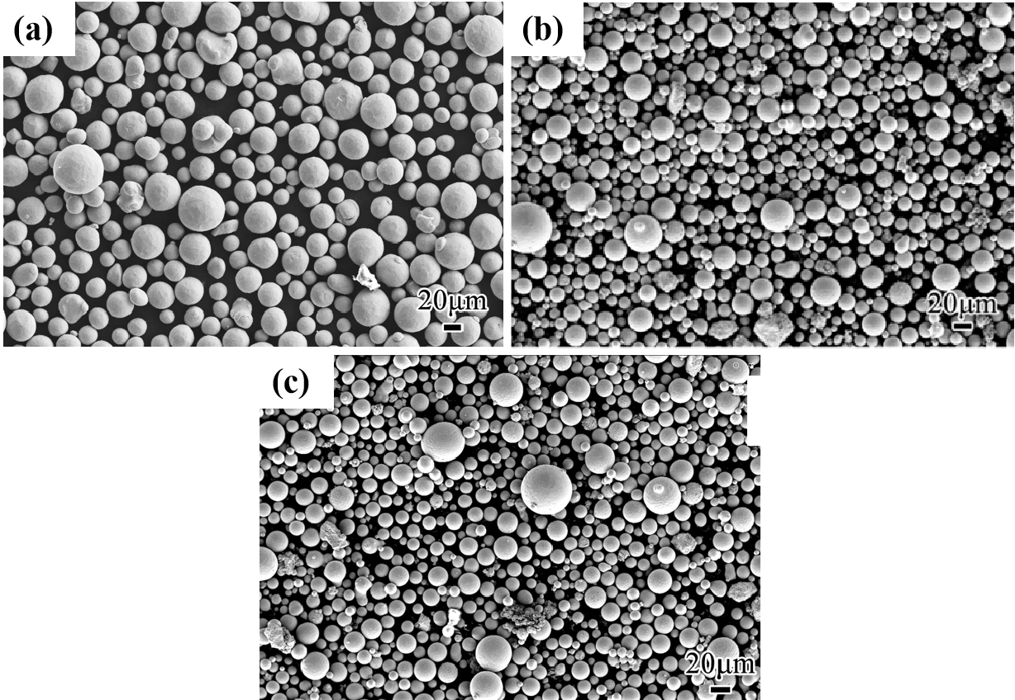
Fig. S1. SEM images of (a) raw atomized CP-Ti, (b) plasma-spheroidized N₂-P-milling-1, and (c) plasma-spheroidized N₂-P-milling-2 Ti-TiN nanocomposite powder samples.

