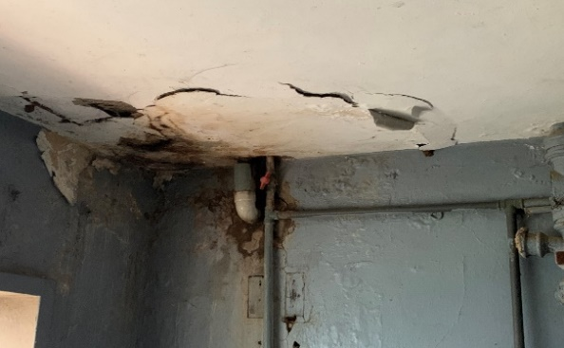

Plate 3.0: Image showing faulty plumbing, spalling and paint peeling
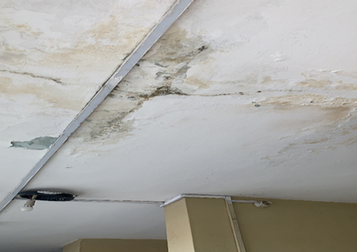
Plate 3.1: Image showing cracks on floor slab
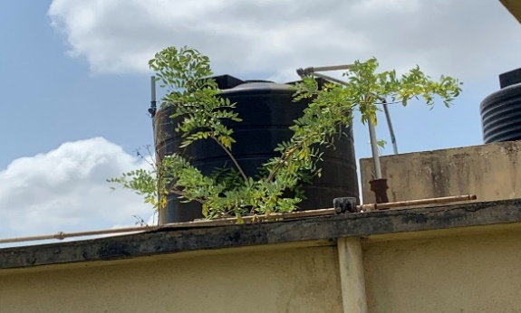

Plate 3.2 Image showing tank and vegetation growth on roof slab

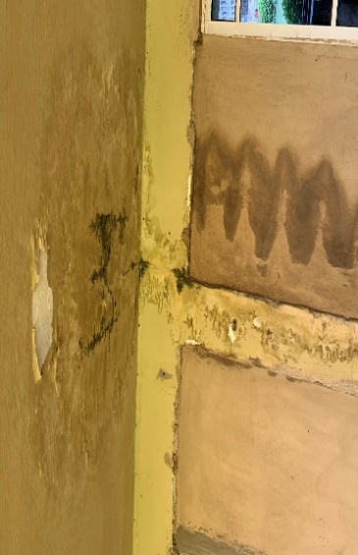
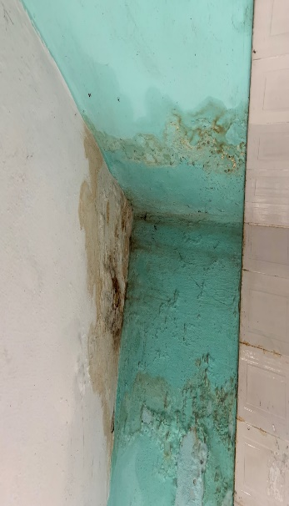
Plate 3.3: Image showing dampness on walls

Plate 3.4: Image showing water stains and dampness on walls

