Supplementary Figures

S1, forest plot presenting MD for the effect of pemafibrate VS placebo on LDL-C
S9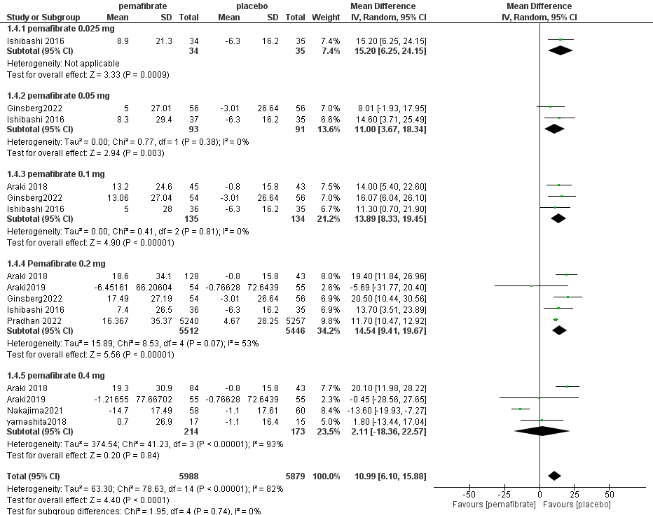

S2, forest plot presenting MD for the effect of pemafibrate VS other fibrates on LDL-C
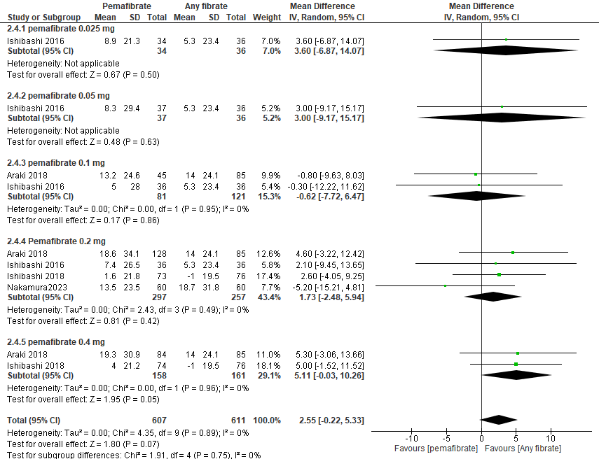

S3, forest plot presenting MD for the effect of pemafibrate VS placebo on HDL-C
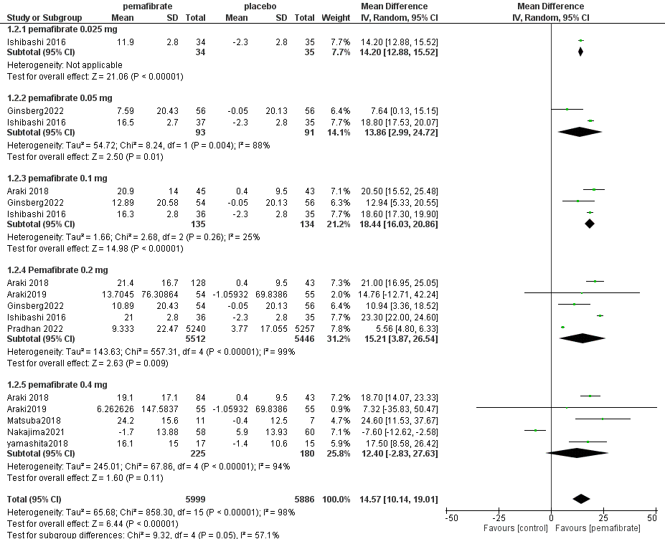

S4, forest plot presenting MD for the effect of pemafibrate VS other fibrates on HDL-C
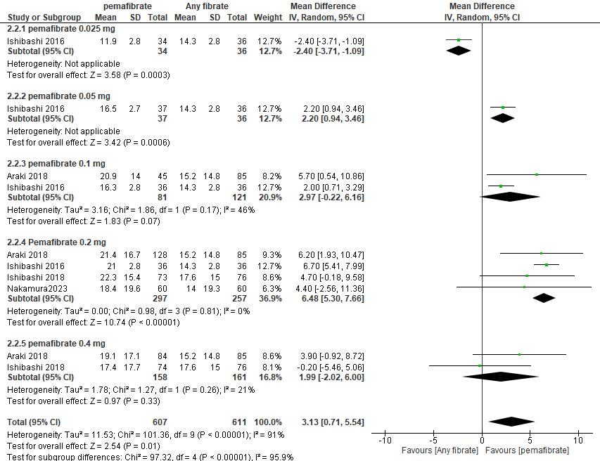

S5, forest plot presenting MD for the effect of pemafibrate VS placebo on Non-HDL-C
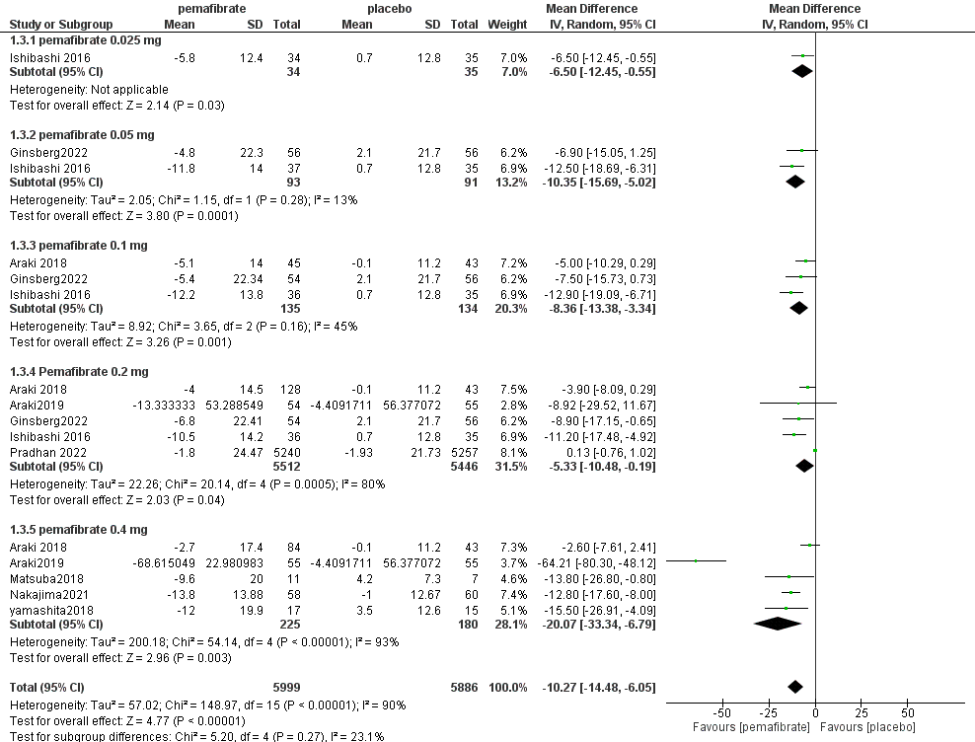

S6, forest plot presenting MD for the effect of pemafibrate VS other fibrates on Non-HDL-C
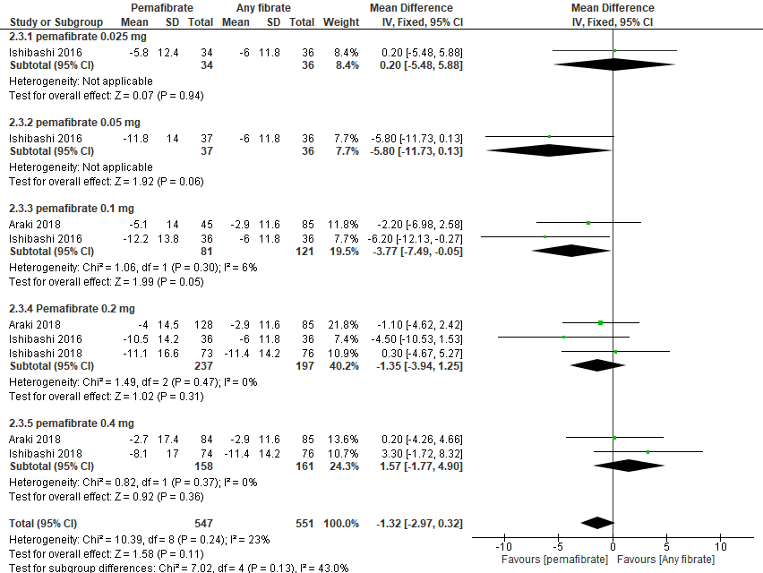

S7, forest plot presenting MD for the effect of pemafibrate VS placebo on VLDL-C
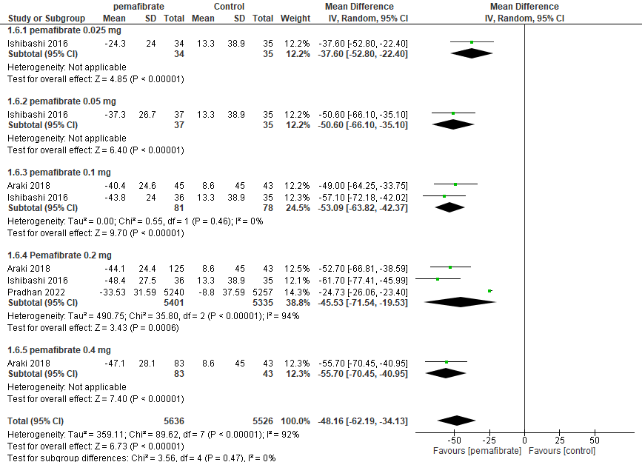

S8, forest plot presenting MD for the effect of pemafibrate VS other fibrates on VLDL-C
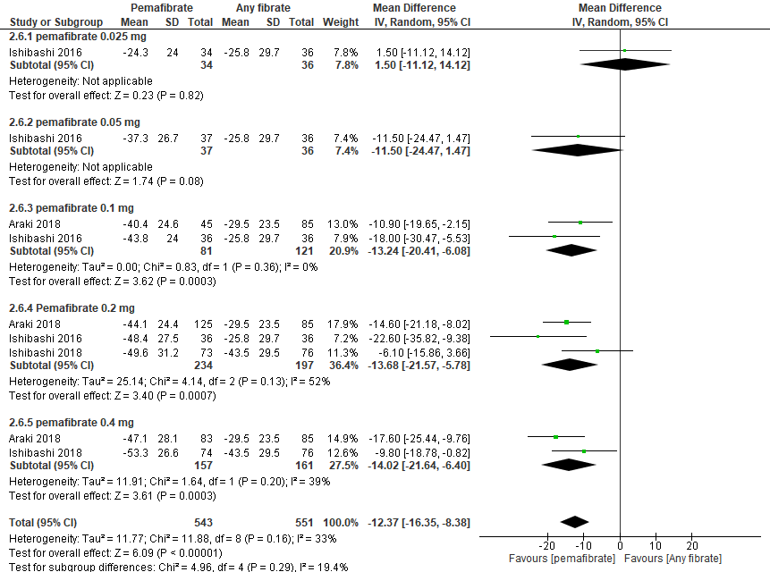

S9, forest plot presenting MD for the effect of pemafibrate VS placebo on Total cholesterol level
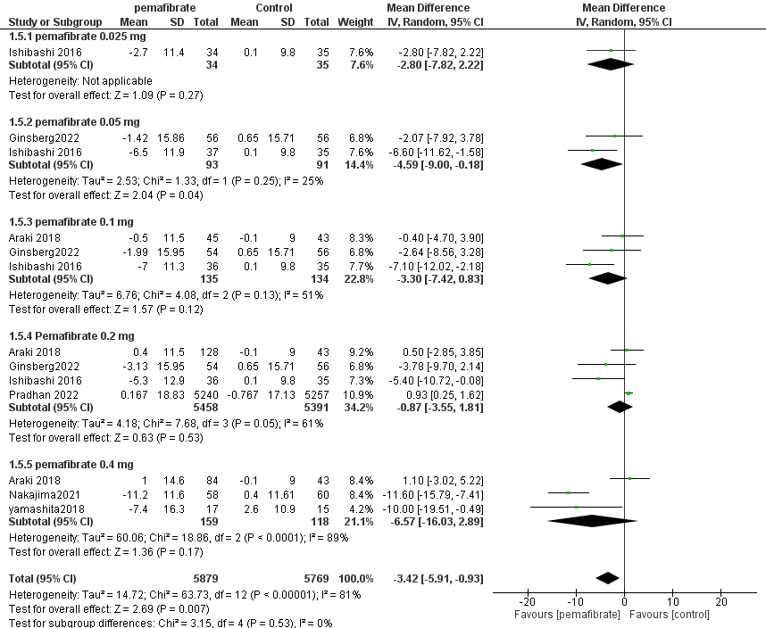

S10, forest plot presenting MD for the effect of pemafibrate VS other fibrates on Total cholesterol level
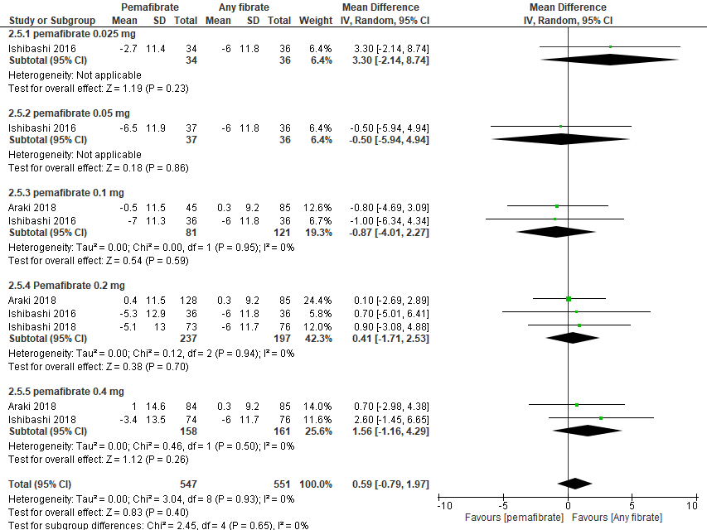

S11, forest plot presenting MD for the effect of pemafibrate VS placebo on Apo B
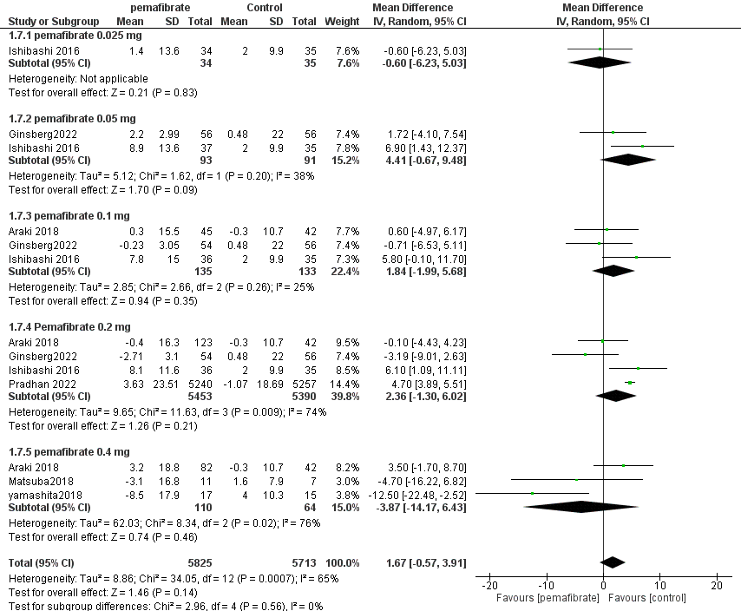

S12, forest plot presenting MD for the effect of pemafibrate VS other fibrates on Apo B
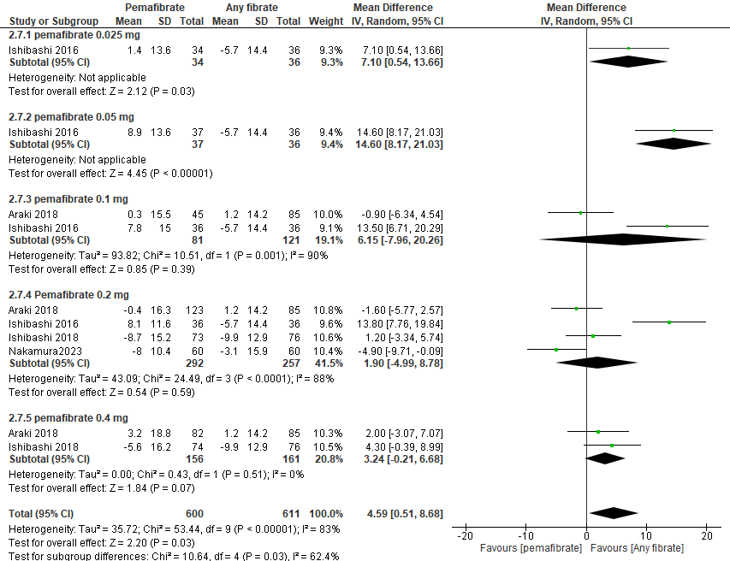

S13, forest plot presenting MD for the effect of pemafibrate VS placebo on Apo A-1
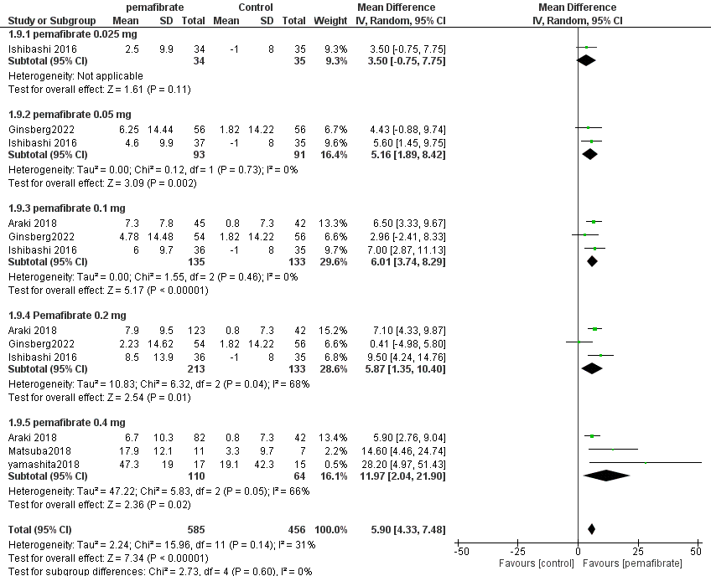

S14, forest plot presenting MD for the effect of pemafibrate VS other fibrates on Apo A-1
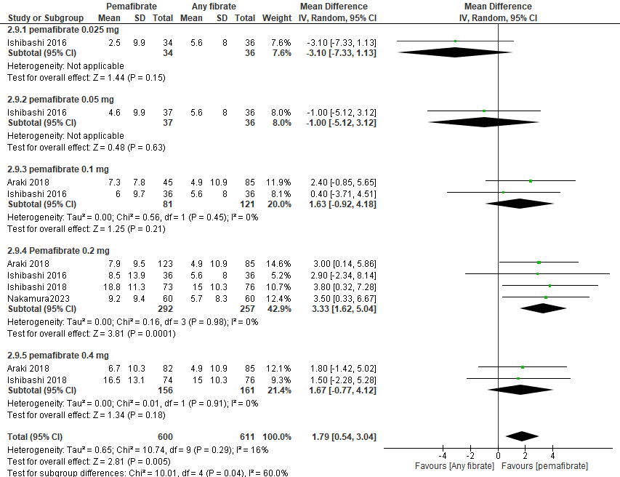

S15, forest plot presenting MD for the effect of pemafibrate VS placebo on Apo A-II
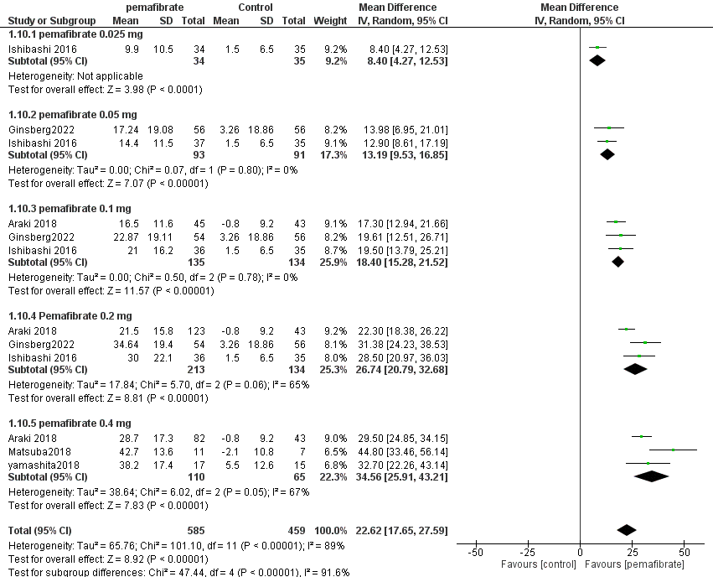

S16, forest plot presenting MD for the effect of pemafibrate VS other fibrates on Apo A-II
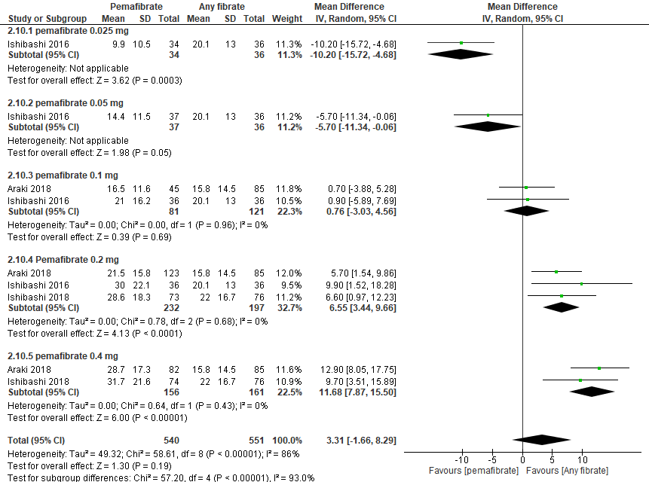

S17, forest plot presenting MD for the effect of pemafibrate VS placebo on ApoB48
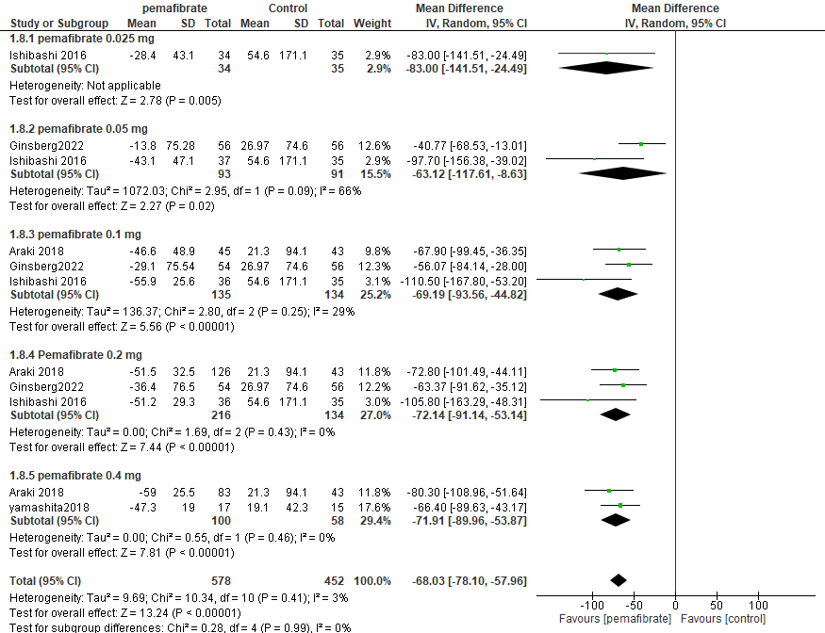

S18, forest plot presenting MD for the effect of pemafibrate VS other fibrates on ApoB48
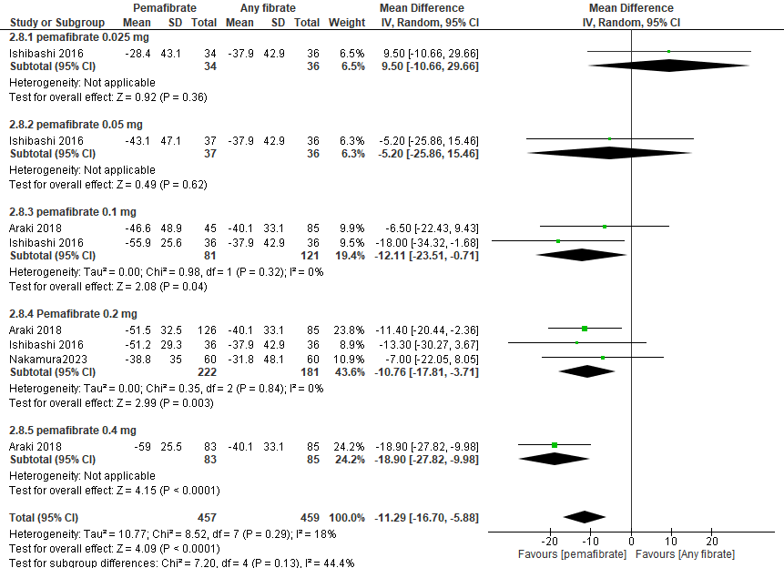

S19, forest plot presenting MD for the effect of pemafibrate VS placebo on Apo C-II
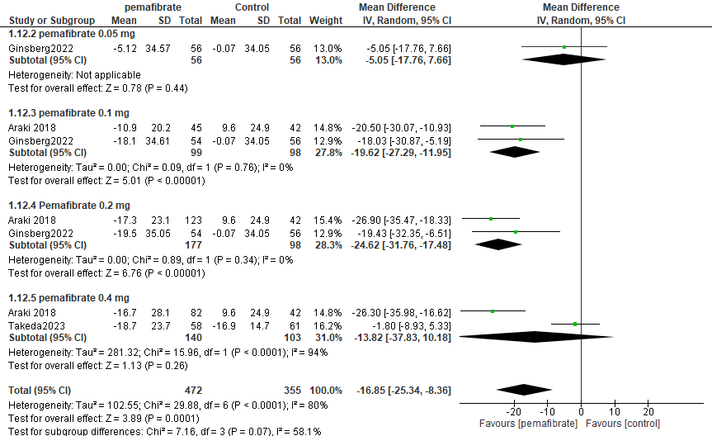

S20, forest plot presenting MD for the effect of pemafibrate VS placebo on Apo C-III
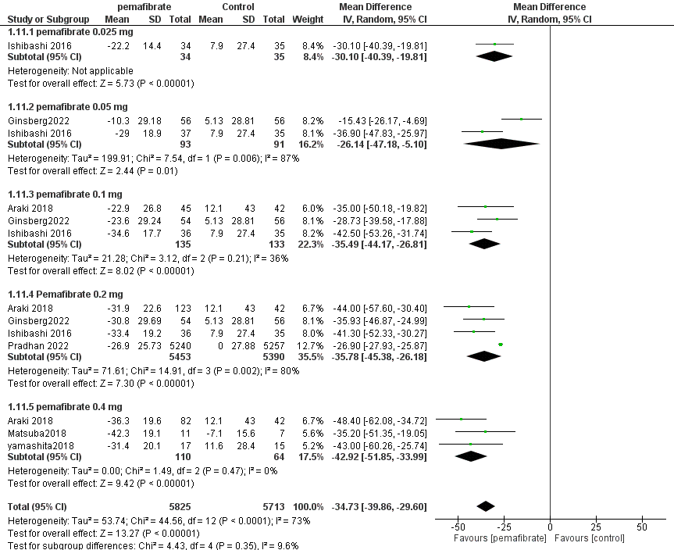

S21, forest plot presenting MD for the effect of pemafibrate VS other fibrates on Apo C-III
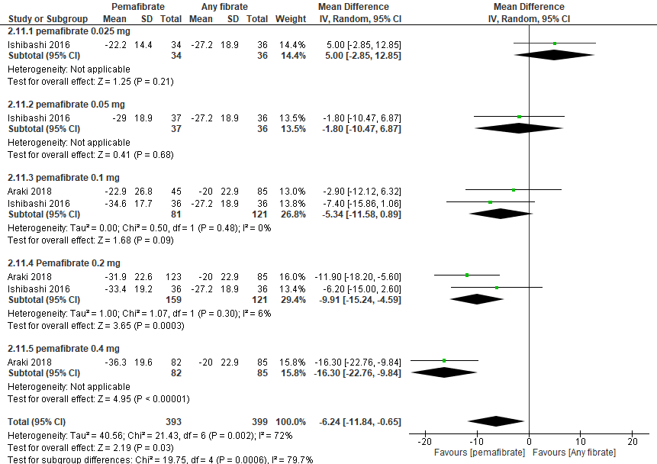

S22, forest plot presenting MD for the effect of pemafibrate VS placebo on RemL-C
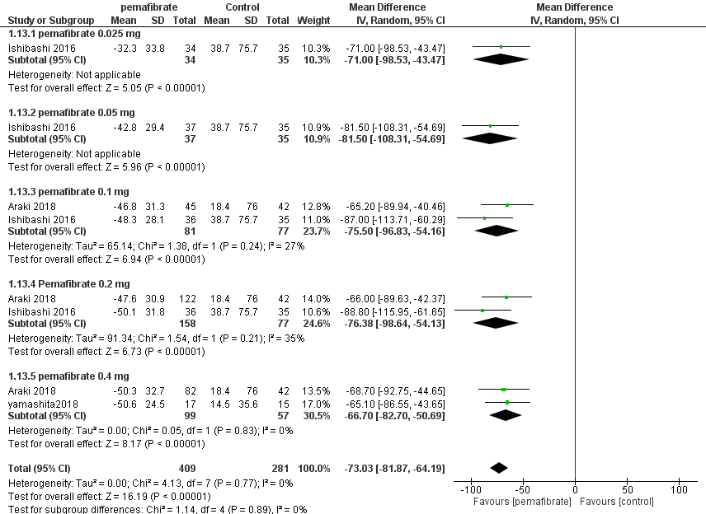

S23, forest plot presenting MD for the effect of pemafibrate VS other fibrates on RemL-C
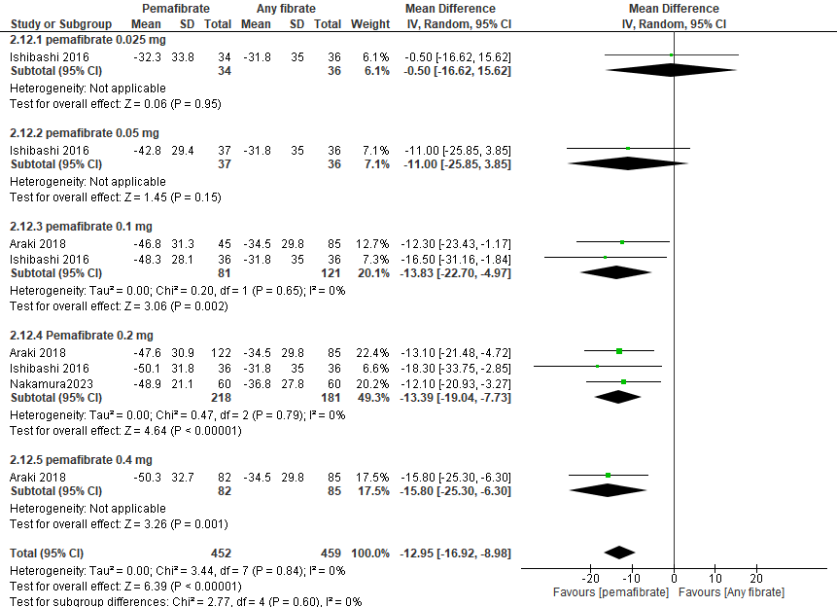

S24, forest plot presenting MD for the effect of pemafibrate VS placebo on HOMA-R
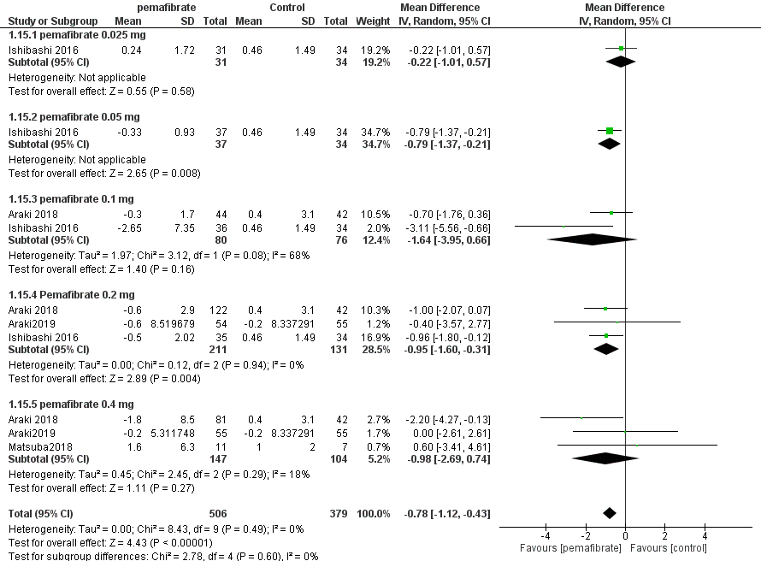

S25, forest plot presenting MD for the effect of pemafibrate VS other fibrates on HOMA-R
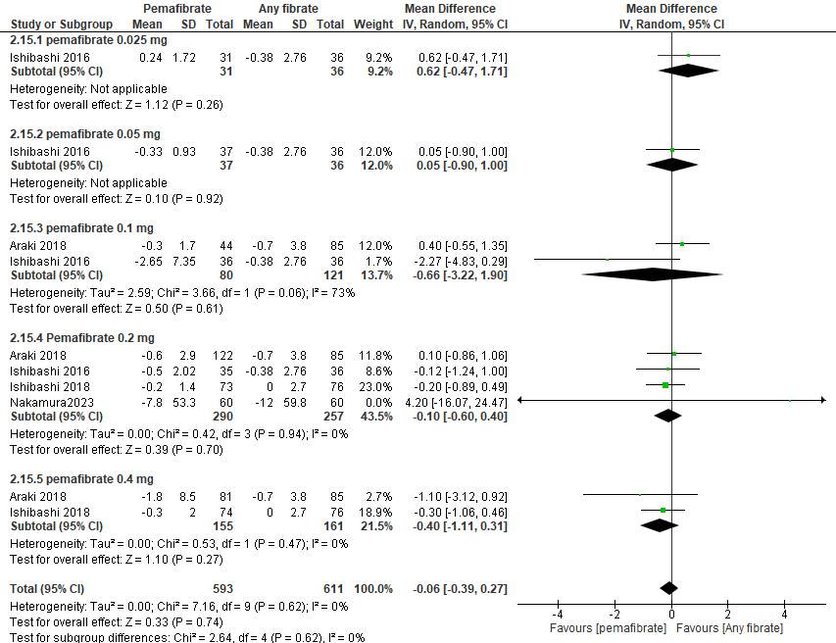

S26, forest plot presenting MD for the effect of pemafibrate VS placebo on FBG
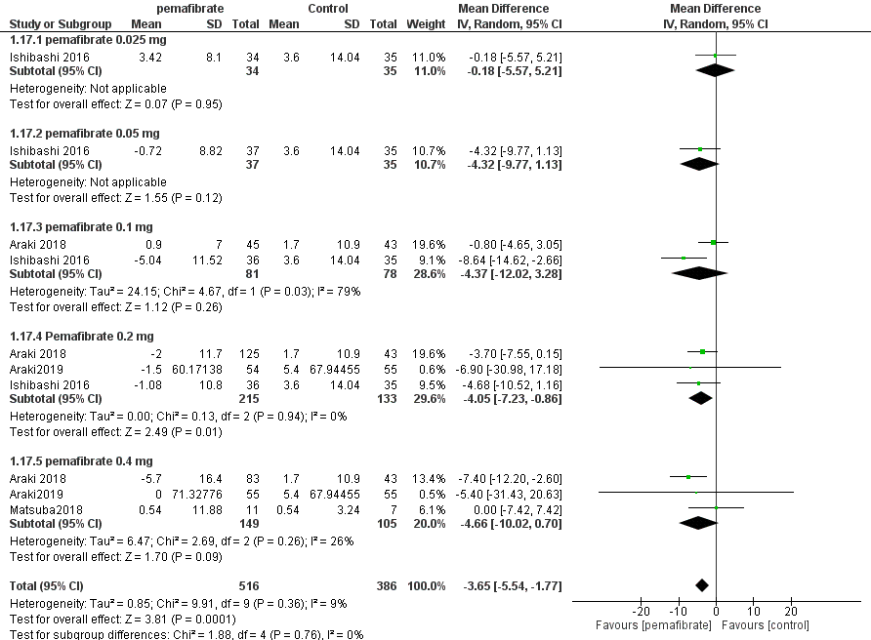

S27, forest plot presenting MD for the effect of pemafibrate VS placebo on fasting insulin

S28, forest plot presenting MD for the effect of pemafibrate VS placebo on HBA1C
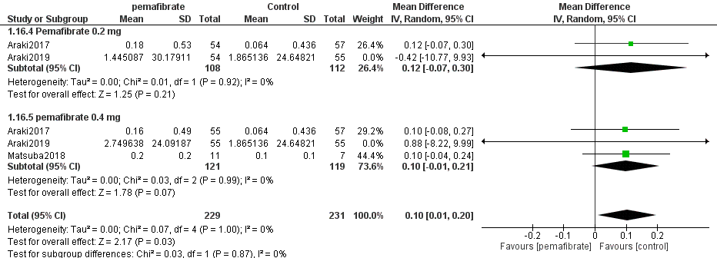

S29, forest plot presenting MD for the effect of pemafibrate VS other fibrates on FBG
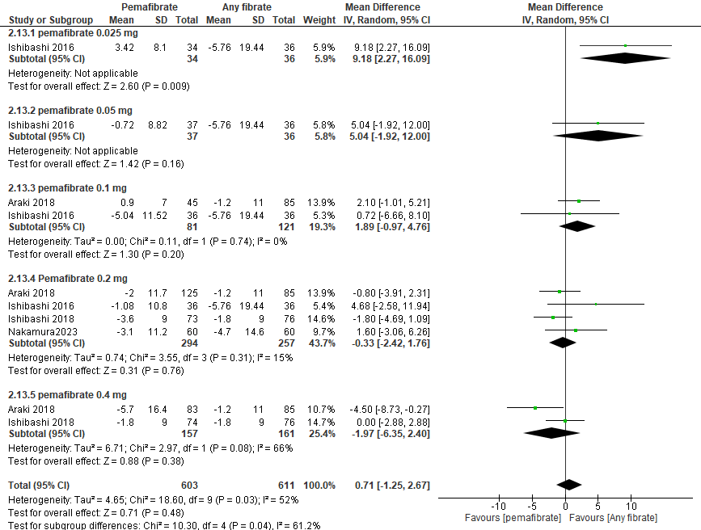

S30, forest plot presenting MD for the effect of pemafibrate VS other fibrates on fasting insulin
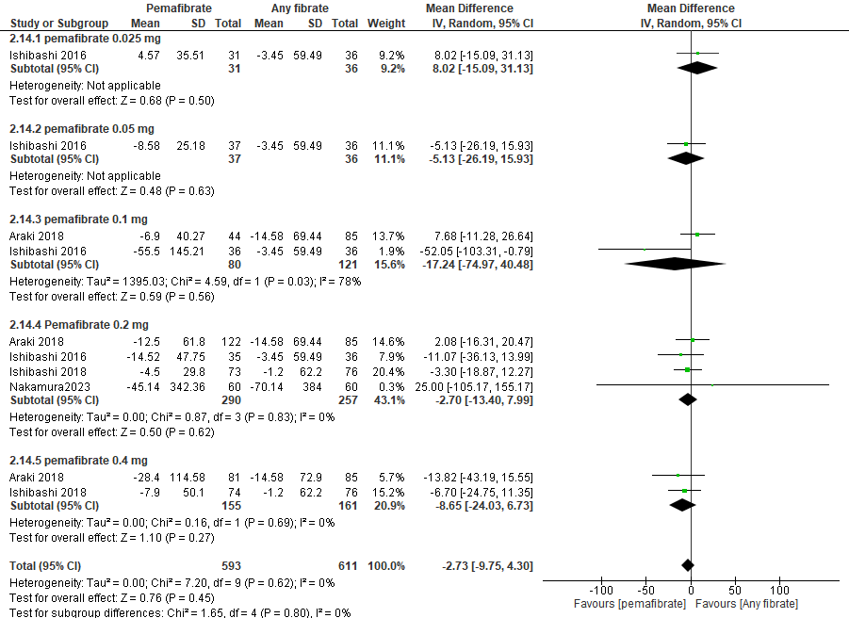

S31, Forest plot presenting OR for effect of pemafibrate VS placebo on Adverse drug reactions
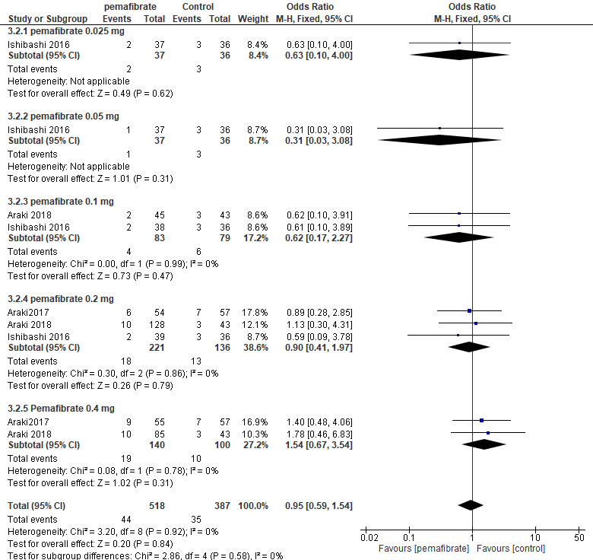

S32, Forest plot presenting OR for effect of pemafibrate VS other fibrates on Adverse drug reactions
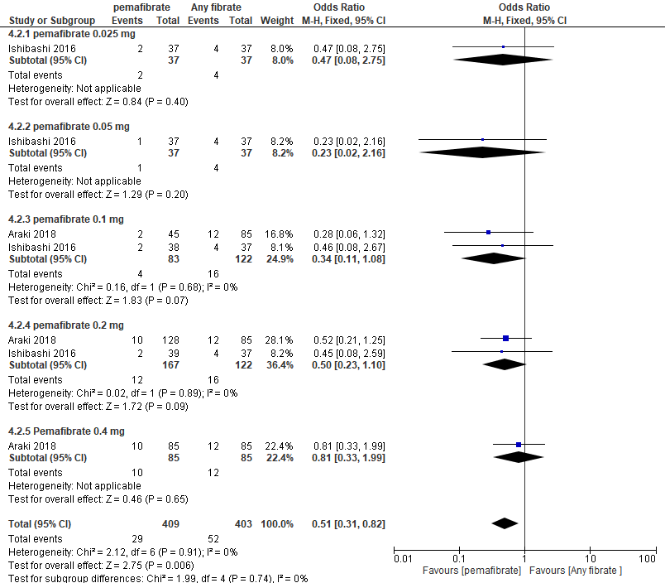

S33, Forest plot presenting OR for effect of pemafibrate VS placebo on Serious Adverse events
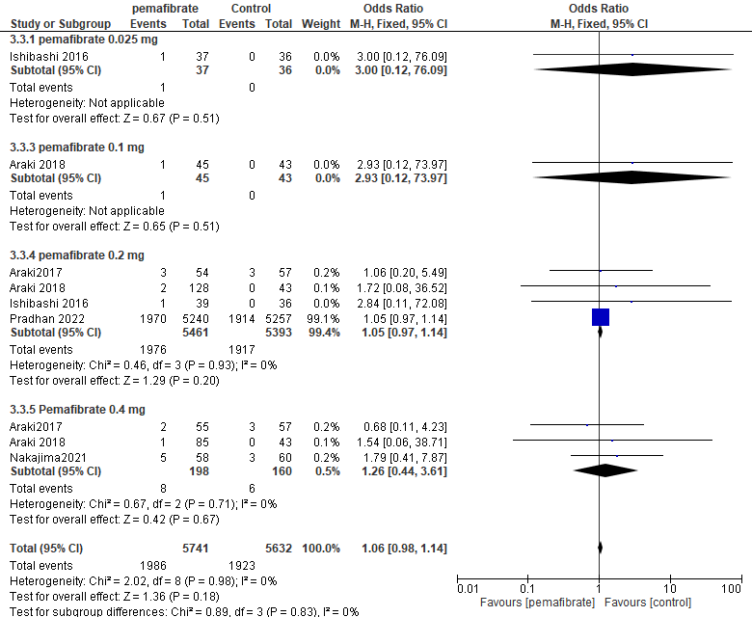

S34, Forest plot presenting OR for effect of pemafibrate VS placebo on Musculoskeletal adverse events
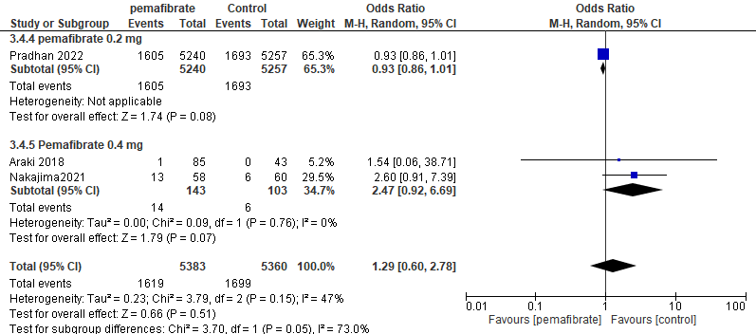

S35, Forest plot presenting OR for effect of pemafibrate VS placebo on Rhabdomyolysis
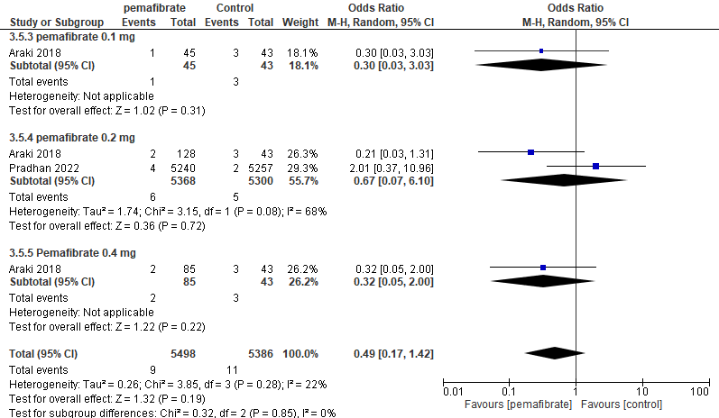

S36, Forest plot presenting OR for effect of pemafibrate VS other fibrates on Serious Adverse events
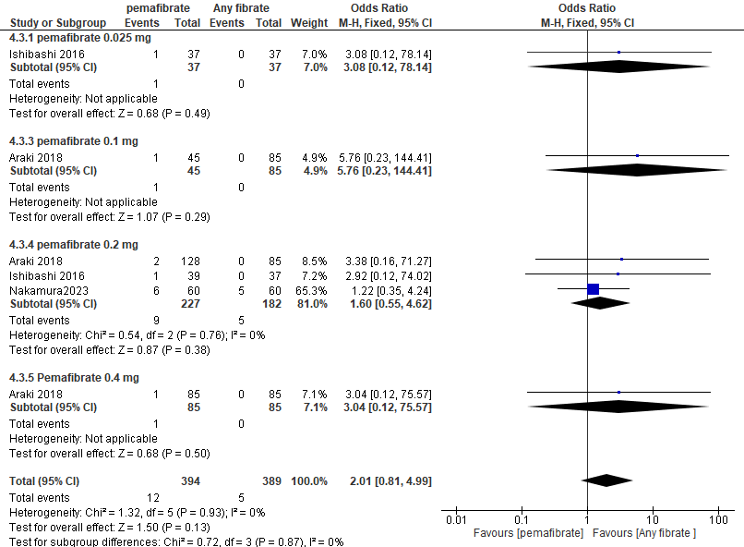

S37, Forest plot presenting OR for effect of pemafibrate VS other fibrates on Musculoskeletal Adverse events
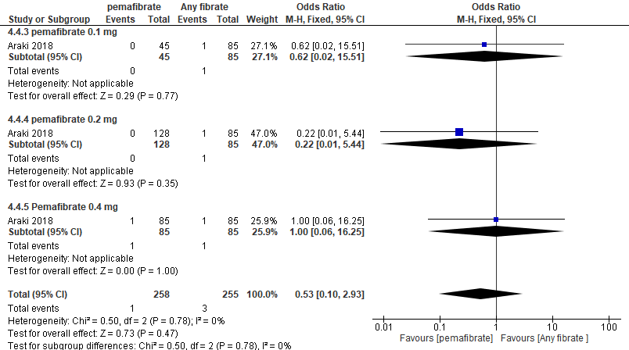

S38, Forest plot presenting OR for effect of pemafibrate VS other fibrates on Rhabdomyolysis
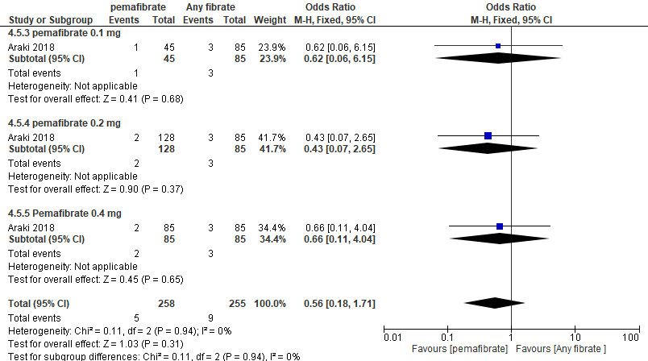

S39, Forest plot presenting OR for effect of pemafibrate VS placebo on hepatic adverse events
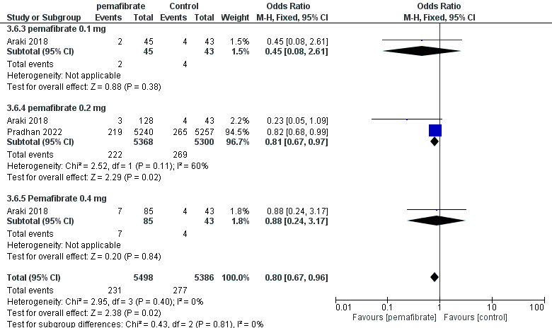

S40, Forest plot presenting OR for effect of pemafibrate VS other fibrates on hepatic adverse events
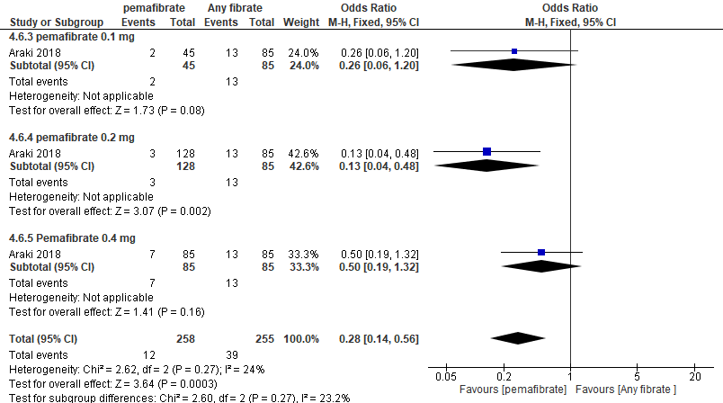

S41, Forest plot presenting OR for effect of pemafibrate VS placebo on ALT being more than upper limit.
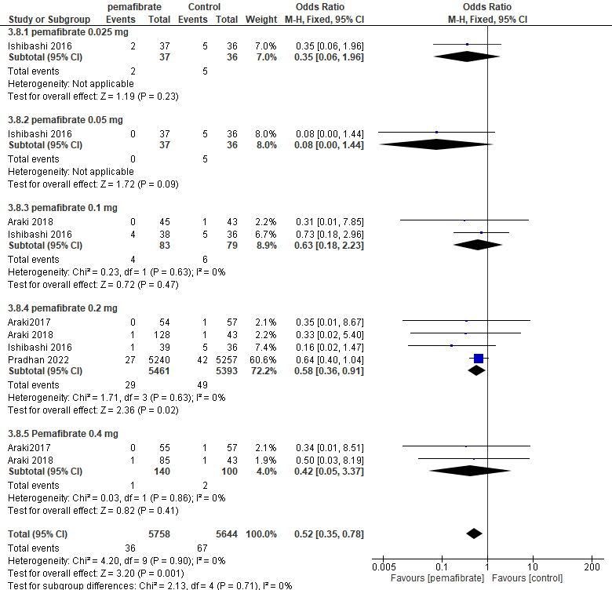

S42, Forest plot presenting OR for effect of pemafibrate VS placebo on AST being more than upper limit.
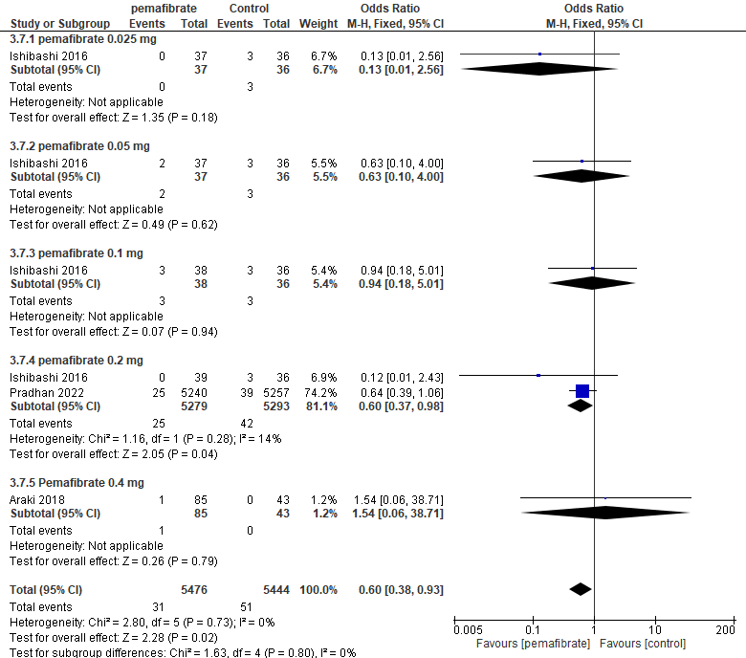

S43, Forest plot presenting OR for effect of pemafibrate VS placebo on GGT being more than upper limit of normal.
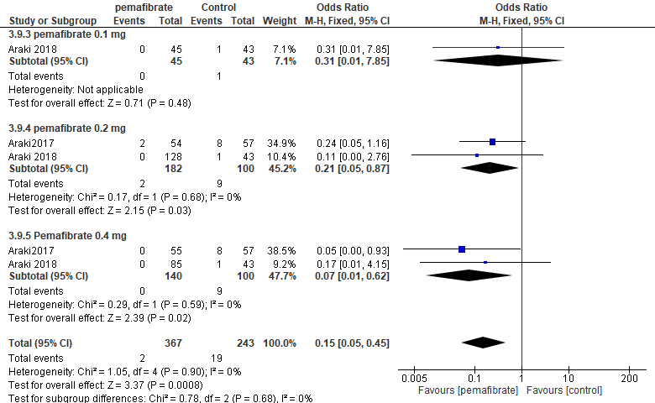

S44, Forest plot presenting OR for effect of pemafibrate VS other fibrates on ALT being more than upper limit.
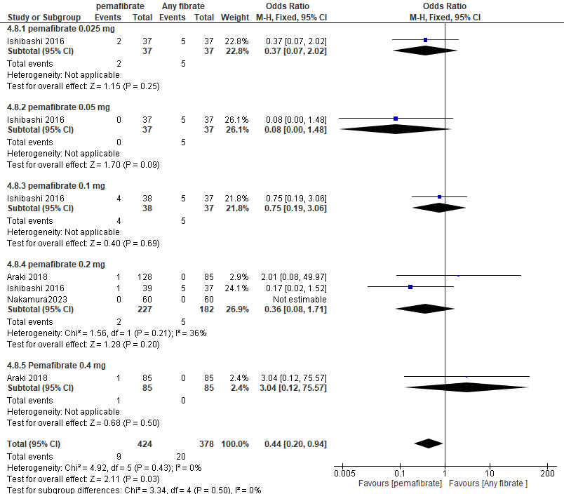

S45, Forest plot presenting OR for effect of pemafibrate VS other fibrates on AST being more than upper limit.
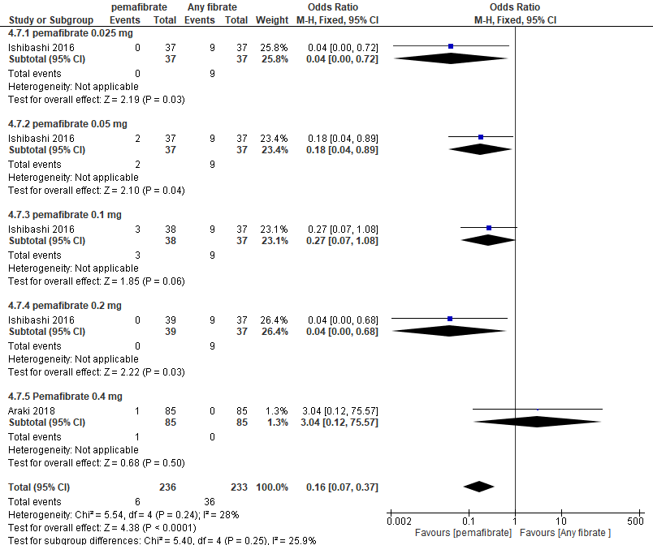

S46, Forest plot presenting OR for effect of pemafibrate VS placebo on creatine kinase levels more than the upper limit of normal
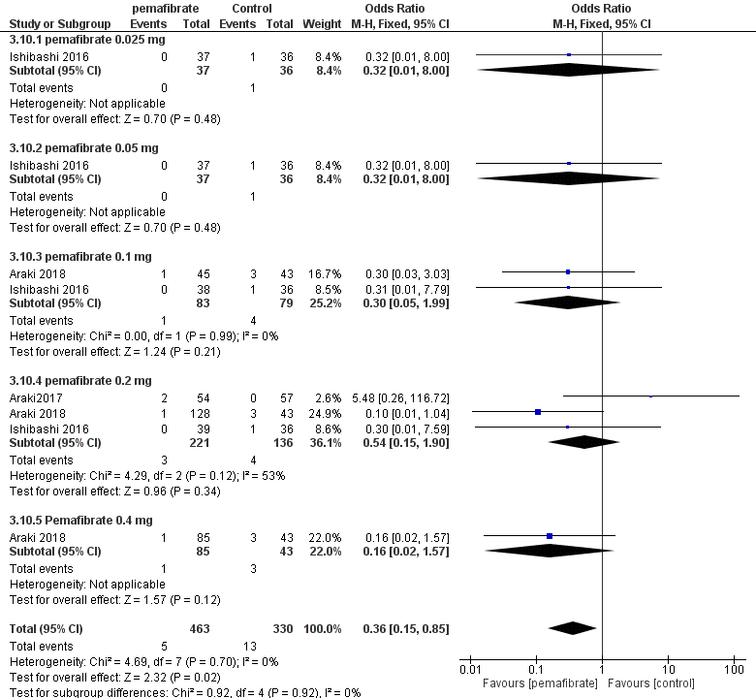

S47, Forest plot presenting OR for effect of pemafibrate VS other fibrates on creatine kinase levels more than the upper limit of normal
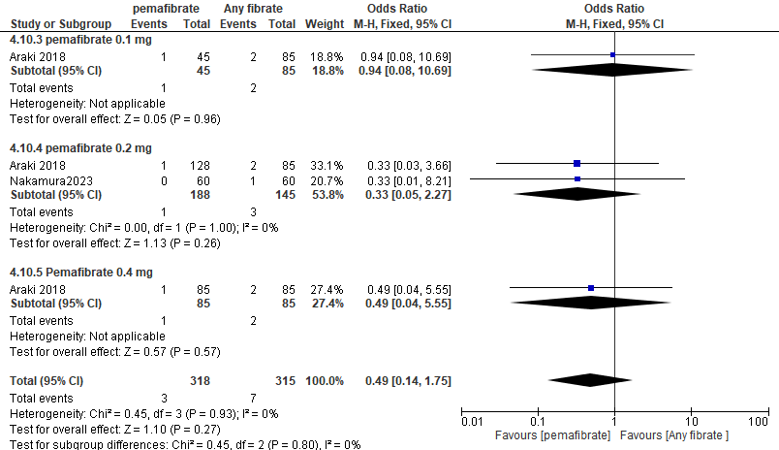

S48, Forest plot presenting OR for effect of pemafibrate VS placebo on Creatinine
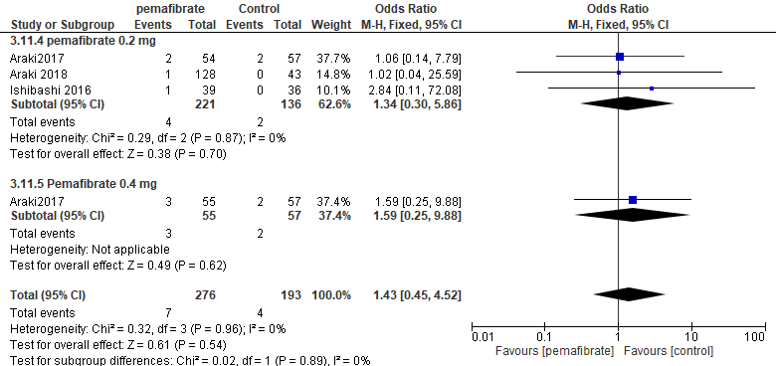

S49, Forest plot presenting OR for effect of pemafibrate VS other fibrates on Creatinine
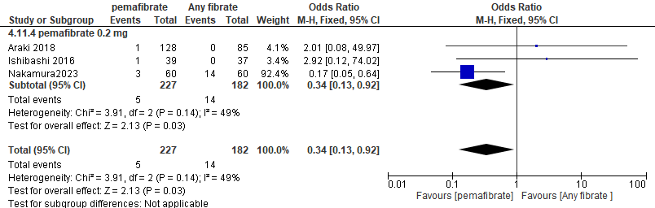

Table of Contents
Supplementary Figures 1
S1, forest plot presenting MD for the effect of pemafibrate VS placebo on LDL-C 1
S2, forest plot presenting MD for the effect of pemafibrate VS other fibrates on LDL-C 2
S3, forest plot presenting MD for the effect of pemafibrate VS placebo on HDL-C 3
S4, forest plot presenting MD for the effect of pemafibrate VS other fibrates on HDL-C 4
S5, forest plot presenting MD for the effect of pemafibrate VS placebo on Non-HDL-C 5
S6, forest plot presenting MD for the effect of pemafibrate VS other fibrates on Non-HDL-C 6
S7, forest plot presenting MD for the effect of pemafibrate VS placebo on VLDL-C 7
S8, forest plot presenting MD for the effect of pemafibrate VS other fibrates on VLDL-C 8
S9, forest plot presenting MD for the effect of pemafibrate VS placebo on Total cholesterol level 9
S10, forest plot presenting MD for the effect of pemafibrate VS other fibrates on Total cholesterol level 10
S11, forest plot presenting MD for the effect of pemafibrate VS placebo on Apo B 11
S12, forest plot presenting MD for the effect of pemafibrate VS other fibrates on Apo B 12
S13, forest plot presenting MD for the effect of pemafibrate VS placebo on Apo A-1 13
S14, forest plot presenting MD for the effect of pemafibrate VS other fibrates on Apo A-1 14
S15, forest plot presenting MD for the effect of pemafibrate VS placebo on Apo A-II 15
S16, forest plot presenting MD for the effect of pemafibrate VS other fibrates on Apo A-II 16
S17, forest plot presenting MD for the effect of pemafibrate VS placebo on ApoB48 17
S18, forest plot presenting MD for the effect of pemafibrate VS other fibrates on ApoB48 18
S19, forest plot presenting MD for the effect of pemafibrate VS placebo on Apo C-II 18
S20, forest plot presenting MD for the effect of pemafibrate VS placebo on Apo C-III 19
S21, forest plot presenting MD for the effect of pemafibrate VS other fibrates on Apo C-III 20
S22, forest plot presenting MD for the effect of pemafibrate VS placebo on RemL-C 21
S23, forest plot presenting MD for the effect of pemafibrate VS other fibrates on RemL-C 22
S24, forest plot presenting MD for the effect of pemafibrate VS placebo on HOMA-R 23
S25, forest plot presenting MD for the effect of pemafibrate VS other fibrates on HOMA-R 24
S26, forest plot presenting MD for the effect of pemafibrate VS placebo on FBG 25
S27, forest plot presenting MD for the effect of pemafibrate VS placebo on fasting insulin 26
S28, forest plot presenting MD for the effect of pemafibrate VS placebo on HBA1C 26
S29, forest plot presenting MD for the effect of pemafibrate VS other fibrates on FBG 27
S30, forest plot presenting MD for the effect of pemafibrate VS other fibrates on fasting insulin 28
S31, Forest plot presenting OR for effect of pemafibrate VS placebo on Adverse drug reactions 29
S32, Forest plot presenting OR for effect of pemafibrate VS other fibrates on Adverse drug reactions 30
S33, Forest plot presenting OR for effect of pemafibrate VS placebo on Serious Adverse events 31
S34, Forest plot presenting OR for effect of pemafibrate VS placebo on Musculoskeletal adverse events 31
S35, Forest plot presenting OR for effect of pemafibrate VS placebo on Rhabdomyolysis 32
S36, Forest plot presenting OR for effect of pemafibrate VS other fibrates on Serious Adverse events 32
S37, Forest plot presenting OR for effect of pemafibrate VS other fibrates on Musculoskeletal Adverse events 33
S38, Forest plot presenting OR for effect of pemafibrate VS other fibrates on Rhabdomyolysis 33
S39, Forest plot presenting OR for effect of pemafibrate VS placebo on hepatic adverse events 34
S40, Forest plot presenting OR for effect of pemafibrate VS other fibrates on hepatic adverse events 34
S41, Forest plot presenting OR for effect of pemafibrate VS placebo on ALT being more than upper limit. 35
S42, Forest plot presenting OR for effect of pemafibrate VS placebo on AST being more than upper limit. 36
S43, Forest plot presenting OR for effect of pemafibrate VS placebo on GGT being more than upper limit of normal. 37
S44, Forest plot presenting OR for effect of pemafibrate VS other fibrates on ALT being more than upper limit. 38
S45, Forest plot presenting OR for effect of pemafibrate VS other fibrates on AST being more than upper limit. 39
S46, Forest plot presenting OR for effect of pemafibrate VS placebo on creatine kinase levels more than the upper limit of normal 40
S47, Forest plot presenting OR for effect of pemafibrate VS other fibrates on creatine kinase levels more than the upper limit of normal 41
S48, Forest plot presenting OR for effect of pemafibrate VS placebo on Creatinine 41
S49, Forest plot presenting OR for effect of pemafibrate VS other fibrates on Creatinine 42

