AI-driven drug design for short-term anxiety disorder

Hari Ram S¹, Latha V²*, Gomathi V³, Ranichitra A⁴, Varsha Dhamotharan⁵, Vidhyavathi RM⁶ & Prabhu D⁷

^{1,3}IP Research Centre, Department of CSE; National Engineering College, Kovilpatti-628 503, Tamil Nadu, India
^{2*}Dept of Chemistry & ⁴Computer Science; Sri S. Ramasamy Naidu Memorial College, Sattur-626 203, Tamil Nadu, India
⁵Dept of Biotechnology, Mepco Schlenk Enginering College, Sivakasi-626 005, Tamil Nadu, India
⁶Bio-Computing Lab; Dept of Bioinformatics; Alagappa University, Karaikudi-630 003, Tamil Nadu, India
⁷Dept of Biotechnology; Karpagam Academy of Higher Education, Coimbatore-641 021, Tamil Nadu, India

Table S1. Desired values for QSAR model validation parameters
QSAR model validation parameters | Value | Purpose
R² and $R_{adj}^{2}$ | ≥0.6 | A fraction of the total variation attributed to the model, it varies directly with the increase in number of descriptors. It can be adjusted for the number of explanatory variables in the model
Q² | >0.5 | External validation of model, as it is closer to 1.0, better the model
p² | <0.05 | Confidence interval at 95% confidence level
R² - Q² | ≤0.3 | Difference between regression coefficients and the cross-validation regression coefficient, that fine tune the model
(NOTE: R² = non-cross validated coefficient of determination; R² _{adj} = an adjustment for the Coefficient of Determination that takes into account the number of variables in a data set; Q² = coefficient of determination for leave-one-out (LOO) internal-cross validation; p² = coefficient of determination for test set predictions)

Table S2. Binding interactions, type and distances of lead compounds with 4COF
Donor |  | Acceptor |  | Distance (Å) | Category | Type
Lorazepam (Ref. Drug)
B:THR176:HG1 | H-Donor | :Lora:O | H-Acceptor | 2.21 | Hydrogen Bond | Conventional Hydrogen Bond
:Lora:O | H-Donor | B:ASP43:OD1 | H-Acceptor | 3.13 | Hydrogen Bond | Conventional Hydrogen Bond
B:TYR62 | Pi-Orbitals | :Lora | Pi-Orbitals | 5.06 | Hydrophobic | Pi-Pi Stacked
B:TYR62 | Pi-Orbitals | :Lora | Pi-Orbitals | 4.64 | Hydrophobic | Pi-Pi Stacked
C:PHE200 | Pi-Orbitals | :Lora | Pi-Orbitals | 4.82 | Hydrophobic | Pi-Pi Stacked
C:PHE200 | Pi-Orbitals | :Lora | Pi-Orbitals | 5.06 | Hydrophobic | Pi-Pi Stacked
C:PHE200 | Pi-Orbitals | :Lora | Pi-Orbitals | 3.85 | Hydrophobic | Pi-Pi Stacked
C:TYR205 | Pi-Orbitals | :Lora | Pi-Orbitals | 5.20 | Hydrophobic | Pi-Pi Stacked
B:TYR62 | Pi-Orbitals | :Lora:Cl1 | Alkyl | 5.10 | Hydrophobic | Pi-Alkyl
C:TYR97 | Pi-Orbitals | :Lora:Cl1 | Alkyl | 5.06 | Hydrophobic | Pi-Alkyl
C:TYR157 | Pi-Orbitals | :Lora:Cl1 | Alkyl | 4.91 | Hydrophobic | Pi-Alkyl
:Lora | Pi-Orbitals | C:ALA201 | Alkyl | 5.36 | Hydrophobic | Pi-Alkyl
:Lora | Pi-Orbitals | C:LEU99 | Alkyl | 5.27 | Hydrophobic | Pi-Alkyl
Molecule ID – M1
C:LYS274:HN | H-Donor | :M1:O | H-Acceptor | 2.34 | Hydrogen Bond | Conventional Hydrogen Bond
: M1:C | H-Donor | B:ASP48:O | H-Acceptor | 3.11 | Hydrogen Bond | Carbon Hydrogen Bond
: M1:C | H-Donor | C:ASN54:O | H-Acceptor | 3.26 | Hydrogen Bond | Carbon Hydrogen Bond
: M1:C | Alkyl | C:PRO273 | Alkyl | 5.45 | Hydrophobic | Alkyl
: M1 | Pi-Orbitals | C:LYS274 | Alkyl | 5.46 | Hydrophobic | Pi-Alkyl
: M1 | Pi-Orbitals | C:MET55 | Alkyl | 4.95 | Hydrophobic | Pi-Alkyl
Molecule ID – M4
B:ALA201:HN | H-Donor | :M4:N | H-Acceptor | 1.9 | Hydrogen Bond | Conventional Hydrogen Bond
A:TYR62 | Pi-Orbitals | :M4 | Pi-Orbitals | 4.62 | Hydrophobic | Pi-Pi Stacked
B:PHE200 | Pi-Orbitals | :M4 | Pi-Orbitals | 5.13 | Hydrophobic | Pi-Pi Stacked
B:TYR205 | Pi-Orbitals | :M4 | Pi-Orbitals | 4.83 | Hydrophobic | Pi-Pi Stacked
:M4:Cl | Alkyl | A:MET115 | Alkyl | 4.59 | Hydrophobic | Alkyl
B:TYR205 | Pi-Orbitals | :M4:Cl | Alkyl | 5.03 | Hydrophobic | Pi-Alkyl
Molecule ID – M5
B:GLN64:HE21 | H-Donor | :M5:O | H-Acceptor | 2.49 | Hydrogen Bond | Conventional Hydrogen Bond
:M5:O | H-Donor | C:THR202:OG1 | H-Acceptor | 3.00 | Hydrogen Bond | Conventional Hydrogen Bond
:M5:C | H-Donor | B:ASN41:OD1 | H-Acceptor | 3.20 | Hydrogen Bond | Carbon Hydrogen Bond
:M5:C | H-Donor | B:TYR62:O | H-Acceptor | 3.68 | Hydrogen Bond | Carbon Hydrogen Bond
B:ASP43:OD1 | Negative | :M5 | Pi-Orbitals | 4.13 | Electrostatic | Pi-Anion
B:THR176:HG1 | H-Donor | :M5 | Pi-Orbitals | 3.05 | Hydrogen Bond | Pi-Donor Hydrogen Bond
B:TYR62 | Pi-Orbitals | :M5 | Pi-Orbitals | 4.64 | Hydrophobic | Pi-Pi Stacked
B:TYR62 | Pi-Orbitals | :M5 | Pi-Orbitals | 4.70 | Hydrophobic | Pi-Pi Stacked
C:PHE200 | Pi-Orbitals | :M5 | Pi-Orbitals | 4.41 | Hydrophobic | Pi-Pi Stacked
C:PHE200 | Pi-Orbitals | :M5 | Pi-Orbitals | 5.36 | Hydrophobic | Pi-Pi Stacked
:M5 | Pi-Orbitals | C:ALA201 | Alkyl | 4.09 | Hydrophobic | Pi-Alkyl
Molecule ID – M6
E:LYS102:HZ1 | H-Donor | :M6:N | H-Acceptor | 2.18 | Hydrogen Bond | Conventional Hydrogen Bond
D:ASP48:O | Lone Pair | :M6 | Pi-Orbitals | 2.94 | Other | Pi-Lone Pair
:M6:Cl | Alkyl | D:LEU183 | Alkyl | 5.40 | Hydrophobic | Alkyl
:M6:Cl | Alkyl | D:PRO184 | Alkyl | 4.74 | Hydrophobic | Alkyl
:M6 | Pi-Orbitals | D:MET49 | Alkyl | 5.40 | Hydrophobic | Pi-Alkyl
:M6 | Pi-Orbitals | E:MET55 | Alkyl | 5.02 | Hydrophobic | Pi-Alkyl
:M6 | Pi-Orbitals | E:ALA135 | Alkyl | 5.12 | Hydrophobic | Pi-Alkyl
:M6 | Pi-Orbitals | D:VAL50 | Alkyl | 5.39 | Hydrophobic | Pi-Alkyl
:M6 | Pi-Orbitals | D:PRO184 | Alkyl | 5.06 | Hydrophobic | Pi-Alkyl
Molecule ID – M7
:M7:N | H-Donor | E:MET55:SD | H-Acceptor | 3.39 | Hydrogen Bond | Conventional Hydrogen Bond
D:PRO184:CD | H-Donor | :M7:O | H-Acceptor | 2.9 | Hydrogen Bond | Carbon Hydrogen Bond
:M7:Cl | H-Donor | D:ILE47:O | H-Acceptor | 3.44 | Hydrogen Bond | Carbon Hydrogen Bond
E:MET55:SD | Sulfur | :M7 | Pi-Orbitals | 4.9 | Other | Pi-Sulfur
D:ASP48:C,O;MET49:N | Amide | :M7 | Pi-Orbitals | 5.06 | Hydrophobic | Amide-Pi Stacked
:M7:C | Alkyl | E:PRO273 | Alkyl | 4.95 | Hydrophobic | Alkyl
:M7:C | Alkyl | E:LYS274 | Alkyl | 4.45 | Hydrophobic | Alkyl
:M7 | Pi-Orbitals | D:PRO184 | Alkyl | 4.5 | Hydrophobic | Pi-Alkyl
:M7 | Pi-Orbitals | D:PRO184 | Alkyl | 4.84 | Hydrophobic | Pi-Alkyl
:M7 | Pi-Orbitals | E:ALA135 | Alkyl | 5.46 | Hydrophobic | Pi-Alkyl
Molecule ID – M9
C:ALA45:HN | H-Donor | C:ASP43:O | H-Acceptor | 2.99 | Hydrogen Bond | Conventional Hydrogen Bond
C:ALA45:HN | H-Donor | C:THR60:O | H-Acceptor | 2.08 | Hydrogen Bond | Conventional Hydrogen Bond
C:SER46:HN | H-Donor | C:THR60:O | H-Acceptor | 2.16 | Hydrogen Bond | Conventional Hydrogen Bond
C:SER46:HG | H-Donor | C:ASP48:OD1 | H-Acceptor | 2.23 | Hydrogen Bond | Conventional Hydrogen Bond
C:THR60:HN | H-Donor | C:SER46:O | H-Acceptor | 1.97 | Hydrogen Bond | Conventional Hydrogen Bond
D:ASN100:HD21 | H-Donor | D:ALA135:O | H-Acceptor | 2.38 | Hydrogen Bond | Conventional Hydrogen Bond
D:ALA135:HN | H-Donor | D:ASN100:O | H-Acceptor | 1.92 | Hydrogen Bond | Conventional Hydrogen Bond
D:MET137:HN | H-Donor | :M9:O | H-Acceptor | 1.89 | Hydrogen Bond | Conventional Hydrogen Bond
C:SER46:CB | H-Donor | :M9:N | H-Acceptor | 3.64 | Hydrogen Bond | Carbon Hydrogen Bond
C:ALA45:C,O;SER46:N | Amide | :M9 | Pi-Orbitals | 5.45 | Hydrophobic | Amide-Pi Stacked
D:MET55 | Alkyl | D:MET137 | Alkyl | 4.79 | Hydrophobic | Alkyl
D:ALA135 | Alkyl | D:LYS102 | Alkyl | 4.79 | Hydrophobic | Alkyl
C:TYR62 | Pi-Orbitals | C:ALA45 | Alkyl | 5.19 | Hydrophobic | Pi-Alkyl
:M9 | Pi-Orbitals | D:ALA135 | Alkyl | 4.18 | Hydrophobic | Pi-Alkyl
:M9 | Pi-Orbitals | D:MET137 | Alkyl | 5.31 | Hydrophobic | Pi-Alkyl
Molecule ID – M10
E:GLN224:HE22 | H-Donor | :M10:N | H-Acceptor | 2.75 | Hydrogen Bond | Conventional Hydrogen Bond
:M10:Cl | H-Donor | E:ILE264:O | H-Acceptor | 2.94 | Hydrogen Bond | Carbon Hydrogen Bond
E:HIS267:NE2 | Positive | :M10 | Pi-Orbitals | 4.84 | Electrostatic | Pi-Cation
E:HIS267:NE2 | Positive | :M10 | Pi-Orbitals | 4.82 | Electrostatic | Pi-Cation
:M10:C | Alkyl | A:LYS274 | Alkyl | 5.24 | Hydrophobic | Alkyl
E:TYR220 | Pi-Orbitals | :M10:C | Alkyl | 4.94 | Hydrophobic | Pi-Alkyl
E:PHE221 | Pi-Orbitals | :M10:C | Alkyl | 5.16 | Hydrophobic | Pi-Alkyl
E:HIS267 | Pi-Orbitals | :M10:C | Alkyl | 5.36 | Hydrophobic | Pi-Alkyl
:M10 | Pi-Orbitals | E:LEU268 | Alkyl | 4.85 | Hydrophobic | Pi-Alkyl
:M10 | Pi-Orbitals | E:ILE264 | Alkyl | 5.00 | Hydrophobic | Pi-Alkyl
Molecule ID – M11
B:LYS102:HZ1 | H-Donor;Halogen Acceptor | :M11:F | H-Acceptor;Halogen | 2.29 | Hydrogen Bond;Halogen | Conventional Hydrogen Bond;Halogen (Fluorine)
B:ASN54:O | Halogen Acceptor | :M11:F | Halogen | 2.63 | Halogen | Halogen (Fluorine)
B:MET55:O | Halogen Acceptor | :M11:F | Halogen | 3.61 | Halogen | Halogen (Fluorine)
:M11:Cl | Alkyl | A:PRO184 | Alkyl | 4.77 | Hydrophobic | Alkyl
:M11:Cl | Alkyl | B:PRO273 | Alkyl | 4.78 | Hydrophobic | Alkyl
:M11 | Pi-Orbitals | B:MET55 | Alkyl | 4.88 | Hydrophobic | Pi-Alkyl
:M11 | Pi-Orbitals | B:ALA135 | Alkyl | 5.49 | Hydrophobic | Pi-Alkyl
:M11 | Pi-Orbitals | B:MET137 | Alkyl | 5.35 | Hydrophobic | Pi-Alkyl
:M11 | Pi-Orbitals | A:PRO184 | Alkyl | 4.85 | Hydrophobic | Pi-Alkyl
Molecule ID – M12
A:TRP237:HN | H-Donor | A:THR233:O | H-Acceptor | 2.75 | Hydrogen Bond | Conventional Hydrogen Bond
A:TRP237:HN | H-Donor | A:ILE234:O | H-Acceptor | 2.13 | Hydrogen Bond | Conventional Hydrogen Bond
A:PHE240:HN | H-Donor | A:TRP237:O | H-Acceptor | 2.41 | Hydrogen Bond | Conventional Hydrogen Bond
A:TRP241:HN | H-Donor | A:VAL238:O | H-Acceptor | 2.12 | Hydrogen Bond | Conventional Hydrogen Bond
A:SER436:HN | H-Donor | A:PRO432:O | H-Acceptor | 2.03 | Hydrogen Bond | Conventional Hydrogen Bond
B:LEU297:HN | H-Donor | B:PHE293:O | H-Acceptor | 2.03 | Hydrogen Bond | Conventional Hydrogen Bond
B:PHE301:HN | H-Donor | B:LEU297:O | H-Acceptor | 1.79 | Hydrogen Bond | Conventional Hydrogen Bond
A:TRP237:CD1 | H-Donor | A:SER236:OG | H-Acceptor | 3.34 | Hydrogen Bond | Carbon Hydrogen Bond
A:TRP241:CD1 | H-Donor | A:TRP237:O | H-Acceptor | 3.33 | Hydrogen Bond | Carbon Hydrogen Bond
A:PRO432:CD | H-Donor | A:SER427:O | H-Acceptor | 3.7 | Hydrogen Bond | Carbon Hydrogen Bond
A:ARG428:NH1 | Positive | A:TRP241 | Pi-Orbitals | 4.84 | Electrostatic | Pi-Cation
:M12:C | C-H | A:TRP241 | Pi-Orbitals | 3.99 | Hydrophobic | Pi-Sigma
A:TRP237 | Pi-Orbitals | M12 | Pi-Orbitals | 5.85 | Hydrophobic | Pi-Pi Stacked
A:TRP241 | Pi-Orbitals | M12 | Pi-Orbitals | 3.72 | Hydrophobic | Pi-Pi Stacked
A:TRP241 | Pi-Orbitals | M12 | Pi-Orbitals | 4.66 | Hydrophobic | Pi-Pi Stacked
A:TRP241 | Pi-Orbitals | M12 | Pi-Orbitals | 4.65 | Hydrophobic | Pi-Pi Stacked
A:TRP241 | Pi-Orbitals | B:TYR304 | Pi-Orbitals | 5.64 | Hydrophobic | Pi-Pi T-shaped
A:TRP237 | Pi-Orbitals | A:PRO432 | Alkyl | 4.91 | Hydrophobic | Pi-Alkyl
A:TRP237 | Pi-Orbitals | A:ILE234 | Alkyl | 4.79 | Hydrophobic | Pi-Alkyl
A:TRP237 | Pi-Orbitals | A:PRO432 | Alkyl | 4.09 | Hydrophobic | Pi-Alkyl
A:TRP241 | Pi-Orbitals | A:ARG428 | Alkyl | 4.27 | Hydrophobic | Pi-Alkyl
A:TRP241 | Pi-Orbitals | A:ARG428 | Alkyl | 4.13 | Hydrophobic | Pi-Alkyl
A:TRP241 | Pi-Orbitals | : M12:Cl | Alkyl | 4.98 | Hydrophobic | Pi-Alkyl
B:PHE293 | Pi-Orbitals | B:LEU297 | Alkyl | 4.94 | Hydrophobic | Pi-Alkyl
: M12 | Pi-Orbitals | B:LEU297 | Alkyl | 4.92 | Hydrophobic | Pi-Alkyl
: M12 | Pi-Orbitals | A:PRO432 | Alkyl | 5.21 | Hydrophobic | Pi-Alkyl

Table S3. Cross-validation parameters of QSAR models
QSAR Model# | R² | $$R_{adj}^{2}$$ | $$Q_{LOO}^{2}$$ | $$Q_{ext}^{2}$$ | PRESS | RSS | SER | SDEC | SDEP | Model Equation
1 | 0.8192 | 0.7288 | 0.4712 | -12.843 | 3.2794 | 1.1211 | 0.4323 | 0.3348 | 0.5727 | y = 27.15911 + (-0.23514) * MDEC-23 + (1.37176) * SM1_Dzv + (-86.91944) * VE2_Dzpe
2 | 0.8272 | 0.7407 | 0.6137 | 0.4948 | 2.3958 | 1.0720 | 0.4227 | 0.3274 | 0.4895 | y = 14.82176 + (0.65928) * Mor10 + (-2.41373) * Mor20v + (-42.27828) * VE2_Dzp
3 | 0.8579 | 0.7868 | 0.6786 | 0.5285 | 1.9932 | 0.8814 | 0.3833 | 0.2969 | 0.4465 | y = 2.17213 + (-0.00209) * GRAVp + (0.09838) * SsF + (3.12088) * Xpc-4dv
4 | 0.8366 | 0.7548 | 0.6788 | 0.7100 | 1.9922 | 1.0137 | 0.4110 | 0.3184 | 0.4463 | y = -1.35838 + (0.71680) * Mor10 + (-2.53376) * Mor20v + (3.18605) * VE3_Dzm
5 | 0.8390 | 0.7585 | 0.6819 | 0.7116 | 1.9727 | 0.9985 | 0.4079 | 0.3160 | 0.4442 | y = -1.34930 + (0.71963) * Mor10 + (-2.53175) * Mor20v + (3.18302) * VE3_Dzp
6 | 0.9015 | 0.8523 | 0.7183 | -2.095 | 1.7469 | 0.6109 | 0.3191 | 0.2472 | 0.4180 | y = 2.59428 + (0.58642) * GGI3 + (4.31667) * Mor26v + (3.43733) * MATS1i
7 | 0.8928 | 0.8392 | 0.7678 | -0.4698 | 1.4404 | 0.6650 | 0.3329 | 0.2579 | 0.3795 | y = 1.58108 + (1.30787) * GGI3 + (4.76862) * Mor26v + (1.29751) * MATS3i
8 | 0.9124 | 0.8686 | 0.8489 | -0.0367 | 0.9369 | 0.5432 | 0.3009 | 0.2331 | 0.3061 | y = 3.08660 + (1.60902) * GGI3 + (5.49511) * Mor26v + (-1.60304) * GATS3d
9 | 0.9385 | 0.9078 | 0.8683 | 0.2319 | 0.8170 | 0.3813 | 0.2521 | 0.1953 | 0.2858 | y = 2.01955 + (0.93615) * GGI3 + (5.05765) * Mor26v + (-2.86886) * MATS2i
10 | 0.9646 | 0.9468 | 0.9356 | 0.9768 | 0.3995 | 0.2198 | 0.1914 | 0.1482 | 0.1999 | y = 2.51878 + (0.93305) * GGI3 + (7.57223) * Mor26v + (-2.40609) * Mor26
11 | 0.9758 | 0.9637 | 0.9363 | 0.1069 | 0.3948 | 0.1501 | 0.1582 | 0.1225 | 0.1987 | y = 2.15427 + (0.14688) * ABCGG + (8.46746) * Mor26v + (-3.21537) * Mor26
12 | 0.9739 | 0.9608 | 0.9402 | 0.5608 | 0.3711 | 0.1620 | 0.1643 | 0.1273 | 0.1926 | y = 3.44936 + (0.00405) * ATS6d + (8.79108) * Mor26v + (-3.45954) * Mor26
13 | 0.9856 | 0.9784 | 0.9586 | 0.7936 | 0.2566 | 0.0895 | 0.1221 | 0.0946 | 0.1602 | 3.44728 + (0.00407) * ATS7s + (9.06986) * Mor26v + (-3.57461) * Mor26
(NOTE: R² = non-cross validated coefficient of determination; R² _{adj} = an adjustment for the Coefficient of Determination that takes into account the number of variables in a data set; Q²_{LOO} = coefficient of determination for leave-one-out (LOO) internal-cross validation; Q²_{ext} = coefficient of determination for external-cross validation; PRESS= predicted residual sum of squares; RSS=sum of squares of response value; SER = standard error of regression; SDEC = standard deviation error in calculation; SDEP = standard deviation error in prediction;)

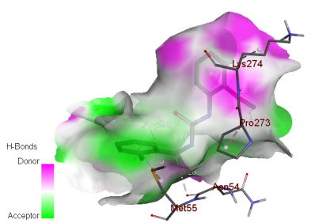 | 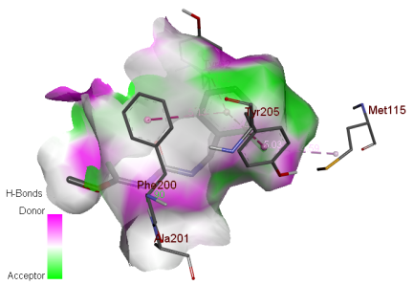 | 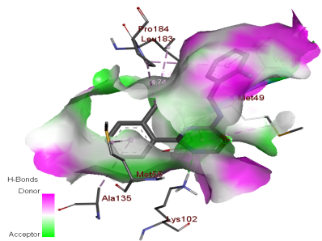
M1 | M4 | M6
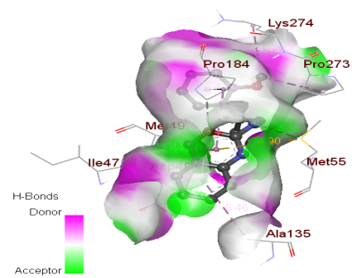 | 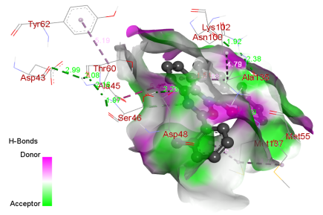 | 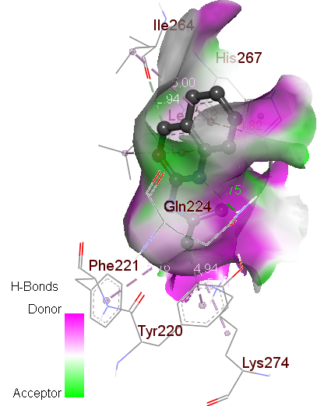
M7 | M9 | M10
 | 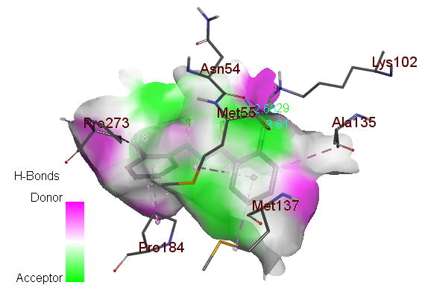
 | M11
Fig. S1: Electrostatic (H-bond) interactions with nearby amino acid residue for compounds(M1, M4-M7& M9-M11)

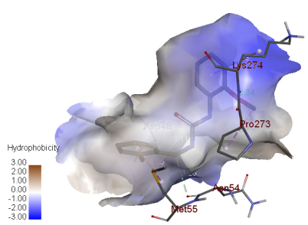 | 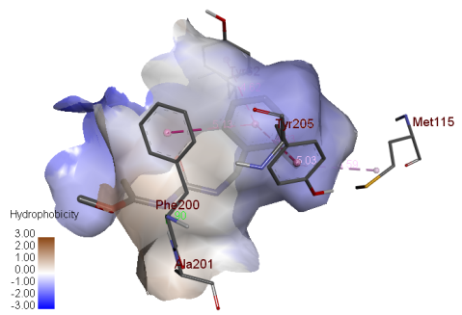 | 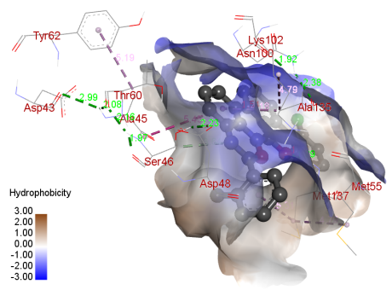
M1 | M4 | M6
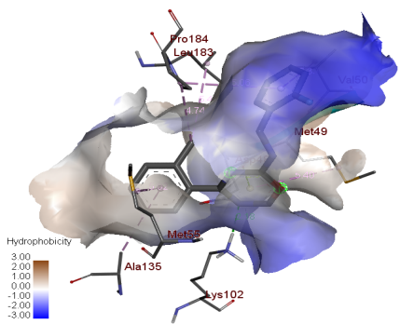 | 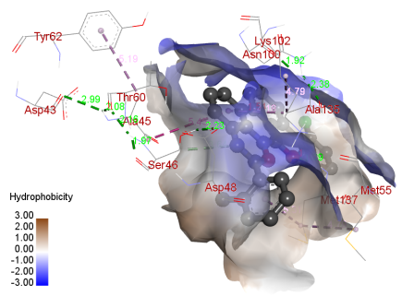 | 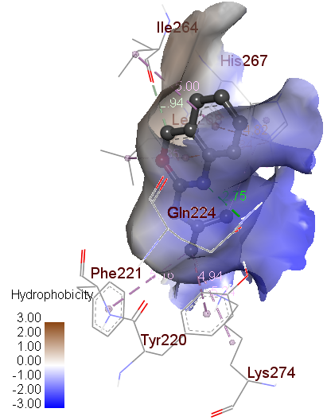
M7 | M9 | M10
 | M11
Fig. S2: Hydrophobic interactions with nearby amino acid residue for compounds (M1, M4-M7& M9-M11)

