SUPPLEMENTARY INFORMATION

- Mathematical relation of cell volume changes and rate of water flux. The dynamics of the cell volume ($Vol$) changes can be described by the following differential equation:

$\frac{dVol}{dt}= P_{w} \left(\frac{n_{i}}{Vol}-Π_{ex}\right)$,

where $n_{i}$ is the intracellular moles of osmotically active substances, $Π_{ex}$ is the extracellular osmolarity and $P_{w}$ is the water permeability of the cell membrane.

Integrating eqn. (1) from an initial cell volume ${Vol}_{i}$ we obtain:

$$n_{i} log\left(\frac{n_{i}-Π_{ex} Vol}{n_{i}-Π_{ex} {Vol}_{i}}\right)-Π_{ex} \left({Vol}_{i}-Vol\right)=-Π_{ex}^{2} P_{w} t$$
At relatively small times, at which ${Vol}_{i}≅Vol$, we obtain $\frac{n_{i}-Π_{ex} Vol}{n_{i}-Π_{ex} {Vol}_{i}}=e^{-\frac{Π_{ex}^{2} P_{w} t}{n_{i}}}$
Using the approximation: $e^{-\frac{Π_{ex}^{2} P_{w} t}{n_{i}}}≈1-\frac{Π_{ex}^{2} P_{w} t}{n_{i}}$, we obtain:

$Vol= {Vol}_{i}+$ $Π_{ex} P_{w} \left(1-\frac{Π_{ex}{Vol}_{i}}{n_{i}}\right)t$

Thus, the volume change is expected to change linearly with time, with a slope proportional to the water permeability of the cell membrane.

- Proton currents recorded in EGFP and tORF3a cells.

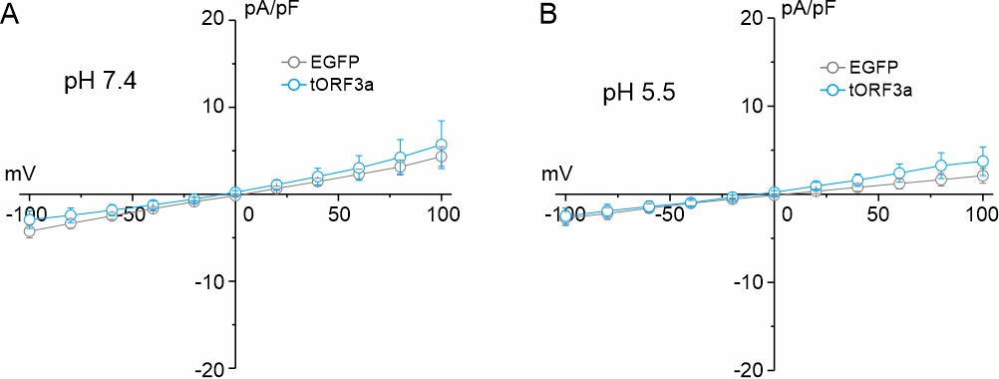

Supplementary Figure S1. Proton current recordings. A and B) Average current-voltage (I–V) relationship analysis in cEGFP (grey circles, n=4) and tORF3a (blue circles, n=5) cells, during application of an extracellular solution at pH 7.4 (A) and upon application the same solution at pH 5.5 (B). Data are shown as mean ± SEM.

- Additional ultrastructural observations in ORF3a-WT transfected cells. In addition to the presence of markedly enlarged lysosomes, cells transfected with the ORF3a-WT protein exhibited other notable structural alterations summarized in Supplementary Fig. S2. First, in more than 50% of ORF3a-WT transfected cells we observed an unusual presence of large double-membrane structures, measuring up to 1.7 µm² of cell surface. Such large structures, never found in cells from the other two groups, may represent autophagosomes/amphisomes that cannot fuse with inactivated lysosomes. Another important ultrastructural alteration observed in ORF3a-transfected cells, was the striking remodeling of intracellular membranes, likely of ER/Golgi origin, to form a labyrinth of membranes of a quite regular pattern resembling a honey-comb structure, covering large area (up to 30%) of the cell. These structures, which were never found neither in control cEGFP nor in ORF3a-N82W cells, were very similar to those described in a recent study showing that SARS-CoV-2 viral proteins perturb the ultrastructure of the endomembrane system¹. Finally, most of mitochondria of ORF3a-WT transfected cells were morphologically altered and damaged. In the cytoplasm of control cEGFP cells mitochondria usually appeared as round or more often as elongated bean-shaped organelles, with fairly parallel cristae within a dark/electron dense matrix (Supplementary Fig. S2). In ORF3a-WT transfected cells many mitochondria appeared structurally abnormal, with an irregular bean-shaped morphology, and they displayed an aberrant internal matrix. Moreover, damaged mitochondria often displayed disrupted internal cristae resulting as densely dark and packed stripes structurally resembling the zebra-skin pattern and containing large clear vacuoles. Such altered mitochondria were never found in cEGFP cells, whereas rarely found in ORF3a-N82W cells.
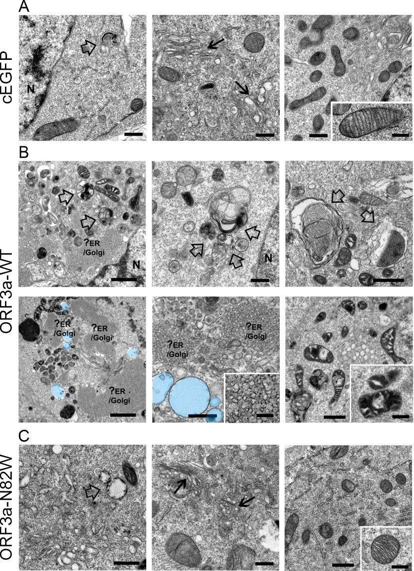

Supplementary Figure S2. Additional ultrastructural observations in ORF3a-WT cells. A-C) Representative EM images obtained from cEGFP cells (A) and from cells either transfected with the full-length ORF3a-WT (B) or ORF3a-N82W (C). Empty arrows to abnormal accrual of large double-membrane structures (likely autophagosomes/amphisomes), whereas black arrows point to intracellular “cubic membranes”. Accumulation of phospholipid membranes in B, likely of ER/Golgi origin (?ER/Golgi) are present only in cells transfected with the ORF3a-WT protein. Enlarged lysosomes are falsely labeled in light blue for easier visualization. High magnification of area of the cell shows structurally normal mitochondria, which appear as round or more often as elongated bean-shaped organelles, with parallel cristae within a dark/electron dense matrix in cEGFP (A) and in ORF3a-N82W (C) cells, while structurally abnormal, with an irregular bean-shaped morphology and an aberrant internal matrix in ORF3a-WT cells (B). In B, N as for nucleus. Scale bars: A - C, 1 µm. Insets: 0.5 µm.

The accumulation of damaged organelles may result from an altered autophagic process.
Autophagy is an evolutionarily conserved process used by animal cells to remove damaged materials, such as altered, non-functioning and/or aged organelles, thereby maintaining cellular homeostasis. Besides, autophagy also functions as a cellular surveillance mechanism essential to protect the host cell from invading pathogens, such as viruses. Many viruses have evolved strategies to inhibit or evade autophagy, preventing their destruction and perpetuating their production. SARS-CoV-2 uses the ORF3a protein to block the autophagy and to exploit inactivated lysosomes for its egress. The current view, supported by several studies published over the past four years, is that ORF3a inhibits autophagy by interacting and sequestering the homotypic fusion and protein sorting (HOPS) component VPS39. This would disrupt VPS39 interaction with the Rab7 GTPase protein and prevents the assembly of the Rab7-HOPS-SNARE complex, essential for the fusion of autophagosomes/amphisomes with lysosomes^{2–6}. However, besides the VPS39-mediated block of autophagy, it has also been well documented a ORF3a-mediated lysosomes inactivation through their deacidification, that appears important to prevent virus degradation. As reported above, the newly identified function of the ORF3a protein as a water transporter may be related to its ability to deacidify lysosomes, likely by inducing lysosome swelling. Importantly, lysosome inactivation could also lead to the inhibition of autophagy⁷. Therefore, ORF3a could play a dual function in blocking autophagy in infected cells: on the one hand, it would deactivate lysosomes thanks to its function as a water transporter, inhibiting lysosomal digestive power; on the other hand, it would inhibit the molecular machinery necessary for the fusion of autophagosomes/amphisomes with lysosomes.
However, how ORF3a contributes to mitochondrial damage and accumulation of ER/Golgi membranes remains unclear. A possible explanation would be that ORF3a, by promoting lysosome deacidification/inactivation, inhibits the autophagic machinery of the transfected cells. In fact, ORF3a is located among ER, Golgi apparatus, lysosomes, and on plasma membrane, but not mitochondria. Therefore, accumulation of damaged/swollen mitochondria could not be due to a direct action of ORF3a on these organelles. Concerning the accumulation of ER/Golgi membranes, it has been reported that SARS-CoV-2 ORF3a destructively perturbs the ER membrane organization, leading to an abnormal accumulation of intracellular membranes previously named “cubic membranes”¹. Interestingly, these highly convoluted membrane structures are very similar to those observed in our ORF3a transfected cells. The cubic membranes are also observed in coronavirus-infected cells and are considered essential for replication of viral particles⁸. However, it would also be possible that, similarly for the accumulation of damaged swollen mitochondria, accumulation of ER/Golgi membranes would be the result of defective autophagy.
Strikingly, both the presence of damaged/swollen mitochondria and ER/Golgi membranes almost disappear in cells transfected with the ORF3a-N82W mutant. As this residue is essential to form the selectivity filter that mediates the passage of water and since it is distant from the ORF3a unstructured loop (residues) necessary for the interaction with the VPS39 protein⁵, we think that the N82W mutation would reactivate the autophagic machinery by preventing the swelling-induced lysosome deacidification/inactivation. However, future studies will be necessary to better understand this aspect.
Collectively, these data would suggest that the ORF3a-mediated water transport may be required for all the observed ultrastructural modifications.

REFERENCES

1. Lee, Y. Bin et al. Super-resolution proximity labeling reveals anti-viral protein network and its structural changes against SARS-CoV-2 viral proteins. Cell Rep 42, 112835 (2023).
2. Chen, D. et al. ORF3a of SARS-CoV-2 promotes lysosomal exocytosis-mediated viral egress. Dev Cell 56, 3250-3263.e5 (2021).
3. Miao, G. et al. ORF3a of the COVID-19 virus SARS-CoV-2 blocks HOPS complex-mediated assembly of the SNARE complex required for autolysosome formation. Dev Cell 56, 427-442.e5 (2021).
4. Zhang, Y. et al. The SARS-CoV-2 protein ORF3a inhibits fusion of autophagosomes with lysosomes. Cell Discov 7, (2021).
5. Miller, A. N. et al. The SARS-CoV-2 accessory protein Orf3a is not an ion channel, but does interact with trafficking proteins. Elife 12, 84477 (2023).
6. Walia, K. et al. SARS-CoV-2 virulence factor ORF3a blocks lysosome function by modulating TBC1D5-dependent Rab7 GTPase cycle. Nat Commun 15, (2024).
7. Li, M. et al. Suppression of Lysosome Function Induces Autophagy via a Feedback Down-regulation of MTOR Complex 1 (MTORC1) Activity. Journal of Biological Chemistry 288, 35769–35780 (2013).
8. Deng, Y. & Angelova, A. Coronavirus-Induced Host Cubic Membranes and Lipid-Related Antiviral Therapies: A Focus on Bioactive Plasmalogens. Front Cell Dev Biol 9, 630242 (2021).

