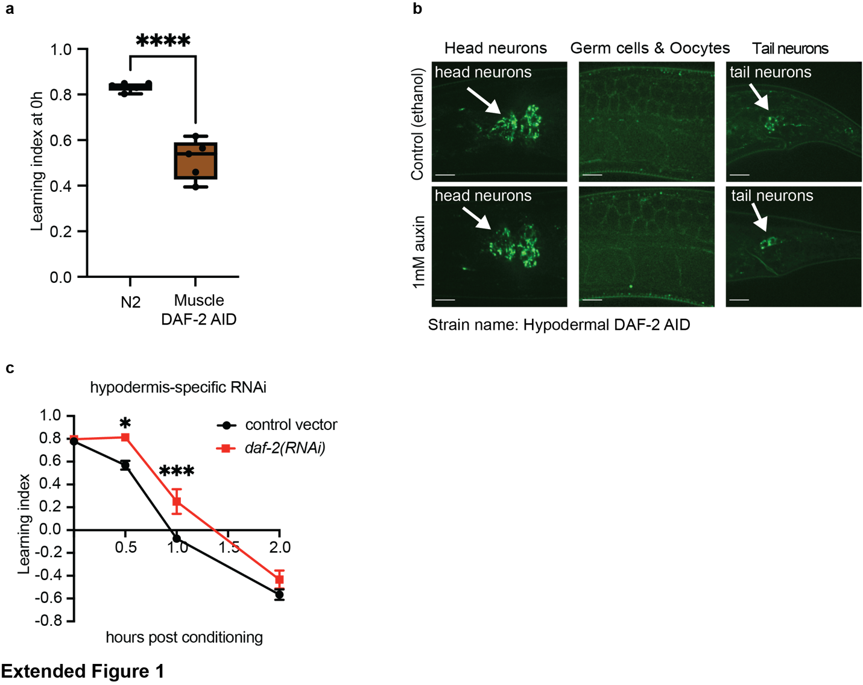
Extended Figure 1. Knocking down daf-2 specifically in the hypodermis improved memory (a) Worms with auxin-inducible DAF-2 degradation in the muscle had learning defects prior to auxin treatment in Day 2 adult animals. Unpaired t-test. (b) Pdpy-7::TIR-1 did not induce DAF-2 degradation in neurons. DAF-2 is fused with a mNeonGreen tag at the C-termini. White arrows point to head and tail neurons. Scale bar: 10 $μ$m. (c) Knocking down daf-2 in young adult hypodermal-specific-RNAi worms increased associative memory. Mean ± s.e.m., two-way repeated measures ANOVA, Bonferroni post hoc tests. In all memory assays: n ≥ 4. *p ≤ 0.05, **p ≤ 0.01, ***p ≤ 0.001, ****p ≤ 0.0001.

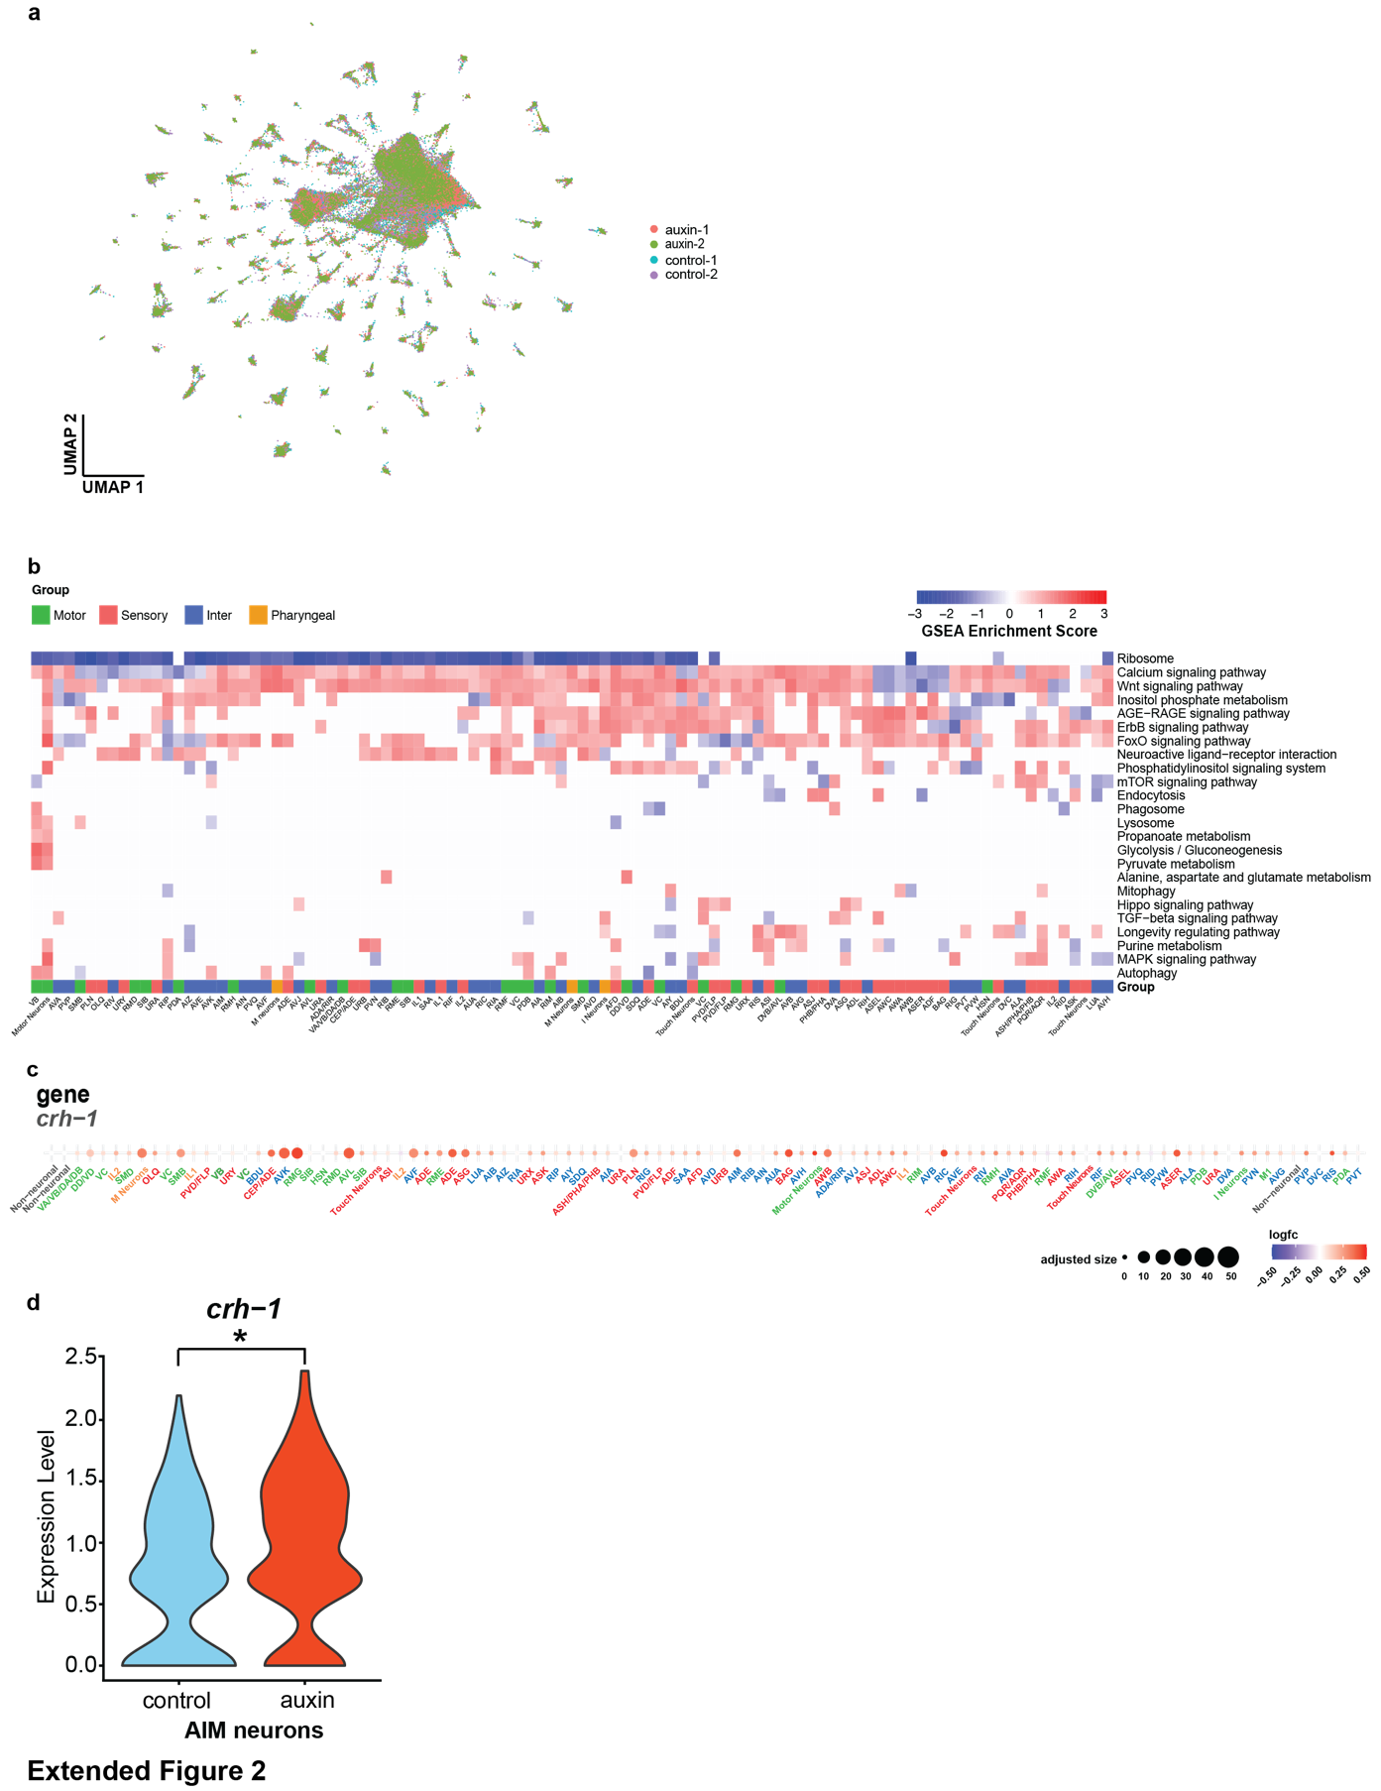

Extended Figure 2. Single-nucleus sequencing of adult C. elegans reveals that neuronal function- and longevity-related pathways and crh-1 contributes to the memory extension. (a) a UMAP of all nuclei shows that hypodermal IIS reduction caused no change in neuron identity. (b) Gene set enrichment analysis of hypodermal daf-2-regulated neuronal genes revealed longevity- and neuronal function-related pathways. (c) Hypodermal DAF-2 degradation upregulated crh-1 in most neurons. (d) Hypodermal DAF-2 degradation upregulated crh-1 in AIM interneurons.

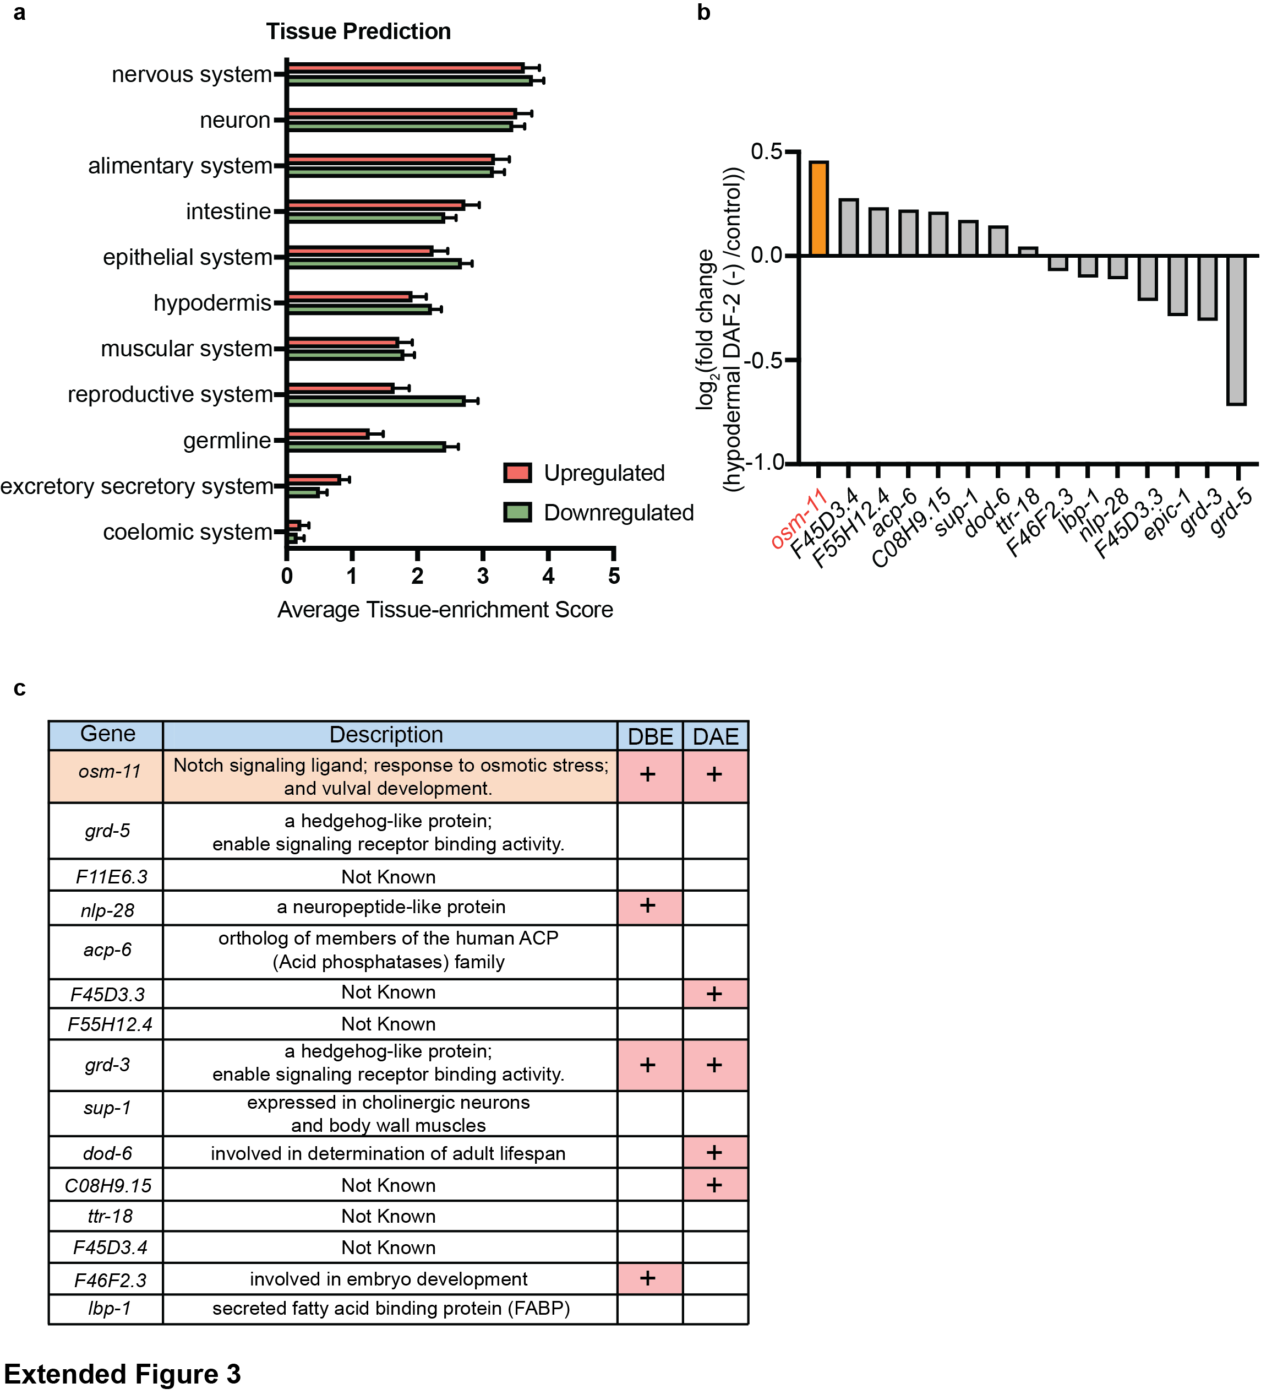
Extended Figure 3. RNA-seq results of whole worms with hypodermal DAF-2 degradation (a) Prediction mean tissue enrichment scores for the genes significantly altered after hypodermal DAF-2 degradation. (b) log₂ fold change shows the transcription level of the 15 candidate genes altered after hypodermal DAF-2 degradation. (c) Description of all 15 candidate IIS targets. +: genes have DAF-16 Binding Element (DBE) or DAF-16 Associative Element (DAE) in their 1kb upstream promoters.

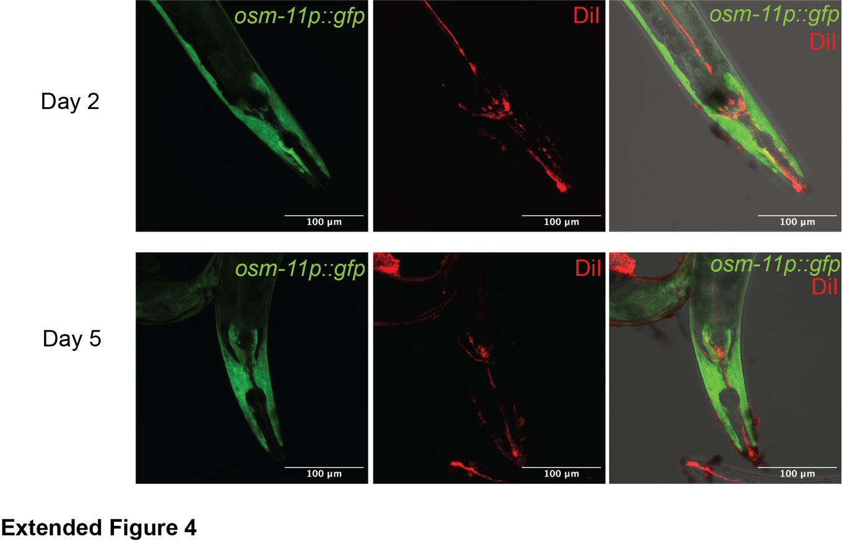
Extended Figure 4. OSM-11 is not expressed in neurons.
OSM-11 is not expressed in neurons using a osm-11p::gfp reporter construct in both young (Day 2) and older adults (Day 5). Neurons were labeled as red using DiI staining. Representative images of 15-20 worms. Scale bar: 100 $μ$m
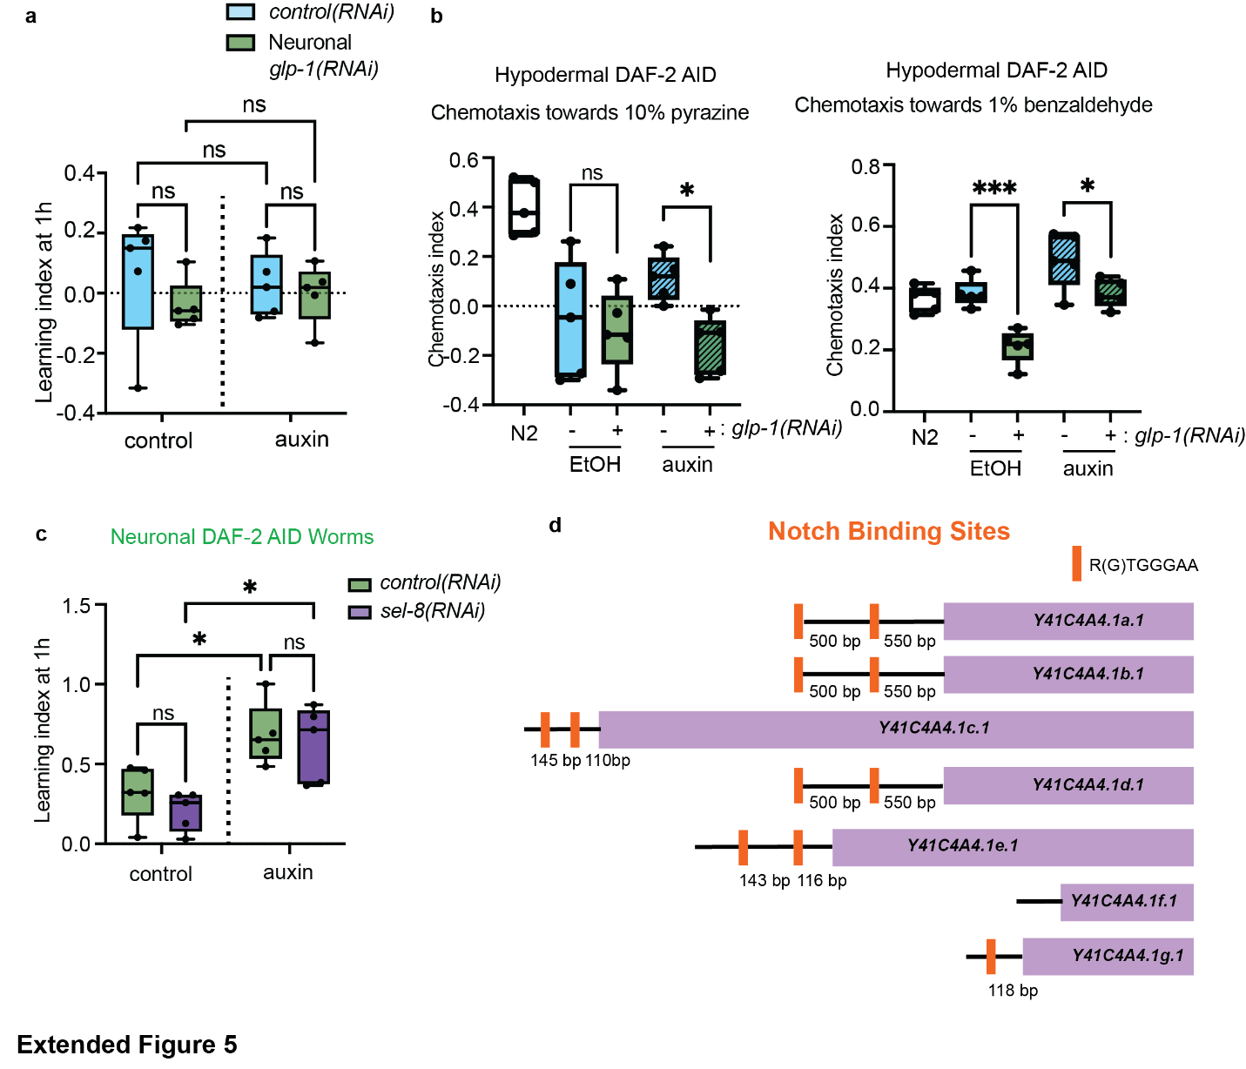
Extended Figure 5. Knocking down glp-1 specifically in ciliated neurons impaired chemosensory (a) Knocking down glp-1, one of the Notch signaling receptors, specifically in the ciliated neurons, abolished memory in Day 2 adult worms, thus memory cannot be measured. two-way repeated measures ANOVA, Tukey post hoc tests. (b) Knocking down glp-1 in the ciliated neurons impaired chemotaxis towards 10% pyrazine and 1% benzaldehyde in young Day 2 adult worms. Unpaired t-test. (c) The Notch signaling was not required for memory enhanced by neuronal DAF-2 degradation. Knocking down sel-8 by RNAi from L4 stage did not affect the memory enhanced by loss of neuronal DAF-2. two-way repeated measures ANOVA, Tukey post hoc tests. In all memory assays: n ≥ 4 chemotaxis plates at each time point. Each plate contains roughly 100 worms. *p ≤ 0.05, **p ≤ 0.01, ***p ≤ 0.001, ****p ≤ 0.0001. (D) Notch binding sites in ~1kb promoter of different crh-1 isoforms.

