Reduced GO decorated waste Moringa oleifera fiber composite for sustainable electromagnetic shielding
material
Waste and Biomass Valorization

Biswabandita Samantara, Rajib Barik and Ganeswar Nath*
Department of Physics, Veer Surendra Sai University of Technology, Burla, Sambalpur, Odisha, India
*Email: ganeswar.nath@gmail.com

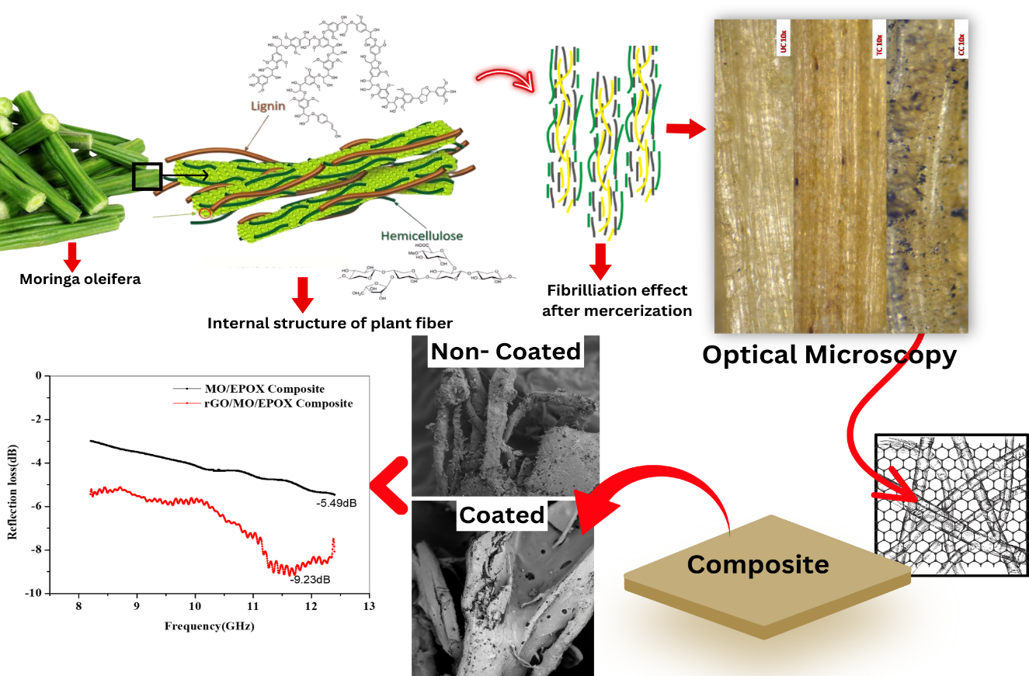
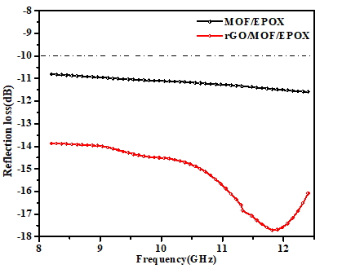
Graphical Abstract

