Supplementary data

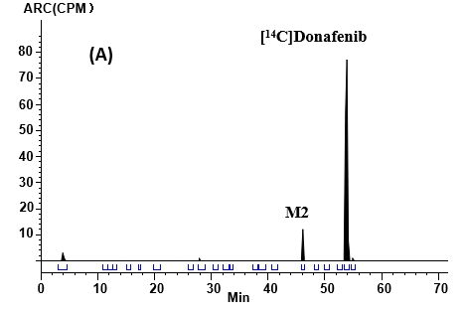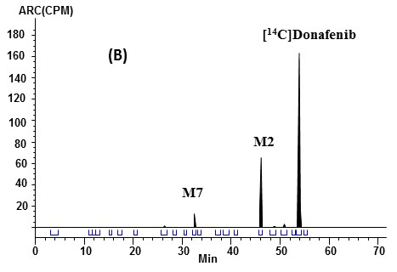
Sup. Fig. 1. Representative radiochromatograms of human plasma after a single oral dose of 300 mg (120 μCi) [¹⁴C]donafenib: (A) pooled 0.75 h plasma sample from six patients,
(B) pooled 12 h plasma sample from six patients.

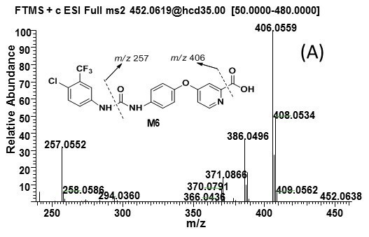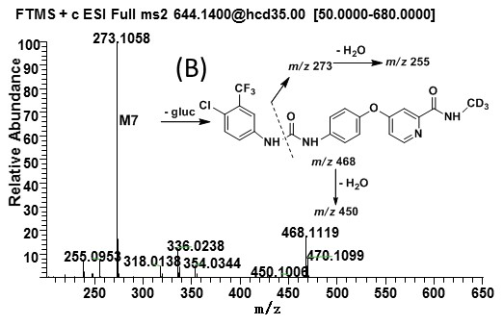

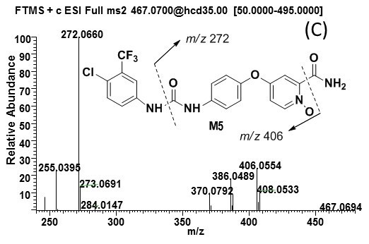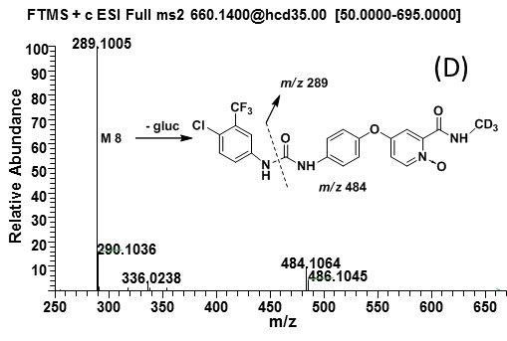

Sup. Fig. 2. MS2 spectra and fragmentation of M6 (A), M7 (B), M5(C), M8 (D)

