Supplemental Materials and Methods

ATF3 is required for the prevention of cardiomyopathy via the regulation of mitochondrial oxidative stress

Myong-Ho Jeong^{1*}, Yi-deul Jeong^{2,3,*}, Su-Yeon Cho¹, Seung Hee Lee¹, Geun-Young Kim¹, Min-Ju Kim¹, Won-Ho Kim^{1#}

¹Division of Cardiovascular Disease, Center for Biomedical Sciences, Korea National Institute of Health, Cheoungju, Republic of Korea
²Department of Molecular Cell Biology, Sungkyunkwan University School of Medicine, Suwon 16419, Republic of Korea
³Research Institute of Aging Related Disease, AniMusCure Inc., Suwon 16419, Republic of Korea

*These two authors contributed equally as first authors.

Corresponding authors
Won-Ho Kim, Ph.D
Director, Department of Chronic Disease Convergence Research, National Institute of Health.
Cheongju-si 28159, Republic of Korea
E-mail address: jhkwh@korea.kr, Telephone:+82-43-719-8600, Fax: +82-43-719-8602

Contents
Supplemental Figures 1-8
Supplemental Tables 1-3
References 1-6
Supplemental Figures
Figure S1. ATF3 depletion causes mouse cardiomyocyte hypertrophy, while its overexpression attenuates ET-1-induced cellular hypertrophy.
A. Representative fluorescence images for NMVM treated with ET-1 for 24 h followed by PBS or Cre for 24 h. B. Measurement of the relative cell surface area is shown in panel (A). C. Immunoblotting of vehicle- or Cre-treated NMVMs treated with PBS or ET-I for 24 h. α-Tubulin was used as a loading control. D-G. qRT‒PCR analysis of Atf3, Anp, Bnp and β-Mhc levels in the control or Cre recombinase-treated NMVMs following PBS or AngII treatment. H. Representative immunostaining images of Ad-RFP- or Ad-RFP-ATF3-transfected NMVMs treated with PBS or ET-1 for 24 h. I. Quantification of the cell surface area, as shown in panel (H). J. Protein expression of Ad-RFP- or Ad-RFP-ATF3-transfected NMVMs treated with PBS or ET-1 for 24 h. α-Tubulin was used as a loading control. K‒M. Relative qRT‒PCR analysis of Anp, Bnp and β-Mhc levels in control or Ad-RFP-ATF3-transfected NMVMs treated with PBS or ET-1 for 24 h. n=3. For analysis of statistical significance, one-way ANOVA was used. *p<0.05, ***p<0.0005, ****p<0.0001. The data represent ±SD. Scale bars: 20 μm (A and H)
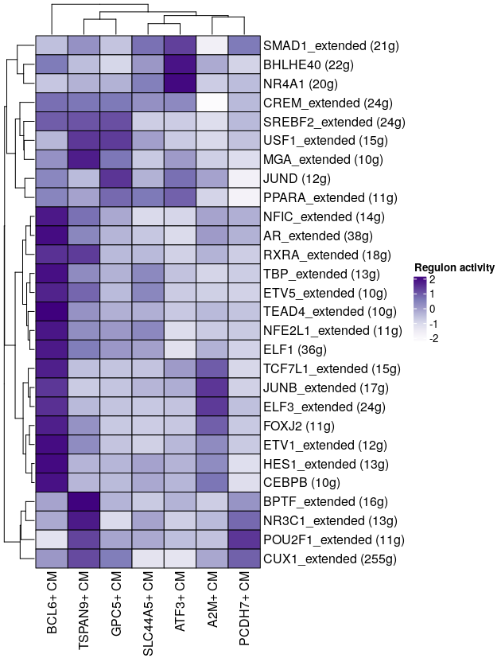
Figure S2. Heatmap analysis of the transcriptional activities of the indicated transcription factors in normal ventricular cardiomyocyte subclusters.

Figure S3. DEG analysis for the control and cKO mouse hearts.
A. Heatmap shows up- and downregulated genes between the control and cKO heart samples. B. Volcano plot of DEGs in the control and cKO hearts. C. The list of top-ranked terms of Gene Ontology analysis for biological processes are shown. (1.3-fold, RC log2>2, P<0.05, FDR<0.05)

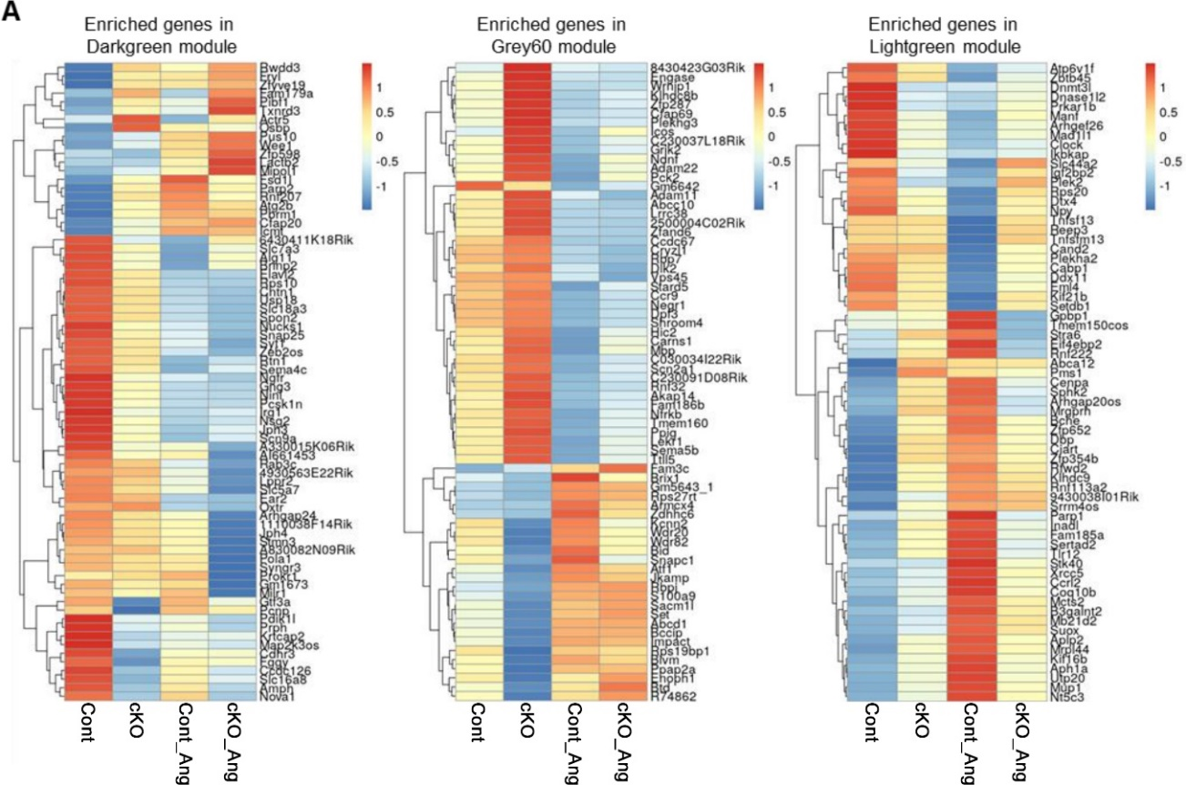
Figure S4. Heatmaps for gene expression patterns of statistically significant modules from the Cont, cKO and Cont-AngII hearts samples. (1.3fold, p<0.05, RC log2 > 2)

Figure S5. GSEA of cell adhesion-related GO terms in AngII-infused cKO mouse hearts. A. Interaction networks of genes enriched in GO terms of cell substrate adhesion and cell matrix adhesion. B. Heatmaps for each gene expression level (z score).

Figure S6. AngII-infused cKO hearts exhibit reduced mitochondrial chaperones and proteases.
A. Heatmap showing differentially expressed genes encoding mitochondrial chaperones and proteases (>1.25-fold, RC log2>2). Red asterisks indicate significant differences (P<0.05) between the Cont-AngII and cKO-AngII heart samples. B-I. Detailed expression of genes marked with asterisks in panel A. *P<0.05, **P<0.01

Figure S7. Atf3 depletion causes mitochondrial dysfunction in NMVMs following AngII treatment.
A. JC-1 analysis of the control or Cre-treated NMVMs with or without AngII treatment. B. Quantification of the red/green ratio for panel A. Scale bars: 20 μm. C. The relative mitochondrial DNA-to-nuclear DNA ratio. The values from the control were set to 1. For analysis of statistical significance, one-way ANOVA was used. *p<0.05, **p<0.005, ***p<0.0005. The data represent ±SD.

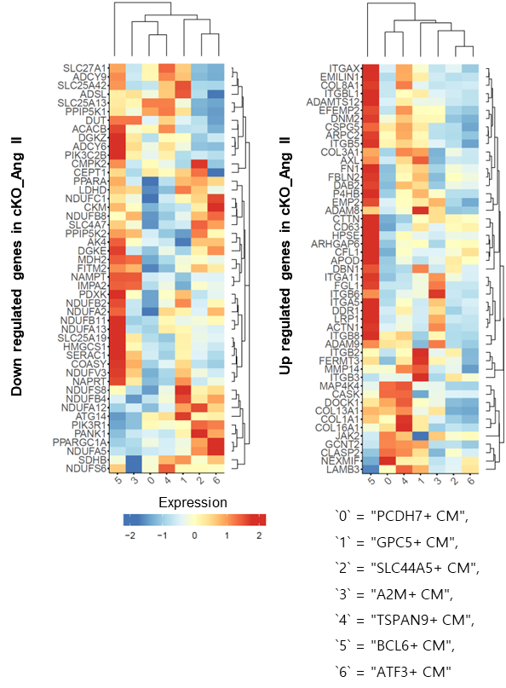
Figure S8. Heart maps of the gene expression levels of up- and downregulated genes in the AngII-infused cKO heart tissue samples in cardiomyocyte subsets of the scRNA sequencing database of human normal heart tissues.

Table S1. Echocardiography analysis after AngII infusion in the control and cKO mice. All groups treated with TMX were compared.
 | Cont |  |  | AngII
 | Atf3^{f/f} | Atf3^{f/f-MCM} | P-1 | Atf3^{f/f} | Atf3^{f/f-MCM} | P-2 | P-3
 | n=5 | n=5 | P-1 | n=5 | n=7 | P-2 | P-3
IVS;d | 0.98 (±0.08) | 0.92 (±0.19) | 0.56 | 1.13 (±0.24) | 1.07 (±0.17) | 0.24 | 0.61
IVS;s | 1.51 (±0.12) | 1.42 (±0.08) | 0.26 | 1.49 (±0.3) | 1.23 (±0.23) | 0.15 | 0.16
LVID;d | 3.87 (±0.33) | 4.46 (±0.21) | 0.02 | 3.91 (±0.24) | 4.43 (±0.7) | 0.92 | 0.18
LVID;s | 2.69 (±0.47) | 3.31 (±0.42) | 0.08 | 2.79 (±0.35) | 3.86 (±0.77) | 0.21 | 0.02
LVPW;d | 1.03 (±0.15) | 0.94 (±0.08) | 0.34 | 1.07 (±0.12) | 1.07 (±0.15) | 0.13 | 0.99
LVPW;s | 1.29 (±0.2) | 1.17 (±0.05) | 0.29 | 1.36 (±0.1) | 1.28 (±0.18) | 0.24 | 0.44
P-1: p value of the comparison between Atf3^{f/f}-Cont and Atf3^{f/f-MCM}-Cont
P-2: p value of the comparison between Atf3^{f/f-MCM}-Cont and Atf3^{f/f-MCM}-AngII
P-3: p value of the comparison between Atf3^{f/f}-AngII and Atf3^{f/f-MCM}-AngII

Table S2. List of antibodies used in this study.
Primary antibody
Gene | Host | # Cat | Source
ATF3 | R | 33593S | Cell Signaling Technology
ANP | R | AB2232 | Millipore
α-Tubulin | R | A1978 | Sigma‒Aldrich
α-SMA | M | A2547 | Sigma‒Aldrich
Gapdh | R | 5174S | Cell Signaling Technology
RFP | R | R10367 | Invitrogen
cTnI | R | ab47003 | Abcam
Phalloidin | - | 8878S | Cell Signaling Technology
ATF4 | R | 11815S | Cell Signaling Technology
Laminin | R | ab11575 | Abcam
β-catenin | M | 610154 | BD Transduction Laboratories
OXPHOS complex cocktail | R | Ab110413 | Abcam
Sirt3 | R | 2627S | Cell Signaling Technology
ac-Sod2 | R | Ab137037 | Abcam
Sod2 | R | 13141S | Cell Signaling Technology
p-Akt (S473) | R | 9271S | Cell Signaling Technology
AKT | R | 9272S | Cell Signaling Technology
p-p70S6K | R | 9205S | Cell Signaling Technology
P70S6K | R | 9202S | Cell Signaling Technology
PGC1-α | M | sc-13063 | Santa Cruz
Secondary antibody
Gene | Host | # Cat | Source
Goat anti-Mouse IgG (H+L)-HRP | G | SA001-500 | GenDEPOT
Goat anti-Rabbit IgG (H+L)-HRP | G | SA002-500 | GenDEPOT
Alexa Fluor™ 488 goat anti-mouse IgG (H+L) | G | A11029 | Invitrogen
Alexa Fluor™ 594 goat anti-mouse IgG (H+L) | G | A11032 | Invitrogen
Alexa Fluor™ 488 goat anti-mouse IgG (H+L) | G | A11034 | Invitrogen
Alexa Fluor™ 594 goat anti-mouse IgG (H+L) | G | A11037 | Invitrogen

Table S3. List of primers used in this study.
Host | Gene |  | Sequence (5' to 3')
Human | ATF3 | F | CCT CTG CGC TGG AAT CAG TC
Human | ATF3 | R | TTC TTT CTC GTC GCC TCT TTT T
Human | NPPA | F | ACA GCT TCC GGT ACT GAA GAT AAC
Human | NPPA | R | GCT GCA GCT TAG ATG GGA TGA
Human | NPPB | F | CAC AGG TGT CTG GAA GTC CC
Human | NPPB | R | TAA TGC CGC CTC AGC ACT TT
Human | β-MHC | F | TGG GGC TTT GCT GGC ACC TCC
Human | β-MHC | R | GCG GAG GAG CAA GCC AAC ACC
Human | GAPDH | F | AGC CAC ATC GCT CAG ACA CC
Human | GAPDH | R | GTA CTC AGC GCC AGC ATC G
Rat | Atf3 | F | GCG GAG CCG ACC GAC C
Rat | Atf3 | R | GCC TGG ATG TTG AAG CAT CAT T
Rat | Anp | F | GAA AAG CAA ACT GAG GGC TCT G
Rat | Anp | R | CCT ACC CCC GAA GCA GCT
Rat | Bnp | F | TGG GCA GAA GAT AGA CCG GA
Rat | Bnp | R | ACA ACC TCA GCC CGT CAC AG
Rat | 18s | F | TGG TTG CAA AGC TGA AAC TTA AAG
Rat | 18s | R | AGT CAA ATT AAG CCG CAG GC
Mouse | Atf3 | F | CCT CTG CGC TGG AAT CAG TC
Mouse | Atf3 | R | TTC TTT CTC GTC GCC TCT TTT T
Mouse | Anp | F | GAGTGGGCAGAGACAGCAAA
Mouse | Anp | R | CAGGTGAGACCCGAGGTTAG
Mouse | Bnp | F | CATGGATCTCCTGAAGGTGC
Mouse | Bnp | R | CAACACCGATGACATCCTTGG
Mouse | β-MHC | F | GAAGATGCGGCGGGACCTGG
Mouse | β-MHC | R | GAACGCTGCGTCTCCTCGGC
Mouse | β-actin | F | ACTATTGGCAAGAGCGGTT
Mouse | β-actin | R | CAGGATTCCATACCCAAGAAGGA
Mouse | Sirt3 | F | CTG ACT TCG CTT TGG CAG AT
Mouse | Sirt3 | R | GTC CAC CAG CCT TTC CAC AC
Mouse | Sod2 | F | TAC AAC TCA GGT CGC TCT TCA GC
Mouse | Sod2 | R | AGC CTC CAG CAA CTC TCC TTT
Mouse | Ndufv1 | F | CTT CCC CAC TGG CCT CAA G
Mouse | Ndufv1 | R | CCA AAA CCC AGT GAT CCA GC
Mouse | mtCo1 | F | TGC TAG CCG CAG GCA TTA C
Mouse | mtCo1 | R | GGG TGC CCA AAG AAT CAG AAC

