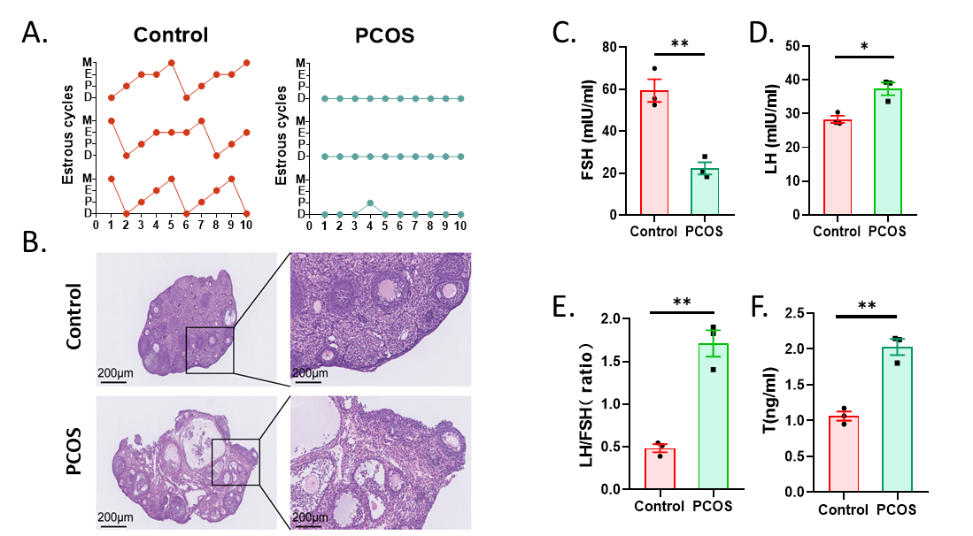
Figure S1. C57BL/6 female mice were administered letrozole (LE) continuously for 21 days to establish a PCOS model. Representative graphs of estrous cycle curves in the last 10 days of LE administration for the pure control group and PCOS model mice (A); and representative images of ovarian tissue phenotypes for the pure control group and model mice at the end of modeling (B), along with changes in serum follicle-stimulating hormone (FSH) (C), luteinizing hormone (LH) (D), LH/FSH ratio (E), and testosterone (T) levels (F). Data are presented as mean ± standard deviation (SD) and analyzed by student t test. n=3. *, p<0.05; **, p<0.01. Scale bar = 200 µm. Met, metformin; NAC, N-acetylcysteine.

