Figure S2. Mean number of E. crypticus and E. bigeminus juveniles in Nitisol (a, d), Cambisol (b, e) and TAS (c, f) spiked with different copper concentrations.
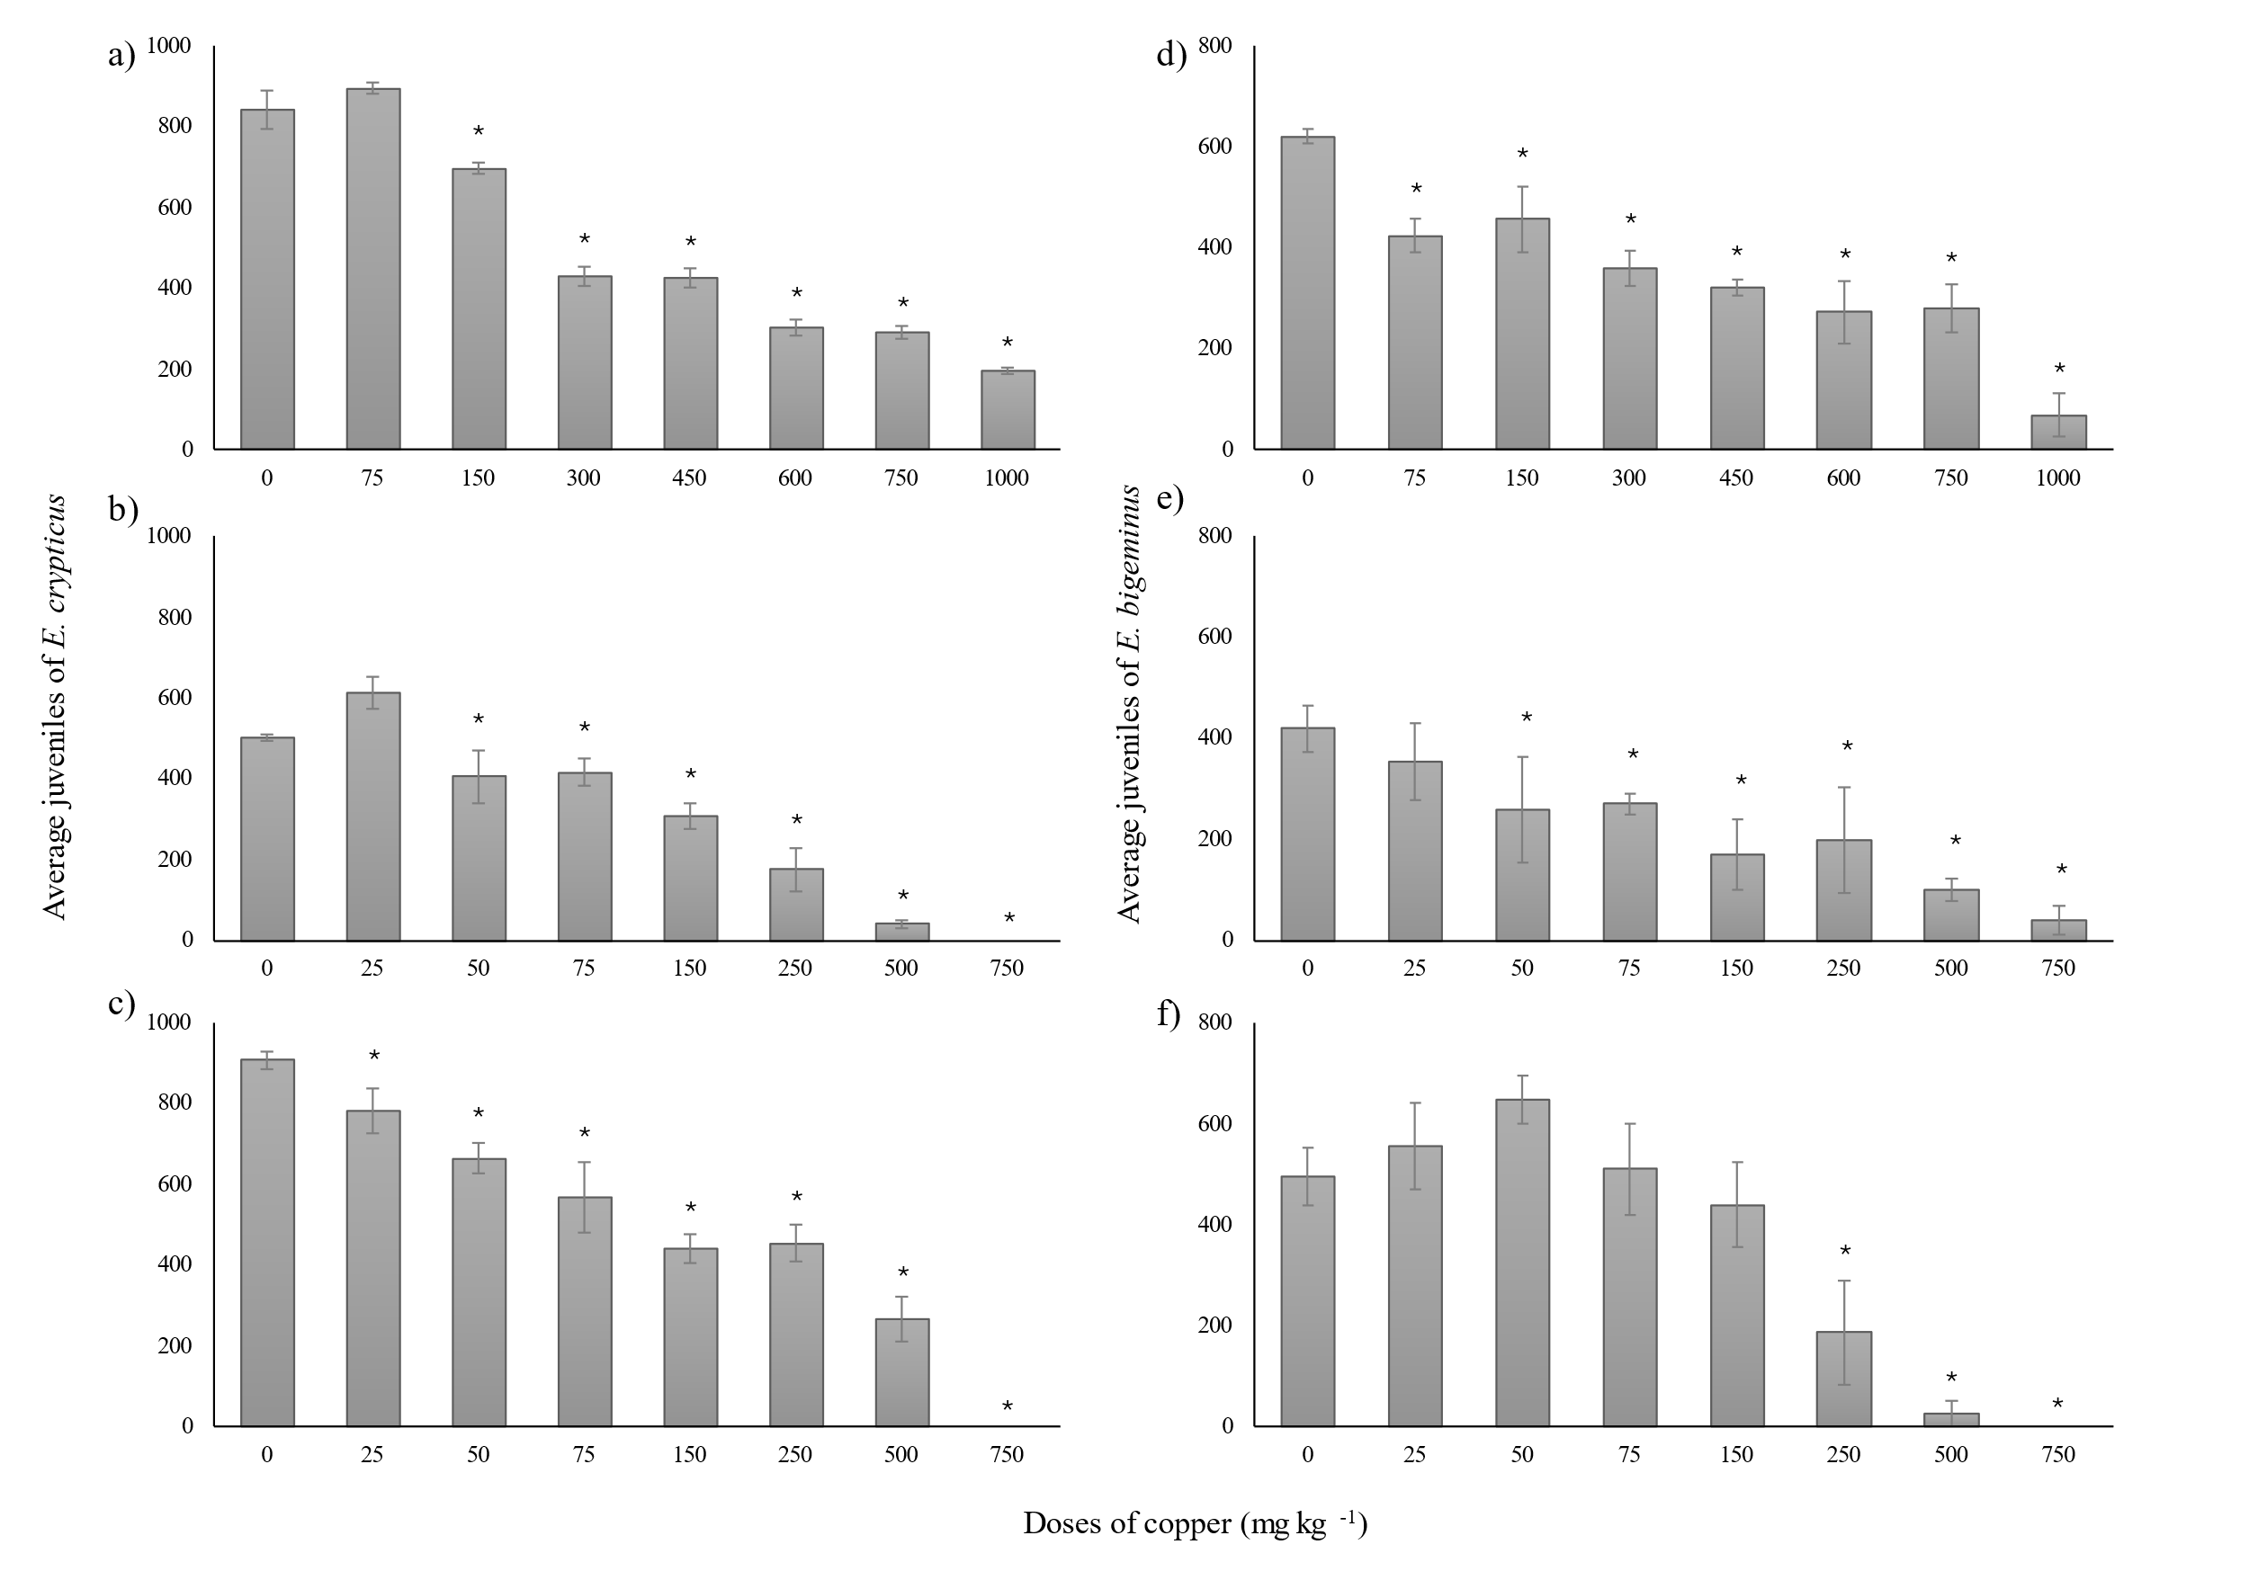
(*) indicates a significant difference (p ≤ 0.05). (┬) Standard deviation. Concentration of 0 represents the control treatment (free from contamination).

