Table S1 Nomenclature of the transgenic aspen lines used in the study
Old | New
Pt XIV Xeg 1a | Xeg-1-1a
Pt XIV Xeg 1b | Xeg-1-1b
Pt XIV Xeg 1c | Xeg-1-1c
Pt XIV Xeg 4a | Xeg-1-4a
Pt XV Xeg 1a | Xeg-2-1a
Pt XV Xeg 1b | Xeg-2-1b
Pt XV Xeg 1c | Xeg-2-1c
Pt XV Xeg 2а | Xeg-2-2a
Pt XV Xeg 2b | Xeg-2-2b
Pt XV Xeg 2c | Xeg-2-2c
Pt XV Xeg 3a | Xeg-2-3a
Pt XV Xeg 3b | Xeg-2-3b
Pt XV Xeg 3c | Xeg-2-3c
Pt XV Xeg 4a | Xeg-2-4a
Pt XV Xeg 4b | Xeg-2-4b
Pt XV Xeg 4с | Xeg-2-4c
Pt XV Xeg 5a | Xeg-2-5a
Pt XV Xeg 5b | Xeg-2-5b
Pt XV Xeg 5c | Xeg-2-5c
Pt XVI Xeg 1a | Xeg-3-1a
Pt XVI Xeg 1b | Xeg-3-1b
Pt XVI Xeg 1c | Xeg-3-1c
Pt XVI Xeg 5c | Xeg-3-5c
Pt XVI Xeg 8a | Xeg-3-8a
Pt XVI Xeg 8b | Xeg-3-8b
Pt I Gus 5a | Gus-1-5a

Table S2 Height (± SD) in the 2-month-old transgenic and control plants in greenhouse conditions and in the 6-month-old transgenic and control plants in semi-natural conditions
Line | Height, cm
Line | 2-month-old | 6-month-old
Pt | 17.1 ± 0.8 | 36.6 ± 1.7
Gus-4-5a | 18.9 ± 1.0 | -
Xeg-1-1a | 22.8 ± 1.1* | 45.6 ± 1.2*
Xeg-1-1b | 20.2 ± 1.0 | 42.3 ± 1.7
Xeg-1-1c | 19.2 ± 0.9 | 37.6 ± 1.5
Xeg-1-4a | 19.1 ± 0.9 | -
Xeg-2-1a | 22.8 ± 1.1* | -
Xeg-2-1b | 23.3 ± 0.9* | 48.1 ± 1.8*
Xeg-2-1c | 15.7 ± 0.8* | -
Xeg-2-2a | 17.1 ± 1.1 | -
Xeg-2-2b | 18.3 ± 0.9 | -
Xeg-2-2c | 18.5 ± 0.8 | -
Xeg-2-3a | 18.3 ± 0.9 | -
Xeg-2-3b | 18.6 ± 1.0 | 42.1 ± 1.6
Xeg-2-3c | 18.8 ± 1.1 | -
Xeg-2-4a | 19.0 ± 0.9 | -
Xeg-2-4b | 18.2 ± 1.0 | -
Xeg-2-4c | 17.9 ± 0.9 | -
Xeg-2-5a | 17.5 ± 0.9 | 38.2 ± 1.8
Xeg-2-5b | 18.9 ± 0.8 | -
Xeg-2-5c | 17.5 ± 0.9 | -
Xeg-3-1a | 17.2 ± 0.8 | -
Xeg-3-1b | 18.2 ± 0.9 | -
Xeg-3-1c | 18.2 ± 0.8 | -
Xeg-3-5c | 18.8 ± 0.8 | -
Xeg-3-8a | 19.9 ± 0.7 | -
Xeg-3-8b | 19.8 ± 1.0 | -
*significantly different from Pt at P ≤ 0.05 based on ANOVA

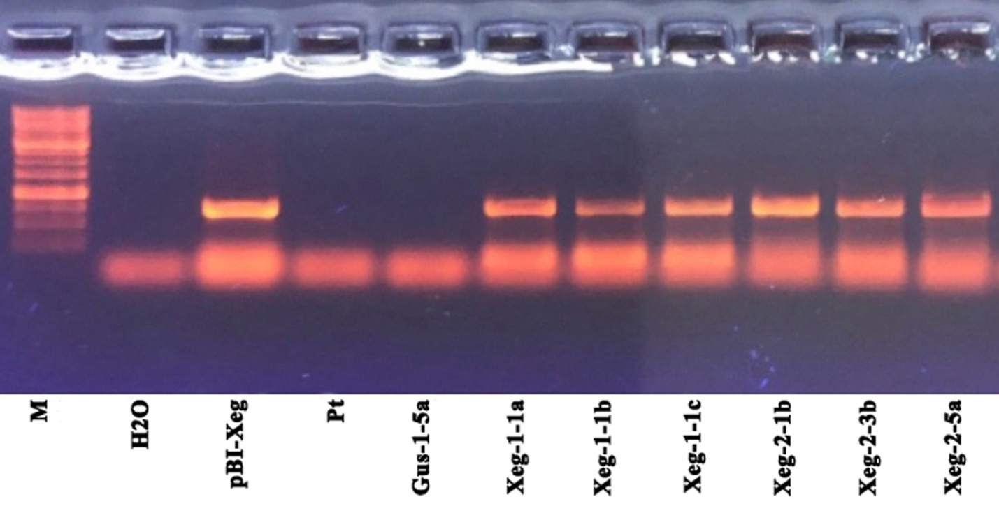
Figure S1 The original, unprocessed and uncropped version of Figure 1. RT-PCR analysis of the sp-Xeg gene expression in transgenic aspen plants (expected amplicon size 762 bp). M - standard molecular marker 1 kb (SibEnzyme), Н₂О - negative reaction control, pBI-Xeg - plasmid DNA (positive control), Pt - non-transgenic control line, Gus-1-5a - transgenic control line

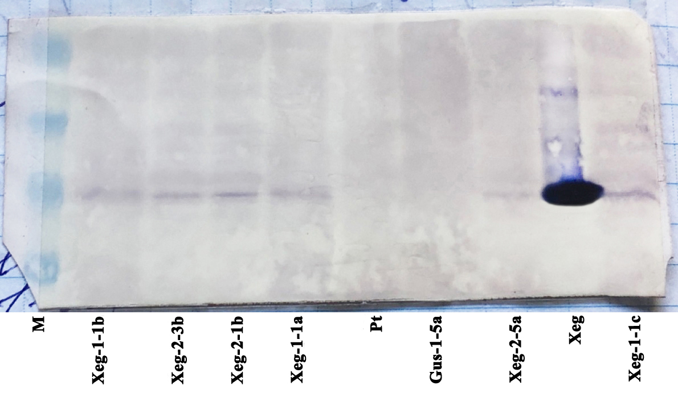

Figure S2 The original, unprocessed and uncropped version of Figure 2. Western blot analysis of protein extracts of transgenic aspens carrying the recombinant gene sp-Xeg. M - standard protein molecular marker, Xeg - fungal extract, Pt - non-transgenic control, Gus-1-5a - transgenic negative control, Xeg-1-1a, Xeg-1-1b, Xeg-1-1c, Xeg-2-1b, Xeg-2-3b, and Xeg-2-5a are transgenic lines

10.7x zoom
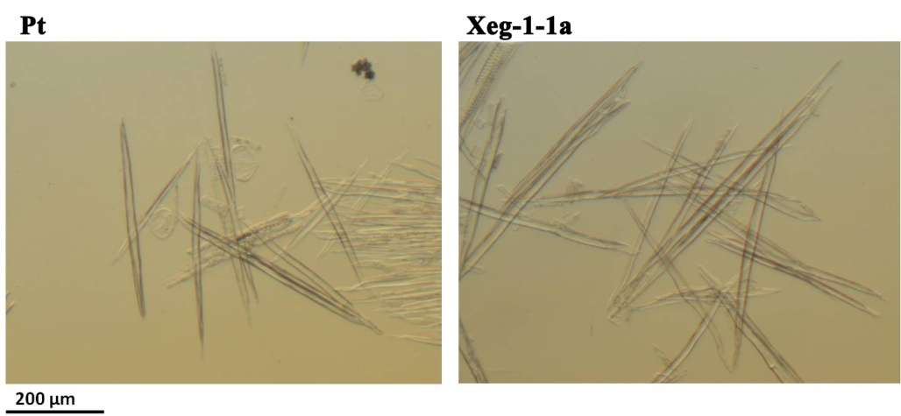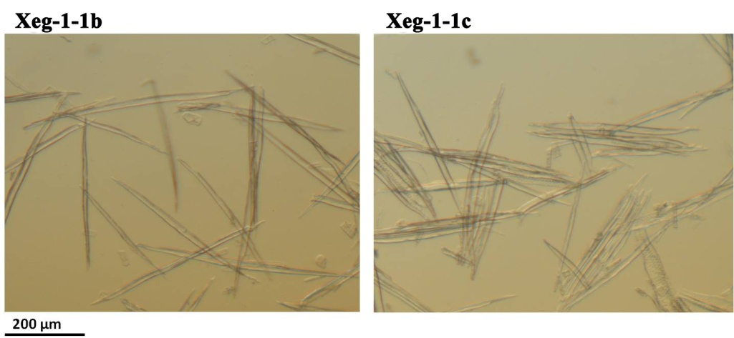
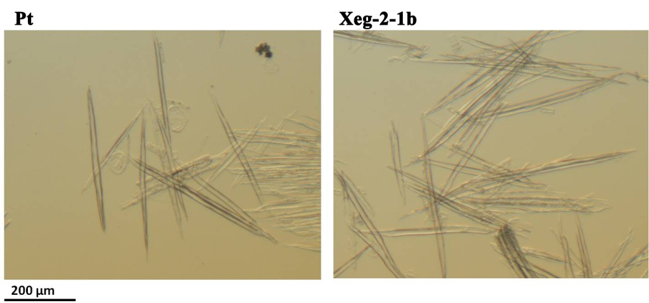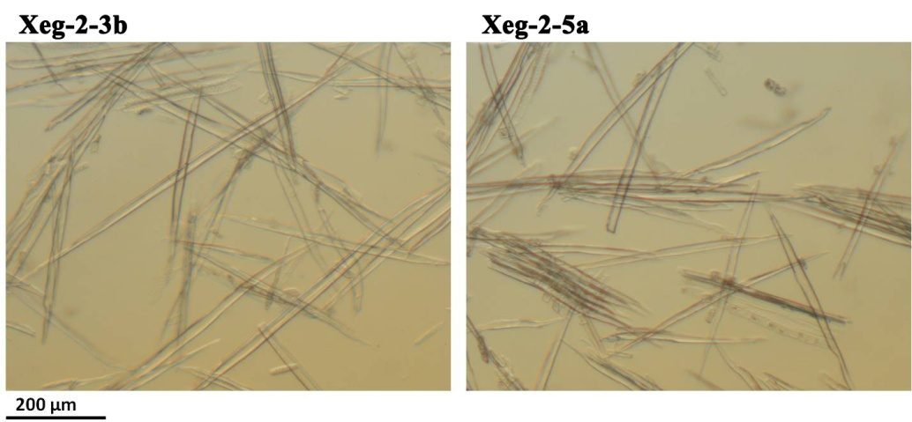

42.5x zoom
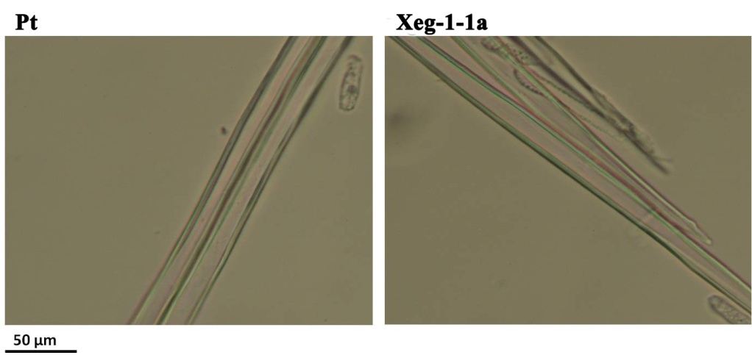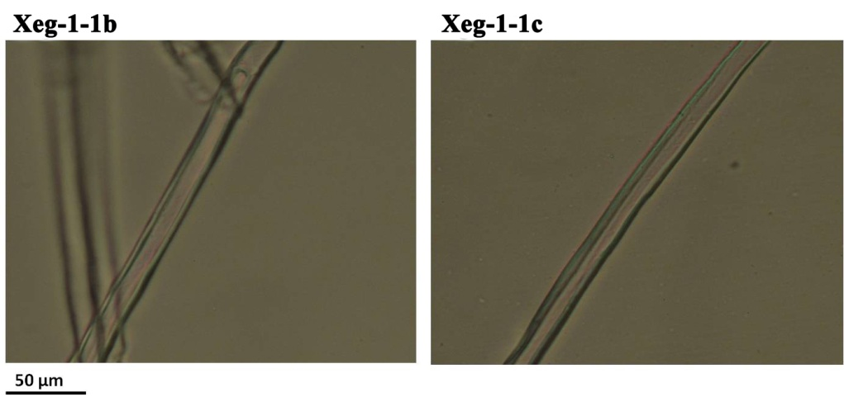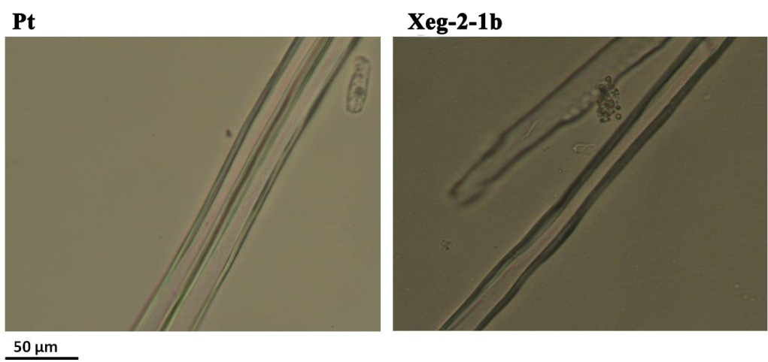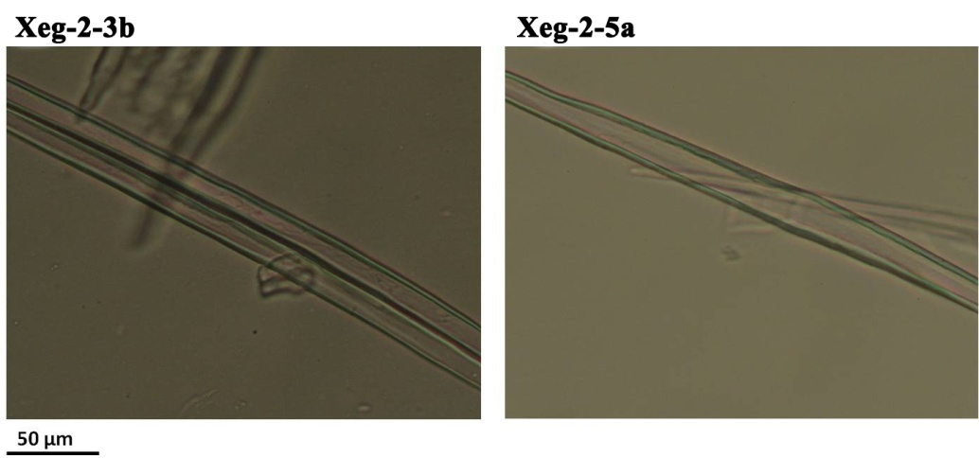
Figure S3 Libriform wood fibers of transgenic and control plants

