Supplementary Information
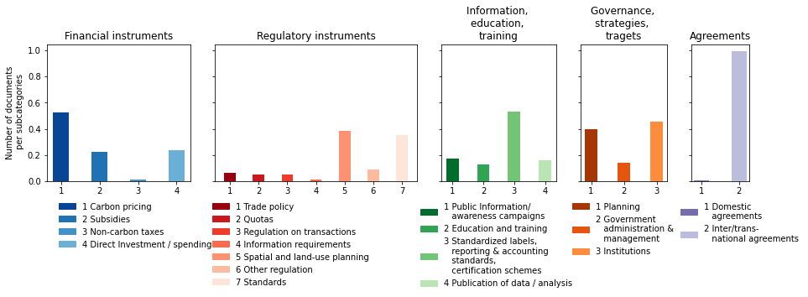

Figure SI 1 Third level coding for political instruments. Shown are the absolute numbers of documents in each category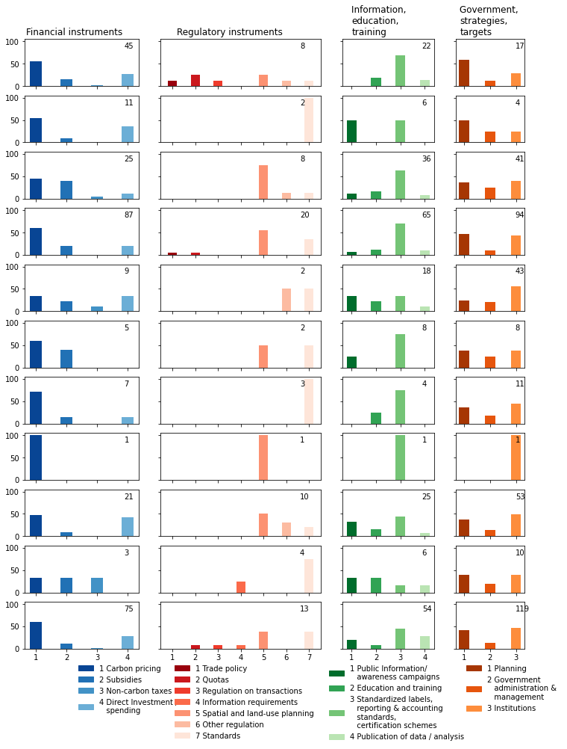
Figure S1 2 Third level coding of governance and policy papers for each technology. Shown is the share of documents in each technology. All bars in one panel add up to 100. The number in the upper indicates the number of papers we report on in each panel.

Supplemental data
- Queries for receiving scientific documents from Web of Science and Scopus: SI_Queries.xlsx
- Study protocol for coding: SI_Coding Protocol.pdf

