Abscisic Acid rescues behavior in adult female mice in Attention Deficit Disorder with Hyperactivity model of dopamine depletion by regulating microglia and increasing Vesicular GABA Transporter expression.
Maria Meseguer-Beltrán^{1,2}; Sandra Sánchez-Sarasúa^{1,2,3}; Nóra Kerekes⁴, Marc Landry³; Matías Real-López^{2,5}; Ana María Sánchez-Pérez^{1,2,*}
¹Institute of Advanced Materials (INAM), Universitat Jaume I, Castellón, Spain.
²Faculty of Health Sciences, Universitat Jaume I, Castellón, Spain.
³CNRS UMR 5293, Institut des Maladies Neurodégénératives, Centre Paul Broca-Nouvelle Aquitaine, University of Bordeaux, Bordeaux, France.
⁴Department of Health Sciences, University West, 46186 Trollhättan, Sweden.
⁵Serious Mental Disorder Program in Childhood and Adolescence, Provincial Hospital Consortium of Castellón, Castellón, Spain.
* To whom correspondence may be addressed: Ana María Sánchez-Pérez (sanchean@uji.es)
Acknowledgments: We would like to thank Servicios de Experimentación Animal (SEA) of University Jaume I for the maintenance and care of the experimental animals and Servicios Centrales (Confocal microscopy) of University Jaume I for obtaining the images. We also thank and BioRender.com for creating all the figures.

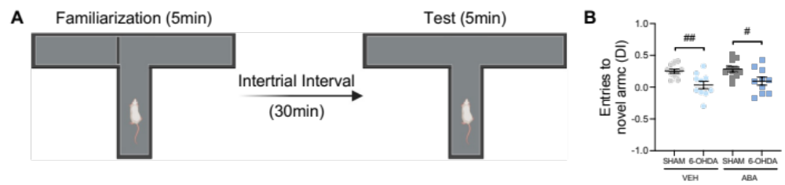
Supplementary Figure S1. Dopaminergic lesion impairs spatial memory. (A) Schematic representation of T-maze test. (B) Number of entries (d-index) to the novel arm. Data are expressed as a DI ((Time exploring novel – time exploring familiar)/total time exploring), presented as mean ± SEM (n = 9-10 per condition), analyzed by unpaired two-tailed Student t-test (# p < 0.05, ## p < 0.01).

Supplementary Figure S2. Dopaminergic lesion do not affect Homer1 puncta density. (A) Representative confocal microscopy images from ACC showing Homer1 and MAP2 markers. Inserts in every image show Homer 1 in post-synaptic terminal. Calibration bar; 100 µm. (B) vGluT1 (C) vGAT and (D) Homer1 puncta density (number of puncta/mm2) in ACC females. Data are presented as mean ± SEM (n = 9-10 per condition) and analyzed using two-tailed Student t-test (* p < 0.05, *** p < 0.001, **** p < 0.0001).

