Appendix:
Figure A1, Figure A2 and Figure A3

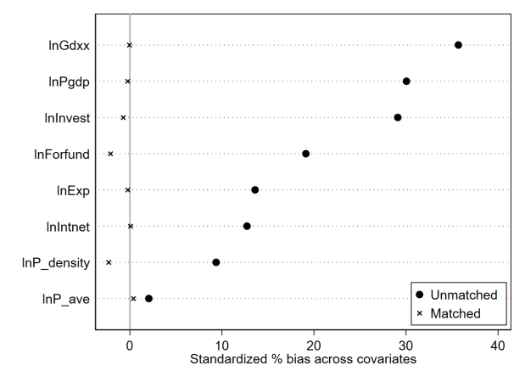
Figure A1 Standardization deviation of each variable

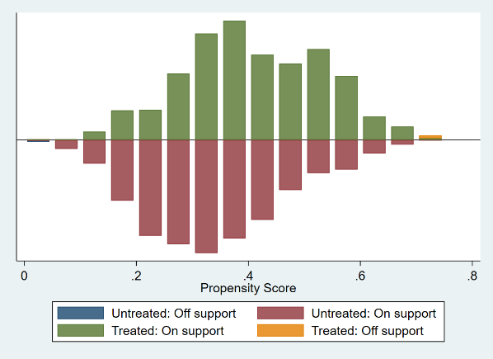
Figure A2 Distribution of propensity scores

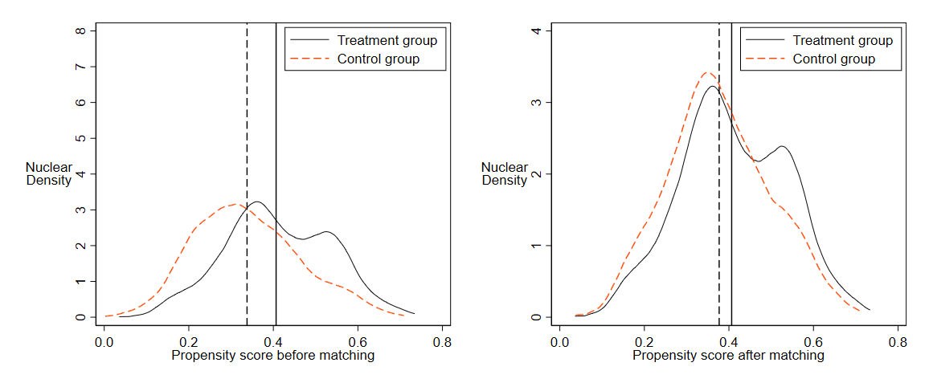
Figure A3 Nuclear density before and after PSM

Table A1 and Figure A4

Table A1 Moran index by year
Year | I | E(I) | Sd(I) | Z | P-value
2006 | 0.036 | -0.004 | 0.006 | 6.465 | 0.000
2007 | 0.032 | -0.004 | 0.006 | 5.881 | 0.000
2008 | 0.035 | -0.004 | 0.006 | 6.357 | 0.000
2009 | 0.039 | -0.004 | 0.006 | 6.913 | 0.000
2010 | 0.047 | -0.004 | 0.006 | 8.221 | 0.000
2011 | 0.047 | -0.004 | 0.006 | 8.328 | 0.000
2012 | 0.046 | -0.004 | 0.006 | 8.158 | 0.000
2013 | 0.049 | -0.004 | 0.006 | 8.613 | 0.000
2014 | 0.057 | -0.004 | 0.006 | 9.811 | 0.000
2015 | 0.059 | -0.004 | 0.006 | 10.179 | 0.000
2016 | 0.055 | -0.004 | 0.006 | 9.698 | 0.000
2017 | 0.053 | -0.004 | 0.006 | 9.268 | 0.000
2018 | 0.051 | -0.004 | 0.006 | 8.979 | 0.000
2019 | 0.053 | -0.004 | 0.006 | 9.382 | 0.000
2020 | 0.050 | -0.004 | 0.006 | 8.842 | 0.000

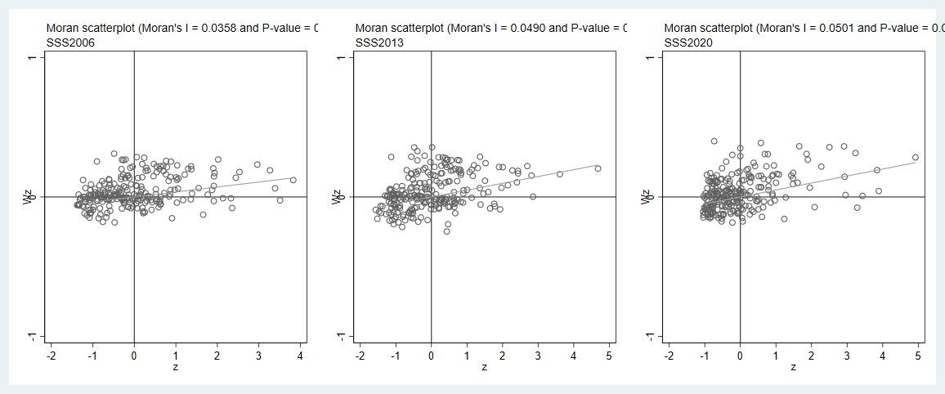
Figure A4 Pollution scattering map of Chinese cities in selected years

