Appendix 1: Participant Pathways
The full study protocol is available from:
https://github.com/iain-buchan/cipha/blob/master/SMART_Release_Return.pdf

A. Uninfected contact participant pathway (illustrated in Figure A1.1)
- Household member of NHS worker was notified they were Covid positive, so their NHS contact started quarantine and notified their employer.
- Employer had adopted SMART Release & Return testing schedule as their local standard policy and directed the staff member to a booking website for the scheme, which provided information sheet, consent process and directions to the unit/site.
- Participant received a 10-day pack of daily dual LFTs and 2 PCR home test kits, and if they had not had a positive Covid test in the past 90 days they took a swab for quick turnaround (binary) PCR.
- Participant received PCR negative result on Day 0 and returned to work on Day 1 with DCT.
- Either Innova (nose/throat) or Orient Gene (nose only) LFTs were taken each morning (or pre-shift) before breakfast in randomised order for 10 days – an information sheet in the pack directed the participant day by day. Either LFT reporting positive was an overall positive result.
- On Day 1 the participant also took home a PCR swab (randomised order with the two LFTs) and returned it by post to Pillar 2 / other (ringfenced) Q-RT-PCR capacity, and the result was not used for any purpose other than research.
- A second Q-RT-PCR swab was taken on Day 5.
- Exit questionnaire gathered participant experiences.
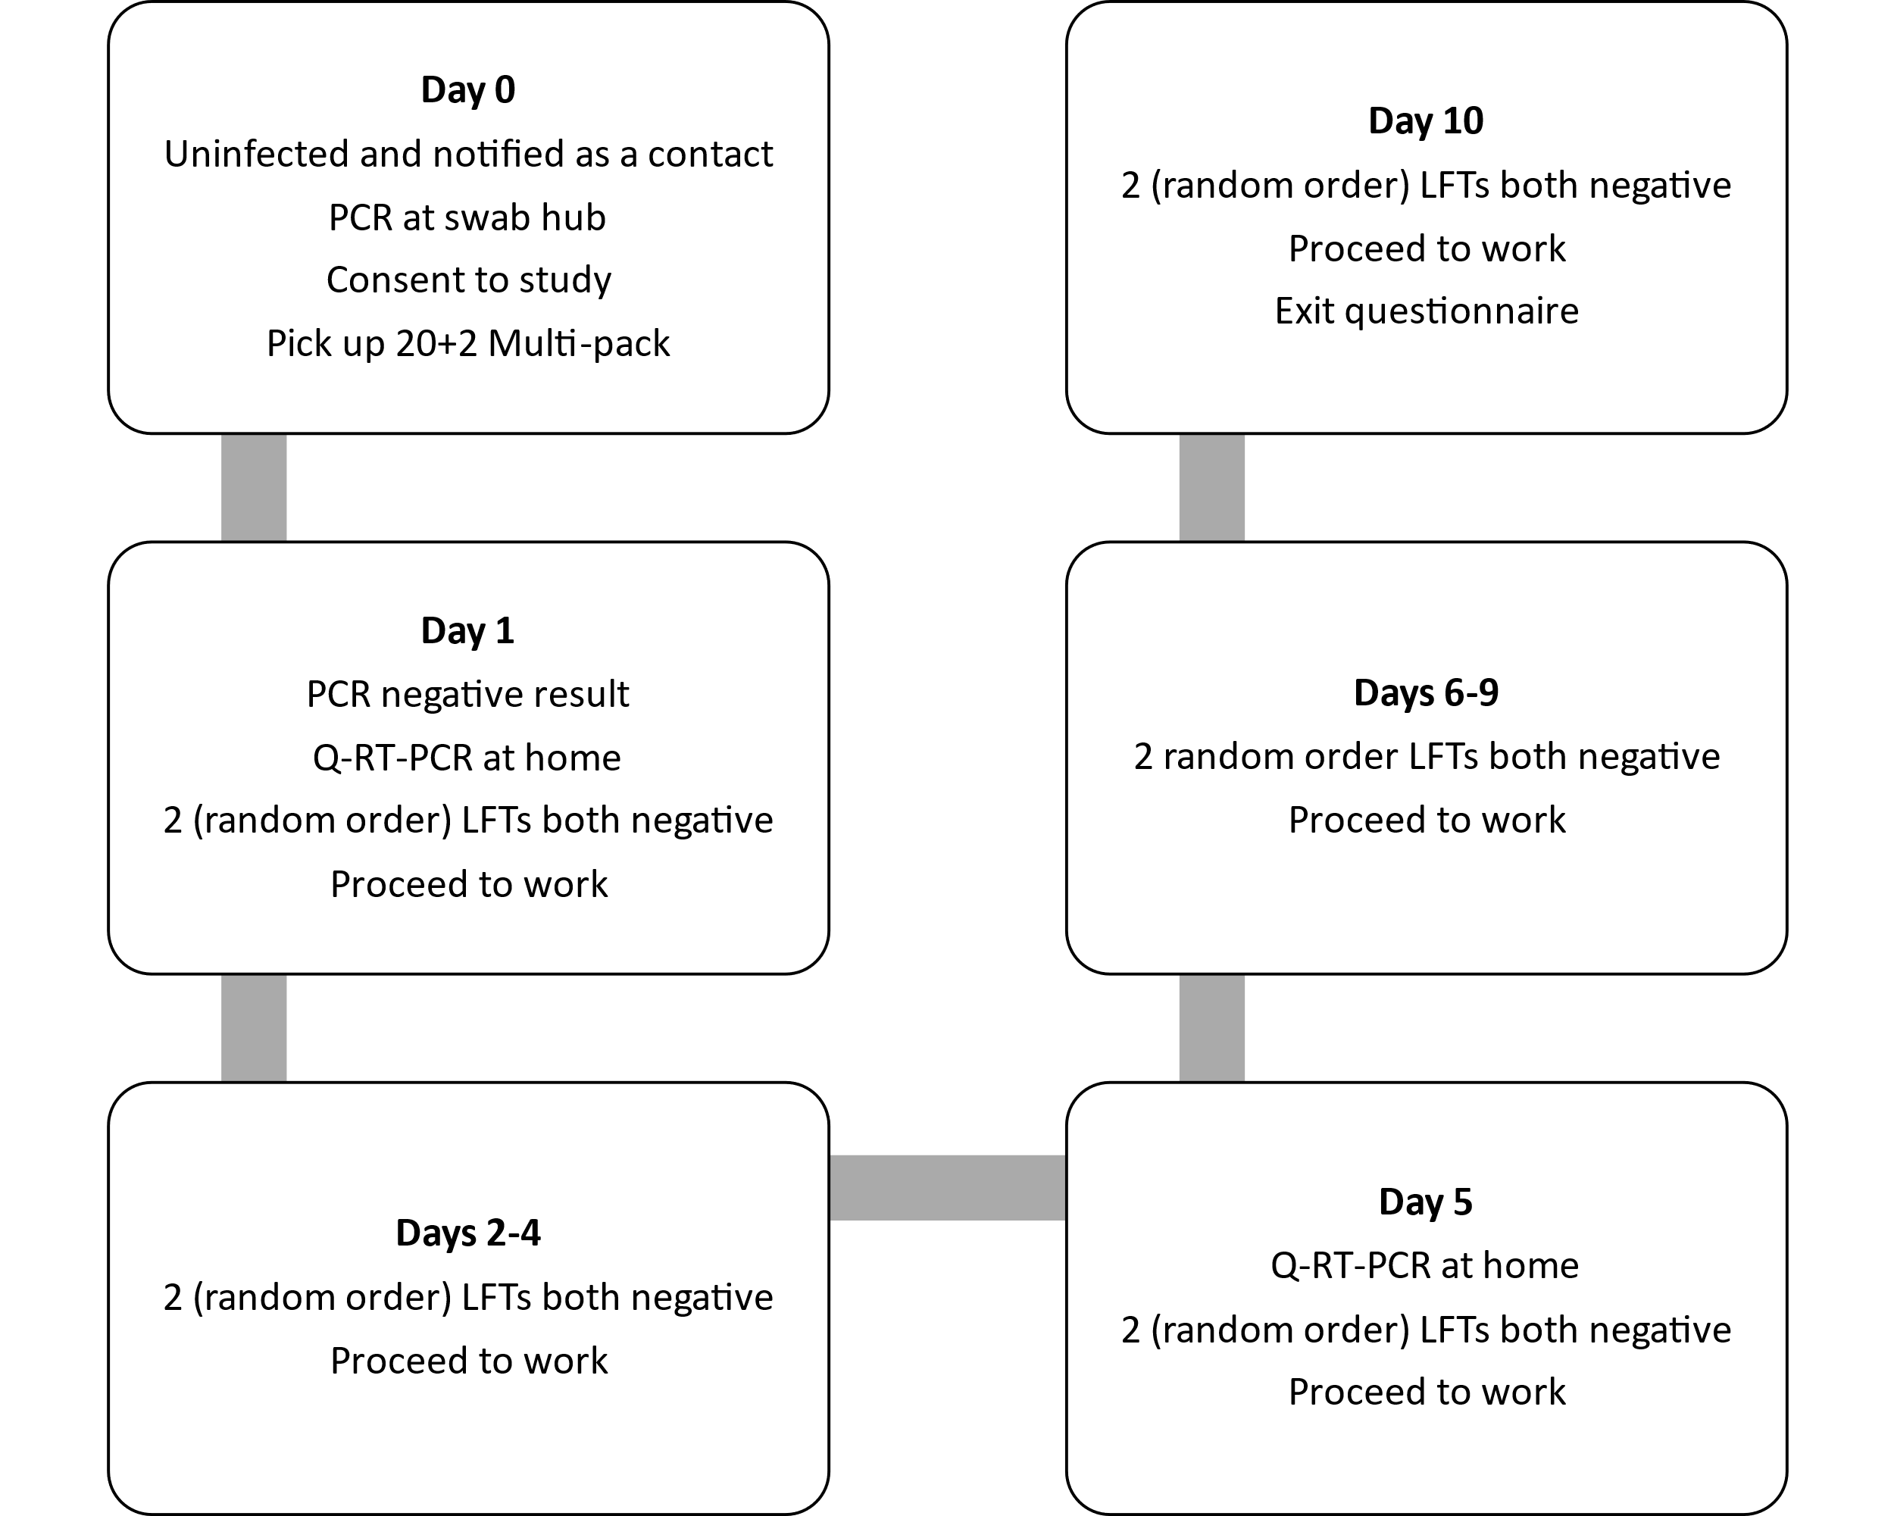
Figure A1.1. Workflow for participant who tested negative throughout the study

B. Asymptomatic infected contact participant pathway (illustrated in Figure A1.2)
- Household member of NHS worker was notified they were Covid positive, so their NHS contact started quarantine and notified their employer.
- Employer had adopted SMART Release & Return testing schedule as their local standard policy, directed the staff member to a booking website for the scheme, and directed them to the standard testing/reception site.
- Consented participant took quick turnaround (binary) PCR test to return to work from quarantine on DCT and received a 10-day pack of daily dual LFT + 2 PCR home test kits.
- Participant received PCR positive result on Day 0 and stayed at home.
- Either Innova (nose/throat) or Orient Gene (nose only) LFTs were taken each morning before breakfast in randomised order – an information sheet in the pack directed the participant day-by-day.
- On Day 1 the participant also took home a PCR swab (randomised order with the two LFTs) and returned it by post to Pillar 2 / other (ringfenced) Q-RT-PCR capacity, and the result was not used for any purpose other than research.
- Second Q-RT-PCR swab was taken on Day 5. (Participant was selected to be in the viral culture sample of 30 cases – and their swab in viral transport medium was collected from their home).
- If Day 5 and 6 dual LFT results (4 tests) were negative the participant may return to work.
- Daily dual LFT testing continued until Day 10.
- If still testing LFT positive at Day 7 the participant was advised to call and arrange a RT-Q-PCR swab in viral transport medium for culture.
- Exit questionnaire gathered participant experiences.
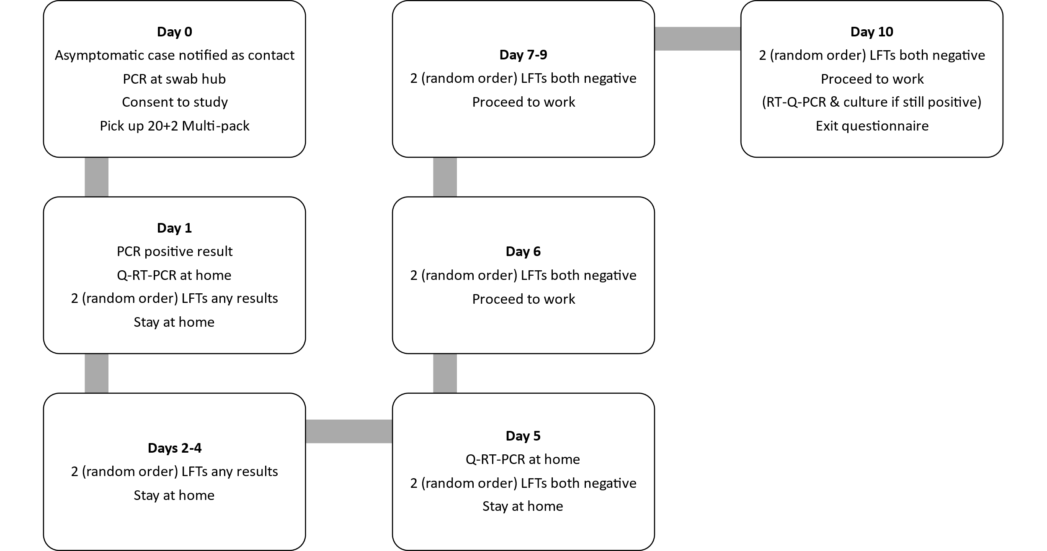
Figure A1.2. Workflow for contact who tested positive in the beginning of the study

C. New case referred to the study (illustrated in Figure A1.3)
- NHS worker was notified they were Covid positive and notified their employer.
- Employer had adopted SMART Release & Return testing schedule as their local standard policy, directed the staff member to a booking website for the scheme, and directed them to the standard testing/reception site.
- Consented participant received a 10-day pack of daily dual LFT + 2 PCR home test kits.
- Innova (nose/throat) and Orient Gene (nose only) LFTs were taken each morning before breakfast in randomised order – an information sheet in the pack directed the participant day-by-day.
- On Day 1 the participant also took home a PCR swab (randomised order with the two LFTs) and returned it by post to Pillar 2 / other (ringfenced) Q-RT-PCR capacity, and the result was not used for any purpose other than research.
- Second Q-RT-PCR swab was taken on Day 5.
- If Day 5 and 6 dual LFT results (4 tests) were negative the participant may return to work.
- Daily dual LFT testing continued until Day 10.
- If still testing LFT positive at Day 7 the participant was advised to call and arrange a RT-Q-PCR swab in viral transport medium for culture.
- Exit questionnaire gathered participant experiences.
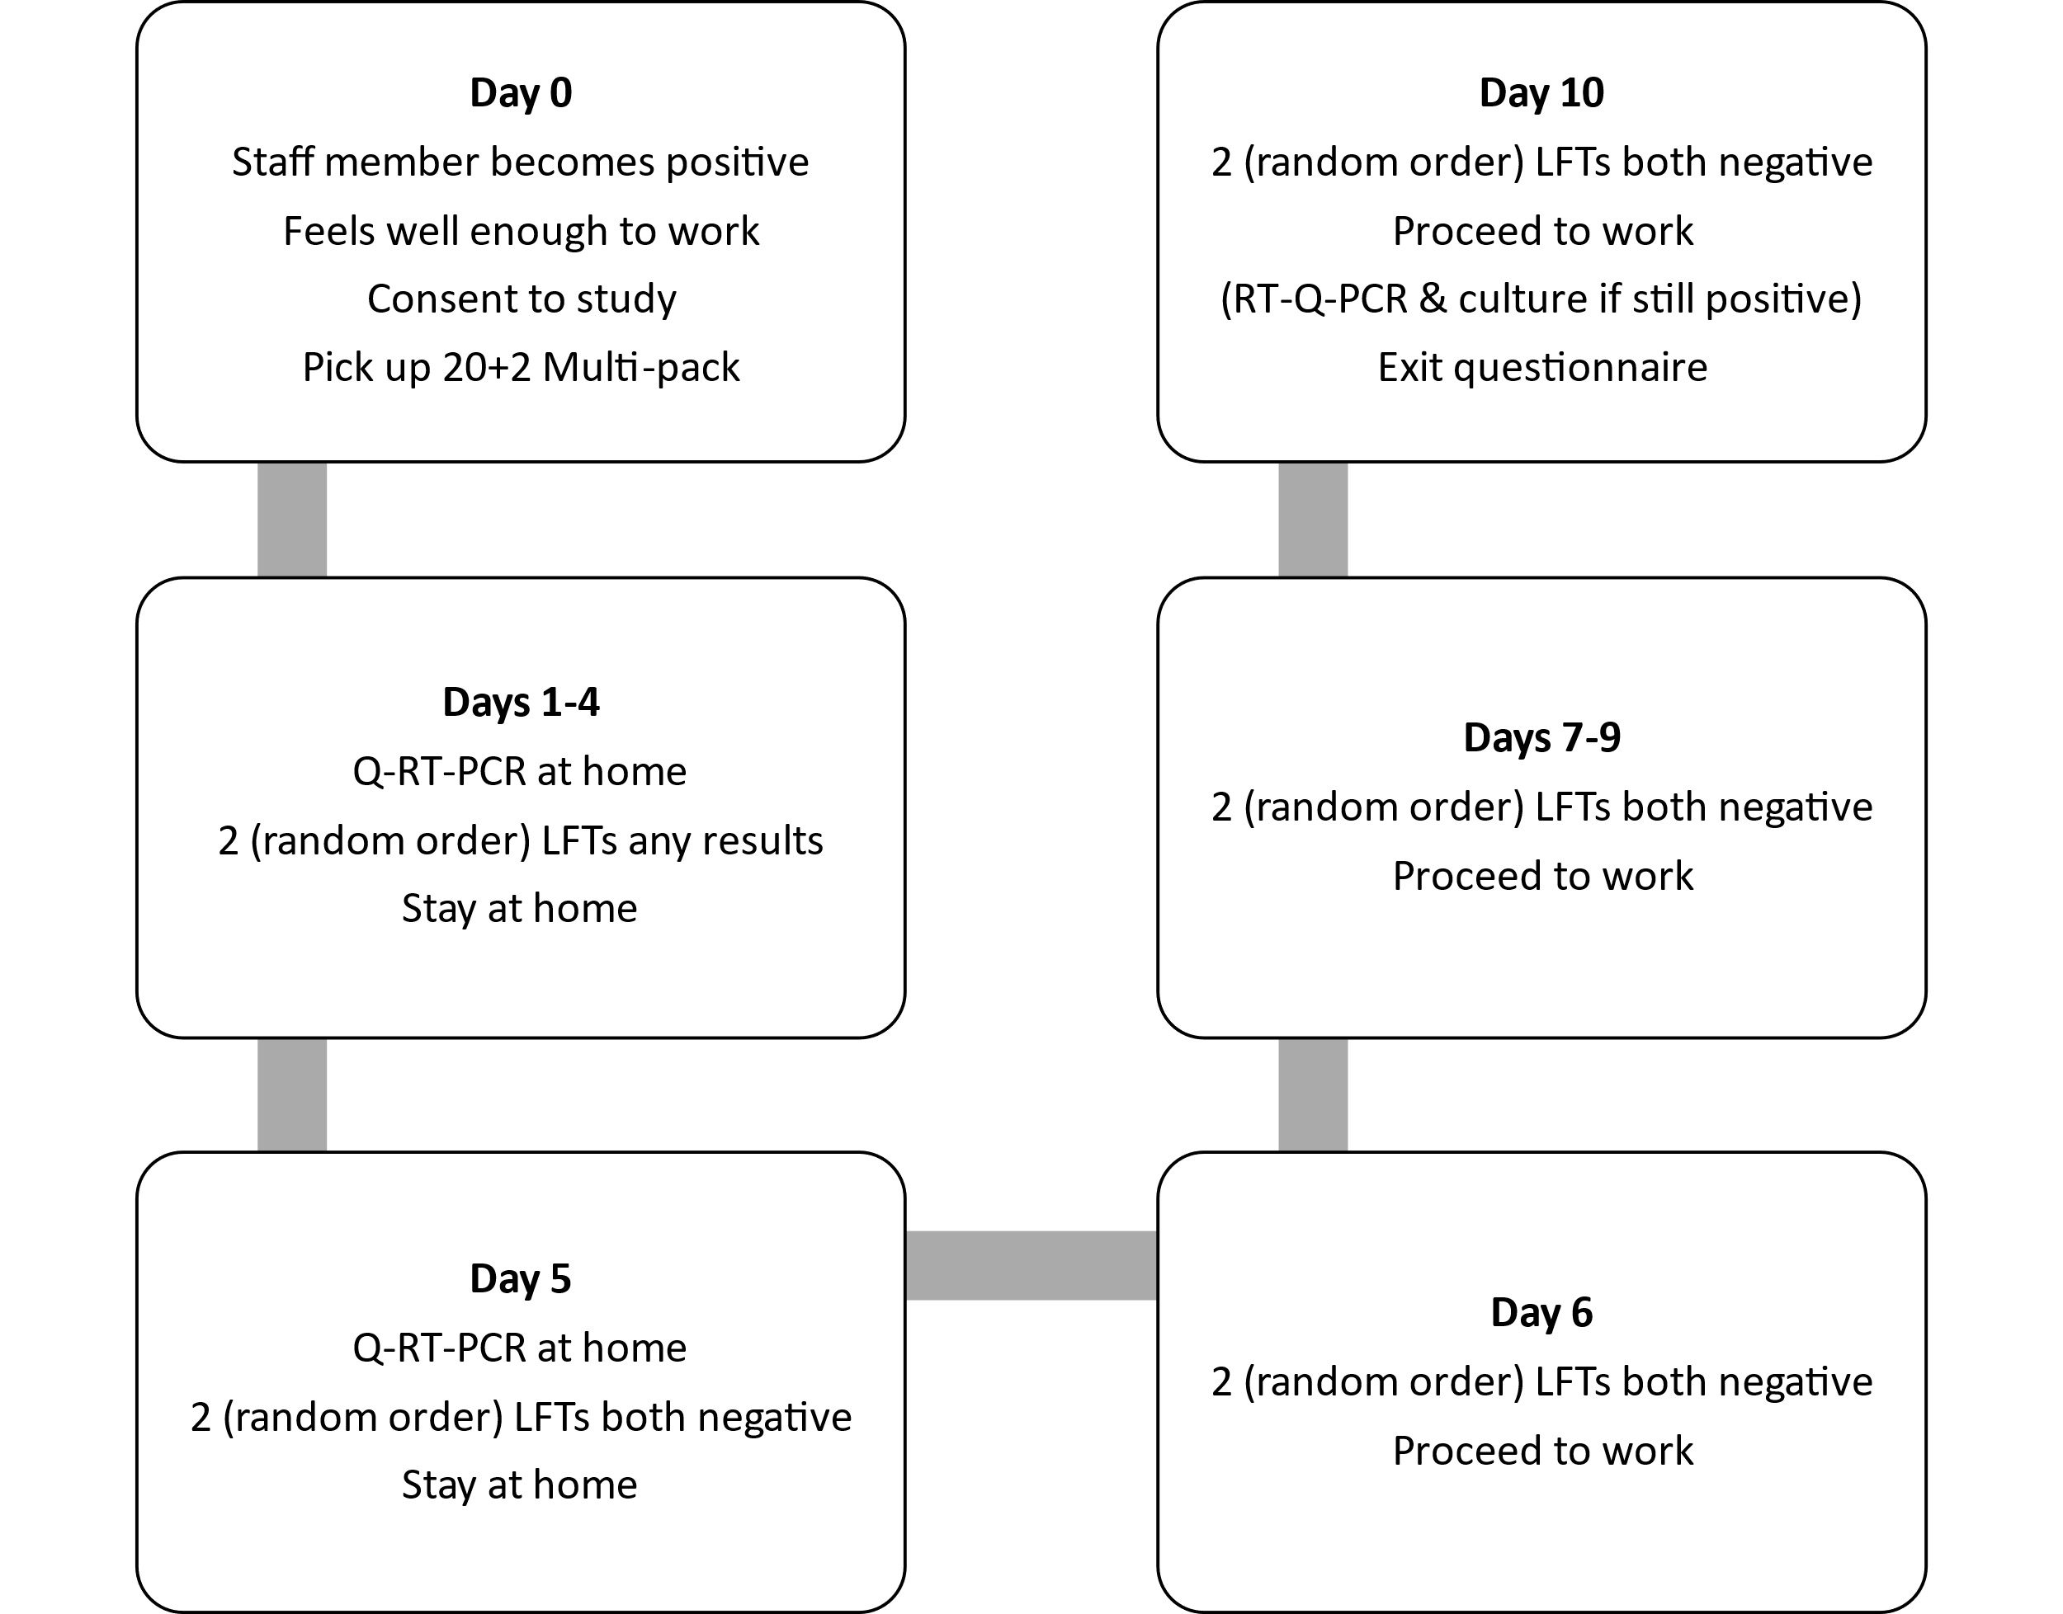
Figure A1.3. Workflow for participant who became positive at some point during the study or entered the study as a case

Appendix 2: Participant information
A personalised randomisation sheet was inserted in the participants’ pack of swabs/tests with boxes/swabs marked A, B or C, with a typical schedule shown below…
Day | First test | Second test | Third test
1 | Lateral flow "B" | Lateral flow "A" | PCR "C"
2 | Lateral flow "B" | Lateral flow "A"
3 | Lateral flow "A" | Lateral flow "B"
4 | Lateral flow "A" | Lateral flow "B"
5 | Lateral flow "A" | Lateral flow "B" | PCR "C"
6 | Lateral flow "A" | Lateral flow "B"
7 | Lateral flow "A" | Lateral flow "B"
8 | Lateral flow "A" | Lateral flow "B"
9 | Lateral flow "B" | Lateral flow "A"
10 | Lateral flow "A" | Lateral flow "B"

The information booklet provided to all participants can be downloaded from: https://github.com/iain-buchan/cipha/blob/master/SMART_RR_Participant_Information.pdf

Appendix 3: Sample Size Calculation
Assuming a conservative LFT sensitivity of 0.5 (accepting sensitivity varies as viral load changes over time) for PCR-LFT concordance, the proportion of cases missed on two consecutive days of single LFD testing would then be about 0.25 (0.5^2; with the limitation that within-individual physiological and behavioural factors may break independence). With dual testing this proportion over two days would be about 0.0625 (0.5^4), probably higher due to dependence between two consecutive LFTs done on the same day. We therefore assumed this proportion to be 40% higher (0.0625*1.4=0.09). So, assuming a LFT sensitivity of 0.5, for every 100 PCR positives, 25 cases are expected to be missed by two consecutive single tests versus approximately 9 cases with dual testing (i.e., 4 tests over two consecutive days).
The estimated odds ratio for single versus dual testing is then 3.37 ((0.25/0.75)/(0.09/0.91)) and the proportion of PCR positives with discordant pairs is about 16/100 positive cases (since the 9 negative cases by dual testing would be also negative by single testing).
Assuming these values for the underlying odds ratio and the % of discordant pairs between the two approaches, the number of positive cases required with 80% power at 5% significance to detect a significant difference between the two approaches in the proportion of cases missed is about 164 positive cases.[A3i] We raised it to 200 to account for loss to follow-up. Using only a contact cohort with about 10% case rate this would require a sample of 2000. We eventually recruited 1929 participants.
Table A3.1 shows the sample size for various values of sensitivity and for different scenarios regarding the dependence between two consecutive LFTs done on the same day. Note that the sample size required varies substantially with the within-individual correlation, which is unknown. We assumed some level of dependence between two tests conducted between minutes of each other, but not tests conducted on consecutive days, and had ignored the manufacturer factor.
Table A3.1 assumes that the two LFTs achieve the same level of sensitivity. Deviation from this assumption (i.e., allowing some degree of differentiation in sensitivities) is not expected to alter the sample size reported in Table A3.1 significantly. The power that can be achieved to detect a 15% drop in sensitivity over a two-day period with nose-only swabbing, when compared to nose-throat swabbing with a kit from a different manufacturer but with equivalent device sensitivity, is provided in Table A3.2 for different sample sizes and values of sensitivity. Subsequent reports of Innova and Orent Gene LFT sensitivity relevant to PCR showed similar profiles across different levels of viral load and different variants, but with Orient Gene the more sensitive.[A3ii-iii] Both tables use equation (7.1) in Machin et al. (2011)[A3i] based on discordance between results.
[A3i] Machin D, Campbell MJ, Tan SB, Tan SH. Sample Size Tables for Clinical Studies. John Wiley & Sons; 2011.
[A3ii] Eyre DW, Futschik M, Tunkel S, Wei J, Cole-Hamilton J, Saquib R, et al. Performance of antigen lateral flow devices in the UK during the alpha, delta, and omicron waves of the SARS-CoV-2 pandemic: a diagnostic and observational study. The Lancet Infectious Diseases 2023;23(8):922–32. Doi: 10.1016/S1473-3099(23)00129-9.
[A3iii] Performance of lateral flow devices during the COVID-19 pandemic. GOV.UK. Available at https://www.gov.uk/government/publications/lateral-flow-device-performance-data/performance-of-lateral-flow-devices-during-the-covid-19-pandemic. Accessed May 3, 2023.

Table A3.1. PCR positive sample size vs LFT sensitivity to detect a significant difference between dual and single LFT testing in the proportion of discordant cases with 80% power and 5% significance level.
LFD Sensitivity | Ps$≡$P_single=Prob (negative LFT based on a single test | positive PCR) | Ps$≡$P_dual=Prob (dual negative LFTs based on 2 consecutive tests within minutes | positive PCR) | P1=Prob (negative LFTs on 2 consecutive days | positive PCR)=Ps² | P2=Prob (dual negative LFTs on 2 consecutive days | positive PCR)=Pd² | Odds Ratio | Proportion of discordant pairs | Number of PCR positives required
Assuming independence (P_dual=P_single*P_single)
0.7 | 0.3 | 0.09 | 0.09 | 0.0081 | 12.1 | 8.2% | 131
0.6 | 0.4 | 0.16 | 0.16 | 0.0256 | 7.25 | 13.4% | 99
0.5 | 0.5 | 0.25 | 0.25 | 0.0625 | 5.0 | 18.8% | 92
0.4 | 0.6 | 0.36 | 0.36 | 0.1296 | 3.78 | 23.0% | 98
Assuming some level of dependence between two tests conducted within minutes
P_dual=P_single*P_single*1.2
0.7 | 0.3 | 0.11 | 0.09 | 0.0117 | 8.07 | 7.8% | 159
0.6 | 0.4 | 0.192 | 0.16 | 0.0369 | 4.98 | 12.3% | 142
0.5 | 0.5 | 0.3 | 0.25 | 0.09 | 3.37 | 16.0% | 164
0.4 | 0.6 | 0.432 | 0.36 | 0.1866 | 2.45 | 17.3% | 254
Pdual=Psingle*Psingle*1.4
0.7 | 0.3 | 0.126 | 0.09 | 0.0159 | 6.13 | 7.4% | 202
0.6 | 0.4 | 0.192 | 0.16 | 0.0502 | 3.61 | 11.0% | 221
0.5 | 0.5 | 0.35 | 0.25 | 0.1225 | 2.39 | 12.75% | 365
0.4 | 0.6 | 0.504 | 0.36 | 0.2540 | 1.65 | 10.1% | 1223
Table A3.2. Power to detect a 15% drop in sensitivity (or higher drop) over a two-day period with a nose-only swabbing LFT brand (when compared to a nose-throat swabbing LFT from a different manufacturer with equivalent device sensitivity) with 5% significance level.
LFT Sensitivity (nose-throat) | LFT sensitivity (nose-throat) over two days | LFT sensitivity (nose-only) over two days | Number of positive PCR cases | Power
0.7 | 0.91 | 0.77 (=0.91*0.85) | 200 | 96%
0.6 | 0.84 | 0.714 | 200 | 85%
0.5 | 0.75 | 0.638 | 200 | 68%
0.4 | 0.64 | 0.555 | 200 | 50%
0.7 | 0.91 | 0.77 | 250 | 98%
0.6 | 0.84 | 0.714 | 250 | 92%
0.5 | 0.75 | 0.638 | 250 | 77%
0.4 | 0.64 | 0.555 | 250 | 58%
0.7 | 0.91 | 0.77 | 300 | 99%
0.6 | 0.84 | 0.714 | 300 | 96%
0.5 | 0.75 | 0.638 | 300 | 85%
0.4 | 0.64 | 0.555 | 300 | 66%

Appendix 4: Viral Culture and Bioinformatics Analysis
Swabs were collected by the study team and transported directly to a University of Liverpool Containment Level 3 (CL3) facility. The universal transport media (UTM) was split into cryovials with 250 μL aliquots. 1 aliquot used for viral culture and the remainder frozen at -80°C. Calu3 cells, cultured at 10^5 cells/well in 24 well plates, were inoculated for viral culture with 100μl UTM after filtration using a 0.2 μm filter and centrifugation at 12000 x g for 4mins to remove bacterial contaminants. The filtered sample was diluted 1:1 with Dulbecco's Modified Eagle Medium (DMEM) +2% Fetal Bovine Serum (FBS) + Plasmocin (clarithromycin)/Gentamicin/Amphotericin B. A mock control of medium only was on each plate. The remaining filtered sample aliquot was frozen down.
After incubation for 30 minutes at 37°C, in 5% CO₂, 500μL DMEM/2% FBS with Plasmocin/Gentamicin/Amphotericin was added to each well and plates returned to the incubator at 37°C, 5% CO₂ for 3 days.
After 3 days plates were checked for cytopathic effect (CPE). If CPE was apparent 250 μL of supernatant was removed from the plate and added to 750μLTrizol-LS for RNA extraction. Any remaining supernatant was stored at -80°C. If no CPE was visible after 3 days, 250 μL of the supernatant was taken from the well and added to a fresh well of Calu3 cells for a 2nd passage. The plate was placed back into the incubator at 37°C, 5% Co2 for a further 3 days. If after 3 days there was still no CPE visible, 250 μL was taken from each well and added to 750 μL Trizol-LS for RNA extraction. Any remaining supernatant was stored at -80°C.
For RNA Extraction, Thermofisher’s Phasemaker™ tubes and TRizol reagent was used, following the manufacturer’s instructions. After precipitation and drying, the RNA was finally resuspended in 50 μL of RNase-free water and incubated in a heat block at 60°C for 15 minutes. RNA was used for amplicon sequencing by MinION, on an Oxford Nanopore GridION device using the ARTIC V4.1 primer scheme and ligation kits (SQK-LSK109).[A4i]
The workflow is summarised in Figure A4.1.
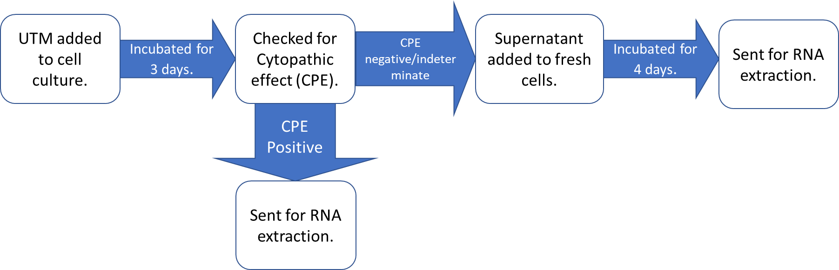
Figure A4.1: Viral culture laboratory process
A total of 41 Patients had swabs taken for laboratory analysis. 31 came from patients still testing LFT positive at Day 5-7. 10 came from patients testing LFT negative at Day 5-7.
Cultures were considered positive if CPE was present. Because CPE is not always present in viral cultures, especially with the omicron variant, culture supernatants had RNA isolated and sequenced culture supernatants had RNA isolated and sequenced by MinION. If cultures were indeterminate for CPE, or if N gene sub genomic RNA (sgRNA) was identified using a published method.[A4ii] In one case, both indeterminate CPE and N sgRNA were identified. This sample had multiple other sgRNAs detected and was considered positive. The remainder of the samples had either indeterminate CPE or N sgRNA but not both, lower levels of N sgRNA, and fewer sgRNAs detected. In these cases we were unable to prove the presence of SARS-CoV-2, these have therefore been considered indeterminate by either CPE or N sgRNA. Table A4 shows a summary of these results.

Culture result | LFT result | Laboratory result | N
Positive | Positive | CPE positive | 5
Positive | Positive | CPE indeterminate, N sgRNA positive, 4 sgRNAs | 1
Indeterminate | Positive | Indeterminate CPE | 9
Indeterminate | Positive | N sgRNA positive (low level, ≤ 3 sgRNAs) | 2
Indeterminate | Negative | Indeterminate CPE | 2
Indeterminate | Negative | N sgRNA positive (low level, ≤ 3 sgRNAs) | 2
Negative | Positive | All negative | 14
Negative | Negative | All negative | 6
Table A4.1: Classification of culture result by LFT status. CPE = cytopathic effect.
Bioinformatics Analysis
Fastq reads were analysed using the ARTIC[A4i] bioinformatic pipeline and lineages were called with Pangolin.[A4iii] LeTRS[A4ii] was used to assess the presence of sgmRNA, indicative of active viral transcription. Sequencing reads were mapped onto a known SARS-CoV-2 genome (GenBank sequence accession: NC_045512.2) using Minimap2 v 2.24-r1122 with parameters “-a -x map-ont".[A4iv] The sorted output was used to count the number of reads mapped on the virus genome using SAMtools v1.9 with “flagstat” option.[A4v] The “genomecov” function in bedtools v2.29.2 was used to calculate the coverage of reads mapped on the virus.[A4vi] LeTRS v2.2.1 was applied to analyse sub-genomes in the sequenced samples with the options set to “-pool 0 -Rtch cDNA -mode nanopore”.[A4ii]
[A4i] SARS-CoV-2 V4.1 update for Omicron variant - Laboratory. ARTIC Real-Time Genomic Surveillance. Available at https://community.artic.network/t/sars-cov-2-v4-1-update-for-omicron-variant/342. Accessed October 10, 2023, 2021.
[A4ii] Dong X, Penrice-Randal R, Goldswain H, Prince T, Randle N, Donovan-Banfield I, et al. Analysis of SARS-CoV-2 known and novel sub-genomic mRNAs in cell culture, animal model, and clinical samples using LeTRS, a bioinformatic tool to identify unique sequence identifiers. GigaScience 2022;11:giac045. Doi: 10.1093/gigascience/giac045.
[A4iii] O’Toole Á, Pybus OG, Abram ME, Kelly EJ, Rambaut A. Pango lineage designation and assignment using SARS-CoV-2 spike gene nucleotide sequences. BMC Genomics 2022;23(1):121. Doi: 10.1186/s12864-022-08358-2.
[A4iv] Li H. Minimap2: pairwise alignment for nucleotide sequences. Bioinformatics 2018;34(18):3094–100. Doi: 10.1093/bioinformatics/bty191.
[A4v] Li H, Handsaker B, Wysoker A, Fennell T, Ruan J, Homer N, et al. The Sequence Alignment/Map format and SAMtools. Bioinformatics 2009;25(16):2078–9. Doi: 10.1093/bioinformatics/btp352.
[A4vi] Quinlan AR, Hall IM. BEDTools: a flexible suite of utilities for comparing genomic features. Bioinformatics 2010;26(6):841–2. Doi: 10.1093/bioinformatics/btq033.

