Supporting Information
Extension of Tomato Shelf Life via Nitric Oxide Treatment Using Air Plasma
Joo Young Park ^{1, *}, Hyungyu Lee^{2,3}, Ki Ho Baek¹, Jong-Seok Song⁴, Seungil Park⁴, Sung Hoon Jee⁴, Sunghoon Jung¹, Seunghoon Lee¹, Sanghoo Park^{2,*}
¹Surface & Nano Material Division, Korea Institute of Materials Science, 797 Changwon-daero, Seongsan-gu, Changwon-si, Gyeongsangnam-do, 51508, Republic of Korea
²Department of Nuclear and Quantum Engineering, Korea Advanced Institute of Science and Technology, 291 Daehak-ro, Yuseong-gu, Daejeon 34141, Republic of Korea
³Present address: Department of Electrical and Biological Physics, Kwangwoon University, 20 Kwangwoon-ro, Nowon-gu, Seoul 01897, Republic of Korea
⁴Institute of Plasma Technology, Korea Institute of Fusion Energy, Gunsan, 54004, Republic of Korea.
Current

*Correspondence
Email: jypark@kims.re.kr, sanghoopark@kaist.ac.kr

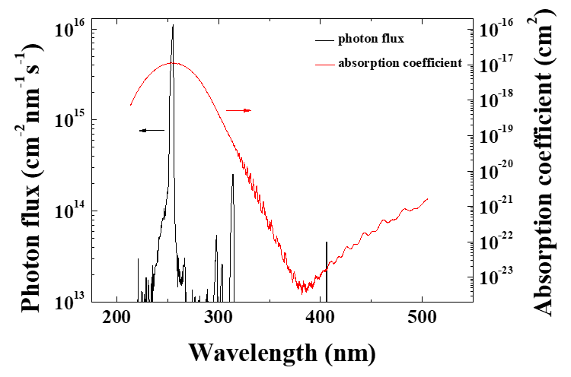
Figure S1. UV photon flux (black) and ozone absorption coefficient (red).

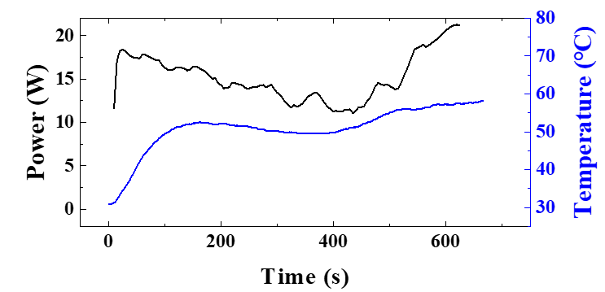
Figure S2. Changes in the dissipated power and air temperature in the DBD chamber. The temperature sensor was located at the center of the chamber.

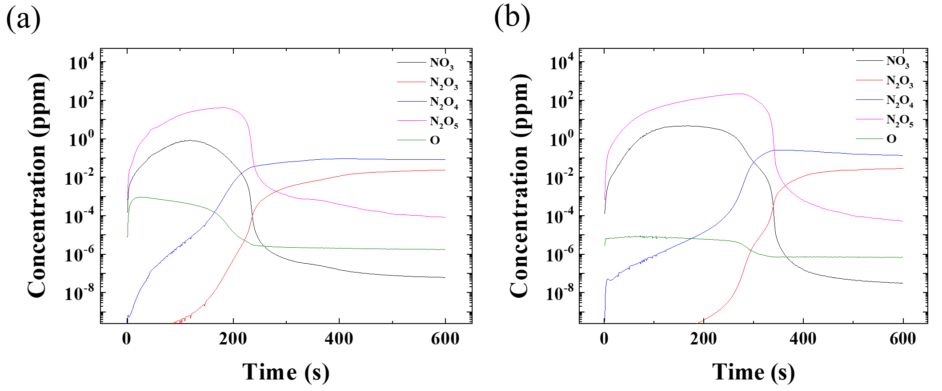
Figure S3. Numerically calculated chemical species in the DBD chamber.

