Supplemental Material Table of Contents
Appendix 1. Supplementary Tables
Supplementary Table 1: The definition of eight cardiometabolic conditions involved in the construction of potential classes
Supplementary Table 2: Adjustment of covariates of the model
Supplementary Table 3: The parameter results of the latent class analysis model
Supplementary Table 4: The probability of individuals in each class
Appendix 2. Sensitivity Analyses for Latent Class Analysis
Validation #1
Table 1: Summary statistics of posterior class membership probability for assigned class
Figure 1: Predicted probability of class membership for the assigned class.
Figure 2: Stacked bar chart of individual-level predicted probabilities of class membership
Figure 3: Percentage of cases with a cardiometabolic condition given class membership for the three-class latent class model.
Validation #2
Table 2: Summary statistics of posterior class membership probability for assigned class
Table 3: Crosstabs comparing longitudinal dataset latent class assignments (rows) to cross-sectional dataset latent class assignments (columns)
Figure 4: Predicted probability of class membership for the assigned class.
Figure 5: Percentage of cases with a cardiometabolic condition given class membership for the three-class latent class model.

Appendix 1. Supplementary Tables

Supplementary Table 1. The definition of eight cardiometabolic conditions involved in the construction of potential classes
The construction of latent classes involved the consideration of eight cardiometabolic conditions: obesity, reduced plasma HDL-C, elevated plasma TG, hypertension, diabetes, arthritis or rheumatism, systemic inflammatory conditions (indicated by raised C-reactive protein), and heart disease. Each of the eight cardiometabolic indicators were considered as separate binary variables based on the presence or absence of an abnormal indicator.
Cardiometabolic conditions | Definition
Obesity | Participants were categorized into BMI groups according to Chinese guidelines: normal weight (BMI 18.5–23.9 kg/m2), overweight (BMI 24.0–27.9 kg/m2), and obesety (BMI ≥28 kg/m2)².
Reduced plasma high-density lipoprotein cholesterol (HDL-C) | HDL-C <1.0 mmol/L for men and <1.3 mmol/L for women) or using lipid-lowing drug
Elevated plasma triglyceride (TG) | TG ≥1.7 mmol/L or using lipid-lowing drugs³.
Hypertension | Systolic blood pressure ≥130 mmHg or diastolic blood pressure ≥85 mmHg, self-reported hypertension, or the use of antihypertensive drugs³;
Diabetes | Self-reported doctor diagnosis of type 2 diabetes, and cases with untreated hyperglycemia and undiagnosed diabetes were detected using HbA1c, with hyperglycemia defined as an HbA1c level ≥48 mmol/mol (6.5%) according to the American Diabetes Association criteria⁴.
Systemic inflammation | C-reactive protein (CRP) levels >3 mg/L, according to the American Heart Association and the Center for Disease Control⁵
Heart disease | Self-reported doctor diagnosis of heart attack, coronary heart disease, angina, congestive heart failure, or other heart problems

Supplementary Table 2. Adjustment of covariates of the model
This study comprehensively assessed a range of covariates potentially associated with CKD, encompassing sociodemographic factors, lifestyle choices, additional comorbidities, and pertinent blood parameters.
covariates | Definition
Sociodemographic Variables | Age, sex, educational attainment (categorized as elementary school or below, secondary school, and college or above), marital status (married vs. others), and type of residence (rural vs. urban)
Lifestyle Variables | Nighttime sleep duration, along with smoking and drinking habits (categorized as yes or no).
Additional Comorbidities | Participants were screened for a history of significant comorbid conditions, including but not limited to, cancer, chronic lung diseases, stroke, liver disease, stomach or other digestive diseases, psychiatric conditions, and memory-related disorders. These were based on self-reporting
Blood Data | A detailed blood analysis was conducted, measuring a variety of parameters indicative of overall health and specific relevance to CKD. This included the white blood cell count (WBC), hemoglobin concentration (HGB), hematocrit (Hct), mean corpuscular volume (MCV), platelet count (PLT), serum creatinine (SCR), blood urea nitrogen (BUN), uric acid (UA), and cystatin C (CysC).

Supplementary Table 3. The parameter results of the latent class analysis model
N_Class | AIC | BIC | G² | χ²
2 | 61595.38 | 61712.36 | 601.1516 | 643.0767
3 | 61385.83 | 61564.74 | 373.598 | 379.3323
4 | 61336.45 | 61577.29 | 306.2236 | 307.6597
5 | 61291.63 | 61594.4 | 243.4046 | 236.9596
6 | 61287.01 | 61651.71 | 220.7838 | 214.1062
7 | 61285.91 | 61712.54 | 201.6781 | 191.347
8 | 61288.54 | 61777.1 | 186.3108 | 172.9838
9 | 61291.63 | 61842.12 | 171.4059 | 161.9493
10 | 61297.25 | 61909.67 | 159.0186 | 147.8659
N_Class: the number of latent classes in your Latent Class Analysis (LCA) model; AIC: Akaike Information Criterion; BIC: Bayesian Information Criterion; G2: likelihood ratio test statistic (deviance statistic); χ²: Pearson's Chi-square test statistic for goodness of fit for a model with 3 latent classes.

Supplementary Table 4: The probability of individuals in each class
cardiometabolic conditions | MetS | CVD | RHC
Obesity
Pr (1) | 0.750244938 | 0.62807057 | 0.260762785
Pr (0) | 0.249755062 | 0.37192943 | 0.739237215
Reduced plasma HDL-C
Pr (1) | 0.310319075 | 0.046846729 | 0.050100015
Pr (0) | 0.689680925 | 0.953153271 | 0.949899985
Elevated plasma TG
Pr (1) | 0.832219937 | 0.274123089 | 0.172952154
Pr (0) | 0.167780063 | 0.725876911 | 0.827047846
Hypertension
Pr (1) | 0.589383852 | 0.858768841 | 0.259561823
Pr (0) | 0.410616148 | 0.141231159 | 0.740438177
Diabetes
Pr (1) | 0.404413634 | 0.324891515 | 0.098353007
Pr (0) | 0.595586366 | 0.675108485 | 0.901646993
High hsCRP
Pr (1) | 0.36631286 | 0.165806202 | 0.087044895
Pr (0) | 0.63368714 | 0.834193798 | 0.912955105
Heart Disease
Pr (1) | 0.178219629 | 0.390681522 | 0.071669769
Pr (0) | 0.821780371 | 0.609318478 | 0.928330231
Arthritis or Rheumatism
Pr (1) | 0.408226021 | 0.485089518 | 0.397550908
Pr (0) | 0.591773979 | 0.514910482 | 0.602449092
The Latent Class Analysis (LCA) results provided analyze eight cardiometabolic conditions, classifying individuals into three latent classes based on their likelihood of having certain diseases (with 1 indicating the presence of disease and 0 indicating the absence of disease). Below is an analysis of these results, focusing on the conditional probabilities for each health condition across the three classes: Each variable has two possible states, denoted as Pr (1) and Pr (0), representing the probability of individuals in each class having that characteristic.

Appendix 2. Sensitivity Analyses for Latent Class Analysis

Validation #1
Examining posterior probability of class membership for assigned classes within cross-sectional dataset (N=9340).

Table 1 shows the posterior probability of class membership for the assigned latent class, as computed from the cross-sectional dataset LCA construction. As you can see, membership within an assigned class was generally associated with a high predicted probability of membership within the given class. Across the cross-sectional dataset, 14.5% of those in the MetS group had <50% probability of class membership in the given class, 2.1% of those in the CVD group had <50% probability of class membership in the given class, and 3.5 % of those in the RHC group had <50% probability of class membership in that class.

Figure 1 shows the distribution of predicted probability of class membership for the assigned class. Figure 2 shows the full probability distributions for everyone assigned to the MetS group (Figure 2a), the CVD group (Figure 2b), and the RHC group (Figure 2c)
Figure 3 shows percentage of cases with a cardiometabolic condition given class membership for the three-class latent class model.

Table 1. Summary statistics of posterior class membership probability for assigned class
 | Mean | St. Dev | Maximum | Minimum
MetS | 0.675 | 0.158 | 0.986 | 0.356
CVD | 0.756 | 0.169 | 0.992 | 0.406
RHC | 0.857 | 0.156 | 0.986 | 0.41
Of the 1,768 people assigned MetS, 257 (14.5 %) had <50% probability of class membership
Of the 1596 people assigned CVD, 33 (2.1%) had <50% probability of class membership
Of the 5,976 people assigned RHC, 207 (3.5 %) had <50% probability of class membership

Figure 1. Predicted probability of class membership for the assigned class.

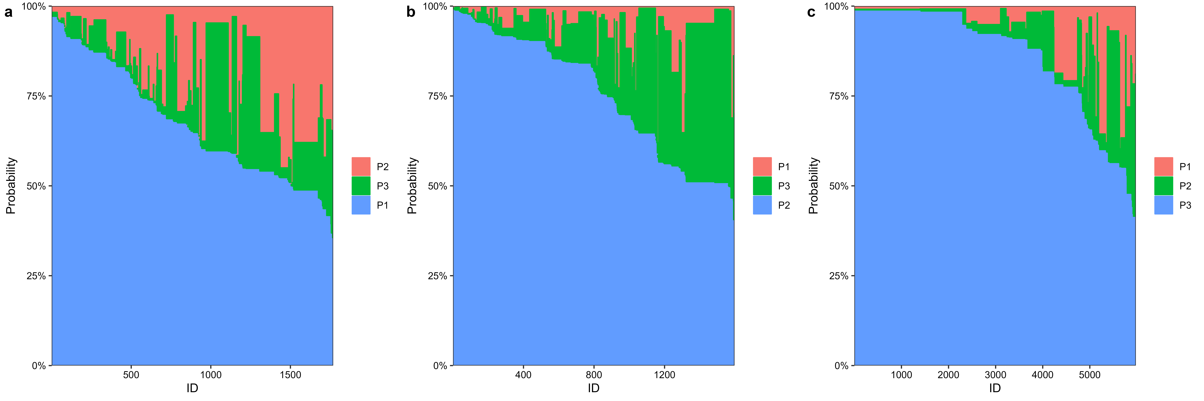
Figure 2. Stacked bar chart of individual-level predicted probabilities of class membership

Figure 3. Percentage of cases with a cardiometabolic condition given class membership for the three-class latent class model.

Validation #2
Latent class construction was run again for the 3-class model within only those in the longitudinal dataset (N=7195). Posterior probability of class membership was then compared with that from the latent classes constructed within the cross-sectional dataset.

Table 2 shows the posterior probability of class membership for the assigned latent class, as computed from the full data cohort LCA construction. Similar classes emerged to the longitudinal dataset (Figure 5). As you can see, membership within an assigned class was generally associated with a high predicted probability of membership within the given class.
Across the longitudinal dataset, 0.5% of those in the RHC group had <50% probability of class membership in the given class, 7.0% of those in the MetS group had <50% probability of class membership in the given class, and 10.1 % of those in the CVD group had <50% probability of class membership in that class.
Figure 4 shows the distribution of predicted probability of class membership for the assigned class.
Table 2. Summary statistics of posterior class membership probability for assigned class
 | Mean | St. Dev | Maximum | Minimum
MetS | 0.733 | 0.169 | 0.993 | 0.366
CVD | 0.651 | 0.141 | 0.925 | 0.347
RHC | 0.835 | 0.166 | 0.986 | 0.393
Of the 1,433 people assigned MetS, 101 (7.0 %) had <50% probability of class membership
Of the 993 people assigned CVD, 101 (10.1 %) had <50% probability of class membership
Of the 4,769 people assigned RHC 23 (0.5 %) had <50% probability of class membership
Table 3. Crosstabs comparing longitudinal dataset latent class assignments (rows) to cross-sectional dataset latent class assignments (columns)
 |  | cross-sectional dataset
 |  | MetS | CVD | RHC
longitudinal  dataset | MetS | 1381(97.25) | 0(0.00) | 52(1.09)
longitudinal  dataset | CVD | 6(0.42) | 987(96.58) | 0(0.00)
longitudinal  dataset | RHC | 33(2.32) | 35(3.42) | 4701(98.91)
Data are presented as n (column %).
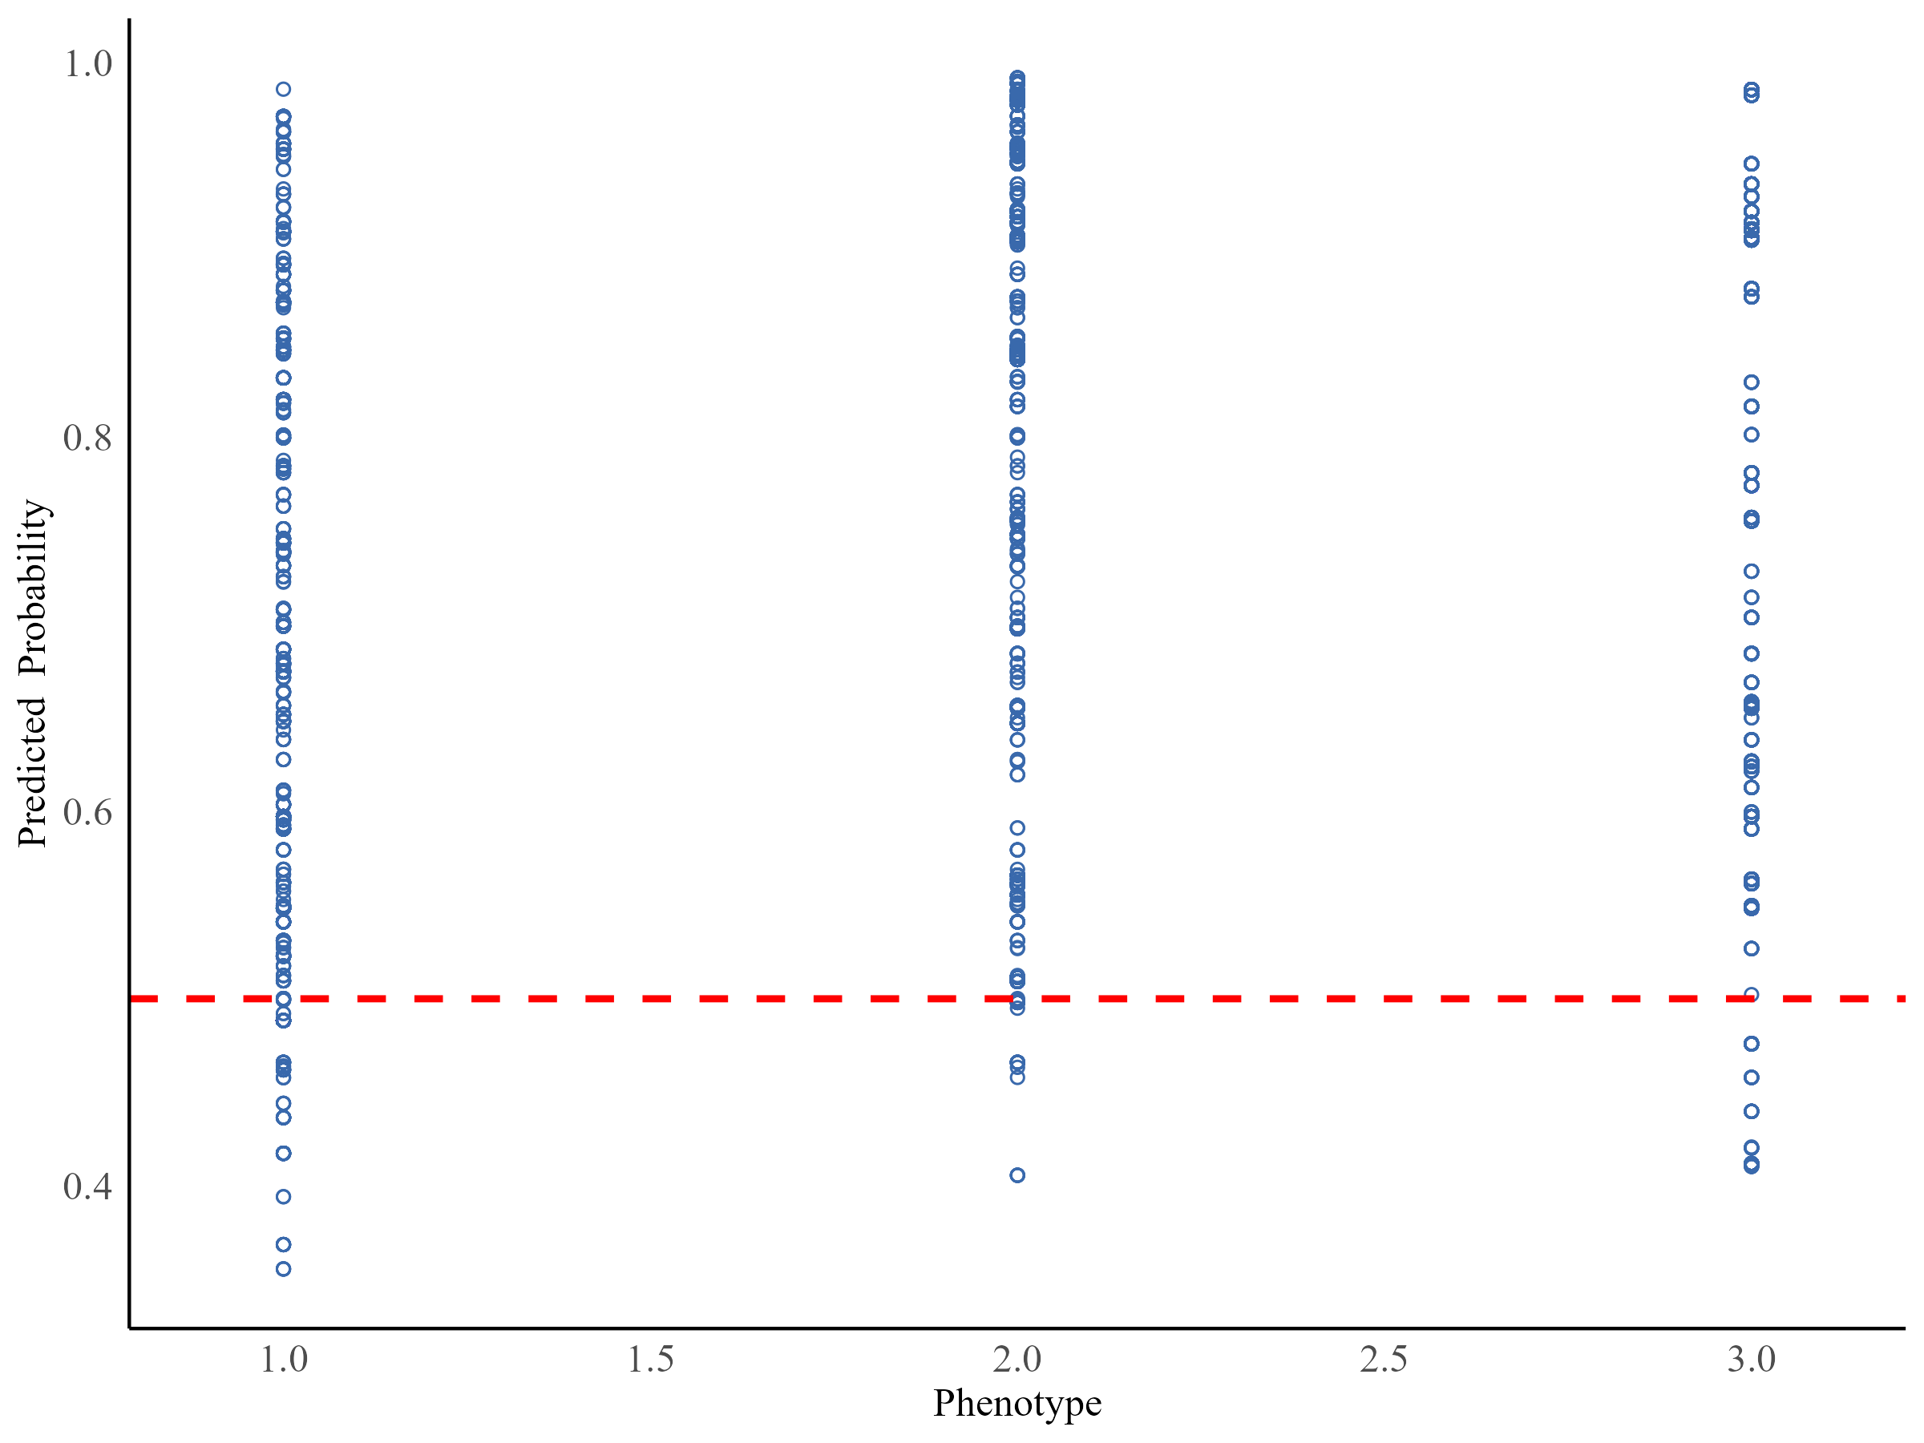
Figure 4. Predicted probability of class membership for the assigned class.

Figure 5. Percentage of cases with a cardiometabolic condition given class membership for the three-class latent class model.

