Specimens | Absorbance | Average absorbance | SD | RSD
6.1 | 0.881 | 0.88133 | 0.00516 | 0.000585
6.2 | 0.881 | 0.88133 | 0.00516 | 0.000585
6.3 | 0.882 | 0.88133 | 0.00516 | 0.000585
6.4 | 0.881 | 0.88133 | 0.00516 | 0.000585
6.5 | 0.882 | 0.88133 | 0.00516 | 0.000585
6.6 | 0.881 | 0.88133 | 0.00516 | 0.000585
Table 1. Results of the Coomassie Brilliant Blue method precision test.

Time | Absorbance | Average absorbance | SD | RSD
0 min | 0.881 | 0.88133 | 0.00516 | 0.000585
5 min | 0.881 | 0.88133 | 0.00516 | 0.000585
10 min | 0.882 | 0.88133 | 0.00516 | 0.000585
Table 2. Coomassie Brilliant Blue method stability test results.

Samples (mg) | Control substance (mg) | Measured content (mg) | Recovery rate | Average recovery rate
0.15245 | 1.2200 | 1.4500 | 1.063565 | 1.01115
0.15245 | 1.5250 | 1.601 | 0.949868 | 1.01115
0.15245 | 1.8250 | 2.014 | 1.020037 | 1.01115
0.15245 | 1.2196 | 1.602 | 1.188545 | 1.09663
0.15245 | 1.5245 | 1.733 | 1.036766 | 1.09663
0.15245 | 1.8294 | 2.100 | 1.064584 | 1.09663
Table 3. Results of Coomassie Brilliant Blue spiked sample recovery test.

Samples | Sample concentration (mg/ml) | RSD
XDI 1 | 309.689 | 0.0453
XDI 2 | 293.153 | 0.0453
XDI 3 | 308.508 | 0.0453
XDI 4 | 293.153 | 0.0453
XDI 5 | 322.681 | 0.0453
XDI 6 | 286.067 | 0.0453
Table 4. Coomassie brilliant blue repeatability test results.

ProteinGroup A | ProteinGroup B
SM medicinal herb | XDI-1 | XDI-2 | XDI-3
Table 5. Sample grouping.

Spectrum |  | Peptides |  | Proteins
Total spectrum | Matched spectrum | Peptides | Unique peptides | Identified | Quantified
59105 | 1743 | 682 | 646 | 173 | 171
Table 6. Identification and quantification results of the ProteinGroup A.

Sample | ProteinGroup
LFQ intensity A1 | 171
LFQ intensity B1 | 4
LFQ intensity B2 | 9
LFQ intensity B3 | 1
Table 7. Identification and quantification results of the ProteinGroup A and B.

Serial Number | Protein Name | Molecular Weight (KD)
1 | Cytochrome P450 CYP98A78 | 57.578
2 | Cytochrome P450 CYP82D70 | 57.638
3 | Enoyl-ACP Reductase | 41.436
4 | ABC Acyl Transporter | 150.15
5 | Carboxyltransferase beta subunit of Heteromeric ACCase | 52.845
6 | Universal stress protein 1 | 19.881
7 | Universal stress protein 26 | 15.323
8 | ATP synthase subunit beta, chloroplastic | 53.746
9 | ABC-type xenobiotic transporter | 181.91
10 | 14-3-3-like protein C (Fragment) | 29.407
11 | Late embryogenesis-like protein | 35.341
Table 8. The molecular weight of the eleven same proteins

 | Sample number | Sample Name
The samples of SM | S1 | SM decoction liquid
The samples of SM | S2 | SM concentrated liquid
The samples of SM | S3 | SM first alcoholic precipitation liquid
The samples of SM | S4 | SM second alcohol precipitation liquid
The samples of SM | S5 | SM water precipitation liquid
The samples of SM | S6 | SM third alcohol precipitation liquid
The samples of SM | S7 | SM alkali precipitation liquid
The samples of SM | S8 | SM spare liquid
Table 9. The samples of intermediates of DO medicinal liquid and SM medicinal liquid

Sample number | Sulfosalicylic acid method |  |  | Tannic acid method
Sample number | Sample Pictures | Added SA | Whether or not to precipitate | Sample Pictures | Added TA | Whether or not to precipitate
S1 | 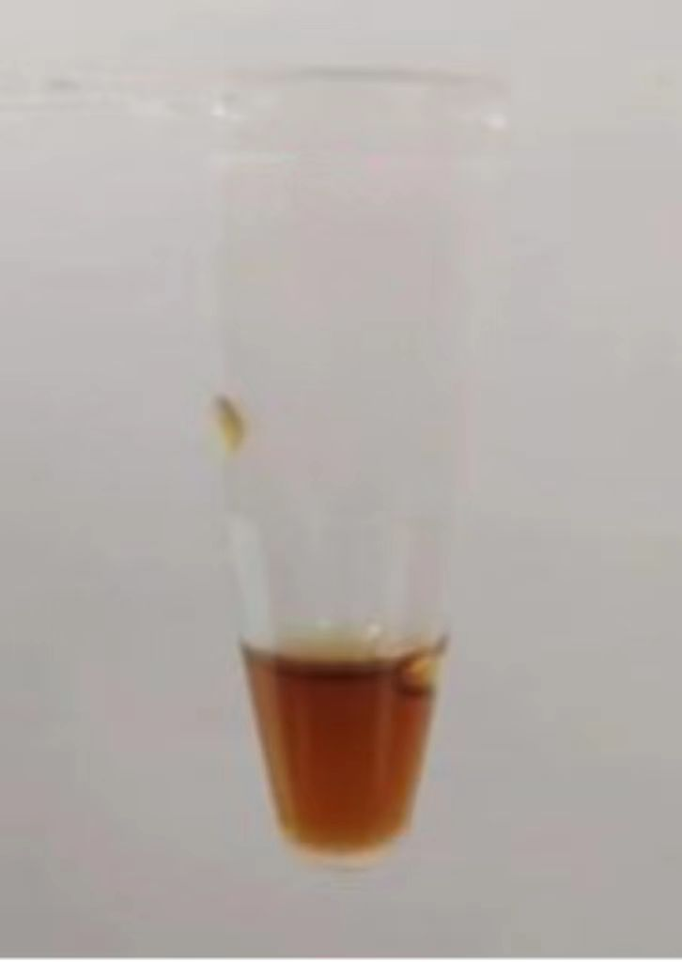 | 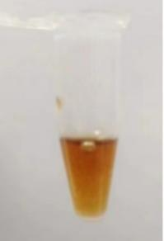 | Not |  | 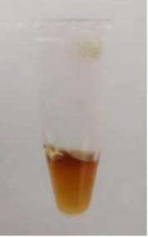 | Not
S2 | 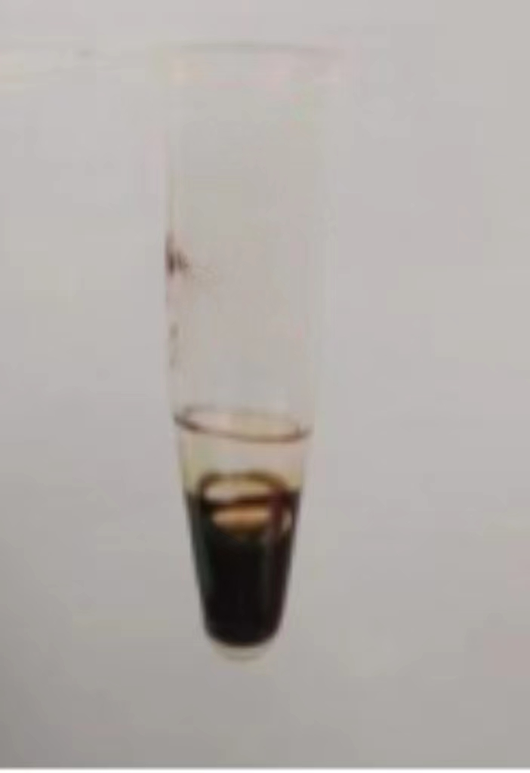 | 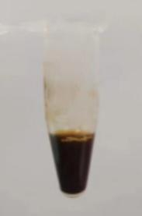 | Not |  | 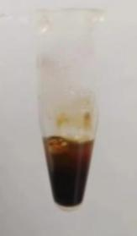 | Not
S3 | 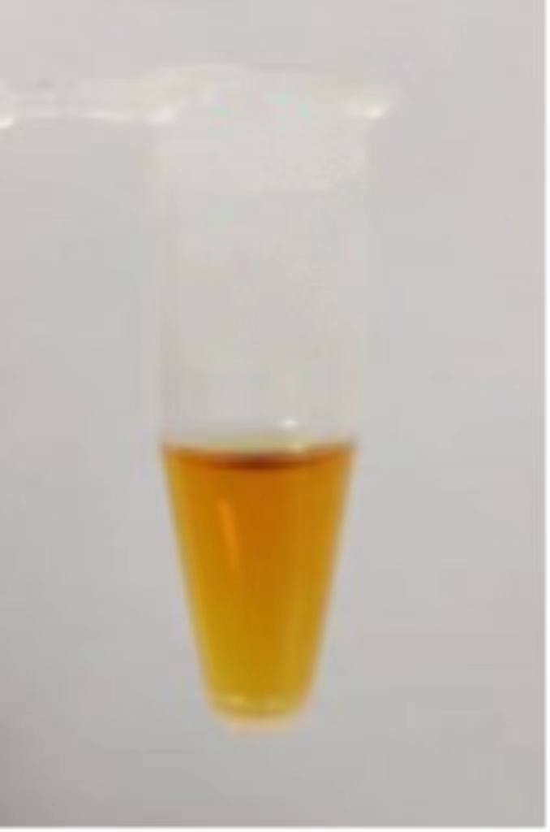 | 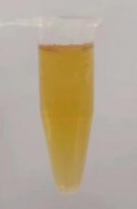 | Not |  | 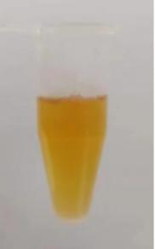 | Not
S4 | 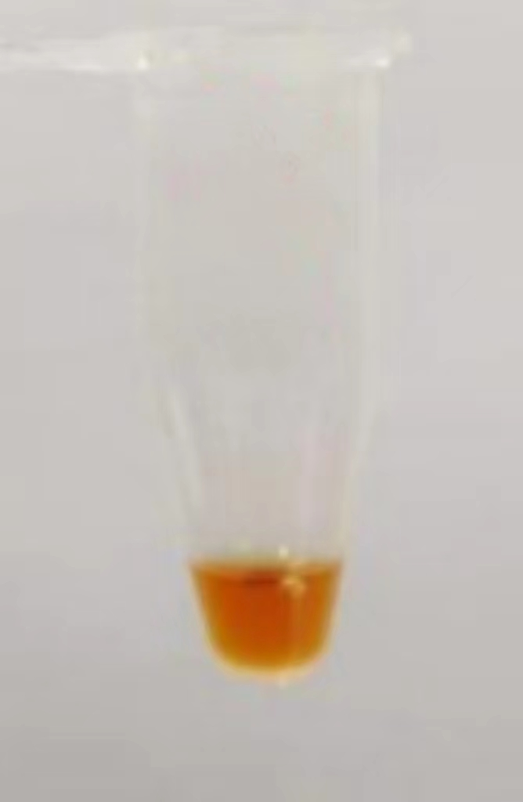 | 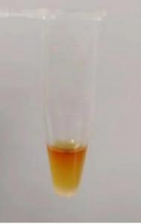 | Not |  | 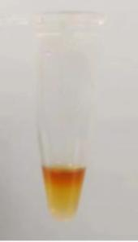 | Not
S5 | 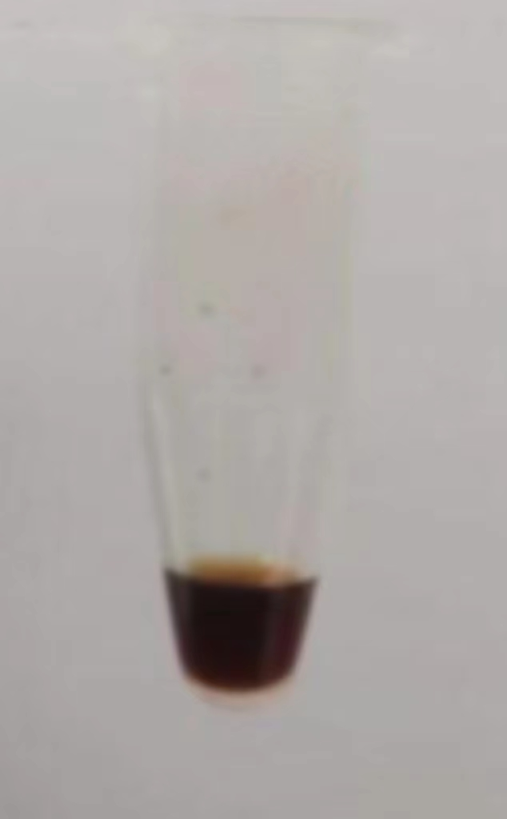 | 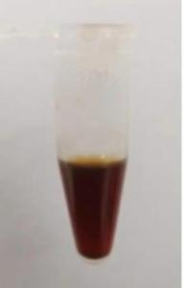 | Not |  | 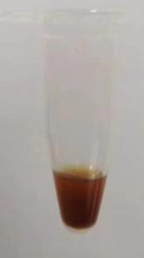 | Not
S6 | 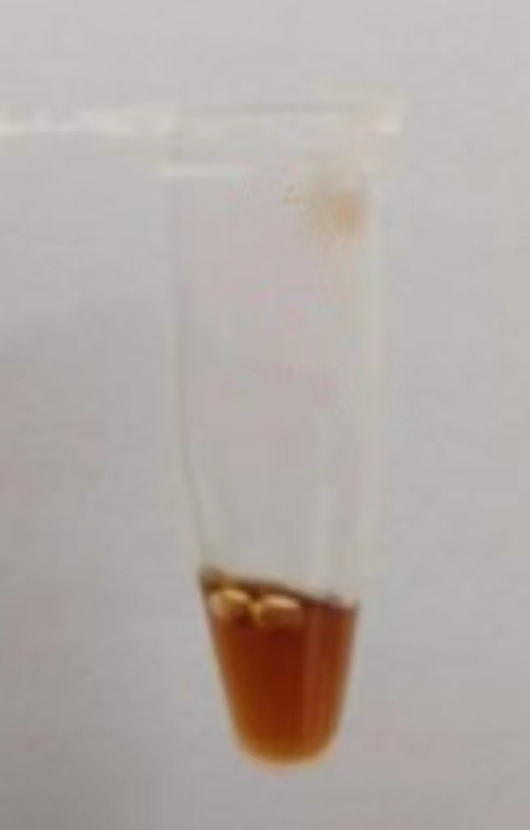 | 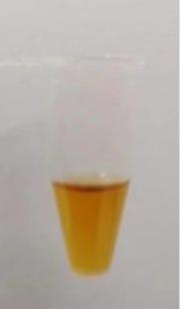 | Not |  | 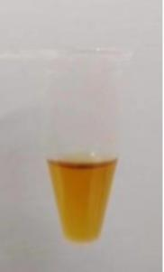 | Not
S7 | 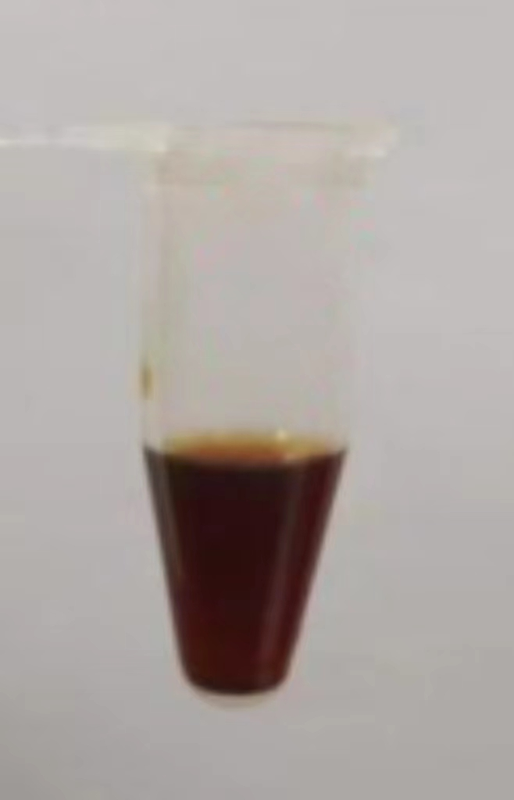 | 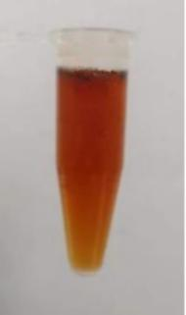 | Not |  | 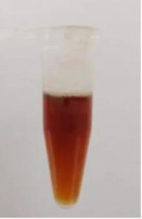 | Not
S8 | 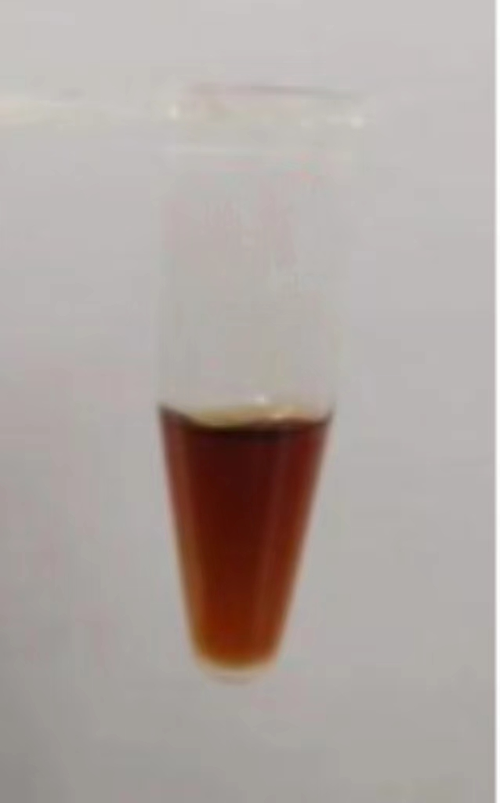 | 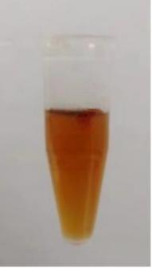 | Not |  | 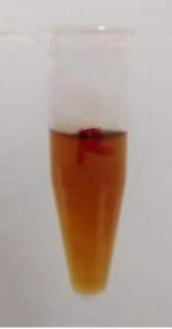 | Not
Table 10. Qualitative results of SM medicinal liquid

Sample number | Sample batch number | Manufacturers
T1 | 210603 | Taicang Pharmaceutical Factory
T2 | 210612 | Taicang Pharmaceutical Factory
T3 | 20140403 | Nanjing Weir Pharmaceutical Factory
T4 | 220302 | Nanjing Weir Pharmaceutical Factory
T5 | 210603 | Nanjing Weir Pharmaceutical Factory
T6 | 101720220702 | Hunan Erkang Products Corporation
Table 11. Sample number of the six Tween 80.

Sample number | SA method | Whether or not to precipitate | TA method | Whether or not to precipitate
T1 | 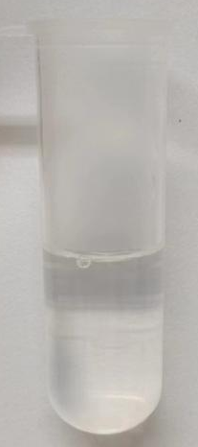 | Not | 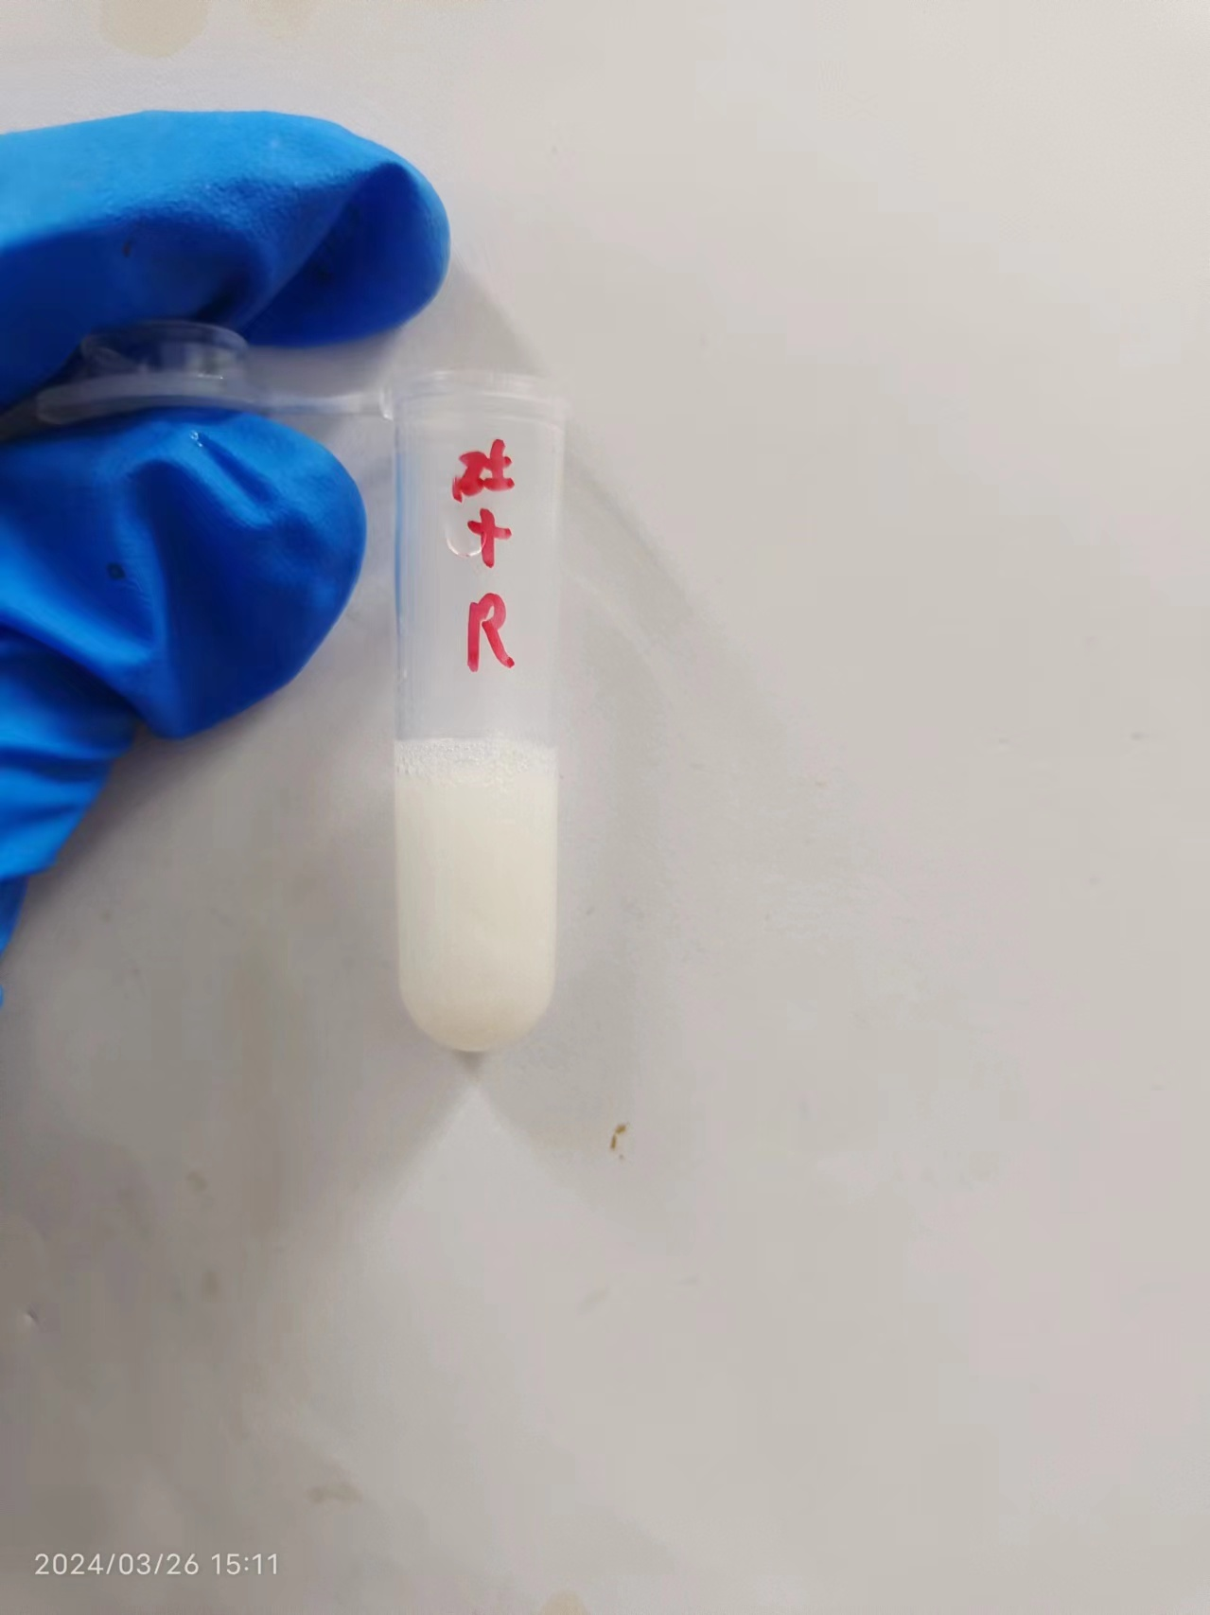 | Yes
T2 | 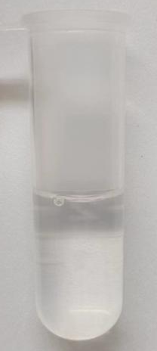 | Not |  | Yes
T3 | 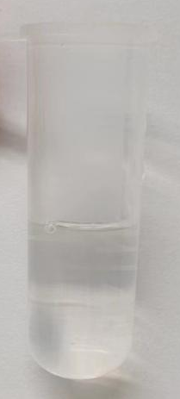 | Not |  | Yes
T4 | 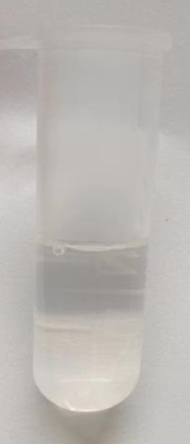 | Not |  | Yes
T5 | 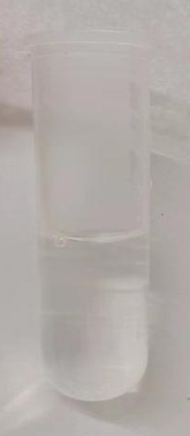 | Not |  | Yes
T6 | 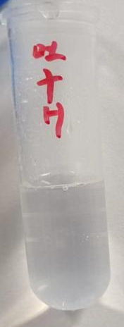 | Not |  | Yes
Table 12. The qualitative results of six kinds of Tween 80 from different manufacturers.

Sample names | 0.5% Tween 80 | 0.05% Tween 80 | 0.025%  Tween 80 | 0.0125%  Tween 80 | 0.00625%  Tween 80 | 0.005%  Twain 80
 | 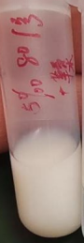 | 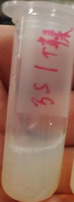 | 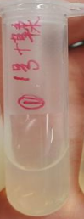 | 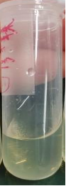 | 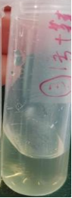 | 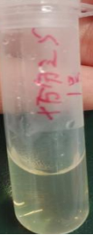
Whether or not to precipitate | Yes | Yes | Yes | Yes | Not | Not
Table 13. Results of different concentrations of Tween 80 with TA

Table 14. Qualitative examination results of SM samples.
Qualitative results | SM samples name
No precipitation | S1+Tween 80 | S7+Tween 80 | S8+Tween 80 | / | /
Generated precipitation | S2+Tween 80 | S3+Tween 80 | S4+Tween 80 | S5+Tween 80 | S6+Tween 80

 | Samples | SA | TA | Samples | SA | TA | Samples | SA | TA
DO | D1 | － | － | T80-1 | － | + | D1+T80 | － | +
SM | S1 | － | － | T80-2 | － | + | S1+T80 | － | +
SM | S2 | － | － | T80-2 | － | + | S2+T80 | + | +
SM | S3 | － | － | T80-4 | － | + | S3+T80 | + | +
SM | S4 | － | － | T80-5 | － | + | S4+T80 | + | +
SM | S5 | － | － | T80-6 | － | + | S5+T80 | + | +
SM | S6 | － | － |  |  |  | S6+T80 | + | +
SM | S7 | － | － |  |  |  | S7+T80 | － | +
SM | S8 | － | － |  |  |  | S8+T80 | － | +
Table 15. Qualitative examination results of the three situations.

Table 16. Results of protein concentration determination.
Sample number | Sample Protein Concentration (mg/ml) | Protein content of samples (mg)
S1 | 0.838 | 12582.391
S2 | 9.491 | 7403.156
S3 | 16.658 | 1999.009
S4 | 7.352 | 1470.564
S5 | 6.884 | 2271.824
S6 | 7.305 | 2410.84
S7 | 5.907 | 1949.617
S8 | 4.813 | 2406.718

Table 17. Determination of the concentration of proteins in XDI.
Sample name | Sample concentration (mg/ml) | Average
XDI 1 | 3.09689 | 3.038
XDI 2 | 2.93153 | 3.038
XDI 6 | 3.08508 | 3.038

