Supplementary Materials

A novel wheat S1-bZIP gene, TabZIP11 confers stress resistance in Arabidopsis
Lina Zhang^{1*}• Zhen Yu¹• Xingyan Liu¹• Yaoyao Wang¹• Jing Luo¹• Yinghong Wang²• Ning Yang¹• Yingli Yang¹• Chuan Xia³• Lichao Zhang³• Xiuying Kong³
1 College of Life Sciences, Northwest Normal University, Lanzhou, Gansu 730070, China; 2 Xinxiang Academy of Agricultural Sciences, Xinxiang, Henan 453000, China; 3 Key Laboratory for Crop Gene Resources and Germplasm Enhancement, MOA, National Key Facility for Crop Gene Resources and Genetic Improvement, Institute of Crop Sciences, Chinese Academy of Agricultural Sciences, Beijing 100081, China
*Corresponding author: lina791001@163.com

Table 1. The gene-specific primers that were designed for RT-qPCR
Gene name | Forward primers (5'-3') | Reverse primers (5'-3')
TaGAPDH  AtActin  AtRD29A AtRD29B  AtRAB18  AtSIZ1  AtDREB2A AtCOR47  AtCOR15A AtCBF1  AtCBF2  AtCBF3 | TTAGACTTGCGAAGCCAGCA  TGTGCCAATCTACGAGGGTTT CGGTGGAAGAGGAAGTGAAAG  CCGCAAAGAACGTCGTTGCCTCA  AATGCTTCACCGCTCCG  AAAGGCAGAGCGATTTAGGG  AAAGGTAAAGGAGGACCAGAG GCATGACCATCCCGAGGAAGAG  CATCCTCGATGACCTCAACGAGG CTTCGCTGACTCGGCTTGG  AACCAGCGGGAAGGAAGAAGT  GATCAGCCTGTCTCAATTTC | AAATGCCCTTGAGGTTTCCC  TTTCCCGCTCTGCTGTTGT GGAGCCAAGTGATTGTGGAGAC  CCACCTCCGGAGAGAGGTAGCT GATGACCTGGCAACTTCTCC  AAGCAAGCGAGTATCAGCAA  GCCAAAGGACCATACATAGC ACTTCCTCTTCAGTGGTCTTGGC  CCTTAGCCTCTCCTGCTTTACCC ACGCACCTTCGCTCTGTTCC  TTTCCTTGGCACAGGTTGATT  CTTCTGCCATATTAGCCAAC
AtCOR15B | AGGAGCAAAGCAGAGTGGTG | TCCTTCGTCTTATCCGTCAC
AtCOR27 | AGGGAATATGCAGCTCTGGC | ATACCTCTGCTTCTCCAACGC
AtRC12A | TATCGCCATCCTCTTGCC | GGCGTATATGATCCCAGG
AtMYB77 | GGTTGAAATGTCTTCGTCTTCGGAG | CGCGTTGTTGTTATTGTTATGGCTC
AtWRKY33 | TCTCTTTTTCTCGATTCCCCTGCTT | CCATTGTTCTGACTGGTTCTTCTTC

Table 2. The gene-specific primers were selected for producing recombinant plasmids for yeast two hybrid analysis, BiFC, and modified yeast one hybrid analysis
Gene name | Primers (5'-3')
TabZIP60-NdeⅠ-F  TabZIP60-BamHⅠ-R | GGGAATTCCATATGATGGATTTTCCGGGA  CGCGGATCCTTACCAAGGGCCCGT
TaCDPK30- NdeⅠ-F  TaCDPK30-BamHⅠ-R  TaCDPK9-1- NdeⅠ-F  TaCDPK9-1-BamHⅠ-R  TaCDPK5- EcoRⅠ-F  TaCDPK5-BamHⅠ-R  TaCDPK1- EcoRⅠ-F  TaCDPK1-BamHⅠ-R  TaCIPK31- EcoRⅠ-F  TaCIPK31-BamHⅠ-R  TabZIP9- EcoRⅠ-F  TabZIP9-BamHⅠ-R  TabZIP11-NdeⅠ-F  TabZIP11-BamHⅠ-R  TabZIP11- EcoRⅠ-F  TabZIP11-BamHⅠ-R  TabZIP14- EcoRⅠ-F  TabZIP14-BamHⅠ-R  TabZIP32- EcoRⅠ-F  TabZIP32-BamHⅠ-R  TabZIP36- EcoRⅠ-F  TabZIP36-BamHⅠ-R  TabZIP11-BP-F  TabZIP11-BP-R(no TAG)  TaCDPK30-BP-F  TaCDPK30-BP-R(no TAA)  TaCDPK5-BP-F  TaCDPK5-BP-R(no TAG)  TaCDPK9-1-BP-F  TaCDPK9-1-BP-R(no TAG)  TabZIP11-pB42AD-F  TabZIP11-pB42AD-R  TaCBF1-promoter-XhoⅠ-F TaCBF1-promoter-XhoⅠ-R | GGGAATTCCATATGATGGGCAACGCCTGCT  CGCGGATCCTCAGGGCGCCATGGAGATGG  GGGAATTCCATATGATGTGCTCCTCCACC  CGCGGATCCCTAGCGTATCTTCAATGCTT  CCGGAATTCATGCATGACCTCTACGCGCT  CGCGGATCCCTAGATTGCACCAGGTGCGT  CCGGAATTCATGGCCCCCACGGCGAAGAA  CGCGGATCCTTACCGAAGCTTCAGTGCAT  GGAGGCCAGTGAATTCATGTATCGGGCCAA  CGAGCTCGATGGATCCTCATGCCACGGTGC  GGAGGCCAGTGAATTCATGAAGAAGTGCGC  CGAGCTCGATGGATCCTCACTTGGACATGG  GGGAATTCCATATGATGCGGGCGCTCATG  CGCGGATCCCTAGCTTTGCAGGGCTGGGA  GGAGGCCAGTGAATTCATGCGGGCGCTCAT  CGAGCTCGATGGATCCCTAGCTTTGCAGGG  GGAGGCCAGTGAATTCATGGAGCGCGTCTT  CGAGCTCGATGGATCCCTACGAGGTCGATC  GGAGGCCAGTGAATTCATGCTGCACCATTA  CGAGCTCGATGGATCCTTATTCAGCAGCGG  GGAGGCCAGTGAATTCATGGAGTGCAGCGG  CGAGCTCGATGGATCCTTACTGAGCATTGG  GGGGACAAGTTTGTACAAAAAAGCAGGCTGCATGCGGGCGCTCATGGAG  GGGGACCACTTTGTACAAGAAAGCTGGGTCGCTTTGCAGGGCTGG  GGGGACAAGTTTGTACAAAAAAGCAGGCTGCATGGGCAACGCCTGCTTCTCCT GGGGACCACTTTGTACAAGAAAGCTGGGTCGGGCGCCATGGAGATGGAGCCG  GGGGACAAGTTTGTACAAAAAAGCAGGCTGCATGCATGACCTCTAC  GGGGACCACTTTGTACAAGAAAGCTGGGTCGATTGCACCAGGTGC  GGGGACAAGTTTGTACAAAAAAGCAGGCTGCATGTGCTCCTCCACC  GGGGACCACTTTGTACAAGAAAGCTGGGTCGCGTATCTTCAATGC  TGCCTCTCCCGAATTCATGCGGGCGCTCAT  CGAGTCGGCCGAATTCCTAGCTTTGCAGGG  ATCTGTCGACCTCGAGTTAGATGGGACGTG GAGCACATGCCTCGAGTGCTAGCTGTCGGA

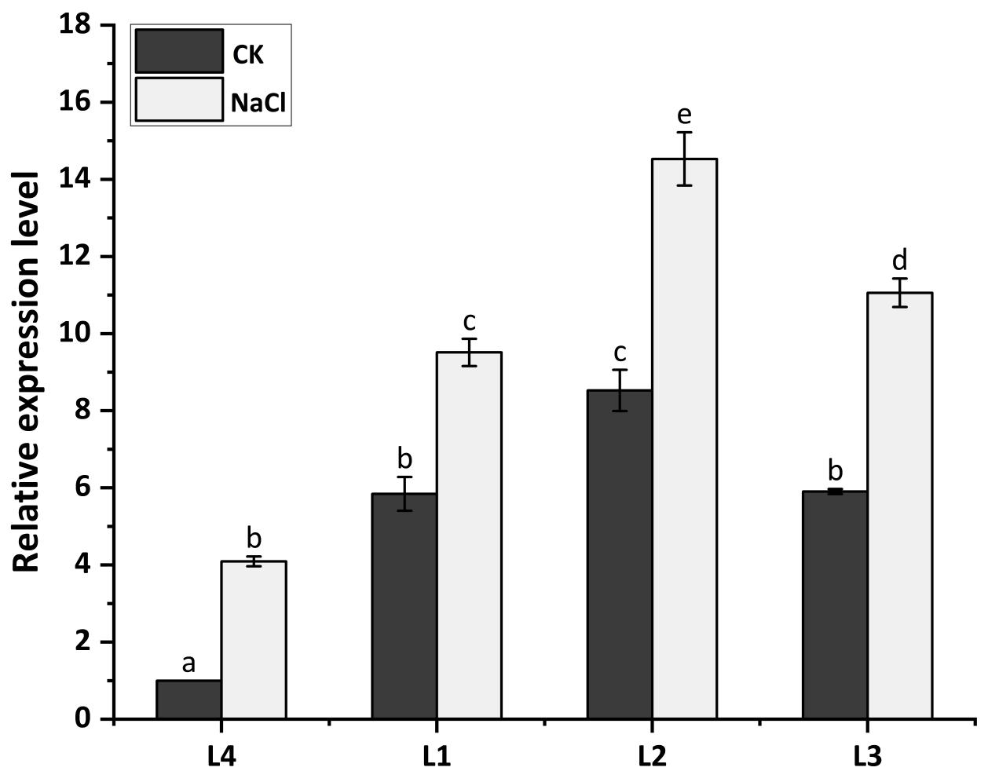

Fig. S1. Expression of TabZIP11 in transgenic lines
The relative expression level of TabZIP11 were calculated via 2^{−ΔCt} method. The Arabidopsis AtActin (AT3G18780) is used to the reference. Three independent experiments are carried out. The different letters show significant difference between the L4 and the three transgenic lines.

