Supplementary Material
Structure preferred spinel ferrite on polypyrrole derived N-doped carbon nanofibers as bifunctional electrocatalyst for Zn-air battery
Yang Shi, ª Xinxin Xu, ª * and Jin Chen ^{b}
a Department of Chemistry, College of Science, Northeastern University, Shenyang 110819, Liaoning, China
b Key Laboratory of Electromagnetic Processing of Materials, MOE, Northeastern University, Shenyang 110819, Liaoning, China

Materials and characterization
All chemicals were of analytical grade, commercially available from Sinopharm Chemical Reagent Co. Ltd and used as received without further purification. PXRD pattern was recorded on X-ray diffractometer with CuK_{α} (λ = 1.5418 Å) radiation (Philips X’Pert Pro Super, Philips). XPS was performed on photoelectron spectroscopy (ESCALAB 250Xi). The morphology was observed on an ultra plus field emission scanning electron microscope (SEM, ultra plus, ZEISS) and transmission electron microscopy (TEM, JEOL, JEM-2100F). Electrochemical experiments were conducted on electrochemical workstation (CHI-760E, Chenhua).
RRDE test in ORR
RRDE (electrode area is 0.2475 cm²) experiment was also conducted in O₂ saturated KOH (0.1 M). Working electrode was fabricated as follows: the mixture of CoFe₂O₄@NCNF (or NiFe₂O₄@NCNF and NCNF, 2 mg) and carbon black (Vulcan XC-72R, 8 mg) was dispersed in aqueous solution of water (0.8 mL), ethanol (0.15 mL) and 50 μL Nafion (5 %). The ink (10 μL) was dropped on RRDE and served as working electrode. Pt wire and Ag/AgCl electrode (3.5 M KCl) were employed as counter and reference electrodes. The disk potential was cycled from 0 to 0.96 V (vs. RHE) with a scan rate of 10 mV·s⁻¹. The ring potential was constant at 1.2 V (vs. RHE). The H₂O₂ selectivity and electron transfer number (n) were calculated with Eq. 1 and 2. In these equations, I_{D} and I_{R} represent the disk and ring currents density. N (N = 0.37, obtained from K₃Fe(CN)₆ reduction experiments at various rotation rates) is the current collection efficiency of the Pt ring.
H₂O₂ % = (200 × I_{R}/N)/( I_{R}/N + I_{D}) (1)
n = 4 × I_{d}/(I_{R}/N + I_{D}) (2)
RDE test in ORR
RDE test was conducted in O₂ saturated KOH (0.1 M) with three-electrode system, in which Pt wire and Ag/AgCl electrode (3.5 M KCl) were employed as counter and reference electrodes. Working electrode was fabricated as follows: the mixture of CoFe₂O₄@NCNF (or NiFe₂O₄@NCNF and NCNF, 2 mg) and carbon black (Vulcan XC-72R, 8 mg) was dispersed in aqueous solution of water (0.8 mL), ethanol (0.15 mL) and 50 μL Nafion (5 %). The ink (10 μL) was dropped on RDE (electrode area is 0.1256 cm²) and served as working electrode. Linear sweep voltammetry (LSV) was recorded at 10 mV·s⁻¹. The rotating speed of RDE was 400, 625, 900, 1225, 1600, 2025 and 2500 rpm. The electron transfer number was calculated by using the Koutechy-Levich (K-L) equation (Eq. 3). In this equation, j is the measured current density, j_{k} is the kinetic current density, ω is the electrode rotating rate. The parameter B could be calculated from the slope of the K-L plots based on the following Levich equation (Eq. 4), in which n is the electron transfer number per oxygen molecule, F is the Faraday constant (F = 96485 C·mol⁻¹), D₀ is the diffusion coefficient of O₂ in 0.1 M KOH (D₀ = 1.9 × 10⁻⁵ cm²·s⁻¹), v is the kinetic viscosity (v = 0.01 cm²·s⁻¹) and C₀ is the bulk concentration of O₂ (C₀ = 1.2 × 10⁻⁶ mol·cm⁻³).
1/j = 1/j_{k} + 1/Bω^{1/2} (3)
B = 0.62nF(D₀)^{2/3}(V)^{-1/6}C₀ (4)
OER test
OER was conducted in N₂ saturated KOH (1 M). Three-electrode system was employed. Working electrode was fabricated as follows: the mixture of CoFe₂O₄@NCNF (or NiFe₂O₄@NCNF and NCNF, 2 mg) and carbon black (Vulcan XC-72R, 8 mg) was dispersed in aqueous solution of water (0.8 mL), ethanol (0.15 mL) and 50 μL Nafion (5 %). The ink (10 μL) was dropped on glassy carbon (GC) electrode (electrode area is 0.1256 cm²). In this system, Pt wire and Ag/AgCl electrode (3 M KCl) were employed as reference electrode and counter electrode, respectively. LSV curves were recorded at 5 mV·s⁻¹.
Zn-air battery assemble
Zn-air battery was assembled with a home-made cell in the size of 4.2 × 4 × 4 cm³. The Zn plate with working area 3.2 cm² acts as anode. CoFe₂O₄@NCNF ink (fabricated as mentioned ORR and OER tests) was casted on carbon paper equipped with air diffusion layer, which was employed as air cathode. The working area of air cathode is also 3.2 cm². The cell was filled with 25 mL mixed solution of KOH (6.0 M) and ZnCl₂ (0.2 M). No additional O₂ was inlet into this battery.
Theoretical calculation details
Density functional theory (DFT) calculations about the ORR/OER were performed using the Vienna ab initio simulation package (VASP). The projector augmented wave (PAW) method was employed. The generalized gradient approximation (GGA) of Perdew-Burke-Ernzerhof (PBE) was used to estimate electron-electron exchange and correlation functional. In our calculation, we used plane-wave basis set with 400 eV kinetic energy cutoff and the Brillouin zone was sampled by the Monkhorst-Pack method with 3×3×1 k-point grids. Gibbs free energy change of each elementary step was calculated with the following equation (Eq. 5). In this equation, T is 298.15 K, E is the reaction energy calculated by the DFT method, ZPE and ΔS are the changes in zero-point energies and entropy in the reaction. For ΔG_{U} = -neU, it represents the applied potential (U) effect on reaction concerning electron (e) in the electrode and n is electron transfer number of elementary reaction.
ΔG = ΔE + ΔZPE - T·ΔS + ΔG_{U} (5)
The over-potential of ORR/OER can be determined by computing Gibbs free energies of the reaction at different elementary steps. Thermo-chemistry parameters of the reactions were obtained by DFT computations along with the computational hydrogen electrode (CHE) model. The ORR and OER could be described Table S3.

Table S1. The comparison ORR activity of CoFe₂O₄@NCNF with recently reported electrocatalysts.
Catalyst | E_{1/2} | Limiting current density | n value | Ref.
Fe/Co-N/S_{1.9}-C | 0.836 V | 5.44 mA cm⁻² | 3.95 | S1
CoFe₂O₄-N,S-C | 0.840 V | 5.25 mA cm⁻² | 3.90 | S2
CoFe₂O₄/CNTs/FA-500 | 0.808 V | 5.40 mA cm⁻² | 3.96 | S3
Co-SAs/N-C/rGO | 0.840 V | 4.51 mA cm⁻² | 3.94 | S4
G-CoNOC | 0.880 V | 3.0 mA cm⁻² | ~4 | S5
CoFe₂O₄@NCNF | 0.831 V | 6.03 mA cm⁻² | 3.79-3.91 | Here

Table S2. The comparison OER activity of CoFe₂O₄@NCNF with recently reported electrocatalysts.
Catalyst | Overpotential (η₁₀) | Tafel | Ref.
CoFe/NC_{30%} | 340 mV | 77.0 mV dec⁻¹ | S6
CFO@CSs | 390 mV | 57.7 mV dec⁻¹ | S7
CuFe₂O₄ | 369 mV | 76.3 mV dec⁻¹ | S8
FeCo@CoN_{x}@FeP_{x}/C | 368 mV | 70.1 mV dec⁻¹ | S9
Fe/12Zn/Co-NCNTs | 343 mV | 92.5 mV dec⁻¹ | S10
CoFe₂O₄@NCNF | 334 mV | 72.2 mV dec⁻¹ | Here

Table S3. The reaction routes in ORR and OER.
 | In ORR | In OER
1 | O₂ + H₂O +e = OOH* + OH⁻ | OH⁻ - e = OH*
2 | OOH* + e = O* + OH⁻ | OH* + OH⁻ - e = O* + H₂O
3 | O* + H₂O + e = OH* + OH⁻ | O* + OH⁻ - e = OOH*
4 | OH* + e = OH⁻ | OOH* + OH⁻ - e = O₂ + H₂O

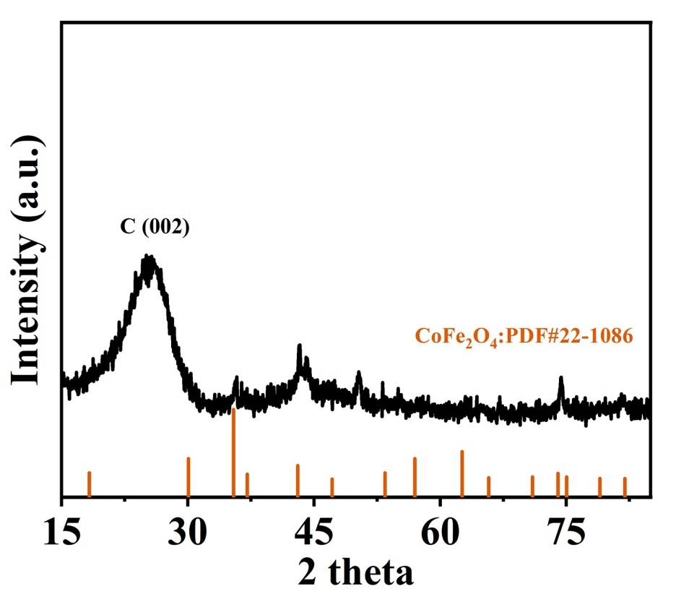
Fig. S1. XRD pattern of CoFe₂O₄@NCNF.

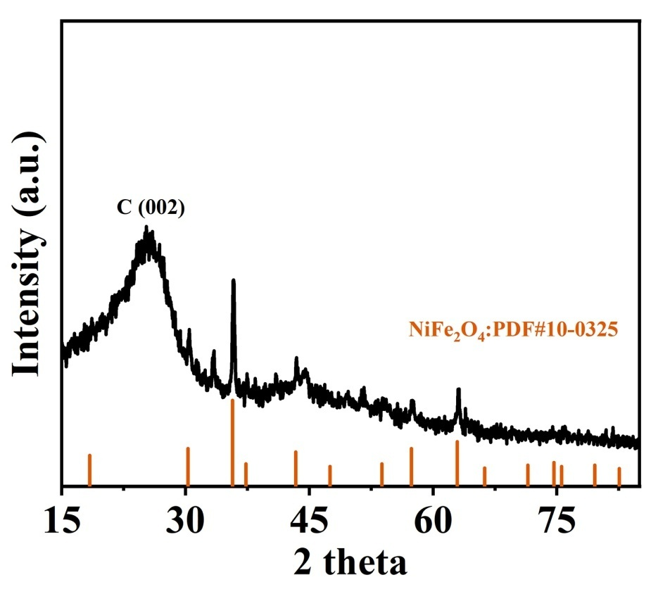
Fig. S2. XRD pattern of NiFe₂O₄@NCNF.

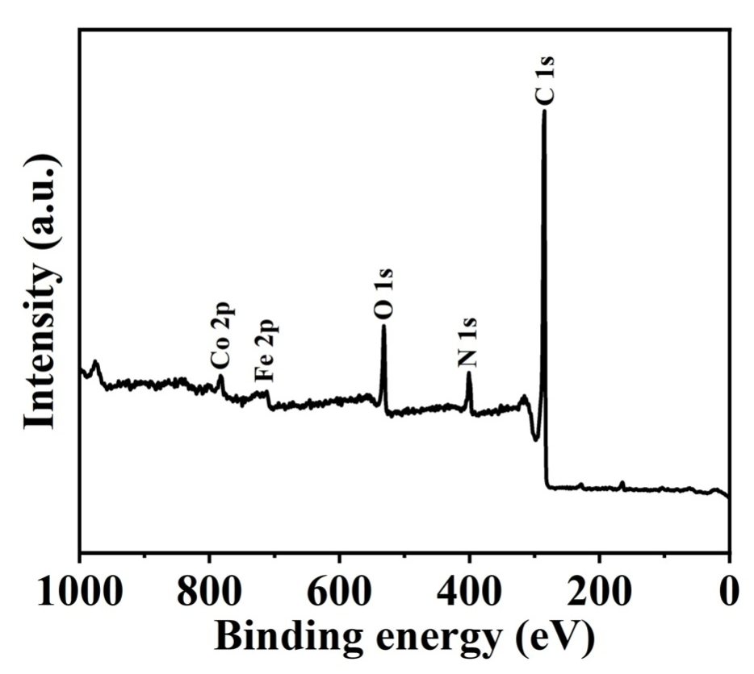
Fig. S3. XPS survey scan spectrum of CoFe₂O₄@NCNF.

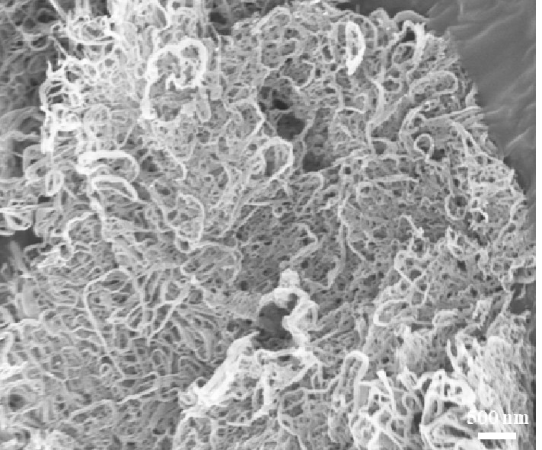
Fig. S4. SEM image of PPy nanofibers.

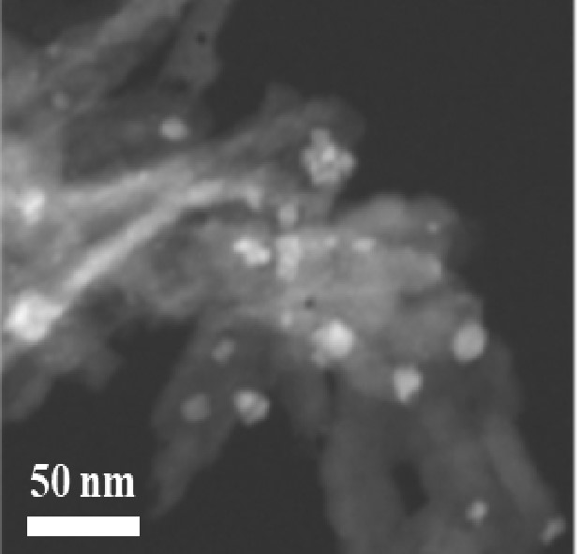
Fig. S5. TEM image of CoFe₂O₄@NCNF.

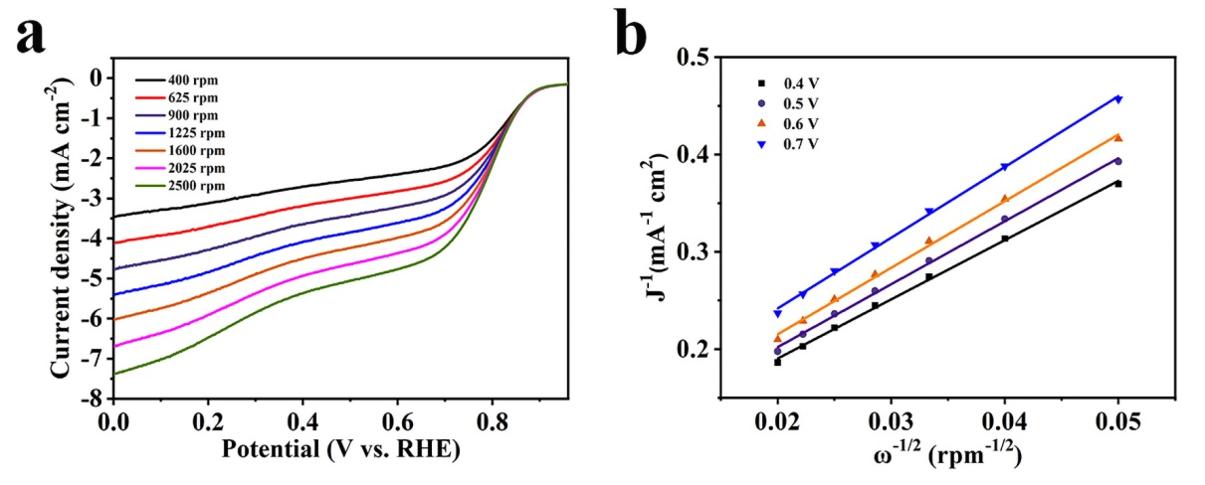
Fig. S6. (a) LSV curves of NiFe₂O₄@NCNF under different rotating speeds; (b) K-L plots at different potentials of NiFe₂O₄@NCNF.

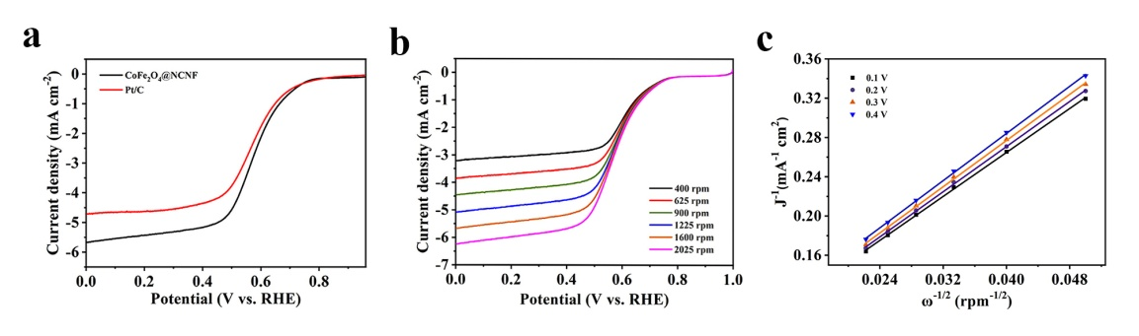
Fig. S7. (a) LSV curves of CoFe₂O₄@NCNF and Pt/C catalysts at 1600 rpm in 0.1 M PBS; (b) LSV curves of CoFe₂O₄@NCNF at various rotation speeds; (c) K-L plots at different potentials of CoFe₂O₄@NCNF.

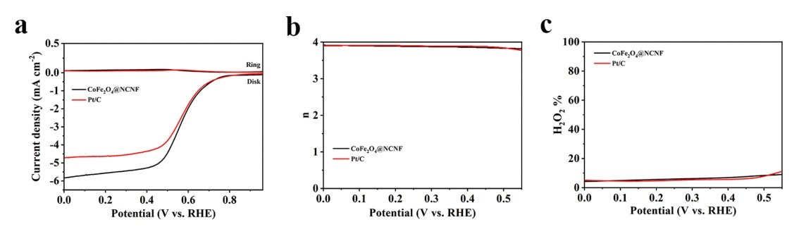
Fig. S8. (a) RRDE voltammograms of CoFe₂O₄@NCNF and Pt/C catalysts at 1600 rpm in 0.1 M PBS; (b) electron transfer number and (c) H₂O₂ selectivity of CoFe₂O₄@NCNF and Pt/C.

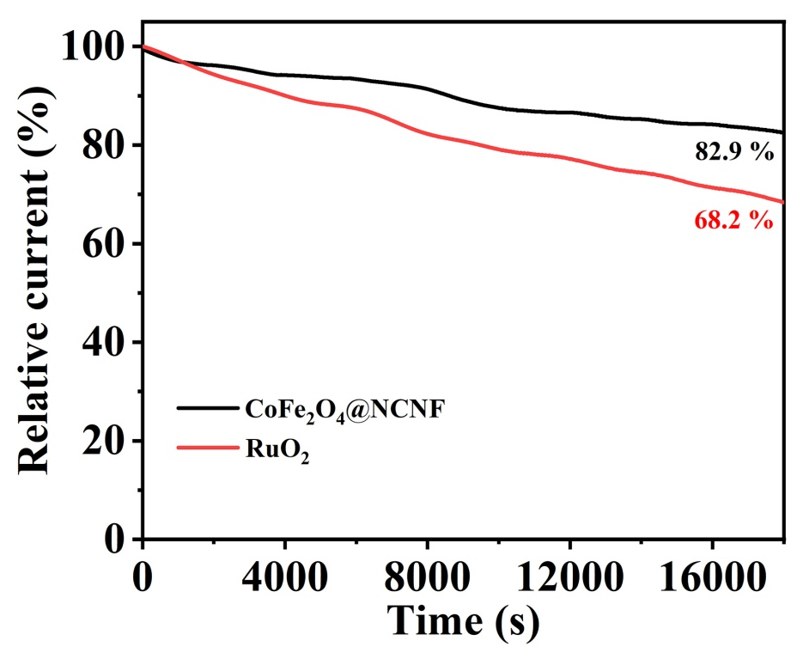
Fig. S9. Chronoamperometry test of CoFe₂O₄@NCNF and RuO₂ catalysts in OER.

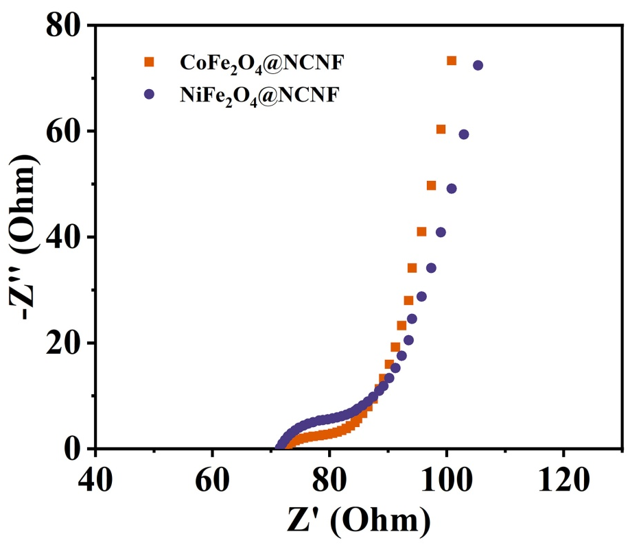
Fig. S10. EIS of CoFe₂O₄@NCNF and NiFe₂O₄@NCNF.

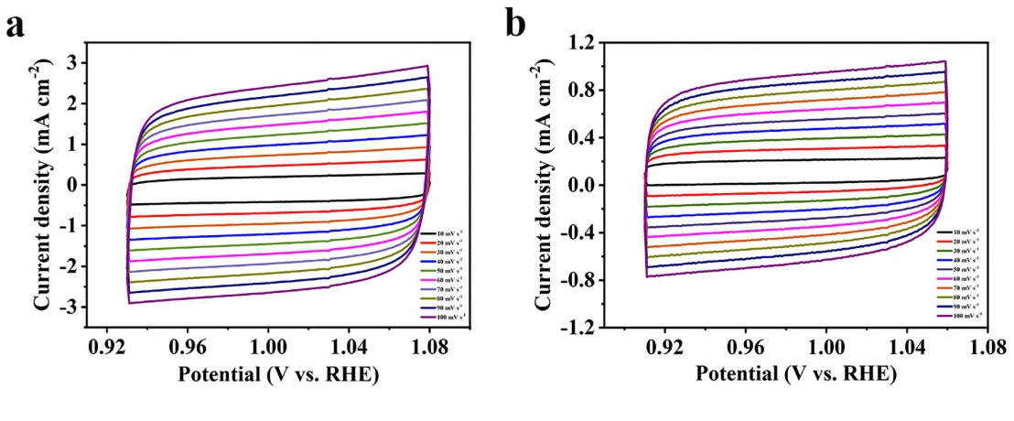
Fig. S11. CV curves of (a) CoFe₂O₄@NCNF and (b) NiFe₂O₄@NCNF under different scan rates from 10 to 100 mV·s⁻¹.

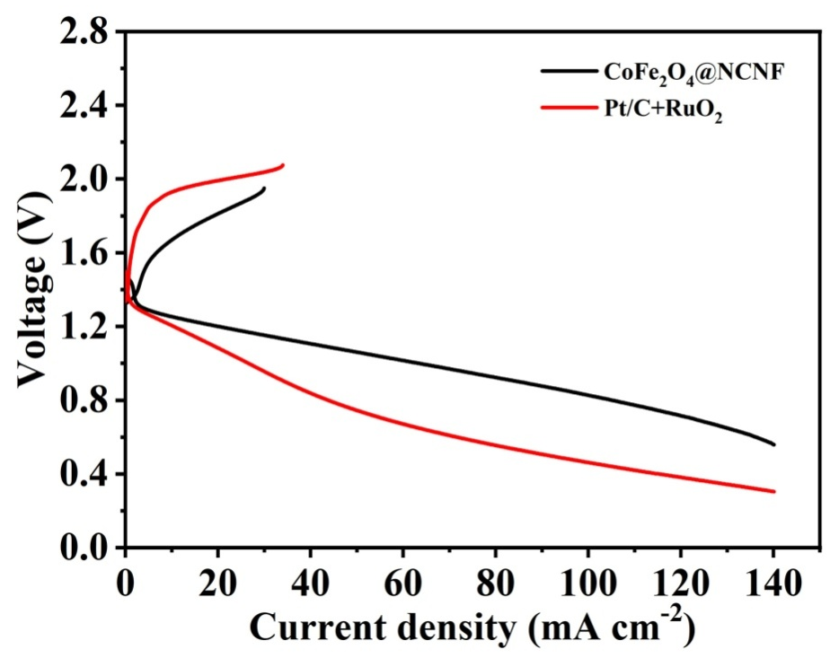
Fig. S12. Charge and discharge polarization curves of ZAB.

References
(S1) Cai, J.; Xu, Y.; Sun, Y.; Zhao, H.; Ye, D.; Tang, Y.; Sun, C.; Liu, L.; Zhang, J. Regulating the coordination environment of Fe/Co-N/S-C to enhance ORR and OER bifunctional performance. Inorg. Chem. Front. 2023, 10, 1826-1837.
(S2) Xiao, Z.; Lv, X.; Liu, S.; Liu, Q.; Wang, F.; Yan, W.; Xing, T.; Li, Z.; Li, X.; Chen, Y. Electronic Band Structure Engineering of Transition Metal Oxide‐N,S‐Doped Carbon Catalysts for Photoassisted Oxygen Reduction and Oxygen Evolution Catalysis. Adv. Mater. Interfaces 2021, 9, 2101386.
(S3) Huang, Q.; Li, C.; Tu, Y.; Jiang, Y.; Mei, P.; Yan, X. Spinel CoFe₂O₄/carbon nanotube composites as efficient bifunctional electrocatalysts for oxygen reduction and oxygen evolution reaction. Ceram. Int. 2021, 47, 1602-1608.
(S4) Li, L.; Li, N.; Xia, J.; Zhou, S.; Qian, X.; Yin, F.; He, G.; Chen, H. Metal-organic framework-derived Co single atoms anchored on N-doped hierarchically porous carbon as a pH-universal ORR electrocatalyst for Zn-air batteries. J. Mater. Chem. A 2023, 11, 2291-2301.
(S5) Geng, D.; Huang, Y.; Yuan, S.; Jiang, Y.; Ren, H.; Zhang, S.; Liu, Z.; Feng, J.; Wei, T.; Fan, Z. Coordination Engineering of Defective Cobalt-Nitrogen-Carbon Electrocatalysts with Graphene Quantum Dots for Boosting Oxygen Reduction Reaction. Small 2023, 19, No. e2207227.
(S6) Gebreslase, G. A.; Martinez-Huerta, M. V.; Sebastian, D.; Lazaro, M. J. Transformation of CoFe₂O₄ spinel structure into active and robust CoFe alloy/N-doped carbon electrocatalyst for oxygen evolution reaction. J. Colloid Interface Sci. 2022, 625, 70-82.
(S7) Alhakemy, A. Z.; Elseman, A. M.; Fayed, M. G.; Ahmed Amine Nassr, A. B.; El-Hady Kashyout, A.; Wen, Z. Hybrid electrocatalyst of CoFe₂O₄ decorating carbon spheres for alkaline oxygen evolution reaction. Ceram. Int. 2022, 48, 5442-5449.
(S8) Ferreira, L. S.; Silva, T. R.; Silva, V. D.; Raimundo, R. A.; Simões, T. A.; Loureiro, F. J. A.; Fagg, D. P.; Morales, M. A.; Macedo, D. A. Spinel ferrite MFe₂O₄ (M = Ni, Co, or Cu) nanoparticles prepared by a proteic sol-gel route for oxygen evolution reaction. Adv. Powder Technol. 2022, 33, 103391.
(S9) Ding, W.; Saad, A.; Wu, Y.; Wang, Z.; Li, X. CNTs/CNF-supported multi-active components as highly efficient bifunctional oxygen electrocatalysts and their applications in zinc-air batteries. Nano Res. 2023.
(S10) Xue, J.; Deng, S.; Wang, R.; Li, Y. Efficient synergistic effect of trimetallic organic frameworks derived as bifunctional catalysis for the rechargeable zinc-air flow battery. Carbon 2023, 205, 422-434.

