Supplementary Information
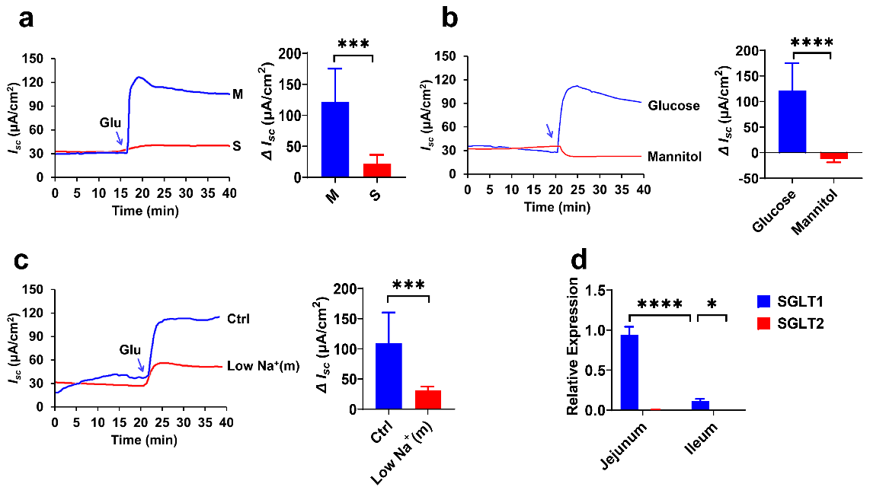
SI.1 Ileal glucose-induced current was dependent on Na⁺ -glucose co-transporters (a) Representative time courses of glucose (25 mM)-stimulated I_{sc} and the summary data of I_{sc} when added (indicated by the blue arrow) to the serosal (S, n = 6) or mucosal (M, n = 11) side of the ileum. (b) Comparison of I_{sc} induced by the mucosal addition of glucose (n = 11) or mannitol (n = 5) at the same concentration (25 mM) in the ileum (indicated by the blue arrow). (c) Comparison of the distal ileum I_{sc} induced by mucosal side addition of glucose (25 mM) in mucosal normal Na⁺ condition (Ctrl, n = 21) or the low - Na⁺ condition (Low Na⁺ (m), LiCl replaced NaCl, n = 6), indicated by the blue arrow. (d) Comparison of mRNA expression of glucose transporters SGLT1 and SGLT2 in jejunum and ileum (n = 5). Ctrl for the control group. Results are presented as mean ± SD, * p < 0.05, *** p < 0.001, **** p < 0.0001.

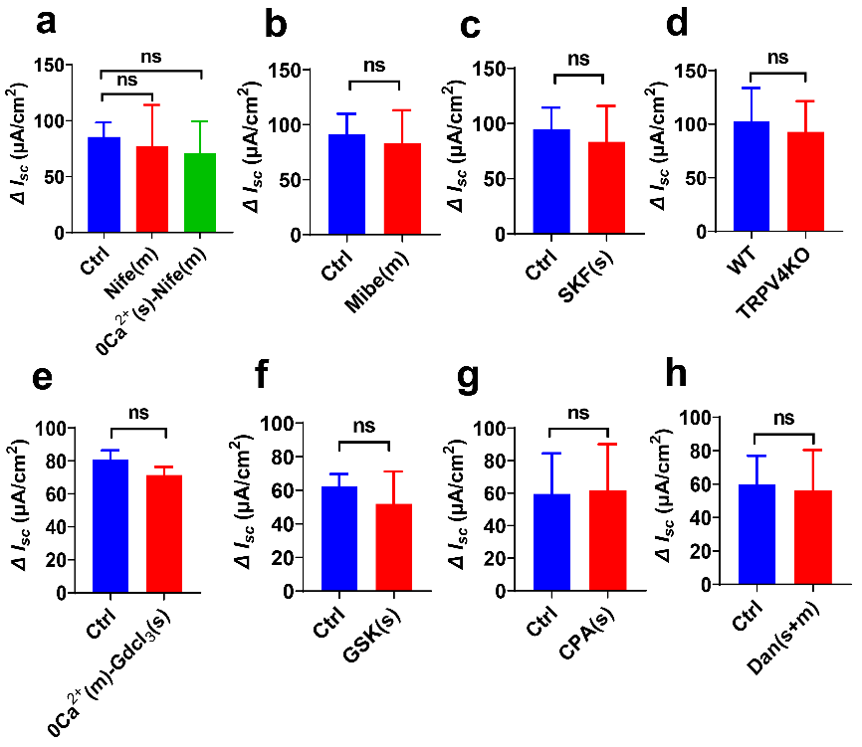
SI.2 Role of Ca²⁺-permeable channels in ileal glucose absorption (a) Effect of nifedipine (Nife, 10 μM, n = 5) on ileal glucose (25 mM) - induced I_{sc} with or without serosal Ca²⁺. (b) The summary data of 25 mM glucose-induced I_{sc} when added mibefradil (Mibe, 10 μM, n = 6) to the mucosal side of the ileum. (c) The summary data of 25 mM glucose-induced I_{sc} when SKF-96365 (SKF, 30 μM, n = 5) was added to the serosal side of the ileum. (d) Summary data compared the glucose (25 mM) -induced ileal I_{sc} (n = 5) between wild-type (WT) and TRPV4 knockdown (TRPV4KO) mice. (e) Effect of GdCl₃ (30 μM, n = 5) on ileal glucose (3 mM)-induced I_{sc} without mucosal Ca²⁺. (f) Summary data showing the effect of serosal (s) addition of GSK-7975A (100 μM, n = 6) on glucose (3 mM)-stimulated I_{sc}. (g) The summary data of ileal glucose (3 mM) - induced I_{sc} when the CPA (30 μM, n = 5) was added to the serosal side. (h) Effect of dantrolene (Dan, 100 μM) on glucose (3 mM) induced I_{sc} in mouse ileal tissue (n = 6). Ctrl for the control group. Results are presented as mean ± SD, ns, no significant differences.

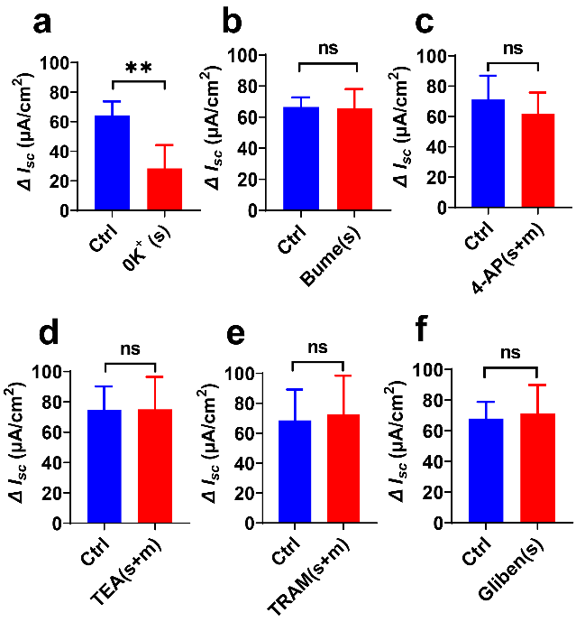
SI.3 Role of K⁺ transport in ileal glucose absorption (a) Summary data showing the effect of serosal 0 K⁺ condition on glucose (3 mM) -induced ileal I_{sc}. (b) Summary data showing the effect of serosal addition of bumetanide (Bume, 100 µM, n = 5) on glucose (3 mM)-stimulated I_{sc}. (c) Summary data showing the effect of bilateral addition of 4-AP (1 mM, n = 6) on glucose (3 mM)-stimulated I_{sc}. (d) Summary data of glucose (3 mM)-stimulated I_{sc} after bilateral addition of TEA (500 µM, n = 6). (e) Summary data showing the effect of bilateral addition of TRAM-34 (TRAM, 10 µM, n = 5) on glucose (3 mM) -stimulated I_{sc}. (f) Summary data of glucose-stimulated I_{sc} after serosal addition of glibenclamide (Gliben, 100 µM, n = 6). Ctrl for the control group. Results are presented as mean ± SD, ns, with no significant differences, ** p < 0.01.

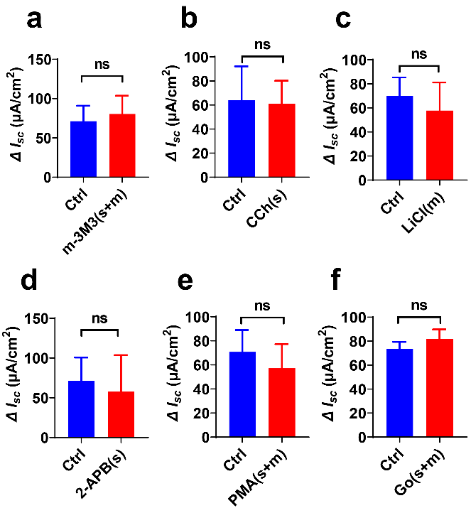
SI.4 Role of PLC-IP₃/PKC pathway in ileal glucose transport (a) Summary data showing the effect of bilateral addition of m-3M3FBS (m-3M3, 100 µM, n = 5) on glucose (3 mM)-stimulated I_{sc}. (b) Summary data showing the effect of serosal addition of carbachol (CCh, 100 µM, n = 7) on glucose (3 mM)-stimulated I_{sc}. (c) Summary data showing the effect of mucosal LiCl (10 mM, n = 6) on glucose (3 mM)-stimulated I_{sc}. (d) Summary data showing the effect of serosal addition of 2-APB (100 µM, n = 5) on glucose (3 mM)-stimulated I_{sc}. (e) Summary data showing the effect of bilateral addition of PMA (10 µM, n = 5) on glucose (3 mM)-stimulated I_{sc}. (f) Summary data showing the effect of bilateral addition of Go 6976 (Go, 3 μM, n = 5) on glucose (3 mM)-stimulated I_{sc}. Compared with a control group (Ctrl, n = 11) without any drug treatment. Results are presented as mean ± SD, ns, with no significant differences.

