Standard Curve generation for qRT-PCR

Taqman qRT-PCR Standard Curve Generation of Housekeeping Gene GAPDH
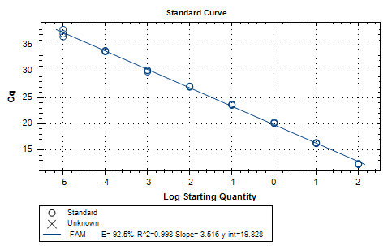
Taqman qRT-PCR Amplification Curve Generation of Housekeeping Gene GAPDH
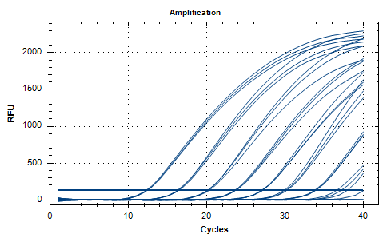

Taqman qRT-PCR Standard Curve Generation of Ie2b siRNA

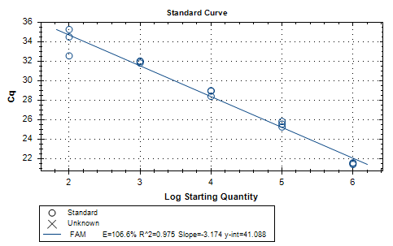

Taqman qRT-PCR Amplification Curve Generation of Ie2b siRNA

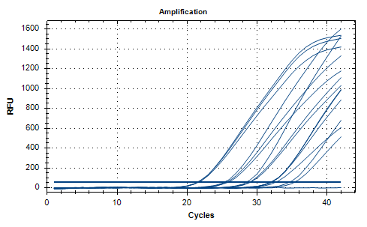
Taqman qRT-PCR Standard Curve Generation of dpb siRNA

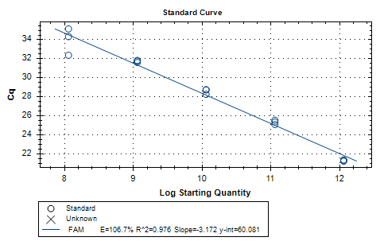

Taqman qRT-PCR Amplification Curve Generation of dpb siRNA
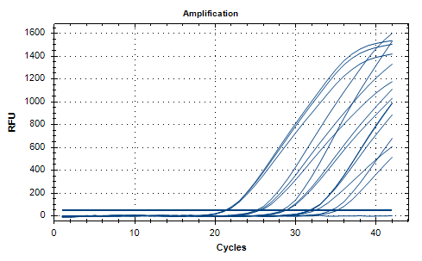
Taqman qRT-PCR Standard Curve Generation of dpc siRNA
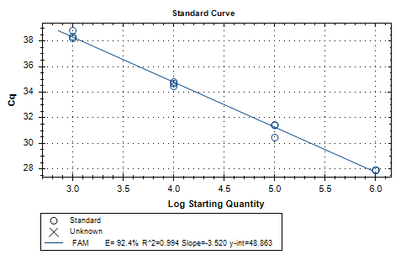

Taqman qRT-PCR Amplification Curve Generation of dpc siRNA

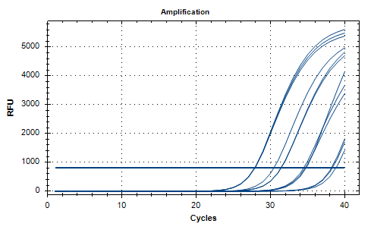

Gating reference for UNSTAINED for apoptosis analysis

Gating reference for PI only for apoptosis analysis

Gating reference for FITC only for apoptosis analysis

