Supplementary figures and legends.
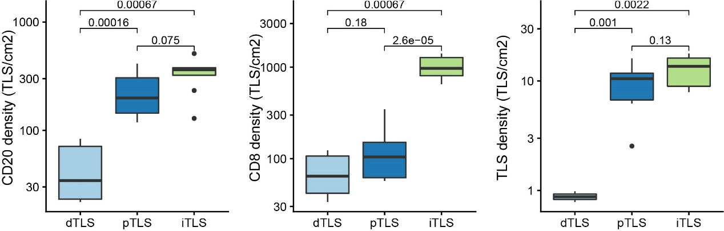
Fig S1: The cell distribution density of CD20+ B cell, CD8+ T cell, and TLS density in dTLS-GC, pTLS-GC, and iTLS-GC sample, estimated by mIHC staining. P value was estimated by t.test.

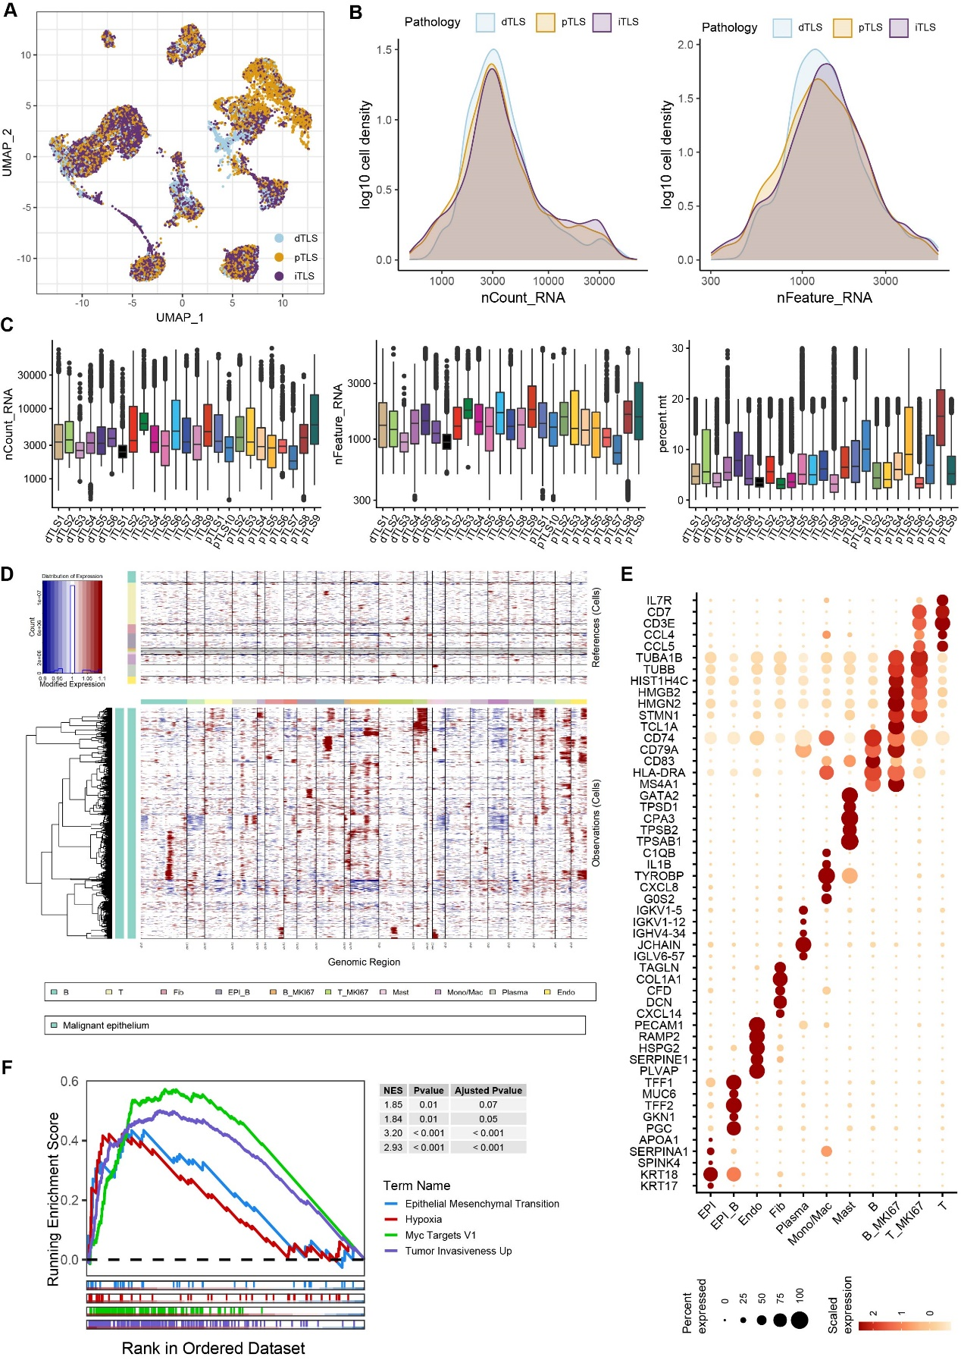
Figure S2, scRNA-seq quality control and CNV analysis A, UMAP plot showing the sample origin of 78,027 high-quality cells. B, the number of UMI counts and detected genes in all the cells. C, boxplots showing number of UMI counts, detected genes and percentage of mitochondrion DNA (mtDNA) of each tumor sample. D, heatmap showing the copy number variation (CNV) signal across cell types using inferCNV, cell types were marked by different colors. E, bubble plot showing signature genes expression across different cell types. F, GSEA analysis revealing the signal pathway enriched in malignant epithelium compare to non-malignant epithelium.
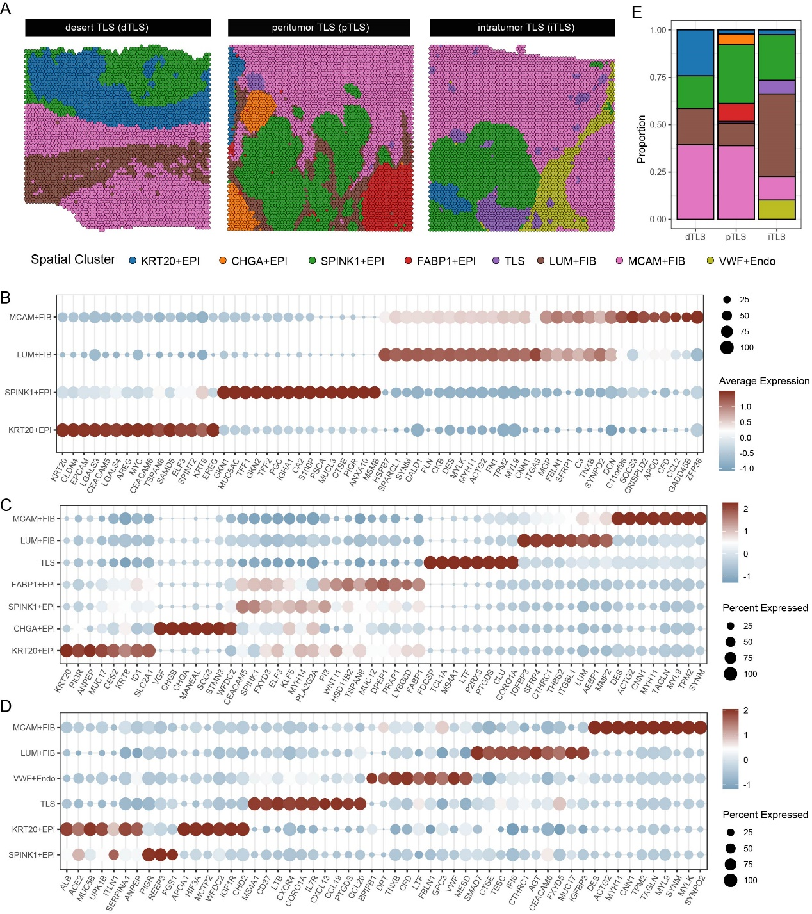
Figure S3, spatial transcriptomic sequencing of GC with different TLS status. A, integrated analysis of three GC spatial transcriptomic dataset reveals the spatial cluster. B-D, heatmap showing the expression of top 10 DEGs in each spatial cluster in dTLS-GC (B), pTLS-GC (C), and iTLS-GC (D). E, barplot showing the percentage of spatial cell cluster in GC with different TLS status.

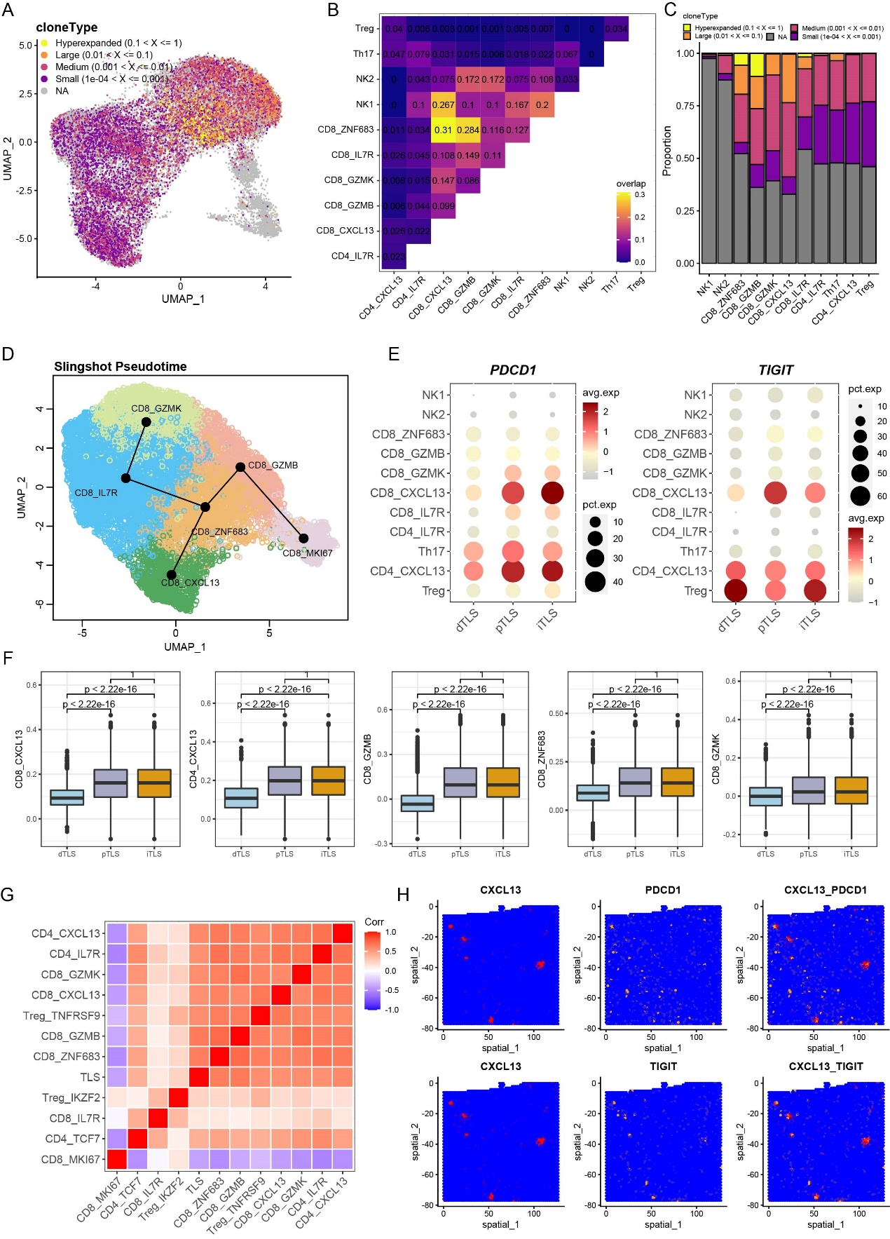
Fig S4, T cell characteristics A, UMAP of T cell subsets clonal expansion information. B, heatmap showing the clonal expansion correlation among the T cell subsets. C, bar plot showing the proportion of different clones across various T cell subsets. D, UMAP of pseudo time analysis revealing the trajectory of T cell development. E, bubble plot displaying enrichment of PDCD1 and TIGIT in T cell subpopulations within dTLS-GC, pTLS-GC, and iTLS-GC. F, boxplot displaying differential enrichment of CD8_CXCL13, CD4_CXCL13, CD8_GZMB, CD8_GZMK and CD8_ZNF683 within dTLS-GC, pTLS-GC, and iTLS-GC by spatial transcriptomic sequencing. G, spatial correlation among T cell subsets by spatial transcriptomic sequencing. H, spatial distribution of CXCL13, PDCD1 and TIGIT expression revealed an overlap between CXCL13 signal with PDCD1 and TIGIT signal.

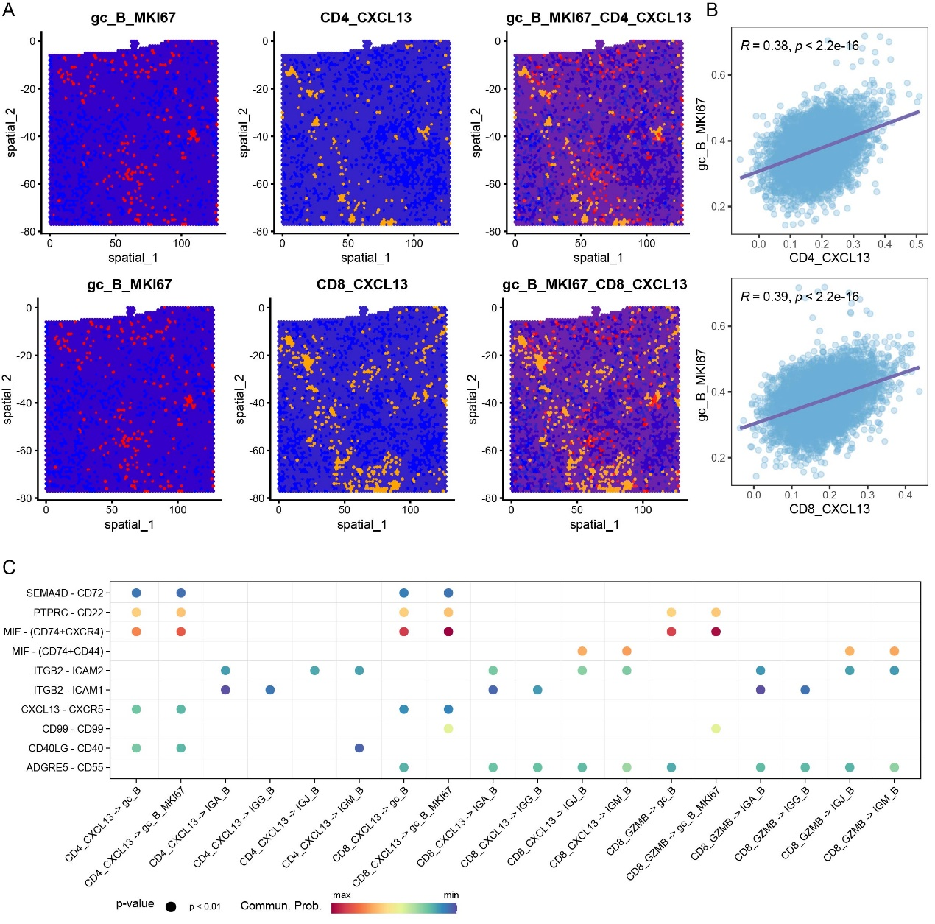
Fig S5, B cell characteristics A-B, spatial colocalization among T cell and B cell subsets revealed by spatial transcriptomic sequencing. C, intercellular crosstalk analysis revealed the enriched ligand-receptor pairs among the T cell and B cell subsets by scRNA-seq.

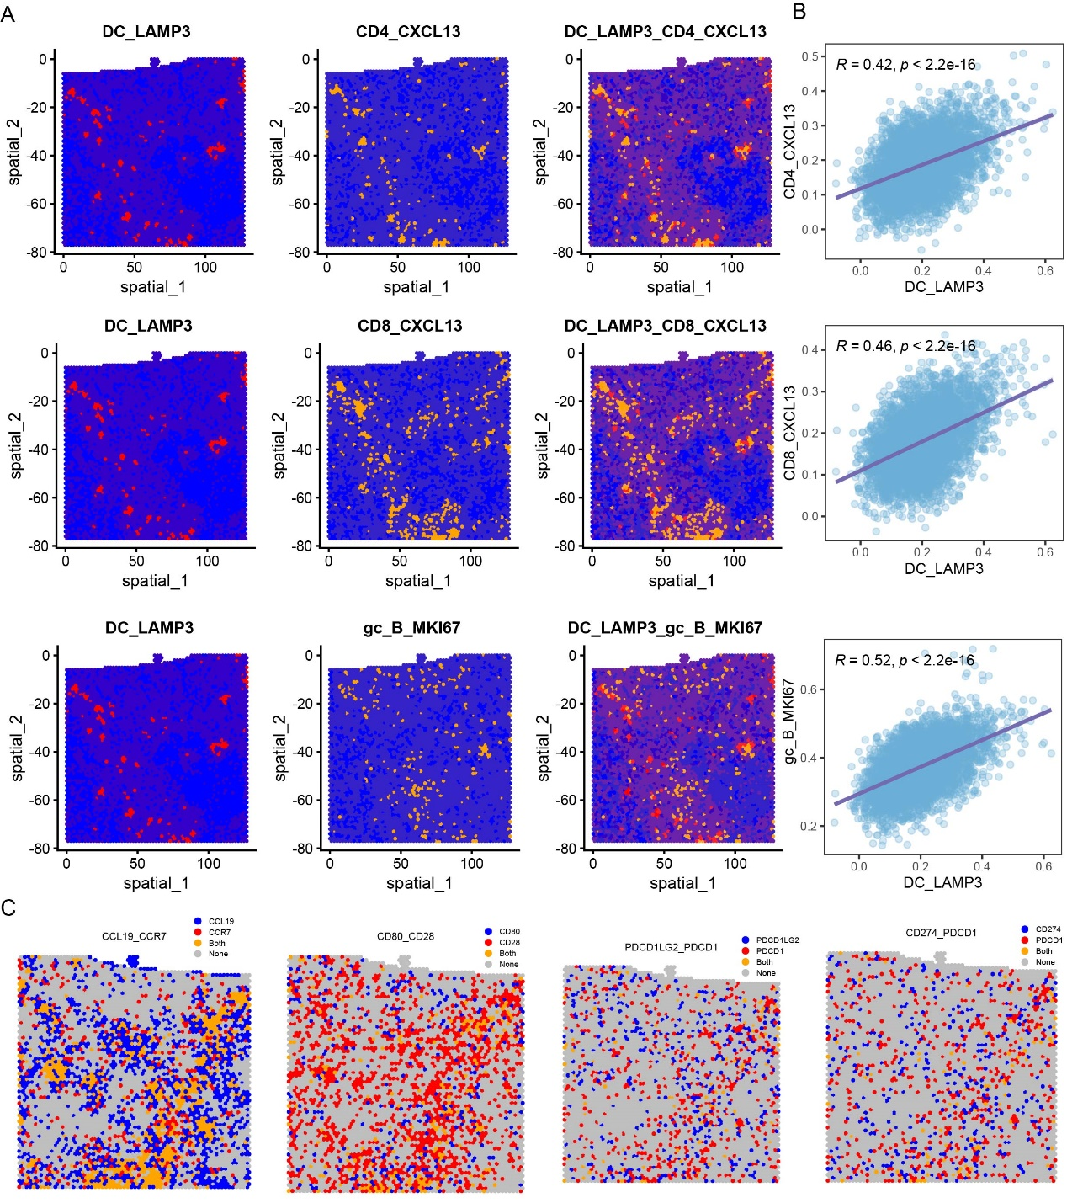
Figure S6 Myeloid cell characteristics A, spatial colocalization among CXCL13+ T cell, gc_B_MKI67, and LAMP3+DC cell subsets revealed by spatial transcriptomic sequencing. B, the dot plot indicating the correlations between the CD4_CXCL13 (upper), CD8_CXCL13 (middle) and gc_B_MKI67 (bottom) with LAMP3_DC, the oblique line and R represent the average correlation coefficient, P values were calculated by Wilcoxon test. C: spatial distribution of CCL19-CCR7, CD80-CD28, PDCD1LG2-PDCD1 and CD274-PDCD1 in iTLS-GC, revealed by spatial transcriptome profiling.

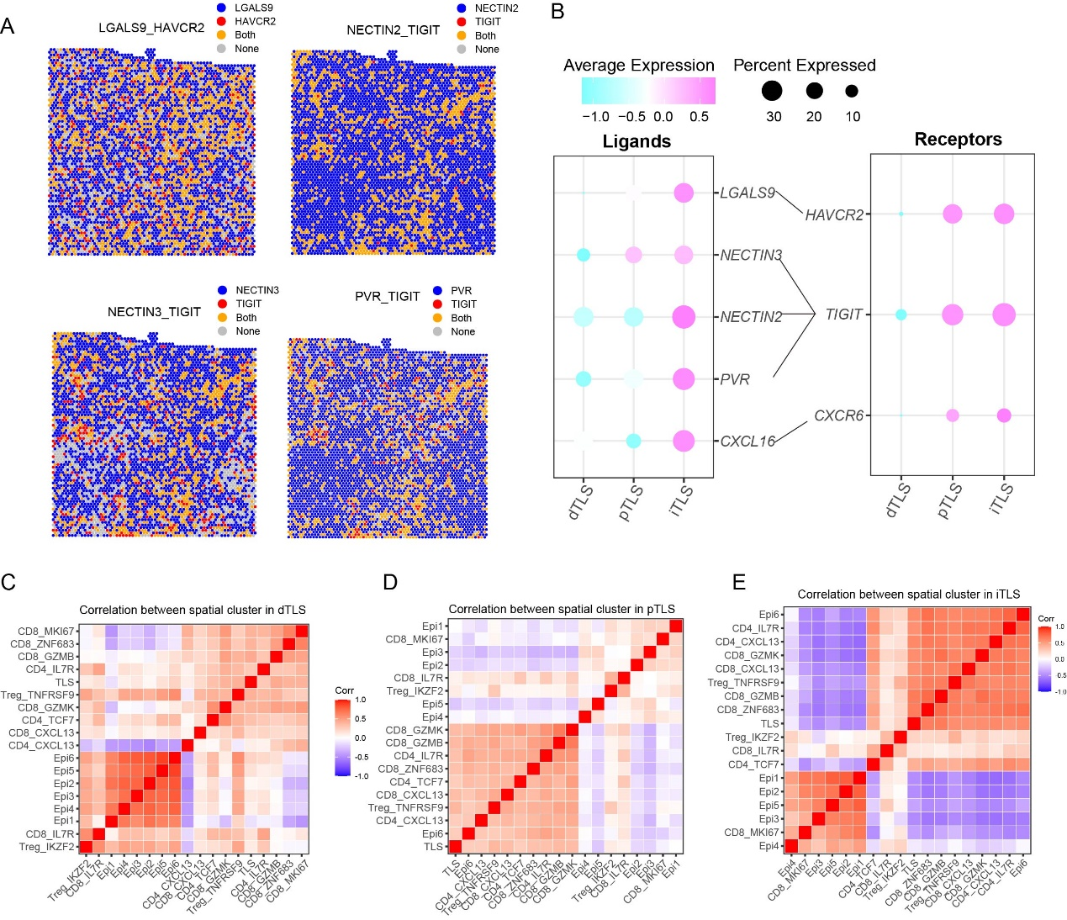
Figure S7 epithelium characteristics A-C: The heatmap showing the correlation among the cell clusters of GC TME within dTLS-GC (A), pTLS-GC (B), and iTLS-GC (C). D, spatial location and co-exist of immune checkpoint molecule related LRP including LGALS9-HAVCR2, NECTIN2/3-TIGIT and PVR-TIGIT within iTLS-GC tissue. E, bubble plot showing the enrichment of immune checkpoint molecule related LRP including LGALS9-HAVCR2, NECTIN2/3-TIGIT and PVR-TIGIT within dTLS-GC, pTLS-GC, and iTLS-GC.

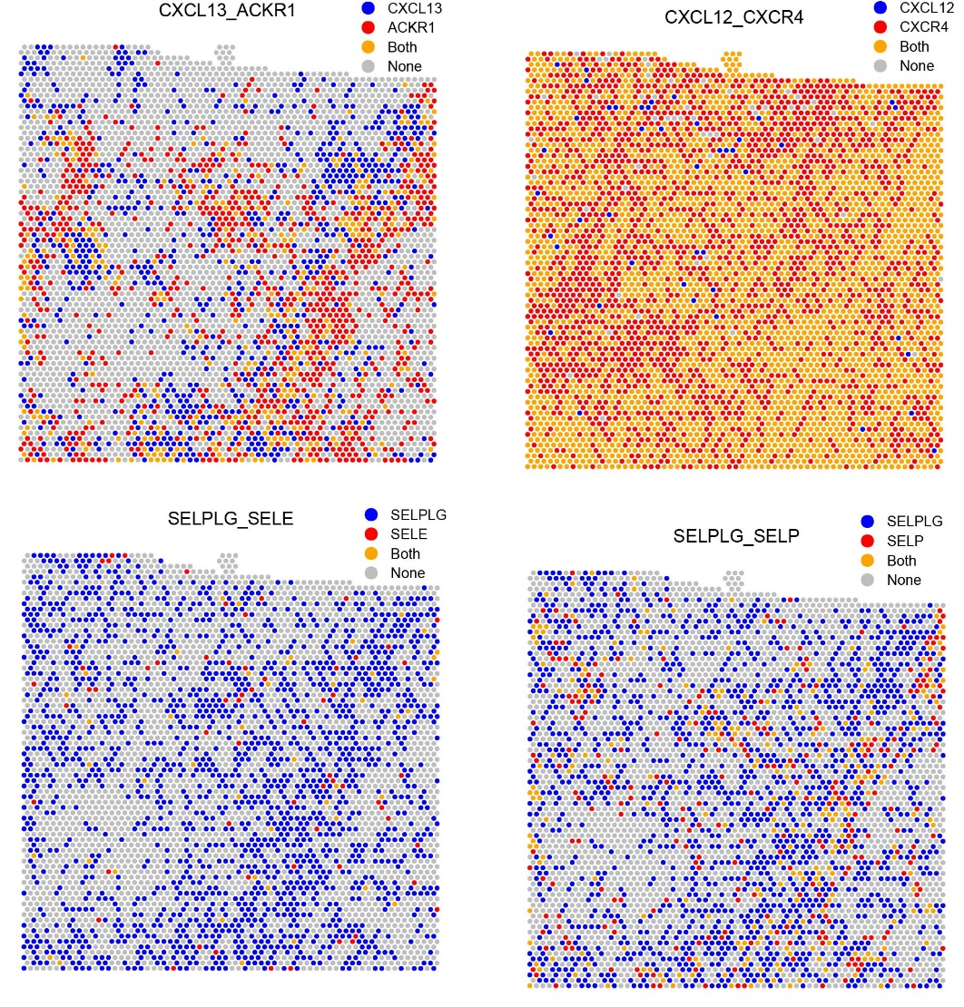
Figure S8 The spatial location and co-exist LRP enriched in HVE including CXCL13-ACKR1, CXCL12-CXCR4 and SELPLG-SELE/P within iTLS-GC tissue.

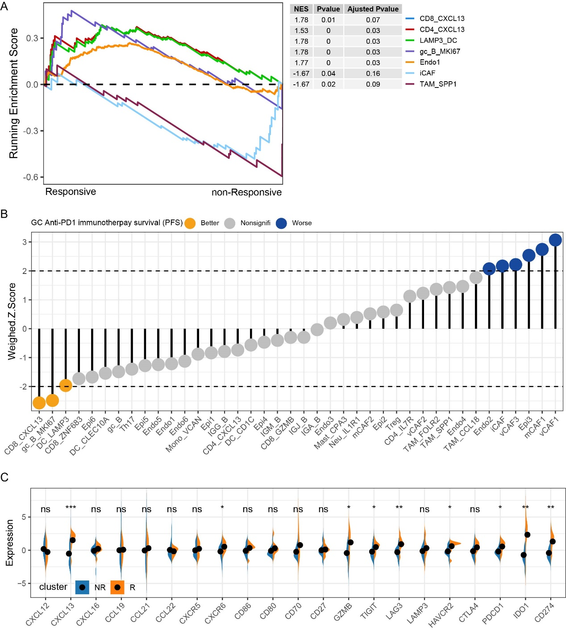

Figure S9 A, Gene set enrichment analysis revealing the immunotherapy sensitivity of cells subsets enriched in iTLS-GC, the statistics significance was evaluated by p value and adjusted p value by student’ t test. B, the dumbbell chart showing the progressions-free survival (PFS) of anti-PD1 immunotherapy efficacy outcome of cell components identified in TME of GC with varying TLS infiltration. C, the correlation of molecules enriched in iTLS-GC with immunotherapy response based on TCGA dataset.

